|  |  |
| --- | --- |
| Government of Kenya | Brands of the World™ | Download vector logos and  logotypes | **MINISTRY OF ENERGY**  Republic of Kenya |

|  |  |
| --- | --- |
|  | The World Bank Logo | evolution history and meaning, PNG |

**KENYA OFF-GRID SOLAR ACCESS PROJECT (KOSAP) FOR UNDERSERVED COUNTIES**

**Component 1: Mini grids for Community Facilities, Enterprises, and Households**

**ESIA REPORT FOR THE PROPOSED BOJI GARAS OFF-GRID SOLAR PROJECT AT COORDINATES 1°42’45.8” N, 40°46’12.3” E**

|  |  |  |  |  |
| --- | --- | --- | --- | --- |
|  |  |  |  |  |
|  |  | | |  |

# CERTIFICATION

This ESIA project report for the proposed Boji Garas Off-Grid Solar Projecthas been prepared by ESIA /EA Firm of Experts, **Centric Africa Ltd, Reg. No.7112 and Norken International Ltd, Reg. No.0181.** The report has been written with diligence in accordance with the World Bank Operational Procedures OP, Environmental Safeguards Standards (ESS), the EMCA 1999 *(Amended, 2015)* and the Environmental and Social Impact Assessment and Audit Regulations, 2003 to bring out the true nature of the intended development**.** The report was prepared based on the information provided by various stakeholders and village elders at Boji Garas in Wajir County as well as from primary and secondary sources. It is therefore, issued without any prejudice.

We the undersigned, certify that the particulars in this CPR are correct and righteous to the best of our knowledge.

**ESIA/EA FIRM OF EXPERTS:**





Isaiah Kegora

NEMA Expert (Reg. No. 1893).

*For Norken (I) Ltd & Centric Africa Ltd*

Signature: ________________________ Date: **­­______________________**

**PROPONENT:**

Mr. Rodney I. Sultani

Project Coordinator, KOSAP

Ministry of Energy and Petroleum,

P.O. Box 30582-00100,

Kawi House, Nairobi, Kenya

Signed: ____________________________ Date: _____________________

-------------------------------------------------------------------------------------------------------

*Disclaimer:*

*This ESIA report is strictly confidential to MoE (the Proponent) and any use of the materials thereof should strictly be in accordance with the agreement between the Proponent and the consultants; Norken International Limited and Centric Africa Limited (the Environmental Impact Assessor). It is, however, subject to conditions in the Environmental (Impact Assessment and Audit) Regulations, 2003 under the Kenya Gazette Supplement No. 56 of 13th June 2003.*

TABLE OF CONTENTS

CERTIFICATION ii

ACKNOWLEDGEMENT x

LIST OF TABLES xi

LIST OF PLATES xii

LIST OF FIGURES xiii

LIST OF ACRONYMS xiv

EXECUTIVE SUMMARY 1-16

1 INTRODUCTION 1-25

1.1 Context 1-25

1.2 Project Overview 1-26

1.3 Purpose and Scope of Work 1-26

1.4 Terms of Reference (ToR) for the ESIA Process 1-27

1.5 ESIA Study Team 1-27

1.6 Project Justification for the ESIA 1-27

1.7 Approach and Methodology 1-28

1.7.1 Screening and Scoping 1-29

1.7.2 Project Description 1-29

1.7.3 Baseline Condition 1-30

1.7.4 Impact Assessment (IA) Prediction 1-30

1.7.5 Environmental and Social Management Plan (ESMMP) 1-30

1.7.6 Stakeholder Consultations and Participation 1-31

1.7.7 Limitations 1-33

1.8 Target Group for the ESIA Report 1-33

1.9 Assumptions 1-34

1.10 Uncertainties in Compiling Information 1-34

1.11 Layout of the Report 1-34

2 PROJECT DESCRIPTION 2-36

2.1 Introduction 2-36

2.2 Project Location 2-37

2.2.1 Project site setting 2-38

2.3 Land Requirement and Procurement Process 2-38

2.3.1 Land Tenure 2-38

2.3.2 Compensation Details 2-38

2.4 Description of Project Facilities, Components and Activities 2-39

2.4.1 Project Components 2-39

2.5 Project Phases and Activities 2-43

2.5.1 Pre-Construction/ Project Design 2-43

2.5.2 Operational Activities 2-45

2.5.3 Project’s Decommissioning Activities 2-45

2.6 Resource Requirement 2-46

2.6.1 Workforce Requirement 2-46

2.6.2 Water Requirement and Source 2-46

2.6.3 Raw Material Requirement 2-46

2.6.4 Road Access Requirement 2-47

2.6.5 Power Requirement 2-47

2.6.6 Fire Safety and Security 2-47

**2.7** **Pollution Streams during Construction Phase** 2-48

**2.7.1** **Solid Waste Generation** 2-48

**2.7.2** **Air Emissions** 2-49

**2.7.3** **Liquid Waste Generation** 2-50

**2.7.4** **Noise Emissions** 2-50

2.8 Safety of the Facility 2-50

3 BASELINE SETTINGS- ENVIRONMENT AND SOCIAL 3-52

3.1 Study Area 3-52

3.2 Environment Baseline 3-52

3.2.1 Geology and Soil 3-52

3.2.2 Topography 3-52

3.2.3 Hydrogeology and Drainage 3-52

3.2.4 Ground Water Development 3-53

3.2.5 Ecological Conditions 3-53

3.2.6 Climatic Conditions 3-54

3.3 Socio-economic Environment 3-54

3.3.1 Community Profile 3-54

3.3.2 Socio-economic status of Study Area 3-54

4 ANALYSIS OF ALTERNATIVES AND PROJECT JUSTIFICATION 4-59

**4.1** **Site Selection** 4-59

4.2 Power Scenario in Boji Garas 4-60

4.2.1 Present Power Supply Position 4-60

4.2.2 Vision 2030 4-61

**4.3** **Analysis of Alternative** 4-61

4.3.1 Alternative Location for Project Site 4-61

4.3.2 Alternative Sources of Energy 4-62

4.3.3 Zero or No Project Alternative 4-63

4.3.4 Analysis of Alternative Construction Materials and Technology 4-63

4.3.5 Solid Waste Management Alternatives 4-63

4.3.6 Alternative Solar Mini-Grid 4-64

4.3.7 Conclusion 4-65

5 POLICY AND LEGISLATIVE FRAMEWORK 5-66

5.1 Introduction 5-66

5.2 Environmental Policy Framework 5-66

5.3 Institutional, Regulatory and Legal Framework 5-66

5.4 Kenya Policy Provisions 5-68

5.4.1 Kenya Energy Policy, 2014 5-68

5.4.2 The Constitution of Kenya 5-69

5.4.3 Policy paper on Environment and Development (Sessional Paper No. 6 of 1999) 5-72

5.4.4 National Policy on Water Resources Management and Development, 1999 5-72

5.4.5 Sessional Paper No. 10 of 2014 on the National Environmental Policy, 2014 5-72

5.5 National Legal Framework 5-73

5.5.1 Administrative Framework 5-73

5.6 Relevant statutes 5-73

5.7 National Administrative Requirements 5-82

5.8 International Safeguard Requirements 5-82

**5.8.1** **World Bank Policy OP 4.01 Environmental Assessment** 5-83

**5.8.2** **World Bank Policy OP 4.04 Natural Habitats** 5-84

**5.8.3** **World Bank Policy OP 4.12 Involuntary Resettlement** 5-84

**5.8.4** **World Bank Policy OP 4.10 Indigenous Peoples** 5-85

**5.8.5** **Alignment of WB and GoK policies to this project** 5-85

5.9 Environmental and Social Management Framework (ESMF) for KOSAP 5-86

5.10 Resettlement Policy Framework (RPF) for KOSAP 5-86

5.11 Vulnerable and marginalized Groups Framework (VMGF) for KOSAP 5-86

5.12 Comparison between the World Bank and Kenyan Laws to the Project 5-87

6 STAKEHOLDER ENGAGEMENT 6-89

6.1 Legal Requirement for Stakeholder Engagement 6-89

6.2 Objectives of Public Participation 6-89

6.3 Stakeholder Consultation and Disclosure Requirement for the Project 6-90

6.4 Stakeholder Characterization and Identification 6-90

6.4.1 Stakeholder Mapping 6-91

6.5 Stakeholder Analysis 6-92

6.6 Summary of Community Consultation meeting leading to Land Identification and GRC Constitution- (Screening Level) 6-92

6.7 Key Feedback of Further Stakeholder Consultation Process Carried out During ESIA 6-94

6.7.1 Positive Comments about the Project from the Participants 6-94

6.7.2 The identified negative impacts of the project 6-94

**6.7.3** **Additional Responses from the Consultant** 6-95

6.7.4 Consent 6-95

**6.7.5** **Community Presentation** 6-95

6.8 Focused Group Discussions analysis 6-96

6.8.1 Female Stakeholders’ Consultation and Participation 6-96

6.8.2 Male Stakeholders’ Consultation and Participation 6-98

6.8.3 Youth Stakeholders’ Consultation and Participation 6-100

6.8.4 Education Stakeholders’ Consultation and Participation 6-101

6.9 Disclosure of ESIA to the Stakeholders 6-101

6.10 Stakeholder Engagement and Grievance Management Post ESIA 6-102

7 GRIEVANCE REDRESS MECHANISM 7-1

7.1 Introduction 7-1

7.2 Grievance Mechanism 7-1

7.3 National Grievances Redress Committee (NGRC) 7-2

7.4 County Grievance Redress Committee (CGRC) 7-2

7.5 Locational Grievance Redress Committee (LGRC) 7-3

7.6 Available Grievance Redress Mechanism - Maslaha 7-4

8 IMPACTS ASSESSMENT MITIGATION MEASURES 8-1

8.1 Identification 8-1

8.2 Assessment Methodology 8-1

8.3 Defining Impacts 8-1

**8.4** **Assessment of Significance** 8-1

**8.5** **Magnitude of Impact** 8-3

**8.6** **Sensitivity of Resources and Receptors** 8-3

**8.7** **Likelihood** 8-3

8.8 Definition of Mitigation Measures 8-4

8.9 Positive Impacts – Construction phase 8-4

8.9.1 Creation of Employment Opportunities 8-4

8.9.2 Improving local economy 8-5

8.10 Positive Impacts during Operation Phase 8-5

8.10.1 Quality, Reliable Power Supply 8-5

8.10.2 Employment Creation 8-5

8.10.3 Reduction of Pollution Associated with Thermal Power Generation, Kerosene and Wood Fuel Usage: 8-6

8.10.4 Improvement of Local and National Economy 8-6

8.10.5 Education 8-6

8.10.6 Health Benefits of the Project 8-7

8.10.7 Improved Standard of Living 8-7

8.10.8 Security 8-7

8.10.9 Communications 8-7

8.10.10 Positive Impacts during Decommissioning Phase 8-7

8.10.11 Employment Opportunities 8-7

8.10.12 Site Rehabilitation 8-7

8.11 Negative Environmental and Social Impacts during Pre-Construction Phase 8-8

8.11.1 Impact on Land Acquisition 8-8

8.11.2 Impact on Wayleaves 8-8

8.11.3 Stakeholder Identification and Consultation 8-9

8.11.4 Other negative impacts at Pre-Construction Phase 8-10

8.12 Negative Environmental and Social Impacts – Construction phase 8-11

8.12.1 Vegetation Clearance 8-11

8.12.2 Soil Erosion Impact 8-11

8.12.3 Contamination of Soil from Fossil Fuels 8-12

8.12.4 Dust Emissions 8-12

8.12.5 Vehicle Exhaust Emissions 8-13

8.12.6 Pollution from Solid Waste Generation 8-13

8.12.7 Impacts on Water Resources and Water Quality 8-13

8.12.8 Noise and vibration 8-14

8.12.9 Impacts from Hazardous Materials 8-15

8.12.10 Accidental Oil Spills or Leaks 8-15

8.12.11 Fire Hazards 8-16

8.12.12 Impacts of construction material sourcing (e.g., quarrying) 8-16

8.12.13 Increased Water Demand 8-16

8.12.14 Energy Consumption 8-17

8.12.15 Occupational Health and Safety Impacts 8-17

8.12.16 Community Safety -Access to Site by General Public 8-17

8.12.17 Spread of HIV/AIDS and STIs 8-18

8.12.18 Increase in competition for scarce resources and strain on public utilities 8-18

8.12.19 Child Labor 8-19

8.12.20 Gender Based Violence- SEA and SH 8-19

8.12.21 Public Health Impacts 8-21

8.12.22 Public Health Impacts Sanitary Waste 8-21

8.12.23 Forced Labor 8-21

8.12.24 Risks related to Inadequate Stakeholder Engagement 8-22

8.13 Negative Impacts during Operation phase of the project 8-22

8.13.1 Solid Waste Generation 8-22

8.13.2 Liquid Waste/Oils Generation 8-22

8.13.3 Increased oil Consumption 8-23

8.13.4 Increased Storm Water Flow 8-23

8.13.5 Fire Outbreaks 8-23

8.13.6 Visual Impacts 8-24

8.13.7 Water demand 8-24

8.13.8 Sanitary waste 8-24

8.13.9 Flooding 8-24

8.13.10 Workers Occupation Health and Safety 8-25

8.13.11 Hazardous waste 8-25

8.13.12 Noise and Vibration 8-25

8.13.13 Electric and magnetic fields (EMFs) 8-25

8.13.14 Shocks and electrocutions to the beneficiaries 8-25

8.13.15 Community safety -Access to the facility by general public 8-26

8.13.16 Risks related to poor or inadequate stakeholder engagement (Conflict) 8-26

8.13.17 Public Health Impacts –HIV/AIDs 8-27

8.13.18 Public health Impacts -Covid 19 disease 8-27

8.13.19 Dust emissions 8-28

8.13.20 Vehicle exhaust emissions 8-28

8.14 Negative impacts during decommissioning phase 8-28

8.14.1 Noise and Vibration 8-28

8.14.2 Solid Waste Generation 8-29

8.14.3 Dust Emissions 8-29

8.14.4 HIV/AIDs awareness and prevention 8-29

8.15 Social Protection 8-29

8.16 Social Inclusion 8-30

9 ENVIRONMENTAL AND SOCIAL MANAGEMENT AND MONITORING PLAN (ESMMP) 9-31

9.1 Purpose and Objectives of ESMMP 9-31

**9.2** **Auditing of ESMMP** 9-31

**9.3** **Incident Reporting** 9-31

**9.4** **Management Responsibility of ESMMP** 9-32

**9.4.1** **Kenya Power and Lighting/Rural Electrification and Renewable Energy Corporation/ Ministry of Energy** 9-32

**9.4.2** **National Environment Management Authority (NEMA)** 9-32

**9.4.3** **Contractor** 9-32

**9.4.4** **Consultant** 9-33

**9.4.5** **County Government of Wajir County** 9-34

9.5 Environmental and Social Management Plan 9-34

9.5.1 Management Plan during Construction Phase 9-34

9.5.2 Management Plan during Operational Phase 9-35

9.6 Monitoring 9-1

9.7 ESMP Monitoring Plan 9-1

10 IMPACT SUMMARY AND CONCLUSION 10-2

10.1 Introduction 10-2

10.2 Impacts Requiring Detailed Assessment 10-2

10.3 Conclusion 10-2

10.4 Recommendation 10-4

11 REFERENCES 11-7

12 APPENDICES 12-8

1. Minutes of EIA Consultation Meeting 12-8

2. List of Attendance - ESIA 12-13

3. Minutes of community consultative meeting leading to land acquisition 12-24

4. List of Attendance – Land Identification 12-34

5. Abbreviated Resettlement Action Plan (A-RAP) 12-43

6. Firm and Lead Expert’s EIA Practicing License 12-48

# ACKNOWLEDGEMENT

The consultant wishes to acknowledge and appreciate the efforts and inputs by MOEP, the Implementing Agencies (KPLC and REREC), and the World Bank Group teams in reviewing this report

# LIST OF TABLES

Table 2: Issues Discussed and in cooperation into the Project Reports 1-20

Table 3: Summary of Pre-Construction Impacts 1-21

Table 4: Summary of Construction and Decommissioning Phase Impacts 1-21

Table 5: Summary of Operational Phase Impacts 1-22

Table 6: Structure of the ESIA Report 1-33

Table 7: Component of the proposed Solar Mini-grid 2-35

Table 8: Inputs and equipment -Construction phase 2-46

Table 9: Summary of demographic profile of Boji Garas Sub-Location 3-54

Table 10. Kenya power stakeholders and their roles 5-70

Table 11: Administrative stakeholders and their roles 5-72

Table 12: National Policy Framework 5-73

Table 13: Relevant Enforcement agencies 5-81

Table 14: World Bank safeguards 5-81

**Table 15: Comparison between the WB safeguard policies and the Kenya Legislation** 5-86

Table 16: Identified Stakeholders 6-90

Table 17: Stakeholder Significance and Engagement Requirement 6-90

Table 18: The consultative meeting had a wide representation 6-94

Table 19: FGD dates and attendance 6-95

Table 20: Categories of Significance 8-2

Table 21: Overall Significance Criteria for Environmental Impacts 8-2

Table 22:Impact qualitative scale 8-3

Table 23: Environmental and Social Management Plan (ESMP) 9-1

Table 27: Environmental and Social MonitoringDuring Construction Phase 9-1

Table 28: Environmental and Social Monitoring During Operation Phase 9-4

Table 29: Institutional Framework and Compliance/Implementation of the ESIA/ESMP 9-1

# LIST OF PLATES

Plate 1: Project site environs and activities 2-37

Plate 2: Project area soil and flora presentation 3-53

Plate 3: Pastoral activities near the project site 3-55

Plate 4: Boji Garas water tank 3-57

Plate 5: Public participation “Baraza” Session 6-96

Plate 6: FGD session with Women 6-97

# LIST OF FIGURES

Figure 1: Proposed project area distribution line 1-26

Figure 2: Summary of Environmental and Social Impact Assessment Methodology 1-31

Figure 3: Project location 2-37

Figure 4: Map showing the KOSAP Counties Lot 3 2-38

Figure 5: Illustration sketch of the proposed design of the proposed project 2-43

Figure 6: KOSAP Grievance Redress Mechanism 7-5

# LIST OF ACRONYMS

|  |  |
| --- | --- |
| **ACRONYM** | **DEFINATION** |
| ADR | Alternative Dispute Resolution |
| AoI | Area of Influence |
| CBO | Community Based Organization |
| CoK | Constitution of Kenya |
| CDI | County Development Index |
| CEMP | Construction Environmental Management Plan |
| CGRC | County Grievance Redress Committees |
| CIDP | County Integrated Development Plan |
| CSR | Customer Social Responsibility |
| CoC | Code of Conduct. |
| Covid 19, | Coronavirus Diseases 2019 |
| CPR | Comprehensive Project Report |
| CPS | Country Partnerships Strategy |
| CRA | Commission on Revenue Allocation |
| DOSHS | Directorate of Occupational Safety and Health Services |
| ECD | Early Childhood Development |
| EHS | Environmental and Health Standards |
| EIA | Environmental Impact Assessment |
| EMCA | Environment Management Coordination Act |
| EMF | Electromagnetic Field |
| EPRA | Energy and Petroleum Regulatory Authority |
| EPT: | Energy and Petroleum Tribunal |
| ESI | Electricity Supply Industry |
| ESIA | Environmental and Social Impact Assessment |
| ESMF | Environmental and Social Management Framework |
| ESMP | Environmental and Social Management Plan |
| ESMMP | Environmental and Social Management and Monitoring Plan |
| FGD | Focus Group Discussions |
| GBV | Gender Based Violence |
| GDC | Geothermal Development Company |
| GoK | Government of Kenya |
| HIV/STD | Human Immune Deficiency syndromes/Sexually transmitted diseases |
| HDPE | High Density Poly Ethylene |
| IAs | Implementing Agencies |
| IEC  IPPs | International Electrotechnical Commission  Independent Power Procedures |
| IPs | Indigenous Peoples |
| KETRACO | The Kenya Electricity Transmission Company |
| KII | Key Informant Interview |
| KOSAP | Kenya Off-Grid Solar Access Project |
| KPLC | Kenya Power and Lighting Company |
| LEP | Labor & Employment Plan |
| LGRC | Locational Grievance Redress Committees |
| MoEP | Ministry of Energy of Petroleum |
| NEMA | National Environmental management Authority |
| NGOs | Non-Government organizations |
| NGRC | National Grievances Redress Committee |
| NLC | National Lands commission |
| OP | Operation procedures |
| OP/BP | Operational Procedures/bank policy |
| OHS | Occupational Health and Safety |
| OM | Operation and Maintenance |
| OP | Operational Policies |
| PAD | Project Appraisal Document |
| PAPs | Project Affected Persons |
| PCU | Project Co-ordination Unit |
| PPAs | Power Purchase Agreements |
| PPEs | Personal Protective Equipment |
| PV | Photo-voltaic |
| PLWDs | People living with disabilities |
| RPF | Resettlement Policy Framework |
| SA | Social Assessment |
| SEA/SH | Sexually Exploitation Activity/Sexual Harassment |
| SERC | Standards and Enforcement Review Committee |
| SHS | Solar Home Systems |
| SIA | Social Impact Assessment |
| SOP | Safe Operation Procedure |
| STDs | Sexually Transmitted Diseases |
| STI | Science, technology and innovation |
| SMMP | Social Management and Monitoring Plan |
| ToR | Terms of Reference |
| TSC | Teachers Service Commission |
| VMGs | Vulnerable and Marginalized Groups |
| VMGP | Vulnerable and Marginalised Group Plan |
| WB | World Bank’s |
| WMP | Waste Management Plan |
| WRA | Water Resources Authority |

# EXECUTIVE SUMMARY

**E.1 Context Setting**

The Government of the Republic of Kenya (GoK), through the Kenya Off grid Solar Access Project (KOSAP) intends to provide access to clean energy and modern energy services through off-grid solar to 14 underserved counties. The objective of this project is to increase access to modern energy services in underserved counties of Kenya. With the improved electricity services, access to improved social services and commodities will be made easier and cheaper. Further, the availability of affordable and modern energy will stimulate economic growth and accelerate job creation to improve the economic wellbeing of Kenyans. The KOSAP project is being financed through credit from the International Development Association (IDA).

This proposed project is in line with the commitment of the Government of Kenya to reach 100% electricity access by 2020 through grid extension, stand-alone individual plant and autonomous mini- grids. The Ministry of Energy and Petroleum (MOEP) Kenya is coordinating the implementation of the Kenya Off-Grid Solar Access Project (KOSAP) to provide access to clean and modern energy services through off-grid solar to 14 underserved counties. The 14 underserved Counties include Mandera, Wajir, Garissa, Tana River, Samburu, Isiolo, Marsabit, Narok, West Pokot, Turkana, Taita Taveta, Kwale, Kilifi and Lamu.

The Government of Kenya target to achieve universal access to electricity by 2020; to remote, low density, and traditionally underserved areas of the country which is key to achieving Kenya’s Vison 2030. The World Bank’s (WB) Country Partnerships Strategy (CPS) for Kenya (2014-18) also recognizes the access to basic electricity, as a key developmental issue. Further, it emphasizes the importance of mobilizing concessional funding to expand the sector including electricity generation, transmission, and distribution to meet the Government’s economic growth targets.

KOSAP directly promotes the achievement of these objectives by supporting the use of solar and clean cooking solutions to drive electrification of households (including host communities around refugee camps), enterprises, community facilities, and water pumps in fourteen (14) “marginalized areas” based on the County Development Index (CDI) by the Commission on Revenue Allocation (CRA, 2013).

The 14 underserved counites collectively represent 72% of the Country’s total land area and 20% of the Country’s population; the inhabitants of these areas are largely cash poor and pastoralists. Their population is highly dispersed, at a density four times lower than the national average. They present profound infrastructure deficits, including lack of access to roads, electricity, water, and social services. There is also significant insecurity in certain areas undermining economic prosperity.

The proposed project is designed to address low affordability of the potential users, and sustainability of service provision in the underserved identified counties. Therefore, sustainability of the proposed approach to energy access expansion beyond the Nationally owned power network is predicated on two primary factors - public funding, local community participation: and institutional capacity of Kenya Power and, Rural Electrification and Renewable Energy Corporation (REREC) and the Ministry of Energy (MOEP) as the implementing agencies.

The objective of KOSAP is to increase access to modern energy services in through the implementation of four components namely; Component 1: Mini-grids for Community Facilities, Enterprises, and Households- This component will support electrification of areas where electricity supply through mini-grids represents the least cost option from a country perspective; Component 2: Standalone Solar Systems and Cooking Solutions for Households- This component will support electrification of households using standalone solar systems in areas where load clusters do not exist, and the best technical and financial solution is standalone solar systems; Component 3: Standalone Solar Systems and Solar Water Pumps for Community Facilities and Component- This component will support electrification of public institutions and community facilities using standalone systems and also support the installation of solar PV-powered water pumps for consumptive purposes 4: Implementation Support and Capacity Building- This component will finance various technical assistance and capacity building activities to ensure the sustainability and measure the impact of the interventions devised and implemented within the other components of KOSAP.

The proposed off grid solar project located at Boji Garas village, Boji Garas Location, Khorof Harar Ward in Wajir South sub county of Wajir County, is one of 27 mini-grid facilities proposed by the proponent in Wajir County. To meet both national and donor requirements, the Proponent contracted the consortium of Norken International Limited and Centric Africa Limited to conduct this ESIA. The ESIA was carried out in accordance with the provisions of the Environmental Management and Coordination Act (EMCA) 1999 and its amendments, as well as international environmental and social policies such as the World Bank's OP 4.01 on environmental assessment.

The Ministry of Energy and Petroleum will provide overall coordination of the project and oversight during planning and implementation while Kenya Power will be the implementing agency and will work closely with the County Government of Wajir.

**E.2 Project Categorization and Justification**

***World Bank Context-*** A comprehensive environmental and social safeguards evaluation was undertaken by the World Bank during the design stage of the project. Under the evaluation, KOSAP is categorized as a Category B project, with impacts on human populations and environmentally sensitive areas are scope (local), manageable, or receptive to mitigating actions. The effects have been identified as site specific, predictable, and readily manageable impacts. KOSAP Component 1 focus is on the construction of mini grids to provide electricity to community facilities, enterprises, and households across the 14 counties under KOSAP.

***Kenyan Context-*** Section 8 (f) of the Environmental Management and Coordination Act (EMCA 1999) Legal Notice 31 of 2019 Amendment of the 2nd Schedule categorizes solar power farms as medium risk projects. This categorization provides a framework for assessing and managing the potential environmental and social impacts associated with such projects. By categorizing the Boji Garas site as a solar power facility, it falls within the medium risk project category as per the Kenyan legislative framework.

**E.3 Approach and Methodology**

This ESIA report has been developed to ensure that the proposed mini-grid is in conformity with national policy requirement of securing sustainable development. This report has been developed to ensure compliance with requirements of the EMCA 1999 and its 2015 Amendment- Kenya’s supreme environmental law and the National Constitution. Section 58 of EMCA requires that all proposed development in Kenya to be subjected to environmental impact assessment and to be conducted in line with the Second Schedule (of EMCA) and the Legal Notice 101 (Regulations for Environmental Assessment and Audit) of June 2003, World Bank Operational Policy OP 4.01 and other relevant legal obligations.

The Environmental and Social Impact Assessment (ESIA) for the proposed Boji Garas project followed a structured process, beginning with kick-off meetings and online discussions involving the Proponent, Implementing agencies, and the World Bank Environmental and Social Safeguard Team. These consultations were instrumental in establishing the project's scope, deliverables, timeline, and methodology. Subsequently, screening and scoping exercises were conducted to evaluate potential social and environmental risks. A thorough desk-based review was also undertaken to assess existing project documentation, legal requirements, and relevant plans.

The study employed a comprehensive approach to gather primary and secondary data for the project. Both qualitative and quantitative methods were utilized, with secondary data obtained through literature reviews. Primary data collection involved various techniques, including physical observations, photography, interviews, and stakeholder consultations. This comprehensive approach enabled a comprehensive examination of the project's environmental and social aspects, ensuring a holistic understanding of its potential impacts.

The study further involved the identification and assessment of potential impacts throughout the project's life cycle. Key areas of evaluation included land use, water resources, biodiversity, air quality, noise levels, community health and safety, and socio-economic conditions. To mitigate adverse effects, the study developed environmental and social management and monitoring plan, aiming to address both positive and negative impacts that may arise from the project. These measures aimed to ensure the project's sustainability and enhance its overall environmental and social performance.

**E-4 Legislative Regulatory Framework**

The evaluation, planning, and implementation of the proposed project is guided by the World Bank's Environmental and Social Framework, the national legislative framework, and the project's safeguard instruments. These measures aim to ensure environmental sustainability, protect the rights and needs of indigenous peoples and marginalized groups, and minimize adverse impacts through effective management and mitigation measures.

The Government of Kenya established the Environmental Management and Coordination Act (EMCA) in 1999, providing a legal framework for environmental management. EMCA takes precedence over other sectoral laws related to the environment. In 2013, the government formulated a national Environmental Policy with the goal of promoting sustainable management and use of the environment.

Collaboration and consultation among government agencies and stakeholders are essential for coordinating environmental management effectively. Key institutions in Kenya responsible for environmental issues include the National Environment Management Authority (NEMA), County Environment Committees, National Environmental Complaints Committee, National Environment Action Plan Committee, Standards and Enforcement Review Committee, National Environment Tribunal, and National Environment Council (NEC).

The project also adheres to the World Bank Safeguard Policies, which aim to improve decision-making processes, promote sustainable project options, and involve affected people in consultations. The applicable operational policies for this project include Environment Assessment, Natural Habitats, Indigenous Peoples, and Involuntary Resettlement. The Environmental and Social Impact Assessment (ESIA) considers these policies and addresses potential environmental and social concerns.

Additionally, the ESIA references other Safeguard Instruments prepared under the Kenya Off-Grid Solar Access Project (KOSAP), including the Environmental and Social Management Framework (ESMF), Resettlement Policy Framework (RPF), and Vulnerable and Marginalized Groups Framework (VMGF). These instruments provide procedures and guidelines for assessing and managing environmental and social aspects specific to the proposed subprojects under KOSAP.

**E.5 Environmental Setting**

The proposed project site is in Boji Garas village in Wajir County's Wajir South Sub-County. The ecological set up of the area is more or less similar to the general neighborhood, according to the field work assessment. Drought-tolerant tree species found in Boji Garas include Acacia species and Commiphora Spps, Balanites aegyptiaca, Azadirachta indica (Mwarobaini), and Salvadora persica. Somali ostriches, antelopes, dik-dik, and Avian Spps (Kite, Heron, Sacred Bird and Marabou Stork) are among the fauna.

Sandy clayey soils define the region. At the proposed site, there are prevailing strong winds. The county receives 12 hours of sunshine every day, with an average UV index of 12. The average yearly temperature is around 310 degrees Celsius. The county receives an average of 240 mm of inconsistent and short rainfall per year, making plant growth and rain-fed agriculture difficult. There are two types of rainy seasons: short rains and long rains. Each year, the short rains occur between October and December, and the long rains occur between March and May.

The village's land is communally held and primarily utilized for grazing, with a few households doing subsistence farming. The Somali clan, who are Muslims, are the most populous ethnic group.

Boji Sublocation has an estimated population of 1,917 people, 1088 males and 828 females. It has approximately 269 households with 5 people per household as per the KPHC 2019. The gender ratio is currently estimated at about 60% male and 40% female. The inhabitants are mainly pastoralists keeping livestock such camel, cattle, goats, sheep, and donkeys. However, low scale subsistence crop farming is practiced during rainy seasons. Crops grown include maize, sorghum, beans, fruits and vegetables.

Wajir County is located in the ecological zones V-VI and is semi-arid. Zone V has low trees, grass, and bushes and receives 300-600mm of yearly rainfall. Zone VI receives 200-400mm of rain every year. The county receives an average of 240 mm of rain per year, which is inconsistent and brief, making vegetation development and rain-fed agriculture difficult. There are two types of rainy seasons: short rains and long rains. Each year, the short rains are predicted between October and December, and the long rains are expected between March and May. Cropping takes place in the Lorain marsh and along Bute's drainage lines.

Boji Garas’s ecological conditions are influenced by the soil type, altitude, vegetation, rainfall pattern and human activities. As like the rest of the county, Boji Garas is a semi-arid area falling in the ecological zone V-VI.

**E.6 Project Overview**

The proposed Project site is at Boji Garas sub-location, Boji Garas location, Khorof Harar Ward in Wajir South Sub-County, Wajir County on unregistered community land. The GPS coordinates of Latitude 1°42’45.8” N and Longitude 40°46’12.3” E. The project area is located 80 kilometres east of Wajir Town. The site neighbours manyatta settlements & shrubs to the immediate directions while to the far north is the access road (80ms), Boji center to the West and Abaqfin primary school to the South West at 300ms. The project's power will be distributed to Boji Garas village houses through a 4km distribution line to the households within Boji Garas. Boji Garas proposed project cost is estimated at USD. 413,674.

The project utilizes solar panels with a total capacity of 82 kWp to harness solar energy. Solar power is a clean and renewable energy source that will provide a significant portion of the electricity needed for the project. A 264 kWh Battery Energy Storage System is incorporated to store excess solar energy during the day, ensuring a consistent power supply even during cloudy or nighttime conditions. A 50 kVA diesel generator is included to serve as a backup power source for periods of low solar generation or in case of battery depletion. It provides reliability and backup in the event of extended periods of cloudy weather or high demand. A 2,000-liter fuel tank is provided to store diesel fuel for the generator, ensuring continuous operation during extended periods of low solar or high demand. Additionally, PV Inverter: A 68 kW solar PV inverter is used to convert the direct current (DC) electricity generated by the solar panels into alternating current (AC) electricity suitable for consumer use.

The proposed minigrid site has a circuit distribution length of 4km.

The proposed project will have two components in one that is a Hybrid Mini-Grids (solar panel- and Diesel) and construction of power line reticulation lines for distribution to customers. The Solar Photovoltaic (PV) hybrid system is based on a centralized photovoltaic plant connected to a 3-phase 415V AC busbar line, where the multi-mode battery inverter and the diesel generator are also connected. The plant is configured such that a significant portion of daytime loads is fed directly from the solar generator (grid-tie inverter) without intermediate battery storage usage.

The Project’s contractor, responsible for installation of the Project components and development/ procurement of Project related common infrastructure, is yet to be finalized and hired; the process of hiring shall be done after NEMA approval.

The local community agreed with the Proponent to be compensated in-kind for the portion of land that will be utilised for the project. They requested assistance with construction of an underground water tank, supply equipment & medicine at the health center and improve security in the area.

No objections were raised by the community in regard to transferring land 0.834 Hectares for the mini-grid) to Kenya Power and Lighting Company (KPLC) for management of the solar mini-grid. An abbreviated Resettlement Action Plan (A-RAP) outlining the principles and procedures for land acquisition and compensation is annexed to this ESIA.

**E.7 Project Alternatives**

Solar energy is identified as a non-polluting and site-specific option, and this proposed site is chosen as the most suitable location for the mini-grid based on factors such as sunlight availability and the community's lack of grid connectivity. The use of wind power, thermal power, fossil fuels, and power import from neighboring countries are considered as alternative methods of power generation but are found to have limitations or environmental concerns. Solar energy is favored due to its low production costs, versatility, clean nature, and economic savings. The "No Project" alternative is deemed unfavorable as it would maintain the current lack of electricity access and hinder socio-economic development. The project will be constructed using modern materials and technology, with a focus on public health, safety, security, and environmental requirements. The technology will involve a Battery Energy Storage System. The project alternatives are discussed details in chapter 4. The solar mini grid project has most benefits with negative impacts mitigation measures. The proposed project should be upheld to support the local community based.

**E.8 Stakeholder and Public Participation**

Stakeholder consultation is generally useful for gathering environmental data, understanding likely impacts, determining community and individual preferences, selecting Project alternatives and designing viable and sustainable mitigation and compensation plans.

Stakeholder and public participation are guided by various legal and policy framework documents. For the proposed Boji Garas solar mini-grid site public consultation activities conform to both National and International Legal Instruments as described in Kenya Constitution 2010, Public Participation Bill 2016, The Environmental Management and Coordination Act (EMCA), 2015 and subsequent regulations of Environment Impact Assessment and Audit Regulation of 2003 and World Bank Operational Policy OP 4.01.

Stakeholder mapping was done to ensure that all the stakeholders likely to be affected or influenced by the Project were identified and involved in ESIA detailed study. During the ESIA, the following stakeholders were engaged families neighboring the proposed site, underprivileged groups such as the women headed households, elderly, people living with disability, the village-level key informants and local/county administration as well as developing an understanding of their stakes, interests and influences on the project as per the World Bank standards. This aided in understanding stakeholder views on the project and in identifying issues that should be considered in the prediction and evaluation of impacts. The stakeholder engagement was conducted through Focus Group Discussions (FGD) and Key Informant interviews (KII).

The stakeholder consultations highlighted the following key concerns; including positive and negative environmental and social impacts of the proposed project and expectations that were raised during the consultation process:

The key concerns and expectations that were raised during the consultation process have been summarized below:

* The community was in support of the project. They noted that the project will be beneficial to the community as it will:
  + provide them with energy for household usage, such as power to light up Boji Garas village, their businesses, and schools
  + improve their livelihood and enhance their living standards;
  + help them improve their businesses. The youth and women noted that power supply will help boost their businesses and create employment and
  + improve education in the area by providing power to charge their learning digital devices and promote study night preps
  + reduce indoor air pollution through access to clean lighting and cooking solutions
  + provide reliable electricity supply within the rural community households and enterprises. Therefore, reducing the energy marginalization.
  + Provide the nearby school (Abaqfin mixed primary school) with power and easier access to water and sanitation services.
* The community requested the following from the project:
  + The establishment of a health center in the neighborhood is one of the top three community development concerns for the men and women of Boji Garas village, Provision of better educational facilities as well as access to clean water and sanitation. They cited they seek health facility services from the neighbouring area and Abaqfin primary is the nearest school to the villagers.
  + The primary issues facing Abaqfin Primary School, according to the head teacher, are a shortage of teachers, infrastructure, toilet facilities, books, a perimeter fence, and power. As a result, he requesting assistance to aid the school with the aforementioned difficulties.

The Project designs, Environment, and Social Impact Assessment (ESIA) incorporated issues discussed and resolved in the consultative meeting as summarized below.

Table 2: Issues Discussed and in cooperation into the Project Reports

|  |  |  |
| --- | --- | --- |
| **No.** | **Summary of Issues Discussed** | **Response** |
| 1 | Accidents from electrocution due to improperly installed powerlines or connectivity. They requested that the project proponent raise community awareness about safety steps that should be followed to minimize any negative effects | The consultant assured them the poles will be appropriately installed and maintained on a regular basis and the community made awareness about the precautions that should be taken to avoid any unwanted consequences. |
| 2 | Workers’ and community safety | The consultant assured them due process would be strictly followed to reduce the impacts |

**E.9 Potential Impacts and Mitigation Measures**

The Environmental and Social Impact Assessment (ESIA) for the proposed Solar Mini-grid project has identified both positive and negative impacts across its different phases: pre-construction, construction, operation, and decommissioning. In the construction phase, positive impacts include local employment opportunities, boosting local businesses, and sourcing materials locally. During the operation phase, positive impacts encompass reliable power supply, economic improvement, education, health benefits, improved living standards, and enhanced security and communication. Similarly, the decommissioning phase offers positive impacts such as local employment and sourcing.

On the negative side, the pre-construction phase involves minor impacts like land acquisition, while the construction phase encompasses various minor to moderate impacts such as vegetation clearance, soil erosion, dust emissions, and occupational health and safety concerns. Challenges related to stakeholder engagement, labor influx, child labor, and exclusion of vulnerable individuals are also anticipated. In the operation phase, negative impacts include waste generation, increased oil consumption, fire outbreaks, occupational health and safety concerns, and inadequate stakeholder engagement. Issues of exclusion, inadequate grievance management, and public health concerns may arise as well.

During the decommissioning phase, negative impacts primarily relate to solid waste generation, noise and vibration, and challenges in stakeholder engagement, labor influx, child labor, gender-based violence, and exclusion of vulnerable individuals and households.

Summary of anticipated impacts and their corresponding levels of significance, both pre- and post-mitigation are outlined in Table 3, Table 4 and Table 5 below

Table 3: Summary of Pre-Construction Impacts

| **Impact** | **Significance (pre-mitigation)** | **Residual Impact (Post mitigation/enhancement)** |
| --- | --- | --- |
| **Pre- Construction Phase** | | |
| Land acquisition | Minor | Negligible |
| Way leaves | Minor | Negligible |
| Stakeholder identification and consultations | Major | Minor |

Table 4: Summary of Construction and Decommissioning Phase Impacts

| **Impact** | **Pre-construction** | **Construction phase** | **Decommissioning phase** |
| --- | --- | --- | --- |
| Impacts on Local Economy and Employment | Not Applicable | Positive | Positive |
| Change in land use | Not Applicable | Moderate | Positive |
| Site rehabilitation | Not Applicable | Not Applicable | Positive |
| Topography | Not Applicable | Minor | Not Applicable |
| Soil environment | Not Applicable | Minor | Minor |
| Air Quality | Not Applicable | Moderate | Moderate |
| Ambient noise | Not Applicable | Minor | Minor |
| Visual intrusion and change in landscape | Not Applicable | Minor | Positive |
| Waste generation and soil contamination | Not Applicable | Minor | Minor |
| Impact on water environment | Not Applicable | Minor | Not Applicable |
| Impacts from hazardous materials | Not Applicable | Minor | Not Applicable |
| Fire hazards | Not Applicable | Moderate | Minor |
| Impacts of construction material sourcing | Not Applicable | Moderate | Not Applicable |
| Energy consumption | Not Applicable | Negligible | Not Applicable |
| Occupational safety and health | Not Applicable | Moderate | Moderate |
| Community safety and health | Not Applicable | Moderate | Moderate |
| Labor influx | Not Applicable | Minor | Minor |
| Child labor | Not Applicable | Minor | Negligible |
| Cultural heritage | Not Applicable | Minor | Not Applicable |
| Gender based violence, SEA and SH | Not Applicable | Minor | Minor |
| Exclusion of VMGs, Vulnerable individuals and households | Not Applicable | Major | Major |
| Risk of communicable diseases | Not Applicable | Minor | Minor |
| Increased water demand |  | Negligible | Negligible |
| Forced labor |  | Minor | Negligible |

Table 5: Summary of Operational Phase Impacts

| **Impact** | **Significance of Impact (Pre-Mitigation)** | **Residual Impacts (Post-Mitigation)** |
| --- | --- | --- |
| Impact on Economy and Employment | Positive | Positive |
| Quality, reliable power supply | Positive | Positive |
| Reduction of pollution associated with thermal power generation, kerosene and wood fuel usage | Positive | Positive |
| Education | Positive | Positive |
| Health benefits | Positive | Positive |
| Improved standard of living | Positive | Positive |
| Security | Positive | Positive |
| Communication | Positive | Positive |
| Soil environment | Minor | Negligible |
| Waste generation and management | Minor | Negligible |
| Water environment | Negligible | Negligible |
| Landscape and visual impacts | Minor | Negligible |
| Increased oil consumption | Minor | Negligible |
| Increased storm water flow | Minor | Negligible |
| Fire outbreaks | Moderate | Minor |
| Water demand | Negligible | Negligible |
| Sanitary waste | Negligible | Negligible |
| Flooding | Negligible | Negligible |
| Noise and Vibration | Negligible | Negligible |
| Electric and magnetic fields (EMFs) | Negligible | Negligible |
| Dust Emission | Negligible | Negligible |
| Vehicle Exhaust emission | Minor | Negligible |
| Collision and electrical hazards from distribution infrastructure | Minor | Negligible |
| Occupational safety and health | Moderate | Minor |
| Community safety and health | Moderate | Minor |
| Gender based violence, SEA and SH | Minor | Negligible |
| Exclusion of VMGs, Vulnerable individuals and households | Major | Minor |
| Risk of communicable diseases | Minor | Negligible |
| Shocks and electrocution to the beneficiaries | Moderate | Minor |
| Risks related to poor and inadequate stakeholder engagement (conflict) | Minor | Negligible |

**E.10** **Environmental and Social Management and Monitoring Plan**

A comprehensive set of mitigation measures in the form of an Environmental and Social Management and Monitoring Plan (ESMMP) have been prepared for the project. The ESMMP serves as a comprehensive framework for the integrated management of all environmental and social impacts throughout the project's lifecycle. It has been prepared to ensure that the social and environmental impacts and risks identified during the Environmental and Social Impact Assessment (ESIA) process are appropriately managed during the construction, operations, and decommissioning phases of the project. It specifies the mitigation and management measures that the project proponent and contractor are committed to implementing and outlines how organizational capacity and resources will be mobilized to achieve these measures. The ESMMP also ensures compliance with the relevant laws, regulations within Kenya, as well as the environmental and social sustainability requirements of the World Bank's Operational Policies (OPs).

These measures emphasize a proactive approach, prioritizing prevention rather than reaction. They encompass various aspects such as proper waste handling and disposal to prevent pollution, engaging stakeholders to address grievances, providing personal protective equipment (PPE) for workers, ensuring adequate supervision, and emphasizing good workmanship from the contractor. Specific plans are also outlined to address specific issues that may arise. The ESMMP also highlights environmental performance indicators that should be regularly monitored. Monitoring serves as a means to detect and draw attention to any changes or problems in environmental quality. It involves continuous or periodic reviews of the ESMMP implementation progress, allowing for adjustments and improvements as necessary.

While accommodating the recommended mitigation measures to the extent practical and economically viable, the project proponent and contractor should ensure that the measures do not compromise the economic viability of the project or have long-lasting adverse impacts on the environment.

For the mitigation measures to be successful, it is imperative that the Kenya Power and Lighting Company (KPLC) allocates sufficient resources for the implementation of the ESMMP. Adequate resources will enable the proper execution of the proposed measures and ensure their effectiveness in minimizing the identified negative impacts.

Following the project's commissioning, it is mandatory to conduct statutory Environmental and Safety Audits in accordance with national legal requirements. These audits serve to evaluate the environmental performance of the site operations and assess their compliance with the recommended mitigation measures.

**E. 11 Conclusion**

Based on the assessment findings, the consultant concludes that there are no substantial reasons to hinder the proposed project from progressing to the next stage of planning and development. However, this progression is conditional upon the implementation of the recommended mitigations and the monitoring of potential environmental and socio-economic impacts as outlined in the ESMMP. It is in the opinion of the Environmental expert that the anticipated negative impacts can readily and effectively be mitigated and on the whole the proposed project does not pose any significant threat to the Environment and may be licensed to proceed

# INTRODUCTION

The Ministry of Energy (MOE) Kenya is coordinating the implementation of the Kenya Off-Grid Solar Access Project (KOSAP) to provide access to clean and modern energy services through off-grid solar to 14 underserved counties. Wajir county was identified as one of the underserved Counties and others include Mandera, Narok, Garissa, Tana River, Samburu, Isiolo, Marsabit, West Pokot, Turkana, Taita Taveta, Kwale, Kilifi and Lamu. Driven by the imperative to provide equal opportunities across the entire Kenyan territory as key to achieving Kenya’s Vision 2030, and the National target of achieving universal access to electricity by 2020, the GoK now seeks to close the access gap by providing electricity services to remote, low density, and traditionally underserved areas of the country. The World Bank’s (WB)Country Partnerships Strategy (CPS) for Kenya (2014-18) also recognizes the access to basic electricity, as a key developmental issue. The Strategy sets at improving core infrastructure as one of the Projects the WB will be engaged in. It also emphasizes the importance of mobilizing concessional funding to expand the sector including electricity generation, transmission, and distribution to meet the Government’s economic growth targets.

KOSAP directly promotes the achievement of these objectives by supporting the use of solar and clean cooking Solutions to drive electrification of households (including host communities), enterprises, community facilities, and water pumps in Wajir county as one of the counties in Kenya that have been defined as “marginalized areas” based on the County Development Index (CDI) by the Commission on Revenue Allocation (CRA). According to the CRA as the communities in the marginalized areas have been excluded from social and economic life of Kenya for different reasons” (CRA, 2013).

Wajir County and other identified underserved counties, collectively represent 72% of the Country’s total land area and 20% of the Country’s population, including historically nomadic societies that even today continue to rely on pastoralism. The population in Wajir county is highly dispersed, at a density four times lower than the national average. They present profound infrastructure deficits, including lack of access to roads, electricity, water, and social services. There is also significant insecurity in certain areas, giving rise to substantial numbers of displaced persons and livelihood adaptations that further undermine economic prosperity.

## Context

This ESIA report has been prepared based on Site visit baseline survey, desktop survey, documentation review, consultation with stakeholders and in accordance Environmental Management and Coordination (Amendment) Act, 2015 and World Bank’s Environmental and Social Safeguards. The study has also assessed the requirement of the project with respect to the local and national regulations relevant to the project.

Norken International Limited in Joint Venture with Centric Africa Limited were appointed by Ministry of Energy to undertake consultancy services for the Environmental and Social Impact Assessment (ESIA), Social Assessment (SA) and Vulnerable and Marginalized Groups Plan (VMGP) as per the standard TOR and NEMA and WB ESS. As reported, land acquisition has not resulted in any economic or physical displacement and no resettlement is envisaged for the proposed project.

Due to the remoteness and sometimes dispersed nature of the target populations and considering the lifestyles and socio-economic status of those residing in underserved Counties, the Project is designed to address low affordability of the potential users, and sustainability of service provision. Therefore, sustainability of the proposed approach to energy access expansion beyond the Nationally owned power network is predicated on two primary factors - public funding, local community participation: and institutional capacity of Kenya Power and, Rural Electrification and Renewable Energy Corporation (REREC) and the Ministry of Energy and Petroleum (MOEP) as the implementing agencies.

The project components are:

* Component 1- US$40M: Mini-grids for Community Facilities, Enterprises, and Households -This component will support electrification of areas where electricity supply through mini-grids represents the least cost option from a country perspective.
* Component 2- US$48M: Stand-alone Solar Systems and Clean Cooking Solutions for Households; This component will support electrification of households using standalone solar systems in areas where load clusters do not exist, and the best technical and financial solution is standalone solar systems.
* Component 3- US$40M: Stand-alone Solar Systems and Solar Water Pumps for Community Facilities; This component will support electrification of public institutions and community facilities using standalone systems. This component will also support the installation of solar PV-powered water pumps for consumptive purposes.
* Component 4- US$22M: Implementation Support and Capacity Building; This component will finance various technical assistance and capacity building activities to ensure the sustainability and measure the impact of the interventions devised and implemented within the other components of KOSAP.

The MoEP provides overall coordination of the project as well as lead in the implementation of components 2 and 4. Components 1 and 3(a&b) will be implemented by the Kenya Power and Lighting Company (KPLC) and the Rural Electrification and Renewable Energy Corporation (REREC), respectively.

## Project Overview

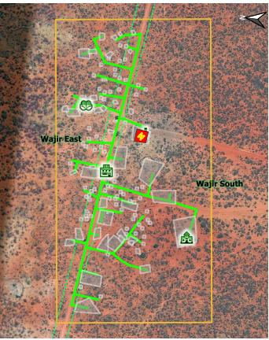The proposed Project site is at Boji Garas sub-location, Boji Garas location, Khorof Harar Ward, Wajir South Sub-County in Wajir County at latitude 1°42’45.8” N and longitude 40°46’12.3” E. The proposed solar mini grid will be located on a communal portion of land within Boji Garas trading centre. The solar mini grid will comprise Solar panels, batteries, invertors, perimeter fence and 4 kilometres distribution line. The project is projected to serve 203 people, with 199 of them being residential and four being non-residential.

## Purpose and Scope of Work

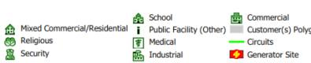The Kenya Off Grid Solar Access Project (KOSAP) intends to support the Government initiative of ensuring increased electricity access to Kenyans, particularly among the low- income groups in off- grid areas. This proposed project is in line with the commitment of the Government of Kenya to reach 100% electricity access by 2023 through grid extension, stand-alone individual plant and autonomous solar mini- grids. Kenya Power as the implementing agency aims to develop the solar/diesel mini- grids to electrify areas that are not economically feasible through national grid extension. The Boji Garas site was proposed as part of this project due to its isolated nature and the high cost of grid extension to the area. This report discusses the environmental and social baseline within which the proposed solar power project is commissioned and assesses the potential adverse and beneficial impacts that the project could have, along with suitable mitigation measures and an Environmental and Social Management and Monitoring Plan (ESMMP) for the project. This report discusses the environmental and social baseline within which the proposed solar power project is commissioned and assesses the potential adverse and beneficial impacts that the project could have, along with suitable mitigation measures and an Environmental and Social Management Plan (ESMP) for the project. The report also evaluates the environmental and social risks associated with the project and implements mitigation measures to avoid adverse impacts for the remainder of the project’s lifecycle. The project must comply with international standards (World Bank Environmental and Social Safeguards) along with applicable national, state, and local regulations.

## Terms of Reference (ToR) for the ESIA Process

The Experts were assigned the task of carrying out Environmental and Social Impact Assessment of the proposed solar Mini-grid. The scope covered various activities related to; project planning activities, construction works of the proposed development which included all works of civil, mechanical, electrical or other nature necessary to construct, commission and decommissioning of the project. The output of this work is a comprehensive Environmental Impact Assessment project which will aid NEMA in deciding on the project. The report is also in compliance to Environmental and Social Safeguard Policies of the proponent’s development partners.

The ESIA experts conducted the study guided by the following terms of reference:

1. Establish the suitability of the proposed site/location to set up a solar Mini-grid.
2. A concise description of the national environmental legislative and regulatory framework, baseline information, and any other relevant information related to the project.
3. A description of the technology, procedures and processes to be used, in the implementation of the project.
4. A description of materials to be used in the construction and implementation of the project, the products, by-products and waste to be generated by the project.
5. A description of the potentially affected environment/social economic and cultural setting of the project area.
6. Identification and consultation with stakeholders including the proposed project beneficiaries.
7. A description of positive and negative impacts of the project on the environmental, health, safety and social cultural aspects of the community
8. Analysis of alternatives including project site, design and technologies
9. Identification of the most appropriate mitigation measures/interventions against negative impacts during construction, operation and decommissioning
10. Development of an Environmental, Health, Safety and Social Management Plan proposing the measures for eliminating, minimizing or mitigating adverse impacts on the environment, including the cost, timeframe and responsibility to implement the measures

## ESIA Study Team

Below is the list of the planning and field team for the study:

|  |  |  |
| --- | --- | --- |
| **NAME** | **INSTITUTION** | **POSITION** |
| Daniel Chumo | Centric Africa Limited | Environmentalist |
| Elijah Lwevo | Centric Africa Limited | Environmentalist |
| Bubicha Mohamed | Centric Africa Limited | Environmentalist |
| Lydia Komen | Norken International Limited | Environmentalist |
| **CLIENT REPRESENTATIVES** | | |
| Wilfried Koech | KPLC Nairobi | Environmentalist |
| Fahma Yussuf | Wajir County Government | CREO |

## Project Justification for the ESIA

This Environmental and Social Impact Assessment on the proposed solar Mini-grid in Boji Garas was commissioned in order to examine its impacts on the environment and community prior to its construction. The purpose of the study was to determine the positive and negative effects of the mini-grid and to suggest ways to minimize the negative effects and maximize the positive effects. The ESIA was conducted in accordance with Section 58 of Environmental Legislation, EMCA 1999, and its 2015 Amendment and the Environmental Impact Assessment and Auditing Regulations (ESIA/EA) of 2003. Further, international environmental and social policies have been adhered to in this report especially the World Bank OP4.01 (Environmental assessment). In addition, appropriate sectoral legal provisions relevant to this project have also been referred to for the necessary considerations during the construction, commissioning, operation and decommissioning of the project.

This Assessment has identified both positive and negative impacts of the proposed project to the environment and community. The report proposes mitigation measures in the Environmental and Social Management and Monitoring Plan (ESMMP) developed to mitigate the negative impacts and enhance positive impacts thus ensuring sustainability of the project

## Approach and Methodology

This Environmental & Social Impact Assessment (ESIA) has been conducted in compliance with the Environmental Impact Assessment Regulation as outlined under the Gazette Notice No. 56 of 2003 established under the Environmental Management and Coordination Act (EMCA) 2015 and EMSF and provisions of the World Bank OP 4.01. The ESIA is expected to achieve the following:

* Identify all potential significant environmental and social impacts of the proposed Project and recommend measures for mitigation.
* Assess and predict the potential impacts during site preparation, construction and operational and decommissioning phases of the Project.
* Guide compliance with project ESMF, WB OP. 4.01 and the national environmental and social regulations.
* Generate baseline data for monitoring and evaluating how well the mitigation measures are being implemented during the Project cycle.
* Promote stakeholders’ engagement and public participation.
* Design an Environmental and Social Management Plan to avoid, mitigate and where not possible, offset the identified impacts so as to ensure sustainability of the proposed Projects.
* Recommend feasible, cost effective and culturally appropriate measures to be implemented to mitigate against the potential negative impacts while ameliorating the positive ones.

The assessment involved an understanding of the Project background, the Project designs and the implementation plan as well as Project commissioning. In addition, the baseline information was obtained through physical investigation of the site and the surrounding areas, interviews with surrounding community members through local administration and County structures, stakeholder mapping, photography and most importantly, discussions with the Client and the Project Design Team.

The following are the key activities undertaken during the study:

* Physical inspections of the proposed project area
* Literature review of relevant documents
* Stakeholder consultations with different stakeholders and project affected persons and beneficiaries
* Gathering environmental and socio-economic data of the area by use of check list
* Continuous discussions with the stakeholders and accessing other sources of information on the proposed project details, the site planning and implementation plan,
* Photography, and interviews with people in the immediate neighborhood.
* Evaluation of the activities around the site and the environmental setting of the wider area.
* Report writing and submission

### Screening and Scoping

#### Screening Methodology

This is the initial stage of this project assessment. Screening of the project sought to ascertain whether or not this project falls within a category that requires ESIA prior to commencement. The proposed project was evaluated during this stage, which was guided by EMCA (1999), the EMCA (amended) Act of 2015, and the Environmental and Social Management Framework (ESMF) of 2015. Electricity development activities are listed as projects requiring EIA prior to commencement in Schedule 2 of the EMCA, 1999. World Banks Social safeguards underpin and demonstrate this commitment. Other factors considered during the screening process included, among others, the physical site location, zoning, nature of the immediate neighborhood, sensitivity of the areas surrounding the site, and socioeconomic activities in the area. Following this screening, the project was subjected to scoping (to produce this Project report) as part of the ESIA process, based on the project category.

Evaluation of ESIA procedure has been undertaken as a fundamental procedure to implementation of the solar power mini-grid development project which is systematically mainstreamed into the project’s Cycle. World Banks Social safeguards underpin and demonstrate this commitment. The main aim of this is to enhance positive social opportunities and benefits as well as ensure that adverse social and environmental risks and impacts are avoided, minimized, and mitigated. The below steps were followed.

#### Kick-off Meeting

Norken and Centric team had a brief kick-off meeting with the Ministry of Energy on 12th July 2021 followed by subsequent online meetings and discussion on various aspects of the project up to 28th October 2021. The meetings addressed varied deliverables and thresholds to be achieved and maintained during this assessment in terms of scope of work, deliverables, timeline, and the methodology. All communication and meetings were done online.

#### Desk based review and baseline assessment

A critical literature review of secondary data was done to establish the following: Relevant legislations and institutional framework governing the proposed project; Licenses and permits requirements and conditions; Baseline information of the project area and, Types of waste likely to be generated Documentation review was a continuous exercise that involved a study of available documents on the project.

A comprehensive description of the KOSAP Component 1: project includes a desktop review of all the existing project documentation including the Project Appraisal Document and the four main safeguard framework documents prepared under KOSAP- these are Social Assessment, Vulnerable and Marginalized Group Framework, Resettlement Policy Framework and the Environmental and Social Management Framework.

### Project Description

With the background obtained from the site investigation, discussions held, and the documentation review, the proposed project was evaluated and an assessment made on the potential environmental and social impacts. The consultant firm has concisely described the project location including its geographical, ecological and the general layout of associated infrastructure including maps at an appropriate scale where necessary. Location of all projects related development sites, including proximal offsite investments; general layout; flow diagrams/drawings of facilities/operation design basis, size, capacity, flow-through of unit operations, including pollution control technology included if any; pre-construction activities and construction activities; construction schedule; staffing size and support; facilities and services around; commissioning, operation and maintenance activities and plan.

### Baseline Condition

This entails description and collection of relevant primary data within the project site’s bio-physical, socio-economic, and cultural profile with respect to the biodiversity profile, land use types, cultural heritage and practices, social and economic issues likely to be affected, expected project activities to be involved during the design, construction, and operation of the proposed facility. The information also includes description of the community social structure, employment and labour market, sources and distribution of income, cultural/religious sites and properties, vulnerable groups, and indigenous populations. This also covers description of the sites’ physical environment including their topography, land cover, geology, climate and meteorology, air quality and hydrology. This entails use of secondary data sources and for some specific environmental parameters the deployment of specialized equipment to measure and record the environmental readings as primary data for analysis and inclusion in the ESIA CPR report. The ecological and biophysical environment will focus on describing the *flora* and *fauna* resident in the Wajir county at the mini-grid site level. This will be based on ecological surveys, KPIs on local indigenous knowledge on historical and status of rare, endemic, and endangered plant and animal species known to occur in these localities. Vegetation assessment was done to gain an understanding of the mini-grid sites habitat type. This has provided for an in-depth description of existing land use type and their linked socio-economic activities.

### Impact Assessment (IA) Prediction

The anticipated impacts generated by the project and subsequent evaluation of their significance are provided by this report. A suite of field data collection methods was deployed including public forums discussions, Focus Group Discussions, Key Informant Interviews incorporating questionnaires for social risks assessment. Based on the outcome of the evaluation, the need for emphasis on critical areas was discussed. To accomplish this task an initial listing of the range of all issues and concerns identified during the study has been undertaken subsequently followed by analysis of the identified potential environmental and social impacts in terms of type (direct, indirect, cumulative, positive, negative), magnitude (local, widespread, random, severity) and duration (temporary, permanent, long term, short term). Consequently, an evaluation system will be used to categorize these impacts and evaluate them. This aided in determining the significance of the identified potential impacts in relation to established criteria or standards, geographic extent of effects, cumulative nature of the impact, community tolerance and preferences, etc. This culminated into generation of a short list of the most critical issues in terms of environmental, ecological, and social impacts both positive and negative associated which the different phases of the project activities that are likely to affect the baseline environmental and social conditions presently occurring at the mini-grid sites.

Socio-cultural risks linked to Component 1 of KOSAP were identified during the assessment. These include, Labour influx, Gender Based Violence, Sexual Exploitation and Abuse, workplace Sexual Harassment, Spread of HIV/AIDS, STDs & other communicable diseases, Gender biases and inequality exclusion of vulnerable and marginalized groups (VMGs) and vulnerable individuals and households from accessing project decision making and governance structures, engagement processes, opportunities, and benefits. The vulnerable individuals and households will include the poor, elderly persons, PWDs, the sick, poor women, poor single mothers, child-headed households. The VMG’s include ethnic minority communities that are present in Boji Garas area.

The impacts and risks were identified in relation to free, prior, and informed comprehensive stakeholder consultations on land acquisition for construction of mini-grid, contractor’s facilities e.g., yard and workers camp site, way leave acquisition for the powerline distribution network; restricted access to grazing lands, water resources, soils and tree resources, economic/livelihoods displacement etc.

### Environmental and Social Management Plan (ESMMP)

The ESMP as the implementation instrument of the ESIA has captured all the parameters that need to be monitored on a routine basis. The parameters as indicated in an Environmental and Social Management and Monitoring Plan (ESMMP) matrix, a detailed description of the implementation and monitoring program.

The ESMMP has a detailed arrangement of responsibilities for managing and monitoring the implementation of mitigation measures and the impacts of the project during construction, operation, and decommissioning. This include: a description of monitoring methodology, specific operations, and features to be monitored, monitoring reporting relationships and arrangements to ensure that monitoring is effective. Simple and straightforward monitoring processes established for ease of implementation through the project cycle. This plan follows through a description of the impacts and areas affected, key mitigation measures, monitor-able indicators, timeframe, responsibilities, and budget implications.

The ESMP include an implementation schedule and budget cost estimates for the mitigation measures both capital and recurrent costs estimate and the financing entity. It also describes institutional arrangements regarding the implementation of the ESMP among the implementing agencies, and the mini-grid contractor(s). This has specific responsibilities, procedures and resources required by each institutional actor engaged in implementing the ESMP.

The “Chance Find Procedures” has also been included in the ESMP as part of prevention and mitigation measures that will be implemented in the event physical cultural resources are encountered during subproject implementation.

Additionally, the ESMP has a component on contracting management that will ensure the implementation of the ESMP by all contractors and subcontractors. A contracting mechanism is included in the ESMP to incentivize contractors and their subcontractors to comply with the ESMP or alternatively penalize them for failure to comply with the ESMP. It also includes contractor clauses that will cover worksite health and safety, the environmental and social management of construction sites; labour camps/out of area workers, HIV/AIDS, and other Sexually Transmitted Diseases (STDs), stakeholder engagement plans, grievance redress mechanism, child protection, gender equity and sexual harassment, labor rights and the employment of community members. The ESMP also have a budget to guide the contractor on resources required for the implementation and monitoring of the ESMP.

Figure 3 is a summary of the methodology the firm will adopt in undertaking environmental and social impacts assessment for the proposed KOSAP project.

Figure 2: Summary of Environmental and Social Impact Assessment Methodology

### Stakeholder Consultations and Participation

This assessment recognizes that consultation is an ongoing process throughout Project implementation phases. Under this Project consultation was undertaken during the ESIA process and will continue during the construction operational and decommissioning phases of the project. A suite of field data collection methods was deployed including public forums discussions, Focus Group Discussions, Key Informant Interviews incorporating questionnaires for social risks assessment with an aim of giving the community a platform to express their environmental and social concerns in relation to the project.

The public (local community members, laborer's and VMG's at the Boji Garas village) were consulted through a public baraza held at the Chiefs’ compound on 28th October 2021 where 31 males, 20 community elders, 25 women and 20 youth members were in attendance including the area senior assistant chief as well as villages elders were engaged through face-to-face discussions as well as engagement walks on the proposed project site. The meeting was held in accordance with the requirements of NEMA and the WB OP. 4.01 policy and guidelines for conducting an ESIA. The specific objectives of this public consultation were to: Disseminate information on the proposed project to the community members; Collect views and issues to be considered in the ESIA; Evaluate perceptions about positive and negative impacts of the project and; Receive concerns about environmental and social impacts and other implementation challenges.

**Stakeholder Identification and mapping**

Stakeholder engagement and participation was carried out at different levels and with different stakeholders. Stakeholder’s identification and mapping was done based on the following criteria that is affected/project beneficiaries and interested persons or parties. The stakeholders include;

* Beneficiaries of the proposed project who largely are the community members living within 3km radius of the proposed project:
* Interested parties include:

County government of Wajir various departments including the office of the governor, land and environment, survey and public administration such as ward and village administrators. In addition is the county commissioner and officers under his administration such as chiefs.

**Approach and Methodology used in carrying out the Public Participation**

Owing to the different categories of the stakeholders, the ESIA team opted to employ various methods in engaging them. The methods included; face to face discussions for the government officers, focused group discussions with the men, women and youth and a public baraza/meeting for the community members

**Mobilization for the community meeting**

Prior to the community engagement meetings, a two weeks’ notice was done/issued to inform the community members of the meeting. This was done by the county renewable energy officer (CREO). The officer called local administrator (the Chief) of the area where the meeting was to take place and requested him to inform the people of the meeting in regard to KOSAP community engagement forums. The chief then informed the people about the meeting through announcement by word of mouth given by the local leaders’ key among them was village administrator and village elders in Boji Garas.

In addition to Stakeholder consultations and participation, ion, baseline information was obtained through physical investigation of the site and the surrounding areas, community checklist, photography, and discussions with interested stakeholders.

The key activities undertaken during the assessment were:

* Continuous discussions with the stakeholders and accessing other sources of information on the proposed project details, the site planning and implementation plan,
* Physical inspection of the proposed site, photography, and interviews with project affected persons and interested stakeholders in the project area.
* Evaluation of the activities around the site and the environmental setting of the wider area. This was achieved through existing information, literature and physical observations
* Review of available documentation
* Reporting, review and submissions

**Public Forum/meeting**

The project team undertook community engagement forums with the target beneficiaries and the communities where the solar Mini-grids will be set. The main objective was to explain the project details including need for land identification and solicit broad community support and acceptability of the project. One open meeting with all the community members was held. The KOSAP team explained to the community members about the project and other related information as discussed in the minutes. The meeting was then opened up for a plenary session.

Community engagement proceedings and resolutions are presented in form of minutes taken/written during the meetings. The meetings were well attended by all people including men, women, youth and persons with special needs.

**Focus Group Discussions**

After the meetings the community members were told of the need to have focus group discussions to discuss the project further and allow the different groups more opportunities to ask questions or give suggestions regarding the project. Therefore, three separate meetings for men, women and youth were held. In these meetings the message on the project was echoed again especially on benefits and impacts (both positive and Negative) of the project to the community, rights of the community and the need to have a grievance redress mechanism and committee with representation from all groups in the community. The Focus Group Discussions were also used as a form of baseline data collection. The respondents were able to give feedback on socio-economic status of their community i.e. education, healthcare, economic activities, cultural practices etc.

**Key Informant Interviews**

Key Informants were identified both at the county and locational levels and they were interviewed to obtain baseline information in regard to the proposed project

### Limitations

The limitations experienced during the study are illustrated below.

* Due to drought that was being experienced the community member were engaged in looking for water and pasture thus delaying in attending public participation meetings. This was mitigated by starting the meeting early enough.
* Risk of being infected or transmitting COVID-19. The teams had to adopt preventive measures by wearing face mask and providing the community members with face mask and sanitizers during the public meetings and interactions.

## Target Group for the ESIA Report

The ESIA Report has been prepared for use by different stakeholders to be involved in the construction and operation of the proposed solar mini-grid site. This report contains useful information on policies and procedures to be adhered to, implementation modalities, analysis of potential environmental and social impacts and suggested mitigation measures at various stages of project activities. The information will be useful in planning, implementation, management and maintenance of the plant. In this regard, the report is useful to the following stakeholders:

* Funding agencies and donors;
* Relevant government ministries and agencies;
* Affected and Interested persons;
* Planners and Engineers to be involved in preparation of designs and plans
* Contractors to be engaged in the construction works

## Assumptions

The Experts made the following assumptions in preparing this ESIA

* All the technical data and information provided by the proponent, implementing and the specialists are accurate and up-to-date
* The design features will be put in place to minimize risks from external factors which could threaten the integrity of the facility which include: risks from landslides and other natural calamities; measures to minimize threats or damage from third parties e.g., terrorist attack
* The public involvement process has been sufficiently effective in identifying the critical issues that needed to be addressed
* The Proponent and the Contractor will implement the measures in the proposed ESMMP.
* The Proponent will undertake monitoring to track the implementation of the ESMMP to ensure that management measures are effective to avoid, minimize and mitigate impacts and that corrective action will be undertaken to address shortcomings and/or non-performances

## Uncertainties in Compiling Information

Uncertainty arises from a variety of aspects in any development, and for this particular study report has emanated from the following:

* The changes that may occur in baseline conditions, due to external factors over the lifetime of the project;
* Uncertainty related to Proponent’s policy initiatives that might influence the assessment of future baseline and post-development conditions;
* Uncertainty in design information which should be dealt with by the definition of design parameters for the development by the Contractor and Proponent;
* Uncertainty in relation to project planning and implementation as the detailed program and means of construction may be influenced by the choice of Contractor and the detailed design of the development; and
* Uncertainty in the understanding of who the VMGs are, and their population.

## Layout of the Report

Table 6: Structure of the ESIA Report

|  |  |  |
| --- | --- | --- |
| **SECTION** | **TITLE** | **DESCRIPTION** |
| Section 1 | Introduction | (*This section*) Introduction to the Project and ESIA scope and methodology adopted. |
| Section 2 | Project Description | Technical description of the Project & related infrastructure and activities. |
| Section 3 | Baseline Settings-Environmental, Ecology and Social | Outlines Environmental, Ecology and Social Baseline status in the study area of the Project |
| Section 4 | Analysis of Alternatives and project justification | Provides information on site selection, power scenario within the project area and gives an analysis of Alternative |
| Section 5 | Policy and Legislative Framework | Discusses the applicable environmental and social regulatory framework and its relevance for the Project. (The world bank safeguards and EMCA and environmental regulations) |
| Section 6 | Stakeholder Engagement | Provides an overview of the stakeholder engagement activities undertaken during the ESIA, stakeholder categorization and profiling |
| Section 7 | Grievance Redress Mechanism | It details the provision of Grievance Redress Mechanism for the project |
| Section 8 | Impact Assessment and Mitigation Measures | This section includes details of identified environmental impacts and associated risks due to Project activities, assessment of significance of impacts and presents mitigation measures for minimizing and /or offsetting adverse impacts identified. |
| Section 9 | Environmental and Social Management and Monitoring Plan | Outline of the ESMP considering identified impacts and planned mitigation measures and monitoring requirements. |
| Section 10 | Impact Summary and Conclusion | Summary of impacts identified for the Project and conclusion of the study. |

# PROJECT DESCRIPTION

## Introduction

This section provides a description of the project in terms of location, facilities and associated project infrastructure and activities during the project lifecycle and facilitates and identification of the potential impacts on resources and receptors that could result from project activities during the pre-construction, construction, operation, and decommissioning stages.

The components of the proposed solar mini grid are provided as follows.

Table 7: Component of the proposed Solar Mini-grid

| **S/NO.** | **PARTICULARS** | **DESCRIPTION** |
| --- | --- | --- |
| 1. | Project location | The proposed project is located in Boji Garas village at Boji Garas sub-location, Boji Garas location, Khorof Harar Ward, Wajir South Sub County in Wajir County. Geographically, the site is located on latitude 1°42’45.8” N and longitude 40°46’12.3” E. |
| 2. | Land Size/Tenure | The proposed solar mini grid will be located on 0.834 Hectares unregistered community land set aside for public use at Boji Garas village |
| 3. | Mini grid Capacity | PV Capacity of 82kw; 264kWh Battery; |
| 4. | Distribution line | LV Circuit of 4km |
| 5. | Target Consumers | 203 (199 Residential and 4 Non-Residential) |
| 6. | Climatic condition | The county's average annual relative humidity is 61.8 percent, with temperatures ranging from 56 percent in February to 68 percent in June. Precipitation averages 240 millimeters per year, or 20 millimeters per month. June is the driest month, with only 1mm of rain on average, while April is the wettest, with 68mm on average.  Rainfall amounts range from 500mm to 700mm in the upper reaches of Bute and Gurar. With a temperature range of 3.5 degrees Celsius, the average monthly temperature is 27.9 degrees Celsius. With average temperatures of 36°C in February and March, and 21°C in June, July, August, and September, February and March are the warmest months. |
| 7. | Site Conditions | The side is generally in open area with minimal *fauna* and *flora*. |
| 8. | Road Accessibility | The project site is accessed via Wajir Handaki road |
| 9. | Nearest Airport | Wajir Airport at about 80km |
| 10. | River/canal/nallah/ pond present in project footprint | Boji Garas borehole commissioned in 2014 and water pan approximately 3km from the village |
| 11. | Protected areas (National Park/ Sanctuary)/ Forest land within 10 kms | None |
| |  |  |  |  | | --- | --- | --- | --- | | **Commercial & public facility consumers** | | | | | School | 1 | Security | 0 | | Religious | 1 | Commercial | 1 | | Industrial | 0 | Medical | 0 | | Mixed | 0 | Other public facilities | 1 | | **Commercial & public facility consumers list:** Selling and Sewing Clothes, Pumping Water,  Worship Center, Primary School Education | | | | | | |

This will entail generation of electricity from solar, distribution of power within a six-kilometer radius using wooden or concrete poles and retailing the same to the community. The total length of LV distribution network will be 4 Km. The community members will pay a connection fee of KES. 1000 once they apply for electricity

## Project Location

The proposed project is at Boji Garas village in Wajir County, at Boji Garas sub-location, Boji Garas location, Khorof Harar Ward, Wajir South Sub County. The site is located at 1°42'45.8"N and 40°46'12.3"E in terms of latitude and longitude. The project is located 80 kilometres east of Wajir Town. Abaqfin mixed primary school, mosque, and industries such as tailoring and water pumping are among the commercial and public facilities located within the project area. The site soil is primarily sandy clayey within the area.

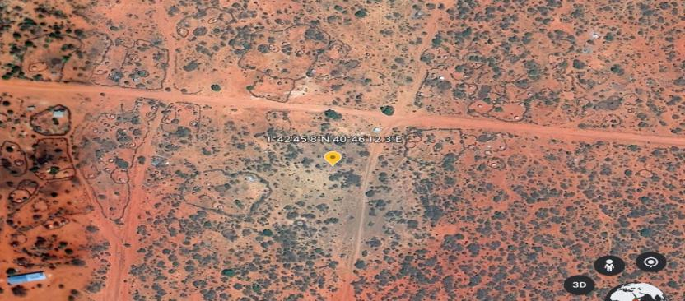

Figure 3: Project location

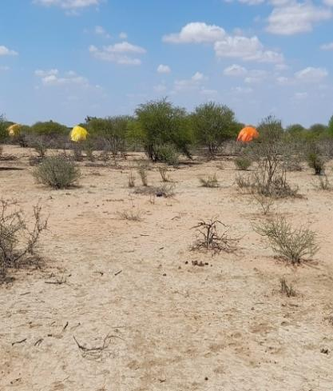 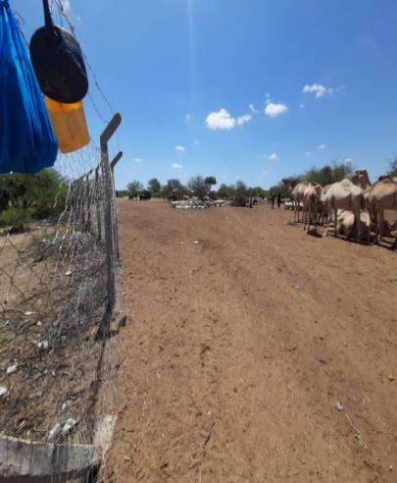

Plate 1: Project site environs and activities

### Project site setting

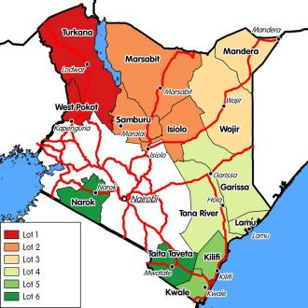The proposed Boji Garas mini grid is in Wajir South Sub County, Wajir County. It falls under cluster 1 with a total of 147 mini grids and LOT 3 which has a total of 60 mini grids characterized as Subproject sites in overwhelming/majority VMG counties (mostly pastoralist counties) with unregistered community land. There are a total of 30 proposed mini grids in Wajir County. Geographically, Boji Garas proposed site falls on coordinates’ latitude 1°42’45.8” N and longitude 40°46’12.3” E.

Figure 4: Map showing the KOSAP Counties Lot 3

## Land Requirement and Procurement Process

The land on which the proposed Boji Garas mini grid will be constructed on unregistered communal land

### Land Tenure

The entire county is categorized as community land apart from a small percentage of the total area occupied by townships. The land is mostly used communally for nomadic pastoralism. However, some small areas are under small scale agriculture by individuals or groups. There are two types of land; Private and Communal land. Private land is mainly found is town and used for residential, business and crop/fodder production. The communal land is for grazing. The average land size for private land is a quarter of an acre. In Boji Garas location, the site falls on Communal land.

Wajir County Government is the custodian of the community land. The proposed Boji Garas mini-grid land is on unregistered community land.

### Compensation Details

Compensation will be done in kind. The main key area for development activities identified by the community in Boji Garas include; provision of clean water sources, Provision of better educational facilities as well as access to clean water and sanitation

## Description of Project Facilities, Components and Activities

### Project Components

The proposed project will be having two components in one that is a Hybrid Mini-Grids (PV- and Diesel) and construction of Power line reticulation lines. The following sections are explanations for each of the components that will be implemented.

#### PV Mini-Grid Sizing

The power system has been sized based on the energy parameters. These are:

|  |  |
| --- | --- |
| **Residential Users (No.)** | 199 |
| **Non-Residential Users (No.)** | 4 |
| **PV Capacity (kWp)** | 82 |
| **Battery Capacity (kWh)** | 264 |
| **PV Inverter (kW)** | 68 |
| **Generator Capacity (kVA)** | 50 |
| **Fuel Tank for diesel generator (Litres)** | 2,000 |
| **LV Network (km)** | 4 |

The project will use PV Array (DC-kW) 80 polycrystalline silicon modules with three strings connected in series. Each string will have five sets of panels connected in series, with output converged at the six-way combiners. The life expectancy of the PV modules is estimated at 25-30 years. The proposed power plant will be configured as AC coupled due to the significant portion of daytime loads that can be fed directly from the solar PV generator without intermediate battery storage. This will include:

* PV modules with PV inverters,
* Diesel Genset,
* Deep-cycle lead-acid electrochemical batteries with liquid electrolyte (largely used in off-grid applications thanks to its well proven technology at baseline costs compared with other types of batteries).

The proponent will be required to apply for a NEMA ESIA variation of the license, during the design changes over the project lifespan

#### Architecture and Basic Design Specifications

This hybrid power generation site is projected to generate 82 (kWp) and is meant to serve approximately 203 households (customers). The proposed mini-grid installations will be built to comply the International Electro technical Commission (IEC) standards. It will have an installation of solar panels of with a capacity of 82 (kWp) and battery house with 264 kWh. The solar panels will have a connection to the batteries through underground cables. The standby generator will also be connected to the system as a backup.

The goal of the hybridization of diesel systems is to reduce fuel consumption by switching off diesel generator set(s) for several hours a day, in order to reach a PV energy, share in the final mix of at least 60% or more. The power will be distributed to the customers by overhead lines. The project site is expected to serve clients within a radius of 3km from the site (generation source).

The PV plant and the battery capacity have been sized accordingly to the daily demand and the solar resources. In addition to this Design architecture, the project site shall have a site office that shall also have a Control Room adjacent as well as a guard house. The guard house shall be constructed using concrete and masonry works whereas the control room and office can also be a containerized facility.

The Solar PV hybrid system is based on a centralized photovoltaic plant connected to a 3-phase 415V AC busbar line, where the multi-mode battery inverter and the diesel generator are also connected.

The plant is configured such that a significant portion of daytime loads is fed directly from the solar generator (grid-tie inverter) without intermediate battery storage usage. The solar PV power plant is also equipped with a Diesel Generator, which is normally used as reserve power. The diesel generator switches on automatically whenever the battery state of charge reaches a certain defined DOD (Depth of Discharge). The diesel generator comprises of kVA unit in three-phase operation and it’s equipped with automatic startup function controlled by the battery inverter charger. The figure 5 below illustrates the preliminary data for the mini-grid in Boji Garas.

#### Battery Energy Storage Systems

The Battery Energy Storage System (BESS) will comprise of Lithium-ion Battery pack that conforms to IEC standards with warranty of 10 years, 3,000 cycles minimum. The Lithium-ion Battery Power Packs will be used to cater for required energy capacity, or equivalent as per approved design, minimum 80% DOD for Lithium-Ion. Batteries will be capable of at least C/4 charge and discharge rate. Batteries will be charged by Battery Inverter / Charger. The project will use 200kwh batteries.

#### PV Generator

The PV generator consists of Silicon Crystalline Photovoltaic modules of capacity at STC of 250 Wp or more. The PV modules should comply with the norms IEC 61215 and IEC 61730. The outside junction box with the positive and negative terminals shall incorporate bypass diodes that have the function of preventing any possibility of the electrical circuit inside the module being broken due to the partial shading of a cell and shall be at least IP 65 and UV resistant.

The module support structure shall be ground-mounted on arid soil with a base made of concrete. The support shall have a tilt angle between 10° - 15° from the horizontal. No soil tests have been performed, at this stage of the proposed project design, but from the site inspection during the pre-feasibility study, ramming or screw foundations could be used. The support frame shall be of either lightweight aluminum or galvanized steel and it shall be easy for installation, maintenance and disassembly at the end-of-life cycle. These materials will be possibly sourced locally or from abroad and shipped to Mombasa port and transported via road to the site town.

Cables used within the PV generator shall have a voltage rating of at least 1,2 VOC; have a temperature rating higher than 40°C above ambient temperature; they will be UV-resistant; water resistant and it is recommended that they be flexible (multithreaded) to allow for thermal/wind movement of modules. The PV inverter shall be of type current source grid-tied to convert DC to an AC Sinusoidal current. String inverters shall be installed indoors or outdoors with a cover and suitable for desert conditions with high ambient temperatures and dust.

The project will use PV Array (DC-kW) polycrystalline silicon modules with three strings connected in series. Each string will have five sets of panels connected in series, with output converged at the six-way combiners. The life expectancy of the PV modules is estimated at 25-30 years.

#### Battery

* **Battery Inverters/Chargers**

The Inverters/charges shall be designed for nominal voltage of 415 Vac which will be continuous, reliable power supply as per specification and shall have internal protection arrangement against any sustained fault in the feeder line and against lightning strikes in the feeder line. The inverters shall be capable of complete automatic operation including wake-up, synchronization & shut down independently & automatically. The inverter shall be 3-phase multi-mode (DC to AC and AC to DC), bi-directional, four-quadrant capability.

* **Battery Energy Storage Systems**

The Battery Energy Storage System (BESS) will comprise of Lithium-ion Battery pack that conforms to IEC standards with warranty of 10 years, 3,000 cycles minimum. The Lithium-ion Battery Power Packs will be used to cater for required energy capacity, or equivalent as per approved design, minimum 80% DOD for Lithium-Ion. Batteries will be capable of at least C/4 charge and discharge rate. Batteries will be charged by Battery Inverter / Charger.

* **Battery Rating**

The battery nominal voltage does not need to be established at this stage and different technology providers may offer different solutions on this issue. Nevertheless, it must be noted that the voltage class, either ELV or LV, will determine the electrical isolation and accessibility requirements of the battery room. The battery shall have at least the rated capacity of 2.16V at the C10 discharge rate according to DIN 43539-9.

* **Battery Performance**

The battery shall have a self-discharge when new of less than 5% per month (at 25oC and fully charged) of its rated capacity and shall have a Coulombic efficiency of at least 85% and energy conversion efficiency of at least 85% when new and charged to more than 50% of capacity. The battery cycle life for discharge/charge regular cycles down to 80% DOD shall be more than 1500 cycles (According to IEC 896-1).

* **Lifetime**

The design lifetime of the batteries shall be of at least 8 years without losing more than 10% of the rated C10 capacity. When the batteries get damaged, they will be stored separately at the site and then transported to Nairobi for proper disposal.

* **Battery Cabling and Protections**

The battery connection point shall be as close as possible to the Multi-mode Inverter. Cables used to connect the battery shall have a temperature rating higher than 20 °C above ambient temperature. It is recommended that they be flexible (multithreaded) to allow for easy installation and maintenance. Fuses in cables that connect components to the battery shall be rated for D.C. use, be installed separately as close as possible to the battery terminals and rated to interrupt high fault currents from the battery. A neutralization kit will be provided at the site to manage any battery acid spills that may occur.

#### Multi-mode Inverter

The multi-mode inverter (or inverter set) for this application is a bidirectional sinusoidal inverter. It can operate in autonomous mode as well as grid-tied mode. The efficiency curve shall be always above 80% in all cases, adjusting it at the load demand curve (base load, partial load or maximum load). A priority function of the Multi-Mode Inverter is to adjust the instantaneous power consumed from the source according to the battery voltage. The operation of the solar priority function shall be done with an automatic adjustment algorithm of the input limit current. The input limit current is decreased, if there is enough energy available at the DC side, from the initial value.

#### Diesel Genset

The Diesel Generator Set shall have a capacity of 50 kVA with an output of 400 V /230 V @ 50 Hz and 1500 r.p.m. The rated consumption will follow a 0.25 L/h/kW curve at stand-by power. It should include a highly corrosion resistant enclosure, control panel and monitoring, fuel tank and circuit breaker protections. The Diesel Genset shall be suitable for indoor or outdoor installation and shall perform accordingly with Multi-mode Inverter and the mentioned architecture model. The Diesel Genset shall be working in a fully automatic manner with the above stated components. The diesel gensets will have base mounted fuel tanks that will be factory tested for leaks. There will also be an external reserve fuel tank with a capacity of 2,000 liters. The proponent, through the operating entity will have regular inspection by the manufacturer. The noise rating for the generator set will be 75dBA @ 1 meter at 75% load under free field conditions. The generator sets will have a high-quality noise absorbent and fire-retardant grade acoustic insulation material complying to IS 8183.

#### Powerhouse

The Battery, Multi-mode inverter and all monitoring equipment will be installed indoors with adequate air ventilation accordingly to the manufacturer’s recommendations. Thus, a powerhouse or a containerized solution, considering the equipment manufacturer’s recommendations shall be installed. All electrical boards and LV protections will also be installed indoors. The batteries will be installed in the powerhouse in a separate room, specifically for their use and meeting the electrical safety requirements according to its voltage class.

#### Distribution lines and Energy Meters

Boji Garas site will have a distribution line circuit of 4 km in total. Supply of concrete poles for the distribution lines will be based on detailed survey and accessories like phase plates, circuit plates, number plates, danger plates, anti-climbing devices as per KPLC requirements/specifications. Erection of the Poles, fixing of insulator strings, stringing of conductor and earth wires along with all necessary line accessories and earthing will be as per KPLC requirements/specifications.

The electricity distribution from the generation plant to the end consumers will be done by means of a distribution line formed by low voltage (LV) line at 415V for three phase and 240V for single phase. All lines shall be over-head mounted on concrete poles or eco poles. The project implementing agency and KPLC will seek way leaves for the LV lines which will run along road reserves and boundaries within the supply area.

Figure 5: Illustration sketch of the proposed design of the proposed project

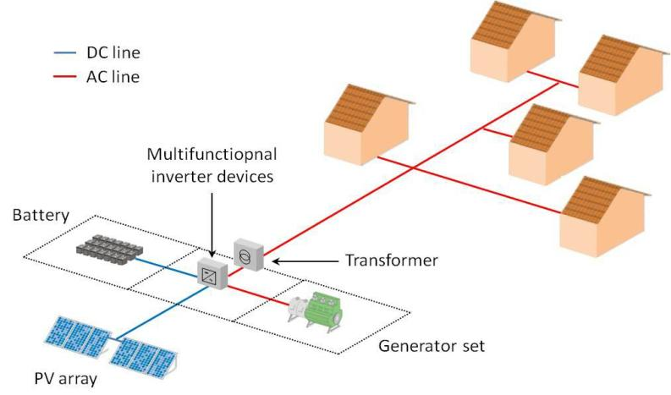

#### Project cost

Boji Garas proposed project cost is estimated at **USD. 413,674**.

## Project Phases and Activities

The main project activities include site clearance and leveling, civil works and construction of utilities and structures for the facilities, installation, and connection of the power plant.

### Pre-Construction/ Project Design

As part of the pre-construction stage, the Project is implemented jointly by the Ministry of Energy, Kenya Power and Lighting (KPLC) as well as Rural Electrification and Renewable Energy Corporation (REREC) who have conducted a feasibility study aiming at providing universal access to electricity in Kenya by 2022, universal access to modern energy services for cooking by 2030, as well as the impetus for growth in achieving Vision 2030. A conceptual design has been developed and will be taken forward for detailed design and implementation including the projects described in the previous section. This ESIA report forms part of the feasibility study.

The MOE is currently applying for various permits and licenses including land acquisition for generation assets, wayleaves, contractor facilities and worker’s camps. The procurement of various goods and services and contracting of private sector contractors and other consultants will begin after completion of the EIA process.

#### Construction Procedures

The project will be constructed based on applicable standards of Kenya, environmental guidelines and health and safety measures in line with OSHA Act 2007.

The project inputs will include the following.

* Construction of raw materials will include solar modules, inverter, wires, metals, among others. All these will be obtained from licensed dealers and especially those that have complied with the environmental management guidelines and policies.
* Construction machines will include machinery such as trucks, and other relevant construction equipment. These will be used for the transportation of materials, clearing of resulting construction debris.
* A construction labour force of both skilled and non-skilled workers will be required.

**Construction activities will include the following:**

* The contractor shall perform site investigations in good time to ensure appropriate designs and construction is done on a sound engineering basis.
* Site preparation (groundbreaking, clearance of vegetation, preparation of a site office and stores, fencing to avoid intrusion),
* Disposal of any soil that could is not required, excavations/earth moving, filling and foundation laying,
* Procurement of construction materials and delivery of the same to the site,
* Storage and utilization of materials,
* Civil, mechanical, and electrical works,
* Building works, trampling and removal of construction wastes,
* Construction of fuel storage tank
* Installing of containerized generators
* Piping of fuel lines
* Cabling
* Installation of the Mini-grid
* Completion of the plant
* Post construction clean–up, restoration and landscaping of site
* Load testing
* Remedying of defects after functional tests
* Solid waste collection and commissioning of the plant.

During construction, the contractor shall observe safety and shall erect warning signs to warn on any potential hazards, ensure proper and efficient use of Personal Protective equipment (PPE) for all on site and observe safe work procedures.

#### Soil Excavation

Soil will be excavated to pave way for the construction of the Solar Mini-grid. Soil excavation process shall be done with utmost care to ensure that the excavated soil is not improperly heaped or not carried away by any surface flows to any nearby surface waters causing siltation. The excavated soil will be used to backfill, and any remainder shall be disposed appropriately in accordance with the environmental management plan. Company safety and environmental policy and other established local environmental protection regulations/standards shall guide the contractor. This will include appropriate safety wear at all times and the contractor will appoint a safety officer on site during all construction activities.

#### Construction Supervision and Safety

Throughout the construction phase, supervision shall be carried out by the KPLC to ensure:

* Workers use personal protective equipment (such as hand gloves, helmets, safety shoes ear muffs, overalls and dust coats) at all times as is appropriate
* Motorized equipment is checked to ensure that they are in good working condition, safe to use and produce minimal noise levels and reduced smoke emission.
* Provision of first aid kit and firefighting equipment (portable cylinders) and placement at strategic positions for access
* Proper disposal of waste material and toilet facilities are provided for construction workers
* Emergency response procedures are in place and all workers are aware of them like in case of fire.
* Any work involving deep excavations, elevated heights and lifting heavy loads, poses a number of risks to personnel. The contractor shall develop a worksite plan before commencement of each of the construction. This will ensure that personnel are equipped with the correct protective clothing and equipment and are ready to work safely while also safeguarding the environment.
* Workers shall be provided ablutions facilities and changing rooms

#### Mini-Grid Components

The following components are planned to be constructed and operated on site. The same will need to undergo regular maintenance during the operation phase.

1. Technician Room
2. Battery Room
3. Generator Room
4. PV Array/Panels
5. Distribution network
6. Guard house.

#### Land Tenure

The selected portion of land for the proposed site is on unregistered communal land. The community has since offered the land to the project proponent establishment of the proposed project.

#### Compensation Details

Compensation for the land for the proposed project will be in kind; as a token of appreciation for the donated land, the Proponent will undertake some projects for the community.

### Operational Activities

The Solar Mini-grid will be operated and maintained by the contractor for the first seven years and then handed over to KPLC. During operation phase of the project, no unauthorized person shall access the Solar Mini-grid site. This is in line with company policy to ensure safety of staff and the public. Routine maintenance is to be done under supervision by authorized staff. Throughout the project life, the KPLC shall adhere to all requirements of National Environmental Management Authority (NEMA) and any other applicable legislation regarding environmental and socio – economic impacts.

### Project’s Decommissioning Activities

Kenya Power shall submit a decommissioning plan to NEMA in good time prior to decommissioning. The decommissioning plan should include a restoration plan.

At the decommissioning/demolition phase, the following activities will take place;

* Removal of Solar Mini-grid panels and Diesel Generator and their associated switching equipment’s
* Removal of electrical fittings, bus bars and steel poles/structures
* Demolish and carefully handle components that contain oil and fuels like the Diesel generators
* Ensure proper handling of the demolished materials and have an authorized and guided transportation and disposal away from human settlement, water bodies and wildlife conservation area in line with NEMA requirements for safe disposal
* Demolish and remove all the concrete works

The host environment should be rehabilitated and restored to its former state through:

* Approved and appropriate landscaping methodology.
* Planting of vegetation.
* Removal of any soils that may have been impacted by oils or fuels for offsite (away from the project area) remediation.

## Resource Requirement

### Workforce Requirement

Approximately 40 skilled, semi-skilled and unskilled Laboure’s will be required at the construction stage. During the operation phase, the following personnel will be required; one operations and maintenance head, 2 engineers and 5 technicians.

Approximately 5 unskilled workers will be involved during operation phase of the project for grass cutting and module cleaning. Also, two trained security guards will be engaged at the operations phase.

### Water Requirement and Source

#### Construction Phase

It has been estimated that approximately 50,000 liters of water will be required per day for civil works during construction stage. Further, water will be required for workers at project site. However, this quantity of water requirement will vary depending upon the mobilization of construction workers at site. The water for the construction phase will be sourced from the local water points within the village.

#### Operation Phase

The water required during operation phase of the project will be mainly for washing the face of the solar modules, Minimal water will be used for this purpose. Water requirement during operational phase of the project will be met from the water vendors in the area.

As previously stated, employees (direct and contractual) will be employed to work during the operation phase. For this workforce, approximately 5,000 Liters of water will be required for domestic consumption.

### Raw Material Requirement

#### Construction Phase

The major raw materials required for the construction phase will be solar modules, fencing materials, construction materials like cement, sand, and aggregate. The fencing materials and the construction materials will be sourced from the local hardware facilities. Solar Modules for the project along with associated structures will be obtained outside the country.

* **Input Materials and Equipment and Machinery**

Works and construction activities are expected to use quality construction materials and procedures to ensure quality work, occupational and public safety and environmental protection. The following inputs and equipment will be required for construction:

Table 8: Inputs and equipment -Construction phase

|  |  |
| --- | --- |
|  |  |
| Lorry | Concrete mixers |
| Plumbing equipment | Welding machines, wheelbarrows |
| Electrical equipment | Excavators |
| Raw construction materials (Sand, cement, natural building stone blocks, hard core, gravel, concrete among others). | Paints, solvents, whitewash, etc., |
| Timber (e.g., doors and frames, fixed furniture, etc.), | Labor force (of both skilled and unskilled workers). |
| Generator Sets and Fuels (Diesel) | Bus bars, Switch gears, Circuit breakers |
| Lightning arrestors and Steel structure members | Water |
| Solar panels | Poles |
| Conductors | Meters |
| Hardcore | Glass |

#### Operation Phase

There will not be major requirement of raw materials during operation phase. Only maintenance spares will be required at this phase.

### Road Access Requirement

Existing roads will be utilized as far as possible during the construction and operational periods. No new road will be constructed because there is an existing road to the Solar Mini-grid. The flow of traffic to the site during the construction period will increase and management of traffic will be paramount. During operations there will be virtually very low traffic considering because once operational the Solar Mini-grid will require minimal maintenance.

### Power Requirement

Power requirement during the construction phase will be met through Diesel Generators sets. The exact

number of Diesel Generator sets to be used, as well as the quantity of fuel, will be ascertained once the project is in the implementation stage.

### Fire Safety and Security

#### Construction Phase

Appropriate firefighting system and equipment shall be provided throughout the construction period. The fire extinguishers will be well distributed according to the fire risks and will be available in areas such as the site office, security area, storage yard etc. A comprehensive emergency response plan with all the emergency numbers will be well displayed at the site and on the fence. Signage, danger plates and name plates will also be displayed at the site. To prevent and avoid hotspots and their negative effect on solar panels, the panel design will take hotspot problems into consideration without obstructions of vegetation or building. Vegetation undergrowth will be controlled through regular slashing and cleaning up of the project site.

#### Operation Phase

**Site Security**

The proposed site is within Boji Garas. The site is in an area that is basically open and in close proximity to residentials and public facilities. This calls for proper security measures to be put in place to protect both human and domestic animals from accessing the Solar Mini-grid site. Therefore, the Mini-grid will have a chain link fence to keep off the electrical installation away from access by unauthorized persons or animals. A gate will be constructed at the entrance to the site which will be locked at all times. The Mini-grid will be lit at night, and a photocell will be used to automatically switch on the lights at a set time each evening. The Mini-grid will also be guarded at all times by two security guards during the day and two guards at night.

**Fire Safety**

Suitable fire protection and fighting systems that will include portable fire extinguishers, automatic fire detection system and means of fire communication will be made available at the entire PV array area, inverter stations, main control room and switchyard.

The systems and equipment’s will align to the Kenyan Fire Reduction Rules of 2007. The Fire protection and fighting systems will be maintained and serviced after every 6 months.

Because off-the-grid systems generally involve an underground wiring system, they are much less prone to weather accidents that lead to fires. They are also much smaller than the typical power grid, so if a fire were to start (against all odds), it would remain contained in a small area. The maintenance contractor using a Vegetation Management Program with mechanical methods will help provide effective vegetation control during the dry season.

An effective grounding system will be installed during power wiring for protection against lightning damage. In addition, lighting arrestors and surge protectors will be installed. To reduce hotspot effects, the contractor will ensure that panels are installed without obstructions. This means they won't be too close or in the shade of anything else, as this will cause shadows on each other.

Physical barriers consisting of conduits and short circuit withstanding capacity will be part of the design to prevent rodents from gnawing on a cable during the operation phase. To ensure the workers are not exposed to occupational hazards from contact with live power lines and cables during maintenance, and operation activities will ensure they: employ prevention and control safety measures associated with live power lines; employ measures to prevent, minimize, and control injuries related to electric shock; all electrical installations should be performed by certified personnel and supervised by a certified person; ensure that there are no equipment, appliances and machinery with unsafe electrical conditions. No equipment or machinery with worn-out or un-insulated wires and conductors; and ensure all electric installations and cables are properly labelled.

* 1. **Pollution Streams during Construction Phase** 
     1. **Solid Waste Generation** 
        1. **Construction Phase**

The key solid waste that is expected to be generated during construction phase includes. Broken solar panels and PV Modules, Hazardous waste like waste oil, lubricants, oil contaminated rags and Domestic soil from the temporary site office.

The hazardous wastes will be stored onsite at separate designated covered area provided with impervious flooring and secondary containment. The storage containers/ bins/ drum will be clearly marked, and color coded for their hazards. The waste will then be collected by a NEMA approved waste handler. Any broken solar panels or PV Modules will be sent back to the vendor as part of buyback arrangement. Alternatively, the e-waste will be disposed by licensed waste handlers in sites that are licensed by NEMA and local authorities to dump e-waste. All the other domestic solid waste will be disposed at the nearest municipality dumpsite.

* + - 1. **Operation Phase**

During operation phase, waste generated from the project will include domestic waste at site office, scrap materials like scrap tools, damaged PPEs etc.; hazardous waste like waste oil, lubricants, used transformer oil; damaged batteries; electronic waste like damaged PV modules etc.

The hazardous wastes will be stored onsite at separate designated covered area provided with impervious flooring and secondary containment. The storage containers/ bins/ drum will be clearly marked, and color coded for their hazards. The waste will then be collected by a NEMA approved waste handler.

Any broken solar panels or PV Modules will be sent back to the vendor as part of buyback arrangement. Alternatively, the e-waste will be disposed by licensed waste handlers in sites that are licensed by NEMA and local authorities to dump e-waste. All the other domestic solid waste will be disposed at the nearest municipality dumpsite.

The operations of this site will consist of a Battery Energy Storage System (BESS) comprising of Lithium-ion Battery pack. Expired lithium batteries are hazardous; sometimes leakages from these batteries are possible. Procedures for the management and disposal of the lithium batteries, including temporary storage, transport and final disposal will be implemented.

Any solar panels or batteries removed from the array for disposal will first be collected and stored in the covered 10ft container provided by the Contractor and for final disposal; the Contractor will ensure hazardous items are shipped offshore to a facility licensed to handle hazardous waste.

* + 1. **Air Emissions** 
       1. **Construction Phase**

Air quality will be impacted due to onsite construction activities. The likely emissions from construction activities would include the following:

* Dust emissions from the dusty roads leading to the site.
* Increased vehicular emissions due to the high traffic of vehicles transporting construction materials, PV Modules, and accessories.
* Dust emissions from site clearing, material handling, piling and use of the construction machinery.
* Exhaust emissions from the diesel generator.

The high dust emissions arising from various activities such as piling, transportation of material (loading and unloading), vehicular movement (on unpaved roads) should be minimized through sprinkling of water and maintaining vehicular speed to 10-15 km/hr. All the vehicles and the Diesel generator should be well maintained and serviced to reduce the rate of exhaust emissions. All the vehicles and the Diesel generator should be well maintained and serviced to reduce the rate of exhaust emissions.

* + - 1. **Operation Phase**

It is expected that the normal operations of the site will produce minimal gaseous emissions from all the operating areas. The minimal gaseous and fugitive dust emissions will be attributed to the in and out movement of the maintenance vehicles. It will be ensured that well maintained vehicles are used for maintenance purposes.

* + 1. **Liquid Waste Generation** 
       1. **Construction Phase**

The liquid effluents generated during the construction phase will include domestic sewage from temporary site offices, kitchen and washing areas. As part of the site preparation stage, septic tank will be constructed for the camp and site office. Sewage disposal trucks should be used to periodically remove the sludge/sewage from the septic tank.

* + - 1. **Operation Phase**

The operational phase will have negligible wastewater generation at site office. Septic tank and soak pits will be provided at the site office for disposal of sewage.

* + 1. **Noise Emissions** 
       1. **Construction Phase**

Noise emissions will be generated from piling, movement of vehicle and other construction machinery and operation of the Diesel Generator. The main noise receptors will be the neighboring settlements and the construction workers. Noise from Diesel Generators will be minimized through provision of acoustic enclosures and occasional maintenance of the generator. Every single noise generating activity will be restricted to Day time only.

* + - 1. **Operation Phase**

Under normal operations, none of the activities of solar power plant will generate noise. The only noise that can be generated at this phase is during the maintenance works and it will be restricted to daytime only. However, during cloudy periods and when solar energy is low, the backup generator that will be utilised will produce noise. Mufflers and silencers will be installed so as to minimize noise pollution from the backup generator. Noise rating for the generator and inverter will not exceed 75dBA at one meter at 75% load under free field conditions.

## Safety of the Facility

As is with other projects, the proposed project is prone to both natural and man-made disasters. However, it is difficult to prevent the occurrence of natural disasters, but the consequences could be reduced by engineering measures. Man-made disasters on the other are preventable. The following safety concerns will be addressed in the proposed project.

1. **Natural Disasters**

In order to reduce the impacts of any potential natural disaster, the proposed project will be designed according to acceptable standards and code and shall be able to reasonably withstand any impacts which may arise as a result of the worst credible seismic event.

1. **Malicious Damage or Theft**

The proposed project could be prone to malicious damage such as terrorist attack or theft. To prevent the occurrence of such events, the following measures will be taken:

* Regular monitoring and inspection of the project and its associated infrastructure.
* 24-hour guard of the premises/office block

1. **Hazard Risk Assessment**

An emergency response procedure will be prepared by the KPLC and be communicated to the contractor. As a minimum requirement, the emergency management plan will cover the following aspects:

* Safety regulations
* Scope of the safety emergency plan
* Notification of local authorities
* Details of the proposed project
* Aim of the safety emergency plan
* Objectives of the study emergency plan
* Emergency arrangements, procedures and plans
* Roles and responsibilities in the event of an emergency
* Evacuation of people
* The role of local communities
* Regular testing of the safety emergency plan
* The risk assessment will include as a minimum:
  + A general process of the project being investigated
  + A description of the potential major incidents associated with that type of installation and the consequences of such incidents
  + An estimation of the probability of a major incident
  + A copy of the site emergency plan
  + An estimation of the damages in the case of an explosion or fire
  + An estimation of the effects of toxic gas releases.
  + The potential effect of an incident on the project or part thereof or an adjacent project or part thereof.
  + The potential effect of a major incident on any other installations, members of the public and residential areas.
  + Meteorological tendencies
  + The suitability of existing emergency procedures for the risks identified.
  + Any requirements laid down in the OSHA 2007 and EMCA 1999.
  + Recommendations regarding any organizational measures.

# BASELINE SETTINGS- ENVIRONMENT AND SOCIAL

## Study Area

The proposed project site will be located at Boji Garas village in Boji Garas location, Wajir South Sub- County in Wajir County. Based on the secondary information of the region, the following baseline information on environment, ecology and social has been discussed under the sections below.

## Environment Baseline

### Geology and Soil

The project site is characterized by sandy clayey soils that support shrubs and grasslands Ideal for livestock keeping. Wajir County is generally covered with young sedimentary rocks with loamy soils in the north bordering the Ethiopian highlands. Crop withering occurs as a result of high temperatures, resulting in lower/no yields. Strong winds cause crop breakage, logging, or bodily injury; they erode top soil, reducing soil fertility; and they accelerate evapotranspiration, causing crop stress and yield reduction. Strong winds, landslides, and dust storms all contribute to soil fertility loss by eroding and transferring fertile top soils elsewhere.

The county is mostly covered in young sedimentary rocks with loamy soils. Limestone and sand resources abound throughout the county, both of which are used in the local construction sector.

### Topography

The project location is a flat plain with elevations ranging from 150 to 460 meters above sea level. At the foothills of Ethiopia's highlands, the plains rise gently from the south and east to the north, reaching 200 meters at Buna and 460 meters at Bute and Gurar.

Seasonal floods inundate the project region and the county as a whole during the wet season, rendering roads impassable and restricting access to key services. It has seasonal wetlands that, thanks to drainage lines, serve as grazing zones during the dry season and cultivation zones during the rainy season. The Lagboghol area, as well as the western and southern parts of Habaswein, have seasonal marshes. The county is largely covered in young sedimentary rocks with loamy soils in the north, near the Ethiopian highlands. The county is rich in limestone and sand resources, both of which are utilised in the local building industry.

The project site is characterized by sandy clay soils, that support shrubs and grasslands Ideal for livestock keeping and farming during the rainy season.

### Hydrogeology and Drainage

The project site is located east of Wajir town in the Boji Garas sublocation of Khorof Harar Ward, and it has similar geological formations. Wajir county has seasonal marshes that serve as grazing zones during the dry season and for farming during the rainy season, thanks to drainage lines. Wajir County's soil structure is fairly uniform, with two types of sedimentary sandstone dominating: sedimentary sandstone, which has similar formations but may have better potential for (deep) groundwater and groundwater storage; and variable sedimentary, which has the potential for water pans and underground tanks. This area is the most affected by land degradation. Groundwater recharge) formations, including the project site, can be provided through soil and water conservation and rangeland management. Central, Western, and Northern Wajir have the most diverse sedimentary strata. They are made up of various lithological and geological formations, as well as various soil types.

### Ground Water Development

There are no permanent surface water sources as most of the water sources are subsurface such as boreholes, shallow wells and pans. The ground water resources were majorly identified during the site assessment by means of observation and selected data hydrological model of the area. The project site area has shallow wells and borehole indicating presence of underground water. Borehole water is slightly salty and mostly used for livestock.

### Ecological Conditions

The ecology of the project area associate with that of the county. The main crops grown in the area are sorghum, beans, fruits and vegetables. Wajir County is located in the ecological zones V-VI and is semi-arid. Zone V has low trees, grass, and bushes and receives 300-600mm of yearly rainfall. Zone VI, on the other hand, receives 200-400mm of yearly rainfall. The county receives an average of 240 mm of rain per year, which is inconsistent and brief, making vegetation development and rain-fed agriculture difficult. There are two types of rainy seasons: short rains and long rains. Each year, the short rains are predicted between October and December, and the long rains are expected between March and May. Crop activity is carried out in the Lorain swamp and along the drainage lines in Bute. The Fauna: include the somali ostriches, antelopes, dik-dik, Avian Spps (Kite, Heron, Sacred Bird and Marabou Stork).

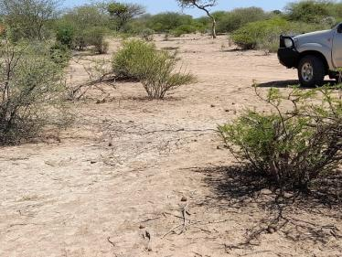 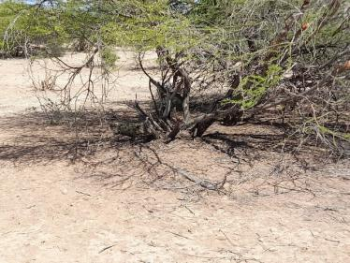

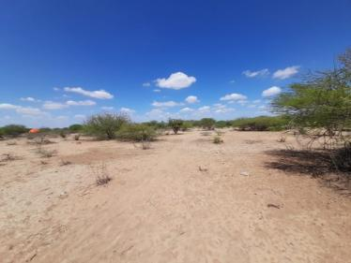 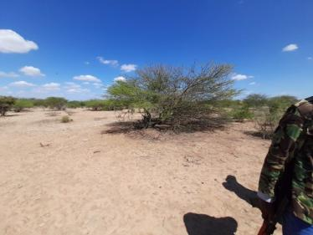

Plate 2: Project area soil and flora presentation

### Climatic Conditions

The county experiences annual average relative humidity of 61.8 per cent which ranges from 56 per cent in February to 68 per cent in June. The average annual precipitation is 240 mm or 20 mm each month. June is the driest month with an average of 1 mm of rain while April is the wettest month with an average of 68 mm of rain. The average temperature is 27.9°C and the range of average monthly temperatures is 3.5°C. The warmest months are February & March with an average of 36°C while the coolest months are June, July, August & September with an average low of 21°C. The project site identifies with the county climatic conditions supporting pastoralism.

The County experience frequent drought episodes especially from June to September, which negatively impact livestock, crop farming, education, nutrition, access to water and pasture. On the other hand, the county also experiences flash floods which damages infrastructure and kills the shoats (goats and sheep). The frequency and intensity of the extreme climatic events has been increasing in the recent past disrupting the livelihood of the communities.

## Socio-economic Environment

### Community Profile

The proposed project site is located on unregistered communal land at Boji Garas village in Boji Garas Location, Khorof Harar Ward, Wajir South subcounty in Wajir County. The project is situated about 34kms North of Bur-Mayo town and about 34kms from Sarman Town. The primary ethnic group is Somali who are Islam. The land is mainly communal and used for grazing. Land is inherited through kinship. The main activity among Boji Garas community members is livestock keeping and small-scale businesses. The community is organized from Area Chief-Elders-Committees-Group representatives.

### Socio-economic status of Study Area

#### Demographic Profile

The demographic profile in terms of total population, number of households, household size and sex -ratio of the selected villages surveyed in study area has been discussed in section below and details are presented below.

Population data as per the last Kenya National Population and Housing Census (2019) indicate that the county had a total population of 781,263, while Wajir South Sub County has a total of 62,206 with 31,990 males whereas female is 30,209. The county has an inter-censual growth rate of 3.22 per cent which is higher than the national population growth rate of 3.0 per cent.

Boji Sub-Location has an estimated population of 1,917 people, 1088 males and 828 females. It has approximately 269 households with 5 people per household as per the KPHC 2019. The gender ratio is currently estimated at about 60% male and 40% female. Below is a summary of demographic profile of Boji Garas. It was noted population within Boji Garas has increased mainly attributed to increased birth rates. The table below is a summary of demographic profile of Boji Garas given during the key informative interview with the chief

Table 9: Summary of demographic profile of Boji Garas Sub-Location

| **Attribute** | **Magnitude/Number** |
| --- | --- |
| Approx. population | 1,917 |
| Households | 269 |
| Gender. | Male – 60%  Female – 40% |
| Vulnerable classes | * The elderly * Female held households * People living with disabilities * Child held households |
| Dominant ethnic group | Somali |
| Primary religion | Islam |
| Other groups | None exists |
| Employment (formal/Informal) | Formal – 20%  Informal – 80% |

#### Educational Infrastructure

The county has an estimated 203 pre-school centers, with 203 teachers, 203 primary schools with a total of 59,065 pupils and served by 889 teachers. The teacher pupil ratio is 1:66 which is higher than the recommended ratio of 1:40. The literacy level is 23.8 per cent. Only 22 per cent of women and 59 per cent of men have received any education (KDHS 2008-09). There are 34 secondary schools in the county with enrolment at 7,195 and staffing at 320 and four polytechnics (Wajir, Habaswein, Khorof Harar and Griftu polytechnics) run by the Ministry of Youth Affairs and currently not operational due to lack of enrolment.

As per the observation and information sought from Boji Garas location, the area has one school; Abaqfin mixed primary school with classes up to grade five. The school has a shortage of teachers, infrastructure, toilet facilities, books, a perimeter fence, and power. On behalf of the school Mr. Mohamed Abdi (Headteacher), he requesting assistance to aid the school with the aforementioned difficulties.

The project will light up the school allowing pupils to attend preps in the evening, improving education in Boji Garas village.

#### Occupation and Livelihood Profile

The primary source of livelihood in the county is livestock keeping, livestock products, and agriculture. The main economic activity in the County is livestock rearing with over 80 percent of the inhabitants relying on livestock for their livelihoods. The main animals reared include cattle, camel, and goats. Nomadic pastoralism defines the lifestyle of most of the county’s inhabitants. This kind of lifestyle has caused environmental degradation as a result of overgrazing caused by overstocking. The other source of livelihood in the County is agriculture,

Plate 3: Pastoral activities near the project site

which is practiced in depressions and along drainage lines where there is more moisture due to seasonal flooding.

Pastoralism and business are the two main sources of income for the residents of Boji Garas village. Pastoralism is primarily practiced in Boji Garas Ward's rural areas, as well as the extensive grassland and shrubland of Wajir South subcounty. During the rainy season, small-scale farming is practiced in rural regions. Khorof Harar Ward and settlements in the Wajir South subcounty benefit from the operations of the Boji Garas village.

The main formal jobs at the area are NGO staff, teaching and other civil services which accounts to approximately 20% of the population. The other 80% of the population is involved in informal employment. The existing livelihood system was confirmed during the community consultation process and FGDs sessions.

#### Land Use and Tenure

Except for a minor portion of the total territory inhabited by townships, the entire county is classified as community land. Nomadic pastoralism is the most common usage of the land. Individuals or groups do, however, operate small-scale agriculture in a few limited places. The majority of the inhabitants practice nomadic pastoralism, with grazing zones covering a considerable amount of the area. There are, nevertheless, a tiny number of farmers who practice rain-fed and irrigated farming on a small scale.

There are two types of land; Private and Communal land. Private land is mainly found is town and used for residential, business and crop/fodder production. The communal land is for grazing. The average land size for private land is a quarter of an acre.

Visual interpretation, survey maps of the area, and ground checking during field surveys were used to interpret the land-use and land-cover of the research area (5kms). Within the project site, grassland and open shrubland are used for residential, commercial, and grazing purposes. During the rainy season, small-scale farming is also practiced. The region is mostly semi-arid, and the population is scarce.

An abbreviated Resettlement Action Plan (A-RAP) outlining the principles and procedures for land acquisition and compensation is annexed to this ESIA. An A-RAP applies where affected persons are not physically displaced, and less than 10% of their productive assets are lost, or fewer than 200 people are displaced. In the case of KOSAP sub-projects, there is no physical displacement of affected persons, and the foreseen impacts on livelihoods such as grazing occasioned by mini-grid construction, wayleaves acquisition, and implementation of community projects are considered minor. A-RAPs will be implemented for sub-project sites on registered and unregistered community land/group ranches.

#### Health facilities

Boji Garas area has no health facility. The residents’ access health services from Wajir Borr Health centre located 16kms away from the village. Referrals are at Wajir hospital.

#### Social and Physical Infrastructure

**Water**: The County has a diverse range of water resources, including subterranean, surface, and subsurface sources. Rainwater collection has a lot of potential, especially after heavy rains that result in flash floods. The county has 272 boreholes, 15 mega pans, and 260 water pans. To identify areas with significant groundwater potential, comprehensive geological surveys are required.

Water primarily comes from the Boji Garas borehole, shallow wells, and water pans 3 kilometers from the village. The community's top priority request is for water to be piped from the Boji Garas well to the trading center, noting that this will save travel distance and time, especially for women and children.

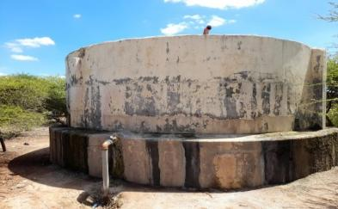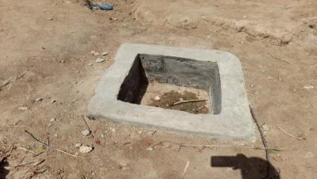

Plate 4: Boji Garas water tank

**Sanitation**: there are pit latrines in some household, school, mosque and health centre however Open defecation (OP) is still practiced in the village. Waste management is poor with community members preferring to burn waste.

**Road Network**: Wajir County has poor infrastructure, the state of the road network is poor, it consists of 4,840 Km of earth surface roads, 440 Km of gravel roads and no bitumen roads. Road’s connectivity within the project site area is poor and not regularly maintained. When it rains access, the area is also impossible. The main forms of transport within the area are Motor bikes and while donkeys and camels also provide alternative modes of transport. The project site is accessed via Wajir-Handaki earth road.

**Mobile Network Coverage:** Information and communication is an enabler to economic and social development is also limited in the county. The mobile communication network connection has 20% coverage mainly limited to main settlement areas. There are three mobile service providers namely Safaricom and Airtel. *Safaricom* is the only Network coverage within the village and majority of people have access to the internet services.

**Power/electricity:** Energy, one infrastructural enabler of the three pillars of Vision 2030 and the level and intensity of commercial energy use is a vital indicator of the degree of economic growth and development. According to the KIHBS 2005/6, 98.4 per cent of the county households depend on wood fuel (Firewood and Charcoal) for cooking and 31.5 per cent depend on lantern for lighting. 96.6 per cent of households use traditional stone fire for cooking. Boji Garas community is not connected to the national grid. The population use mainly portable solar at the household for charging mobiles and lighting. Firewood is used for cooking in homes.

#### Social-Cultural Characterization of the community in the project area

The community living within the proposed project area is the Somali clan. The Somali fit into the criteria of vulnerable and marginalized groups according to the World Bank OP. 4.10 and Constitution of Kenya. Pastoralism is the way of life of the Somali with land being a very valuable and precious asset. They rely on the availability of water, pasture and labour to manage their livestock. Livestock remains primarily socio-cultural rather than economic asset, characterized by holding exceedingly large stocks of animals, whose sale is never a priority despite the ravage of perennial droughts.

Severe climatic shocks and stresses, especially drought, normally have greater economic consequences such as acute food shortages and loss of livestock. As part of coping mechanism, during the rainy seasons, pastoralist increase their livestock numbers this enables them carry over enough healthy stock to provide for subsistence during the dry seasons.

#### Gender Dynamics in the Project Area

The social assessment study sought to establish gender dynamics among the VMGs communities in the project area. The VMGs community in the project area are patriarchal, where women’s position is viewed as subservient, marginalized and disempowered. The main responsibility of men in this ethnic groups is livestock issues which include herding, watering animals, selling and making other key decisions within the household. While, women normally perform domestic duties such as tending the home and children, milking animals, fetching water and firewood, looking after home herds of sheep and goats while a few engage in small scale farming and trade. These gender roles were extensively discussed during FGD interviews with majority of women participants indicating their limited role in decision making.

The social assessment study established that the changing socio-economic environment in the project area has had an impact on assigned gender roles. According to FGD discussions, women in VMGs communities are increasingly taking up more roles that used to be the preserve of men.

#### Gender Based Violence

Based on the Focus Group Discussion with women at Boji Garas, intimate partner violence is not common in the area.

#### Culture and heritage

No cultural site of significance was reported/observed within the project area. Boji Garas is predominantly made up of the Somali community that value keeping livestock including cattle, camel, sheep and goats. The Somali community in the project area are a patriarchal society; men typically speak for women and make decisions in the family. The community practices polygamy and encourages early marriages for young girls.

#### Cultural issues in the project area

The community members confirmed that their culture is conservative and strongly attached to their culture and religion. Hence the community members are predominantly Muslims with a mosque within the locality. The project area is very remote and did not have essential services such as health facilities, electricity, roads, water and schools.

# ANALYSIS OF ALTERNATIVES AND PROJECT JUSTIFICATION

This section analyses the project alternatives in terms of site and technology. Solar projects are non -polluting energy generation projects which are site specific and dependent on the availability of solar irradiance resource. The current site selected is a high solar power potential site with high irradiation and consistent sunny days throughout the year.

* 1. **Site Selection**

Solar projects are non-polluting energy generation projects which are site-specific and dependent on the availability of solar irradiance resource.

The proponent identified one location for the proposed solar project that neighbours manyatta settlements & shrubs to the immediate directions while to the far north is the access road (80ms), Boji center to the West and Abaqfin primary school to the South West at 300ms at Boji Garas village.

Further details on the other locations identified were not available.

* No settlement present in the project site;
* The project site land is predominantly unregistered community land;
* The project site has few scattered trees and shrubs and located near community settlement area (manyattas);
* The project site land is mainly used for grazing and only single crop is cultivated during the post-monsoon season;

The proposed project site has the following location advantages:

* The land is unoccupied and does not have any ecological sensitive receptor such as national parks, Wildlife Sanctuary within 10 km radius;
* No cultural property of archeological importance within 5 km radius and
* There is no available power from National grid located in the area

**Figure 7: Proposed Project Site & Proximity to Consumer Sites**

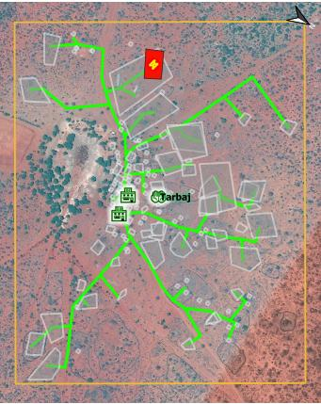

## Power Scenario in Boji Garas

Population data as per the last Kenya National Population and Housing Census (2019) indicate that Boji Garas sub location has an estimated population of 1917 people number of people with approximately 269 households. The proposed solar off grid project is estimated to cover up to 199 residential and 3 non-residential consumers within the area. This will reach out to over 75% of the population within the area.

According to the KIHBS 2005/6, 98.4 per cent of the county households depend on wood fuel (Firewood and Charcoal) for cooking and 31.5 per cent depend on kerosene lantern for lighting. 96.6 per cent of households use traditional stone fire for cooking. This contributes to massive environmental degradation, increased health risks and additional workload for women and girls, and increased emissions of carbon content. Moreover, low enrollment, retention and transition for girls is partly attributed to increased workload related to energy search. Solar energy accounts for 0.2 per cent (2009 KPHC) of energy source but is also limited to schools and health facilities as it is out of reach for majority of the households. The county has a huge potential for renewable energy which can tapped through wind and solar energy and hence be channeled to productive sectors within the county as well as export to other counties.

The existing sources of Energy in Boji Garas village include solar powered appliances such as solar delights. The current energy availability provided by the solar appliances is insufficient and does not meet the objective of the aim of project. Solar energy is mainly utilized for lighting and charging mobile phones. Whereas wood fuel is utilized for cooking and heating water.

Failure to construct and operate the mini grid at Boji Garas village will lead to the failure of achieving one of the Kenya’s national long-term development policies that aims to transform Kenya into a newly industrializing, middle-income country, by providing a high quality of life to all its citizens by 2030 in a clean and secure environment. Beneficiaries will be households, public and community institutions, enterprises and community facilities that cannot access electricity through the national grid and whose use of electricity will replace kerosene and other fuels for lighting and other activities like pumping water.

### Present Power Supply Position

According to the KIHBS 2005/6, 98.4 per cent of the county households depend on wood fuel (Firewood and Charcoal) for cooking and 31.5 per cent depend on kerosene lantern for lighting. 96.6 per cent of households use traditional stone fire for cooking. This contributes to massive environmental degradation, increased health risks and additional workload for women and girls, and increased emissions of carbon content. Moreover, low enrollment, retention and transition for girls is partly attributed to increased workload related to energy search.

Wajir, Griftu, Abakore, Wajir North Habaswein and Eldas centers are Wajir County Integrated Development Plan (2018-2022) 30 connected to diesel power plants where over 20,000 households are supplied with power. Bute is connected to the Ethiopian Grid through Moyale. Solar energy accounts for 0.2 per cent (2009 KPHC) of energy source but is also limited to schools and health facilities as it is out of reach for majority of the households.

The county has a huge potential for renewable energy which can tapped through wind and solar energy and hence be channeled to productive sectors within the county as well as export to other counties.

### Vision 2030

Kenya Vision 2030 is the country’s development blueprint covering the period 2008-2030. It aims to transform Kenya into a newly industrialized, ‘middle income’ country providing a high-quality life to all its citizens by the year 2030.’

Vision 2030 is based on three key pillars namely: Economic, Social, and Political. These pillars are anchored on the following foundations:

* Macroeconomic stability.
* Continuity in governance reforms.
* Enhanced equity and wealth creation opportunities for the poor.
* Infrastructure.
* Energy.
* Science, technology and innovation (STI).
* Land reform.
* Human resources development.
* Security; and
* Public sector reforms.

This policy recognizes that infrastructure, and in particular, a reliable power supply is vital in sparking economic growth. The challenges facing the power sector in Kenya include weak transmission and distribution infrastructure, high cost of power, low per capita power consumption, and low electricity access countrywide.

*The Proponent aims to generate power mainly for community use which will contribute towards meeting the growing energy needs and targets as envisioned in Vision 2030.*

* 1. **Analysis of Alternative**

As per IFC Performance Standards, an analysis of probable alternatives for the chosen technology and location of project site along with other similar factors that contribute to the project as a whole has been carried out. The following scenarios have been taken into consideration:

* Alternate Location for Project Site
* Alternate Sources of Energy
* Zero or No Project Alternative

### Alternative Location for Project Site

In determining the most appropriate site for the establishment of the mini grid, several options were explored. This site selection process considered the following criteria:

* Geophysical Factors-Proximity to Hills-Shade effect, Soil erosion, Drainage of the area, Flooding etc.
* Land identified is free from any dispute on ownership or any other encumbrances
* Proximity to public utilities-Schools, Dispensaries, Places of worship and community settlements
* No squatters, encroachers or other claims to the land
* The Size of the Minigrid to be constructed and the optimal coverage of a Minigrid in terms of the number of people to be reached.
* The Land identified should be on spaces set aside for public use within the community centres.

Boji Garas project site was identified as the most suitable area for the establishment of the proposed mini-grid based on the following factors:

**Location**: The area is in a predominantly pastoral setting. The population density is low, and majority of the surrounding land is de-vegetated grazing lands and tree cover is currently low at 15%. There is enough grazing land for the community and use of the site to construct the mini grid will not significantly impact grazing land.

**Proximity to customer sites**: The proposed solar mini grid project is estimated to cover up to 199 residential and 4 non-residential consumers within Boji Garas village. This will reach out to over 75% of the population within the area.

The land was identified by the beneficiary communities and confirmed by technical staff to be suitable for the sub-project and free from any environmental or health risks. The impacts on the Community will be marginal and will not result in displacement of households or cause loss of household’s incomes and livelihood.

The site identified was considered against the criteria highlighted above and was found suitable for Minigrid construction.

*The community in Boji Garas unanimously agreed to set aside land for Mini-grid construction. A Land Identification form was signed by the representative of the community, the county government and the Implementing Agencies summarizing the process of land identification and the agreements reached with the community. (Attach the Land Identification Form*)

### Alternative Sources of Energy

Harnessing solar energy is an eco-friendly process, with an inexhaustible solar resource and minimal pollution. There are minimal fuel requirements for operational activities. Solar energy has a short development timeframe, more predictable energy output and low maintenance costs as compared to some other forms of renewable energy sources.

The possible alternatives to solar energy include;

* **Wind Power:** The problems in operation of wind power are lack of time series data of wind, trained human resources to intricate design of wind power etc. In addition, providing wind power for Boji Garas residents is technically and financially challenging, expensive to install, dependent on wind pattern. However, generation is cheap, low emissions & insignificant pollution levels.
* **Thermal power**: It use is associated with serious environmental problems like air pollution, waste pollution, noise pollution, temperature pollution etc. Besides coal and petroleum products, the basic input required for the conventional thermal power plants will have to be imported. Therefore, thermal power option based on coal and petroleum products is not a viable option for Boji Garas site.
* **Wood fuel:** The use of firewood and solid waste for electricity generation using thermal technology is another option. But the issue of air pollution and destruction of vegetative cover through firewood harvesting and charcoal burning already are environmental problems of serious concern which will further aggravate the natural environment. For these reasons, the thermal power options evaluated above seem inappropriate for Boji Garas site on environmental as well as economic grounds.
* **Nuclear power:** disadvantages include; use of other fuel sources, has hazards associated with radioactive materials, expensive disposal of waste, high cost of project and long gestation period. The mode however does not emit smoke particles, low fuel cost, low emission levels and continuous electricity production.

Solar energy was a desirable option because:

* It has low energy-production costs
* Versatile installation
* It is a clean source of energy hence minimal impact on the environment air quality
* Economic savings.

### Zero or No Project Alternative

The No Project option in respect to the proposed project implies that the status quo is maintained. This option is the most suitable alternative from an extreme environmental perspective as it ensures non-interference with the existing conditions. This option will, however, involve several losses both to Boji Garas area and Wajir South as a whole. The village and the surrounding area will continue to have no electricity, and this will not help in maximizing and utilizing the area facilities. The No Project Option is the least preferred from the socio-economic and partly environmental perspective due to the following factors:

* The economic status of the local people would remain unchanged.
* Employment opportunities will not be created.
* Increased poverty and crime in the area.

From the analysis above, it becomes apparent that the No Project alternative is no alternative to the local people, Kenyan Government, and Investors.

*It is thereby concluded that the ‘do-nothing’ option is not a good option economically and should therefore be discouraged and rejected. It is therefore imperative for KPLC to establish a new solar mini-grid in the area and supply the community with clean energy.*

### Analysis of Alternative Construction Materials and Technology

The proposed solar Mini-grid will be constructed using modern, locally and internationally accepted materials to achieve public health, safety, security and environmental aesthetic requirements. Equipment that guarantees efficient use of locally available materials will be encouraged to ensure reliability in supply with minimum power loss and good design to allow efficient distribution of power in the area.

The support structures in the Solar Mini-grid can be wooden or steel. Because of its durability and strength, steel is the best choice and all support structures will be steel. Perimeter fence can be a reinforced wire mesh fixed to support structures that can be wooden, concrete or steel. Alternatively, a stone perimeter wall can be constructed and this is the option of choice since it is more durable, offer better protection and requires less maintenance.

The design of the solar mini-grid will be easy to install and dismantle with minimum labor requirements and maintenance costs will be minimal. The process material that are input for the proposed project such as generator diesel fuel and oil and water for cooling the generator and for cleaning purposes are critical elements. There is no alternative for generator oil and water for standby generator cooling and for mini-grid facilities cleaning water. So, the task was to assess alternative water and Diesel generator oils and fuel sources for the project.

### Solid Waste Management Alternatives

A lot of solid wastes will be generated from the proposed project. An integrated solid waste management system is recommendable. First, the KPLC will give priority to reduction at source of the materials. This option will demand a solid waste management awareness program in the management and the staff. Recycling and reuse options of the waste will be the second alternative in priority. This will call for a source separation program to be put in place. The third priority in the hierarchy of options is combustion of the waste that is not recyclable. Finally, the KPLC will need to establish partnership with NEMA approved waste handlers for regular waste removal and disposal in an environmentally-friendly manner. In this regard, a NEMA registered solid waste handler would have to be engaged. This is the most practical and feasible option for solid waste management.

### Alternative Solar Mini-Grid

The identification of potential Mini-grid site for the proposed Boji Garas Solar Mini-grid involved site visits to the study area, preliminary site assessments and consultations among the concerned departments of the KPLC, MOE and REREC. Two sites have been proposed by the community:

Site A-consultations among the community members found that the site belonged to any individual and according to the best practice of avoiding physical displacement the land was found to be unviable.

Site B- is portion of land which is next identified for the Mini-grid. The site identified is part of a larger piece of land which had been identified by the community for setting up community service projects. Between site A and B, site A was rejected because it would result in physical displacement and site B was found to be suitable for the project.

The appropriateness of potential Mini-grid sites identified by the KPLC during the initial site visits was assessed in terms of various suitability criteria and technical restrictions stipulated by KPLC, as outlined below:

* Load growth - the location of Mini-grid first and foremost is informed by the existing and also load growth of an area. Technical studies show that the area will experience load growth over time and there is need to supply electricity.
* Size – proposed potential sites need to be sufficient for the average size of Solar Mini-grid and associated auxiliary facilities. Therefore, the size acquired must meet the required size.
* Topography – consideration is given to the topography of potential sites whereby flat or gently sloping topography is preferred. An ideal gradient for the natural ground is 1:100. A gentle slope facilitates surface drainage and movement of vehicles and people on-site during construction. A steep slope requires costly leveling (cut and fill) for the construction of the solar Mini-grid. In addition, a steep slope inhibits movement, makes vehicle access problematic and increases the potential for environmental impacts during construction as well as operation e.g., steeper slopes have higher surface water flow rates and therefore higher erosive potential. The proposed site is flat and cost-effective during construction.
* Hydrology – consideration is given to the proximity of potential sites to adjacent water courses and wetlands where there may be potential impacts in terms of erosion and siltation of water courses, as well as implications associated with storm-water control at the Solar Mini-grid site. The site is not close to water resources or wetland and so no impact to water sources through siltation. Further, construction of drainage is not complicated.
* Geology and soils – consideration is given to the soil type present within the potential site whereby stable soil and founding conditions are preferable. Less stable soils, i.e., shallow, dispersive soils and soils with poor drainage present an erosion hazard if not managed correctly, and also require the installment of additional, costly foundation infrastructure. The soils at the site are well drained.
* Flora and fauna – potential sites need to be assessed in terms of their ecological value at both a macro and micro scale i.e., within the site and the environment surrounding the site. Both a faunal and floral investigation may be required, with particular emphasis on ensuring the protection of endemic and red data species and their habitat, should they be present. An identified site that has a high ecological value may be excluded from the list of potential sites. The site is not of a high ecological value.
* Visibility – highly visible sites i.e., on a ridge / elevated terrain are considered less favorable in that they have a high visual impact on the surrounding landscape. Sites that are hidden or out of site e.g., behind a hill, may be considered more suitable; the site is on flat part near chief’s office and may not create sharp visual impact because it is not on an elevated point.
* Access – it is preferable that potential sites are located in close proximity to existing public roads so as to avoid the need for construction of new access roads of considerable length. Access is also important particularly as it relates to the transportation of the solar panels, batteries and generator to the site, which are heavy weights and requires the use of a low-bend vehicle. As such, long access routes with sharp bends are to be avoided and the site should not be located in an area that has excessively steep inclines or declines that could hinder access, particularly during periods of heavy rainfall; the site is well accessible as it along the road.
* Distance to site – it is important that the site be located strategically within the receiving area’s electrical load Centre; this is true of the proposed site.
* Adjacent land use – adjacent land use has implications for access and required clearances for the power lines extending from the solar plant site, i.e., it is important that the land surrounding the Mini-grid is relatively clear of obstructions which might otherwise inhibit / obstruct the path of the power lines out of the Mini-grid. Current and future development planning of adjacent land use should therefore also be considered. The site and the developments around do not pose a hindrance for incoming and outgoing feeders.
* Public acceptability – public acceptance criteria relate to such issues as the possible adverse impact on public health, quality of life, and local land and property values. During the public consultations there was overwhelming support for the project with mitigation measures being put in place for the negative impacts.

### Conclusion

Based on the above-mentioned suitability criteria and technical requirements, the proponent decides to put up the Solar Mini-grid within Boji Garas. Relocation option to a different site is an option available to the proponent. The project proponent can look for alternative land to accommodate the scale and size of the project. However, this will be a costly venture, may take a long time although there is no guarantee that the land would be available in the targeted area. It is recommendable that the proponent be allowed to install the project in the proposed site.

# POLICY AND LEGISLATIVE FRAMEWORK

## Introduction

This Chapter outlines the existing national and international environmental and social legislation, policies, and institutions applicable to energy generation that guide the development of the Project.

As Kenya is a signatory to various international conventions and laws, national projects need to be aligned with their requirements; relevant international conventions and laws are therefore presented in this chapter.

Finally, a summary of the World Bank (WB) Environmental and Social operational policies relevant to this Project are presented.

## Environmental Policy Framework

The Kenya government formulated a national Environmental policy in 2013 whose goal is better quality of life for present and future generations through sustainable management and use of the environment and natural resources.

According to the said policy Kenya has a wide variety of ecosystems namely mountains, forests, arid and semi-arid areas (ASALs), freshwater, wetlands, coastal and marine all offering many opportunities for sustainable human, social and economic development. These ecosystems are natural capitals which provide important services such as; regulatory services, provision services, cultural services and supporting services implying that he survival and socio-economic wellbeing of Kenyans is ultimately intertwined with the environment.

The policy comes in handy as it provides a framework to guide the country’s efforts in addressing the ever-growing environmental issues and challenges such as: Environmental governance, Loss of biodiversity, valuation of environmental and natural resources, rehabilitation and restoration of environmentally degraded areas, urbanization, waste management and pollution, climate change, energy, security and disaster management, public participation, environmental education and awareness, data and information, poverty, chemicals management. One of the principles of the policy which this project must adhere to is that the right to development should be exercised taking into consideration sustainability, resource efficiency and economic, social and environmental needs.

## Institutional, Regulatory and Legal Framework

The multi-faceted nature of the environment and the need to integrate environmental considerations in all development planning and activities calls for cooperation and consultation among responsible government agencies and stakeholders at all levels. At present there are several institutions and departments which deal with environmental issues in Kenya. Some of the key institutions include:

1. **National Environment Management Authority (NEMA)**

The objective and purpose for which NEMA was established is to exercise general supervision and co-ordinate over all matters relating to the environment and to be the principal instrument of the government in the implementation of all policies relating to the environment. However, NEMA’s mandate is designated to the following committees:

1. **County Environment Committees**

According to EMCA (Amendment), 2015, every governor shall, by notice in the Gazette, constitute a County Environment Committee (CEC) of the County. The County Environment Committees are responsible for the proper management of the environment, development of county strategic environmental action plan, every five years including implementation of the plans among others.

1. **National Environmental Complaints Committee**

The Committee performs the following functions:

* Investigate any allegations or complaints against any person or against the authority in relation to the condition of the environment in Kenya and on its own motion, any suspected case of environmental degradation and to make a report of its findings together with its recommendations thereon to the Council.
* Prepare and submit to the Council periodic reports of its activities which shall form part of the annual report on the state of the environment under section 9 (3) and
* To perform such other functions and excise such powers as may be assigned to it by the Council.

1. **National Environment Action Plan Committee**

This Committee is responsible for the development of a 5-year Environment Action Plan among other things. The National Environment Action Plan shall:

* Contain an analysis of the Natural Resources of Kenya with an indication as to any pattern of change in their distribution and quantity over time.
* Contain an analytical profile of the various uses and value of the natural resources incorporating considerations of intergenerational and intra-generational equity.
* Recommend appropriate legal and fiscal incentives that may be used to encourage the business community to incorporate environmental requirements into their planning and operational processes.
* Recommend methods for building national awareness through environmental education on the importance of sustainable use of the environment and natural resources for national development.
* Set out operational guidelines for the planning and management of the environment and natural resources.
* Identify actual or likely problems as may affect the natural resources and the broader environment context in which they exist.
* Identify and appraise trends in the development of urban and rural settlements, their impact on the environment, and strategies for the amelioration of their negative impacts.
* Propose guidelines for the integration of standards of environmental protection into development planning and management.
* Identify and recommend policy and legislative approaches for preventing, controlling or mitigating specific as well as general diverse impacts on the environment.
* Prioritize areas of environmental research and outline methods of using such research findings.
* prejudice to the foregoing, be reviewed and modified from time to time to incorporate emerging knowledge and realities and;
* Be binding on all persons and all government departments, agencies, States Corporation or other organ of government upon adoption by the national assembly.

1. **Standards and Enforcement Review Committee**

This is a technical Committee responsible for environmental standards formulation methods of analysis, inspection, monitoring and technical advice on necessary mitigation measures.

1. **National Environment Tribunal**

This tribunal guides the handling of cases related to environmental offences in the Republic of Kenya.

1. **National Environment Council (NEC)**

EMCA 1999 No. 8 part III section 4 outlines the establishment of the National Environment Council (NEC). NEC is responsible for policy formulation and directions for purposes of EMCA; set national goals and objectives and determines policies and priorities for the protection of the environment and promote co-operation among public departments, local authorities, private sector, non-governmental organizations and such other organizations engaged in environmental protection programmes.

The project proponent will adhere to any directive issued by the above institutions that are relevant to the project

## Kenya Policy Provisions

### Kenya Energy Policy, 2014

The Energy Policy sets out the national policies and strategies for the energy sector that align to the Constitution of Kenya and Kenya’s Vision 2030.

The Energy Policy envisages promoting an energy mix that includes solar energy at both the household/institutional levels as well as large-scale solar energy generation. The Government of Kenya has initiated and has been promoting programmes for the provision of electricity to institutions far from the grid through solar PV systems. The Government has also embarked on a programme to provide solar/diesel and solar/wind hybrid generation capacity to off-grid stations.

The Policy strategizes the need to:

* promote the widespread use of solar energy while enforcing existing regulations and standards.
* provide incentives to promote the local production and use of efficient solar systems.
* provide a framework for connecting electricity generated from solar energy to the national and isolated grids, through direct sale or net metering.
* promote the use of hybrid power generation systems involving solar and other energy sources; and
* facilitate the generation of electricity from solar energy by, among other things, funding, provision of land, fast-tracking issuance of permits and licenses, as well as acquisition of data and information to realize at least 100 MW from solar by 2017, 200 MW by 2022 and 500 MW by 2030.

The Kenya Electricity Supply Industry (ESI) is one of the sub-sectors in the energy sector which the Ministry of Energy and Petroleum oversees on behalf of the Government of Kenya (GoK). Under the Energy Act of 2006, the Ministry is responsible for formulation and articulation of policies to provide an enabling environment for operators and other stakeholders in the energy sector. Relevant stakeholders in the ESI are briefly described below.

### The Constitution of Kenya

Environmental management and natural resources utilization is enshrined in the Kenya constitution 2010 under several articles. In article 69 of the Constitution of Kenya, 2010, the State clearly undertakes to carry out the following:

* Ensure sustainable exploitation, utilization, management and conservation of the environment and natural resources, and ensure the equitable sharing of the accruing benefits;
* Work to achieve and maintain a tree cover of at least ten per cent of the land area of Kenya;
* Protect and enhance intellectual property in, and indigenous knowledge of, biodiversity and the genetic resources of the communities;
* Encourage public participation in the management, protection and conservation of the environment;
* Protect genetic resources and biological diversity;
* Establish systems of environmental impact assessment, environmental audit and monitoring of the environment;
* Eliminate processes and activities that are likely to endanger the environment; and
* Utilize the environment and natural resources for the benefit of the people of Kenya.

The constitution in article 42 emphasizes the need for a clean and healthy environment through management of substances that may pollute the environment or cause harm to human health. The right to a clean environment is further enforced by article 70. Article 186 and the fourth schedule allocate functions of natural resources management and environmental protection to both the national and county governments.

The county government on the other hand shall Control air pollution, noise pollution and other public nuisances as stipulated in article 3 of the fourth schedule and in article 10, the county government shall implement specific national government policies on natural resources and environmental conservation.

Public participation is entrenched in several articles across the Kenya constitution 2010. Article 6 provided for devolution and access to services. Responsibilities in major decision-making process have been bestowed to the public (in the bill of rights, articles 118, 174, 196 and 201). The constitution further in article 21 section 3 requires safeguarding the rights and interests of marginalized groups for equity in public service provision. This can be effectively achieved through active involvement of such groups in decision making process at all levels. Hence need to involve the local people in the project area in studies, design and implementation of the proposed project facilities.

The principles of land policy that ensure land is held, used and managed in a manner that is equitable, efficient, productive and sustainable is set out in article 60 of the constitution. Proper land management by regulating the use of any land, or any interest in or right over any land, in the interest of defending, public safety, public order, public morality, public health, or land use planning is ensured by the constitution in article 66.

In regard to environmental protection and natural resources management, article 62 sub-article 1 stipulates what constitutes public land. Both the Land Act22 and the Land Registration Act23 refers to the definition given under the Constitution of Kenya (2010) to be the one to apply in each of the respective statutes. The public land areas are held by the national government in trust for the people of Kenya and shall be administered on their behalf by the National Land Commission as stated in article 62 sub-article 3. The land commission shall also monitor and have oversight responsibilities over land use planning throughout the country regardless of the classification as stated in article 67-2(h).

Private Land under Article 64, includes any land that is vested in a natural or artificial person, and any other land declared through an Act of Parliament. The Constitution 2010 has emphatically stated that: freehold land cannot be owned by a non- citizen of Kenya; and a leasehold interest of over 99 years cannot be held by a non-Kenyan citizen.

Article 63 of the constitution, Community land includes land currently under the Land (Group Representatives) Act; land currently classified as trust lands, community forests, land that is transferred to the community by any process of law, ancestral land and lands traditionally occupied by hunter-gather communities inter alia. Community land is a new category of land explicitly created by new constitution 2010. The term ―community‖ would require a legal definition to allow transfer of land that is currently forest, protected areas or other public land to such communities. Ethnicity may determine the community land however; Article 27 is prohibiting discrimination on the basis of ethnicity. Ancestral land too is not defined, nevertheless, it may be applied to any group or community which identifies itself as traditionally holding a specific area and which it has legal claim as its own.

*For the purposes of this project, the constitution of Kenya provides for sound environmental management and sustainability and therefore this study provides one of the tools through which this can be achieved*

Table 10. Kenya power stakeholders and their roles

|  |  |
| --- | --- |
| Stakeholders | Role |
| Kenya Power lighting Company | Responsible for distribution and retail supply of electrical energy to end users. Kenya Power purchases power in bulk from the Kenya Electricity Generating Company Limited (KenGen) and the Independent Power Producers (IPPs) through bilateral contracts or Power Purchase Agreements (PPAs) approved by the Energy Regulatory Commission (ERC) ([1]). |
| The Energy and Petroleum Regulatory Authority (EPRA) | Established by the Energy Act of 2019. The EPRA’s mandate extends beyond electricity and includes natural gas (including petroleum), renewables and all other forms of energy. The generation, transmission, distribution, supply, import and export of electricity can only be carried out by parties in possession of a license, or a permit issued by the EPRA. If the capacity involved is for own use and less than 1 MW, authorization is not required. Although the generated electricity is expected to be less than 1 MW (0.3 – 1 MW), the fact that the generated electricity is intended for use in a factory and there is a possibility for connection to the national grid and sale of excess power to the government, The project requires a license from the EPRC to generate electricity as stipulated in the Energy Act, 2019. |
| Ministry of Energy and Petroleum | Aims to facilitate provision of clean, sustainable, affordable, reliable, and secure energy services for national development while protecting the environment. |
| The Rural Electrification and Renewable Energy Corporation (REREC): | Is established under Section 43 of the Energy Act, 2019 as a corporate body. The Corporation is the successor to the Rural Electrification Authority established under section 66 of the Energy Act No. 12 of 2006 (now repealed) and subject to this Act, all rights, duties, obligations, assets and liabilities of the Rural Electrification Authority existing at the commencement of this Act is to be automatically and fully transferred to the Corporation and any reference to the Rural Electrification Authority in any contract or document shall, for all purposes, be deemed to be a reference to the Corporation. REREC will be mandated to ensure all environmental issues and concerns under this report as well as those that come up during the project phases |
| The Geothermal Development Company (GDC): | Is a 100% state-owned company, formed by the Government of Kenya as a Special Purpose Vehicle to fast track the development of geothermal resources in the country. The creation of GDC was based on the government’s policy on energy - Sessional paper No. 4 of 2004, and the energy Act No. 12 of 2006. |
| The Kenya Electricity Transmission Company (KETRACO): | Was incorporated on 2nd December 2008 and registered under the Companies Act, Cap 486 pursuant to Sessional paper No. 4 of 2004 on Energy. KETRACO’s mandate is to design, construct, operate and maintain new high voltage electricity transmission infrastructure that will form the backbone of the National Transmission Grid, in line with Kenya Vision 2030. |
| Energy and Petroleum Tribunal (EPT): | The tribunal is established under section 25 of The Energy Act, 2019. The tribunal is established for the purpose of hearing and determining disputes and appeals in accordance with The Energy Act, 2019 or any other written law. In relation to the proposed Project, any disputes or appeals if they arise will need to be addressed by the EPT. |

### Policy paper on Environment and Development (Sessional Paper No. 6 of 1999)

The overall goal of this Sessional Paper is to ensure that environmental concerns are integrated into the national planning and management processes and provide guidelines for environmentally sustainable development. The objectives of the Paper are to conserve and manage the natural resources of Kenya including air, land, flora, and fauna and promote environmental conservation about soil fertility and conservation, biodiversity, to foster afforestation activities, and to protect water catchment areas. More importantly, the Policy emphasizes the enhancement of public awareness and appreciation of the essential linkages between development and environment, involving NGOs, private sector, and local communities in the management of natural resources and their living environment and ensures that an environmental impact assessment report is undertaken for all public and private projects and programmes.

*The proposed solar plant facility must ensure that it promotes this integrated approach to environmental management and development, without compromising the livelihoods of the local community.*

### National Policy on Water Resources Management and Development, 1999

While the National Policy on Water Resources Management and Development enhances a systematic development of water facilities in all sectors for promotion of the country’s socio-economic progress, it also recognizes the by-products of this process as wastewater. The Policy therefore calls for development of appropriate sanitation systems to protect people’s health and water resources from institutional pollution. This implies that industrial and business development activities should be accompanied by corresponding waste management systems to handle the wastewater and other waste emanating therefrom.

*During construction, water will be required for concrete works and during the operational period water supply may be necessary for cleaning the PV modules. Appropriate water treatment and waste handling must be incorporated into the Project design to be in alignment with this policy.*

### Sessional Paper No. 10 of 2014 on the National Environmental Policy, 2014

The overall goal of this Session Paper is to ensure better quality of life for present and future generations through sustainable management and use of the environment and natural resources. This Session Paper calls for the use of environmentally sound technologies based on the best available techniques and policies as a way of minimizing negative impacts to the environment.

Section 5.6 of this Session Paper focusses on infrastructure development and environment and makes explicit policy statements to ensure sustainable management and use of the environment and natural resources during the construction and operation of infrastructure developments. These policy statements require the commitment of the government to:

* Ensure Strategic Environmental Assessment (SEA), Environmental Impact Assessment, Social Impact Assessment and Public participation in the planning and approval of infrastructural projects.
* Develop and implement environmentally friendly national infrastructural development strategy and action plan.
* Ensure that periodic Environmental Audits are carried out for all infrastructural projects

*In line with the above policy statements, this ESIA has been conducted for the proposed solar project (including the associated infrastructure) to ensure that environmental and social issues are appropriately addressed. Once approved by NEMA, the Project Proponent will also need to conduct periodic Environmental Audits to ensure continuous conformity with the overall goal of this Session Paper. In addition, this ESIA has considered analysis of alternatives including alternatives to technology to ensure that the best available and appropriate technology is used.*

## National Legal Framework

### Administrative Framework

In 2001, the Government established the administrative structures to implement the Environmental Management and Co-ordination Act of 1999 (EMCA). The main administrative structures are described in the following sections:

Table 11: Administrative stakeholders and their roles

| Stakeholders | Role |
| --- | --- |
| *NEC* | The **National Environmental Council** is responsible for policy formulation and directions for the purposes of EMCA. The Council also sets national goals and objectives and determines policies and priorities for the protection of the environment.  *The proponent should ensure that the project abides by the set goals and objectives of the Council*. |
| *NEMA* | The responsibility of NEMA is to exercise general supervision and co-ordination over all matters relating to the environment and to be the principal instrument of Government in the implementation of all policies relating to the environment.  *This ESIA has been prepared for submission to NEMA for review and approval prior to the commencement of the Project activities, in compliance to the EMCA.* |
| *PCC* | EMCA has also established a Public Complaints Committee, which provides the administrative mechanism for addressing environmental harm. The Committee has the mandate to investigate complaints relating to environmental damage and degradation. The members of the **Public Complaints Committee** include representatives from the Law Society of Kenya, NGOs, and the business community.  *The proponent should address all issues arising from the Project in accordance with the above requirements, including a clear policy of stakeholder engagement and feedback.* |
| *WRA* | Water Resources Authority is responsible for regulation of water resources issues such as water allocation, source protection and conservation, water quality management and pollution control and international waters. One of its functions among others is to receive water permit applications for water abstraction, water use and recharge and determine issue, vary water permits; and enforce the conditions of those permits as well as formulate and enforce standards, procedures and Regulations for the management and use of water resources and flood mitigation.  *The project area experiences serious water scarcity. The proponent will have to purchase water for use during construction.* |

## Relevant statutes

The current legal provisions for natural resource management in Kenya are contained in over seventy sector-specific statutes. For a long time, the country lacked an umbrella legislative guide for harmonious and holistic environmental management. As such, resources were managed sectoral in accordance with the statutes that were in place.

As these statutes were contradictory at times, in 1999, the Government of Kenya enacted the Environmental Management and Co-ordination Act (EMCA) which is an umbrella legal framework under which the environment is being managed. EMCA establishes the institutional framework under which environmental management is to be coordinated. EMCA prevails over all other Sectoral laws relating to the environment in cases of conflict or contradictions. It also grants the public a *locus standi* in matters of the environment.

Table 12: National Policy Framework

| **No** | **Legislation/**  **Guidelines** | **Description of the Legislation/Guideline** | **Relevance of the legislation/regulations in terms of license, permits, and other requirements** |
| --- | --- | --- | --- |
|  | **NATIONAL POLICY FRAMEWORK** | | |
|  | Vision 2030 | Kenya Vision 2030 is the current national blueprint for development from its inception in 2008 until the milestone year of 2030. This plan is the national long-term development policy that aims to transform Kenya into a newly industrialised, middle-income country by 2030. The Vision is comprised of three key pillars (economic, social, and political), two of which are projected to be positively affected by project implementation. | Under Vision 2030, Energy is identified as one of the key sectors that form the foundation for socio-political and economic growth. Promoting equal opportunities across the entire Kenyan territory and enhancing access to competitively priced, reliable, quality, safe and sustainable energy is essential to the achievement of this vision. |
|  | The Poverty Reduction Strategy Paper (PRSP) of 2001 | The PRSP has the twin objectives of poverty reduction and enhancing economic growth. The paper articulates Kenya ‘s commitment and approach to fighting poverty; with the basic rationale that the war against poverty cannot be won without the participation of the poor themselves. | The proposed project aims at provision and access of renewable electricity geared towards improved economic performance and thus will contribute to poverty alleviation in the project area. |
|  | National Environmental Action Plan (NEAP) of 1994 | The NEAP for Kenya was prepared in mid 1990s. It was a deliberate policy whose main effort is to integrate environmental considerations into the country ‘s economic and social development. The integration process was to be achieved through multi-sectoral approach to develop a comprehensive framework to ensure that environmental management and the conservation of natural resources forms an integral part of societal decision-making. | The NEMA does not approve a development project unless the impacts of the proposed project are evaluated and mitigation measures proposed for incorporation in the project ‘s development plan, which is in line with the requirements of the NEAP. The project will be reviewed by NEMA for approval before implementation. |
|  | Environmental and Development Policy (Session Paper No.6 1999) | As a follow-up to the foregoing, the goal of this policy is to harmonize environmental and developmental goals to ensure sustainability. The paper provides comprehensive guidelines and strategies for government action regarding environment and development. | The proponent:   * Is undertaking an Environmental Impact Assessment, Social Impact Assessment and Public participation as part of the planning and approval of infrastructural projects. * Will ensure that periodic Environmental Audits are carried out for the project |
|  | The National Energy and Petroleum Policy 2015 | The overall objective of the energy and petroleum policy is to ensure affordable, competitive, sustainable, and reliable supply of energy to meet national and county development needs at least cost, while protecting and conserving the environment. This policy stipulates the transformation of the Rural Electrification Authority (REA) to Rural Electrification and Renewable Energy Corporation (REREC) to be the lead agency for development of renewable energy resources. | The policy is relevant to the project in the sense that the project will provide sustainable and reliable energy supply and measures will be put in place to protect and conserve the environment during its development. REREC will oversee the development of the mini grid and maintenance. |
|  | The Gender and Development Policy (Sessional paper no.2 2019) | The overall goal of this policy is to achieve gender equality by creating a just society where women, men, boys, and girls have equal access to opportunities in the political, economic, cultural, and social spheres of life. | * In the absence of appropriate measures, the project can exacerbate gender inequalities and sexual and gender-based violence. In adherence to this policy, measures will be put in place to:   + ensure gender inclusivity in decision making, employment opportunity and access to the energy generated from the Mini-Grid   + mitigate social risks including sexual and gender-based violence, and any form of discriminations |
|  | **NATIONAL LAWS** | | |
|  | The Constitution of Kenya, 2010 | The Constitution of Kenya promulgated in 2010 is the supreme law of the republic and binds all persons and all State organs at all levels of government. The Constitution provides the broad framework regulating all existence and development aspects of interest to the people of Kenya, and along which all national and sectoral legislative documents are drawn. | * The proposed project complies with the Constitution by proposing a structure in its ESIA on how to deal with Social, Health, safety and environmental issues for sustainable development. |
|  | Sexual Offences Act No.3 of 2006 | The Act defines sexual offences and makes provisions for prevention and the protection of all persons from harm from unlawful sexual acts. The Act describes the types of sexual offences punishable by law and this includes rape, attempted rape, assault, defilement, gang rape, and indecent act with a child or adult, promotion of sexual offence with children, child trafficking, child sex tourism, and child prostitution, child pornography, and sexual harassment, cultural and religious sexual offences among others. | * The Act empowers the community members to take legal action in the event of a sexual offence. The code of conduct for solar mini-grid project workers should uphold the provisions of this law |
|  | Gender and Sexual Based Violence policy, 2017 | The purpose of this policy is to put in place a framework to accelerate implementation of laws, policies and programmes for prevention and response to sexual and gender-based violence. The overall objective of the policy is to progressively eliminate sexual and gender-based violence through the development of a preventive, protective, supportive and transformative environment | * This ESIA has outlines measures that the Proponent will put in place to prevent sexual and gender-based violence. The Proponent will develop and implement a Sexual and Gender-Based Violence Action Plan with an Accountability and Response Framework as part of the construction ESMP. The Proponent will put in place a framework to accelerate implementation of laws, policies and programmes for prevention and response to sexual and gender-based violence. |
|  | Children Act, 2001  Sub-section 10 (1) | This section is on protection of children from child labour and armed conflict states that every child shall be protected from economic exploitation and any work that is likely to be hazardous or to interfere with the child’s education, or to be harmful to the child’s health or physical, mental, spiritual, moral or social development. | * This ESIA has put in place measures to ensure protection of children rights through the development and implementation of a Children Protection Strategy that will ensure minors are protected against negative impacts associated with the project including sexual abuse, child labour etc. * The contractor(s) and the Proponent will comply with all relevant local legislation, including labour laws in relation to child labour specifically provisions of Kenya’s Employment Act, 2007 (Cap. 226) Part VII on protection of children against exploitation. Children or persons under the age of 18 years will not be hired by the proposed sub-project as provided by Child Rights Act (Amendment Bill) 2014. |
|  | Persons with Disability Act, No.14 of 2003 (Cap. 133) | Part III of the act provides the rights and privileges of the persons with disability. Including employment where it states that “No person shall deny a person with a disability access to opportunities for suitable employment” | * With the Contractor and the Project Proponent being primary employers during the construction and operational phases of the Project, respectively, they are bound by this law to abide to its stipulations on employee management and relations |
|  | The HIV/ AIDS Policy 2009 | In summary, the policy aims at:   1. Establishing and promoting programmes to ensure non-discrimination and non- stigmatization of the infected. 2. Contributing to national efforts to minimize the spread and mitigate against the impact of HIV and AIDS. 3. Ensuring adequate allocation of resources to HIV and AIDS interventions; | The proposed project is to be implemented in the rural setting at Boji Garas area. The area is not economically empowered hence few HIV/AIDS prevention resources are available. This policy shall provide a framework to both the project proponent and contractor to address issues related to HIV/AIDS during the entire project phase. |
|  | Environmental Management and Coordination Act, 1999 (And the Amendments Of 2015) | The EMCA is a framework environmental law in Kenya. This Act (assented to on January 14, 2000) provides a structured approach to environmental management in Kenya. With the EMCA coming into effect, the environmental provisions within the sectoral laws were not superseded; instead, the environmental provisions within those laws were reinforced to better manage Kenya’s ailing environment. | The proposed project will be undertaken in accordance with relevant sections of the EMCA, specifically Clauses 58 – 63. These sections of the Act are operationalized by subsidiary legislation promulgated under the Act and specifically Legal Notice (L.N.) 101: Environment (Impact Assessment and Audit) Regulations, 2003. |
|  | L.N. 101: EIA/EA Regulations, 2003 And 2016 Amendments | These regulations provide the framework for undertaking EIAs and EAs in Kenya by NEMA licensed Lead Experts and Firms of Experts. An EIA or EA Study in Kenya is to be undertaken by a firm duly licensed by the NEMA. The EIA/EA Regulations also provide information to project proponents on the requirements of either an EIA or EA as required by the EMCA. | The proposed project is subject to relevant provisions of these regulations and subsequently, the ESIA has been undertaken in accordance with the requirements. |
|  | L.N. 120: Water Quality Regulations, 2006 | This regulation provides for the sustainable management of water used for various purposes in Kenya. The regulation contains discharge limits for various environmental parameters into public sewers and the environment. | The contractor will be required to properly manage the effluent from construction activities in accordance with the above regulations prior to discharge into the environment. |
|  | L.N. 121: Waste Management Regulations, 2006 | Generally, it is a requirement under the regulations that a waste generator segregates waste (hazardous and non-hazardous) by type and then disposes them in an environmentally acceptable manner. | Waste to be disposed in accordance with these regulations. |
|  | L.N. 61: Noise and Excessive Vibration Control Regulations, 2009 | The general prohibition of these regulations states that no person shall make or cause to be made any loud, unreasonable, unnecessary, or unusual noise which annoys, disturbs, injures, or endangers the comfort, repose, health, or safety of others and the environment. | Rules 13 and 14 of the regulations define the permissible noise levels for construction sites. These noise limits will be applicable to the proposed project. |
|  | Licenses and Permits Required Under The EMCA | The subsidiary legislations under the EMCA are partially monitored using permits and licenses. Subsequently all licenses and permits required during the construction phase shall be the responsibility of the individual contractors and their agents. During the operational phase, all permits, and licenses required to operate the project will be the responsibility of the proponent. | The following permits to be available for inspection during the construction and operational phases of the project:   * Waste Transport License under Legal Notice 121: The Environment Management and Coordination (Waste Management) Regulations 2006 for disposal of all types of wastes; and * Noise Permit under Legal Notice 61: The Environment Management and Coordination (Noise and Excessive Vibration Control) Regulations, 2009. |
|  | Occupational Health and Safety Act, 2007 | The Occupational Safety and Health Act (OSHA) was enacted to provide for the health, safety and welfare of persons employed in workplaces, and for matters incidental thereto and connected therewith. | * The contractors will be required to fully comply with * Legal Notice 40 titled: Building Operations and Works of Engineering Construction Rules, 1984 (BOWEC). Each contractor will develop and implement a formal construction health and safety plan. |
|  | L.N. 31: The Safety and Health Committee Rules, 2004 | These rules came into effect on April 28, 2004, and require that an Occupier formalise a S&H Committee if there is a minimum of 20 persons employed in the workplace. The size of the S&H Committee will depend on the number of workers employed at the place of work | The contractor will be required to constitute Health and Safety Committee to oversee safety and health at the construction site |
|  | L.N. 24: Medical Examination Rules, 2005 | These rules provide for Occupiers to mandatorily undertake pre-employment, periodic, and termination medical evaluations of workers whose occupations are stipulated in the Eighth Schedule to the OSHA and the First Schedule to this Rules. Workers that fall under the above two schedules are required to undergo medical evaluations by a registered medical health practitioner duly registered by the DOSHS. | The contractor should that the workers exposed to hazards and or accidents undergo requisite medical examinations as required by these rules |
|  | L.N. 25: Noise Prevention and Control Rules, 2005 | The rules set the permissible level for occupational noise in any workplace (which includes construction sites)  The Proponent is to ensure that   * any equipment brought to the site for use shall be designed or have built-in noise reduction devices that do not exceed 90 dB(A). * those employees that may be exposed to continuous noise levels of 85 dB(A) are medically examined as indicated in Regulation 16. If found unfit, the occupational hearing loss to the worker will be compensated as an occupational disease. | The contractor to ensure that equipment is serviced properly and/or use equipment that complies with the threshold noise values provided in the act. Alternatively, each contractor will be required to develop and implement a written hearing conservation programme during the construction phase. |
|  | L.N. 59: Fire Risk Reduction Rules, 2007 | Several sections of the rules apply to the proposed project as enumerated below.   * Regulation 16 requires Proponents to ensure that electrical equipment is installed in accordance with the respective hazardous area classification system. It is also a requirement that all electrical equipment is inspected every six months by a competent person and the Proponent is required to keep records of such inspections. * Regulation 22 provides a description of the functions of a fire-fighting team. * Regulation 23 requires Proponents to mandatorily undertake fire drills at least once a year. * Regulation 34 requires Proponents to develop and implement a comprehensive written Fire Safety Policy * Regulation 35 requires a Proponent to notify the nearest Occupational S&H area office of a fire incident within 24 hours of its occurrence and a written report sent to the Director of DOSHS within 7 days. | The proponent is expected to comply with the requirements of L.N. 59: Fire Risk Reduction Rules, 2007 by   1. Carrying out, and record, a fire risk assessment identifying any possible dangers and risks. 2. Reducing, or where possible remove, the risk of fire and take precautions to deal with the remaining risks. 3. Developing an emergency plan should a fire occur which includes evacuation procedures etc |
|  | The Energy Act, 2019 | The Energy Act of 2019 deals with all matters relating to all forms of energy including the generation, transmission, distribution, supply and use of electrical energy as well as the legal basis for establishing the systems associated with these purposes. The Act also established the Energy and Petroleum Regulatory Authority (EPRA). | The proponent is in line with the Energy act regulations in the following ways.   * The proponent has identified an available site * alignment of the Mini-Grid Project to County development plans. * the Mini-Grid proponent has the technical and financial capability to conduct the project * The proponent has conducted the necessary engagement with the community. |
|  | The Energy (Solar Photovoltaic Systems) Regulations, 2012 | These regulations shall apply to a solar PV system manufacturer, importer, vendor, technician, contractor, system owner, a solar PV system installation and consumer devices. The Regulations prohibits any person from designing or installing any solar PV system unless he/she is licensed by EPRA. | * The Regulations regulates the design and installation of PV systems. The persons engaged in the designing and installation of the Mini-Grid shall be licensed by EPRA |
|  | The Public Health Act (Cap. 242) | The Act prohibits the proponents from engaging in activities that cause environmental nuisance or those that cause danger, discomfort or annoyance to inhabitants or is hazardous to human and environmental health and safety. | * The proponent will be in line with the regulations of this act and will ensure suppression of infectious diseases and maintain proper sanitation during all the phases of the project. |
|  | Community Land Act, 2016 | This Act is critical for the proposed project is within community land. Section 6(1) of the Act provides that ‘county governments shall hold in trust all unregistered community land on behalf of the communities for which it is held’. Furthermore, Section 6(2) maintains that ‘the respective county government shall hold in trust for a community any monies payable as compensation for compulsory acquisition of any unregistered community land’.  Section 30(1) states that ‘Every member of the community has a right to equal benefit from community land’. Section 26(1) provides that ‘a community may set aside part of the registered community land for public purposes and Sub-section (2) holds that ‘where land is set aside for public purposes under Sub-section (1), the (Land) Commission shall gazette such parcel of land as public land’. These provisions offer a window for the proposed project to acquire land for project works legally for communities as necessary and to convert the same into public land. This is useful for the project as once done powerful groups will not have opportunity to exclude them on account of their socio - economic statuses. In any event, Section 35 holds that, ‘subject to any other law, natural resources found in community land shall be used and managed-  (a) Sustainably and productively.  (b) For the benefit of the whole community including future generations.  (c) With transparency and accountability; and  (d) On the basis of equitable sharing of accruing benefits.  The concept of community land has been defined broadly enough to include VMGs. Women, children, old people, and future generations have been thought of as beneficiaries and thus their rights secured in this Act | * The proposed project site falls on community land and the land belong to the Boji Garas community who are pastoralist. The community has since offered to the land in kind for project use. The establishment of the mini grid will convert communal land to industrial use for long term. Further, based on community need assessment the proponent will undertake in kind development project to support the community water needs. * The proponent should adhere to the provision of this legislation |
|  | The Physical and Land Use Planning Act, 2019 | This Act of Parliament makes provision for the planning, use, regulation, and development of land and for connected purposes. | The proposed site is not in contravention of any Zoning regulations. The project site is within unregistered community land; necessary county approvals will be sought by the proponent e.g., Project design approval and change of use. The approvals shall be issued by the Physical planner in the department of Lands, Housing and Urban Development – Wajir County. |
|  | The National Land Commission Act | Section 5 of the Act, the Commission’s functions are to manage public land, recommend national land policy, advise the Government of Kenya on a land registration program, conduct research on land use and natural resources, and monitor and oversee land use planning throughout the country. The same section goes on to stipulate that the NLC ensure that state owned land is managed sustainably for future generations. | The project will be subjected to this act by ensuring the land used for the project is a community land and has no encumbrances to be used for development of the solar mini grid. |
|  | Land Act, 2012 | This is an Act of Parliament intended to give effect to Article 68 of the Constitution, to revise, consolidate and rationalize land laws; to provide for the sustainable administration and management of land and land-based resources, and for connected purposes. Section 110(1) of the Act provides that land may be acquired compulsorily under this if the Commission certifies, in writing, that the land is required for public purposes or in the public interest as related to and necessary for fulfilment of the stated public purpose. In such an acquisition, this Act, in section 111(1) provides that just compensation shall be paid promptly in full to all persons whose interests in the land have been determined. The procedure for land acquisition is laid out in Part VIII of the Act | The proposed site will be developed on community land and no resettlement of people will be done. |
|  | Land Registration Act No.3 of 2012 | This is an Act of Parliament intended to revise, consolidate and rationalize the registration of titles to land, to give effect to the principles and objects of devolved government in land registration, and for connected purposes. | Proposed project site is owned by the community. |
|  | Land Value Amendment Act | Section 107A stipulates that valuation of freehold land and community land for purposes of compensation under this Act shall be based on the provisions of this part and the Land value index developed for the purpose by the cabinet secretary in consultation with the county governments and approved by the National Assembly and the senate.  Section 107B (1) states, Where the lessee of a public land is in breach of any term or condition of the grant, the land shall revert back to the national or county government as provided for under this Act. Part 2 gives guidance on the value of the leasehold land and determining the just compensation to be awarded. While Part VIIIA section 133A highlights the establishment of a land acquisition tribunal. | Compensation for the land for the proposed project will be in kind; as a token of appreciation for the land offered in-kind by the community, the Proponent will undertake some projects for the community. |
|  | The Employment Act No 11 of 2007 | This Act is important since it provides for employer – employee relationship that is important for the activities that would promote management of the environment within the energy sector. | With the Contractor and the Project Proponent being primary employers during the construction and operational phases of the Project, respectively, they are bound by this law to abide to its stipulations on employee management and relations |
|  | The Work Injury Benefit Act, 2007 | This is an Act of Parliament to provide for compensation to employees for work related injuries and diseases contracted in the course of their employment | The Proponent and Contractor will maintain an insurance policy cover for its employees, record of accident, carryout proper accident investigations; organize for pre-employment and regular medical examinations for staff*.* |
|  | Air Quality Regulations (2014) | Regulation 3 stipulates that the objective of these Regulations is to provide for the prevention, control, and abatement of air pollution to ensure clean and healthy ambient air. | The Proponent and contractor will implement mitigation during construction to ensure neighbouring properties are not impacted by nuisance dust |
|  | Kenya National Youth Policy, 2006 | The policy aims to ensure that the youths play their role alongside adults in the development of the country. It visualizes a society where youth have an equal opportunity as other citizens to realize their fullest potential. | The proposed sub-project will provide direct employment to the youths as required by this Policy |

## 

## National Administrative Requirements

A brief description of the relevant enforcement agencies with respect to the institutional framework is described in table 13 below.

Table 13: Relevant Enforcement agencies

|  |  |
| --- | --- |
| **Main Actors** | **Key Functions** |
| Ministry of Energy | Under the leadership of a Cabinet Secretary, the ministry is responsible for formulation and articulation of energy policies through which it provides an enabling environment for all stakeholders. Its tasks include national energy planning, training of manpower and mobilization of financial resources. |
| Energy and Petroleum Regulatory Authority (EPRA) | The Energy Act establishes the EPRA to, among other functions: regulate production, conversion, distribution, supply, marketing and use of renewable energy; collect and maintain energy data; ensure, in collaboration with the Kenya Bureau of Standards, that only energy-efficient and cost-effective appliances and equipment are imported into the country; and co-ordinate the development and implementation of a national energy efficiency and conservation action plan.  The powers of the Authority include, but are not limited to, the power to: issue and renew licenses and permits for all undertakings and activities in the energy sector; manage electric power tariffs and tariff structures; investigate tariff charges; formulate, set, enforce and review environmental, health, safety and quality standards for the energy sector; approve electric power purchase and network service contracts for all persons engaging in electric power undertakings; investigate and determine complaints or disputes between parties over any matter relating to licenses and license conditions under the Energy Act; and impose such sanctions and fines as may be appropriate for violation. |
| Energy and Petroleum Tribunal | The Energy Act establishes the Tribunal to hear and determine civil disputes and appeals from the EPRA and any other licensing authority relating to the energy and petroleum sector. The Tribunal has powers to grant equitable reliefs including, but not limited to injunctions, penalties, damages, specific performance, and the power to, on its own motion or upon application by an aggrieved party, review its judgments and orders. |
| Rural Electrification and Renewable Energy Corporation (RERC) | The main purposes of the RERC are to spearhead development of renewable energy resources in Kenya and to accelerate the pace of rural electrification in the country. The RERC is mandated under the Energy Act to undertake feasibility studies and maintain data with a view to availing the same to developers of renewable energy resources and provide an enabling framework for the efficient and sustainable production, conversion, distribution, marketing, and utilization of renewable sources in Kenya. |
| Renewable Energy Resource Advisory Committee | The Committee is intended to play an advisory role to the Cabinet Secretary for the Ministry of Energy and Petroleum on the criteria for allocation of renewable energy resource, licensing of renewable energy resource areas, management of water towers and catchment areas, development of multi-purpose projects such as dams and reservoirs for power generation and management and development of renewable energy resources. |

## 

## International Safeguard Requirements

The objective of the World Bank’s environmental and social safeguard policies is to prevent and mitigate undue harm to people and their environment in the development process. These policies provide guidelines for the bank and borrower staffs in the identification, preparation, and implementation of programs and projects. Safeguard policies have often provided a platform for the participation of stakeholders in project design and have been an important instrument for building ownership among local population.

The table below shows the applicability of World Bank Safeguards Policies as it applies to the proposed project in Boji Garas area.

Table 14: World Bank safeguards

| **S. No.** | **Safeguard Policies** | **Applicability** | **Description** |
| --- | --- | --- | --- |
|  | Environmental and Social Impact Assessment (**OP/BP 4.01**) | The policy is applicable to this project because there are environmental and social concerns associated with the construction and operation of the proposed project. In response, the KPLC has commissioned and Environmental impact assessment in order to identify and address the potential impacts to a level that is acceptable. | The objective of this policy is to ensure that Bank-financed projects are environmentally sound and sustainable, and that decision-making is improved through appropriate environmental and social screening, analysis of actions and mitigation of their likely environmental and social impacts and monitoring. |
|  | Indigenous People  (**OP/BP 4.10**) | The policy is applicable because the inhabitants of Boji Garas who are the Ajuran are classified as a marginalized group in Kenya. The Ajuran are main inhabitants of Boji and the sole beneficiaries of the proposed solar mini-grid. Further the proponent will continue to engage the beneficiaries in a culturally appropriate way and allow for decision making in a free, prior and informed consent manner throughout the phases of the project. | The objective of this policy is to (i) ensure that the development process fosters full respect for the dignity, human rights, and cultural uniqueness of indigenous peoples; (ii) ensure that adverse effects during the development process are avoided, or if not feasible, ensure that these are minimized, mitigated or compensated; and (iii) ensure that indigenous peoples receive culturally appropriate and gender and intergenerational inclusive social and economic benefits. |
|  | Land Acquisition and Involuntary Settlement (**OP/BP 4.12**) | The policy is applicable for the entire project because there is land acquisition for the Mini-grid, Wayleaves, contractor facilities and worker’s camps | The objective of this policy is to (i) avoid or minimize involuntary resettlement where feasible, exploring all viable alternative project designs; (ii) assist displaced persons in improving their former living standards, income earning capacity, and production levels, or at least in restoring them; (iii) encourage community participation in planning and implementing resettlement; and (iv) provide assistance to affected people regardless of the legality of land tenure. |
|  | Natural Habitats (**OP/BP 4.04**) | The proposed project will not significantly affect natural habitats due to its area of coverage. Additionally, caution will be taken to ensure minimum disruptions to habitats as guided by the (Environmental and Social Management and Monitoring Plan) ESMMP. | This policy recognizes that the conservation of natural habitats is essential to safeguard their unique biodiversity and to maintain environmental services and products for human society and for long-term sustainable development. The Bank therefore supports the protection, management, and restoration of natural habitats in its project financing, as well as policy dialogue and economic and sector work. |

* + 1. **World Bank Policy OP 4.01 Environmental Assessment**

World Bank requires environmental assessment for projects proposed for the Bank financing to help ensure that they are environmentally sound and sustainable, and thus improve on decision making. Projects are screened and assigned categories (A, B, C or FI) depending on the type, location, sensitivity, and scale of the project and the nature and magnitude of its potential environmental impacts.

**Category A:** A proposed project is classified as Category A if it is likely to have significant adverse impact on the environment. A project with complicated impact or unprecedented impact which is difficult to assess is also classified as Category A. The impact of Category A projects may affect an area broader than the sites or facilities subject to physical construction.

**Category B**: A proposed project is classified as Category B if its potential adverse environmental impact is less adverse than that of Category A projects. Typically, this is site-specific, few if any are irreversible, and in most cases normal mitigation measures can be designed more readily.

**Category C**: A proposed project is classified as Category C if it is likely to have minimal or no adverse environmental impact. Projects that correspond to one of the following are, in principle, classified as Category C.

The World Bank has well-established environmental assessment procedures, which apply to its lending activities and to the projects undertaken by borrowing countries, in order to ensure that development projects are sustainable and environmentally sound. Although its operational policies and requirements vary in certain respects, the World Bank follows a relatively standard procedure for the preparation and approval of an environmental assessment study, which;

(i) Identifies and assesses potential risks and benefits based on proposed activities, relevant site features, consideration of natural/human environment, social and trans-boundary issues

(ii) Compares environmental pros and cons of feasible alternatives

(iii) Recommends measures to eliminate, offset, or reduce adverse environmental impacts to acceptable levels (sitting, design, technology offsets)

(iv) Proposes monitoring indicators to implement mitigation measures

(v) Describes institutional framework for environmental management and proposes relevant capacity building needs.

*The assessment considers: the natural environment (air, water, and land); human health and safety) social aspects (involuntary resettlement, indigenous peoples, and physical cultural resources); and transboundary and global environmental aspects. OP4.01 is triggered because the project is likely to have adverse environmental and social impacts that are considered in this ESIA report*.

* + 1. **World Bank Policy OP 4.04 Natural Habitats**

The policy is designed to promote environmentally sustainable development by supporting the protection, conservation, maintenance and rehabilitation of natural habitats and their functions. The policy seeks to ensure that World Bank-supported infrastructure and other development projects considers the conservation of biodiversity, as well as the numerous environmental services and products that natural habitats provide to human society. The policy strictly limits the circumstances under which any Bank-supported project can damage natural habitats (land and water area where most of the native plant and animal species are still present).

*This project will have an interaction with natural habitats observed on site, this policy will be triggered since the project will be implemented in a rural and remote area that may not negatively affect diverse flora, fauna, and avifauna.*

* + 1. **World Bank Policy OP 4.12 Involuntary Resettlement**

The policy states that ―where large-scale of population displacement is unavoidable, a detailed resettlement plan, timetable, and budget are required. Resettlement plans should be built around a development strategy and package aimed at improving or at least restoring the economic base for those relocated.

Experience indicates that cash compensation alone is normally inadequate. Voluntary settlement may form part of a resettlement plan, provided measures to address the special circumstances of involuntary resettled people are included. Preference should be given to land-based resettlement strategies for people dislocated from agricultural settings. If suitable land is unavailable, non-land-based strategies built around opportunities for employment or self-employment may be used.

Involuntary resettlement is triggered in situations involving involuntary taking of land and involuntary restrictions of access to legally designated parks and protected areas. The objective of this policy is to avoid or minimize involuntary resettlement, though participation in resettlement planning and implementation and, where this is not feasible, to assist displaced persons in improving or at least restoring their livelihoods and standards of living in real terms relative to pre-displacement levels or to levels prevailing prior to the beginning of project implementation, whichever is higher. The policy prescribes compensation and other resettlement measures to achieve its objectives and requires that borrowers prepare adequate resettlement planning instruments prior to Bank appraisal of proposed projects.

*The project site is located on a communal land within Boji Garas village. This policy is thus is triggered since there is land take and take procedures will align to the RPF prepared under this project.*

* + 1. **World Bank Policy OP 4.10 Indigenous Peoples**

This policy contributes to the Bank ‘s mission of poverty and sustainable development by ensuring that the development process fully respects the dignity, human rights, economies and cultures of indigenous peoples. For all projects that are proposed for Bank financing and affect indigenous peoples, the Bank requires the borrower to engage in a process of free, prior, and informed consultation.

*This policy is thus not triggered as there are no indigenous persons in the project area.*

* + 1. **Alignment of WB and GoK policies to this project**
* Both the World Bank safeguards policies and GoK laws are generally aligned in principle and objective: Both require Environmental and Social Assessment before project design and implementation (which also includes an assessment of social impacts).
* Both require public disclosure of ESIA reports and stakeholder consultation during preparation.
* While OP 4.01 of World Bank stipulates different scales of ESIA for different category of projects, Kenya ‘s EMCA requires environmental screening to be undertaken for new projects. In the event that notable environmental impacts will occur as a consequence of the sub- project, then an EIA will be undertaken for those sub-projects. If there would only be minimal impacts for a sub-project then the results of the environmental screening will be prepared and submitted to NEMA and the World Bank.
* Where EMCA requires Strategic Environmental Assessments, OP 4.01 requires that an Environmental Assessment be conducted, the complexity and nature of which depends on the project category.
* EMCA recognizes other sectorial laws while WB has safeguards for specific interests.
* The Bank requires that stakeholder consultations be undertaken during planning, implementation and operation phases of the project which is equivalent to the EMCA requirements. Additionally, statutory annual environmental audits are required by EMCA.

In Kenya, it is a mandatory requirement under EMCA 1999 for all development projects (Schedule Two) to be preceded by an EIA study. Thus, under the Laws of Kenya, environmental assessment is fully mainstreamed in all development process consistent with World Bank safeguard policies on EA. Further, in order to fully insure against triggers to WB safeguard policies, individual investments will be screened against each policy as part of the EIA project report requirements.

## Environmental and Social Management Framework (ESMF) for KOSAP

An Environmental & Social Management Framework (ESMF) for KOSAP was prepared by the Environment & Social Unit, Safety, Health & Environment (SHE) Department of Kenya Power in liaison with REA (now REREC) and MoEP now (MOE). The purpose of the Environmental and Social Management Framework (ESMF) was to provide a procedure for environmental and social assessment of the proposed REA, KPLC and MoEP subprojects.

The framework was prepared because the geographic coverage for KOSAP was generally known but the exact locations for the sub projects had not been identified. The ESMF provides guidelines for MoEP, KPLC & REREC in determining the appropriate level of environmental and social assessment required for the sub-projects and in preparing the necessary environmental and social mitigation measures for these sub-projects.

*This ESIA report for Boji Garas Project Site is guided by this KOSAP ESMF*

## Resettlement Policy Framework (RPF) for KOSAP

A resettlement policy framework report was prepared following the Kenyan laws and World Bank policy (O.P 4.12) on involuntary resettlement. The RPF states that K-OSAP component 1 (Mini-grids for Community Facilities, Enterprises, and Households) which involves installation of mini-grids will require land acquisition.

The Framework seeks to avoid, manage, and/or mitigate potential risks arising out of damage to assets, disruption to work, temporary negative impacts on livelihoods and/or in the unlikely case of displacement. The RPF proposes guidelines to develop a Resettlement Action Plan and propose an implementation framework for RAP to mitigate such effects. The RPF states that involuntary resettlement and land acquisition will be avoided where feasible, or minimized or compensated where it cannot be eliminated. Where involuntary resettlement and land acquisition are unavoidable, resettlement and compensation activities will be conceived and executed as sustainable development programs, providing resources to give PAPs the opportunity to share project benefits.

*The Ministry of Energy has partnered with the community who are the owners of the land and the County government of Wajir in identifying land for the proposed project. The sub-project site will be acquired compulsorily by NLC, and in-kind compensation in form of priority community projects provided to affected communities. The A-RAP stipulates procedures and actions for acquiring land and compensating affected communities. The A-RAP also documents the land acquisition consultations undertaken with affected communities.*

## Vulnerable and marginalized Groups Framework (VMGF) for KOSAP

As noted above the KOSAP project trigged O.P 4.10 policy on Indigenous People and therefore a Vulnerable and Marginalized Groups Framework (VMGF) was prepared for use by the Ministry of Energy (MOE) and the implementing agencies KPLC and REREC and other stakeholders. The framework was prepared then because was known that IPs are present in all the 14 target project counties. However, at that stage of project preparation, the exact sub-project sites were not yet identified and the exact impacts of the project on VMGs were not yet completely known. The VMGF describes the policy requirements and planning procedures that during the preparation and implementation of components especially those identified as occurring in areas where VMGs are present.

The purpose of the VMGF is to guide management of issues related to Vulnerable and Marginalised Groups (VMGs) during the development and operation of proposed sub projects and to ensure effective mitigation of potentially adverse impacts while enhancing sharing of benefits.

*In regards to the Solar Mini-grid in Boji, the main inhabitants of Boji Garas- the Ajuran community- are classified as VMGs in Kenya. The ESIA did not identify any adverse impact on the Ajuran community therefore, a Vulnerable and Marginalized Group Plan (VMGP) will not be required however, elements of the VMGP such as inclusion of Ajuran in the stakeholder engagement process as well as representation on the locational grievance redress committee will be incorporated in the ESMP, to ensure that the Ajuran access culturally appropriate project benefits and opportunities, in a gender sensitive and intergenerationally inclusive manner.*

## Comparison between the World Bank and Kenyan Laws to the Project

A comparison between the WB policies and the Kenyan law is presented in this section. The objective is to find out any gaps and propose a recommendation.

**Table 15: Comparison between the WB safeguard policies and the Kenya Legislation**

| World Bank safeguard Policies | Kenyan laws | Comparison | Recommendation |
| --- | --- | --- | --- |
| O.P 4.01 requires screening to determine level of environmental and social assessment to be done  An ESIA is prepared before project implementation | EMCA requires screening of project to determine level of environmental and social assessment to be done  An ESIA is required once determination is done | Similar both require screening | Screening has been done and the project is established as medium risk which requires and ESIA |
| ESIA is needed once determination had been established and should be prepared identifying all environmental and social impacts and mitigation measures proposed to address the impacts | ESIA is needed once determination had been established and should be prepared identifying all environmental and social impacts and mitigation measures proposed to address the impacts | Similar-both require ESIA depending on the project impacts | ESIA is prepared in line with EMCA /EIA regulations and makes reference to WB safeguard policies |
| O.P 4.12 Land Acquisition and Involuntary resettlement should be avoided wherever possible or minimized and exploring all alternatives | The Government and any other organization shall prevent internal displacement linked to development projects to the extent possible by exploring other alternatives. | Similar**-** displacement in projects should be avoided to the extent possible by exploring alternatives. | WB policy is more elaborate than the Kenyan Law. |
| O.P 4.10 on indigenous people seeks to promote the inclusion of these group in development project and especially through consultation to ensure they also share in the project benefits and ensure negative impacts do not disproportionately fall on them  The policy requires these groups to be consulted separately to enhance their participation | The Constitution of Kenya 2010 article 56 provides for the right of marginalized communities and the importance of their input in decision making that regards them.  National Gender and Equality Act and the Children’s Act and Persons with disability Act seeks to promote the inclusion of these persons in all issues as they are often overlooked and left out.  Emphasis is also on consulting with them | Similar-both seek to promote inclusion of these group so that they do can share the projects benefits and ensure that negative impacts of the project do not fall on them disproportionately  WB needs a social assessment to be conducted | WB policy more elaborate and the two are being used to compliment |
| Project affected persons should be meaningfully consulted and be given opportunities to participate in planning and implementing of projects and especially where there is resettlement | EMCA requires that the project owner seeks the views of the people who are affected and explain the project information to them and especially the impacts of project and also obtain their opinions or comments | Both are similar | Consultation has been done and will be progressed in line with the two WB policy and Kenya legislation |

# STAKEHOLDER ENGAGEMENT

This section profiles the key stakeholders for the Boji Garas site solar project and assesses their potential concerns and levels of influence. The process of stakeholder engagement involved.

1. Stakeholder identification and analysis
2. Planning how the engagement with stakeholders will take place.
3. Disclosure of information.
4. Consultation with stakeholders
5. Addressing and responding to grievances; and
6. Reporting to stakeholders

## Legal Requirement for Stakeholder Engagement

The overall objective and the spirit of the Kenya constitution is to involve citizens in project formulation and implementation at the local level. This is enshrined in our constitution in Article 35 which provides that ‘every citizen has the right of access to information held by the state; and information held by another person and required for the exercise or protection of any right or fundamental freedom’.

Further public participation is an essential and legislative requirement for environmental authorization. The ESIA team undertook the stakeholder consultation (SC) for the proposed project in accordance with the requirements for as stipulated in the EMCA, 1999 and its 2015 amendments and ESIA/EA Regulations 2003. The main purpose of public participation is to provide project information to stakeholders and allow them the opportunity to provide input and comment on the project, including issues and alternatives that are to be investigated, thereby facilitating informed decision-making.

Therefore, public participation was a key component of the ESIA of the proposed solar Mini-grid in Boji Garas. Project information was shared with different stakeholders mainly government officers and also community/project affected persons/beneficiaries. The positive and negative views of the stakeholders on the project were sought. The exercise was conducted through a public meeting/baraza, key informant interviews. In addition, gender and intergenerational dimensions of the community members were considered and three separate focus group discussions sessions were held with the men, women and the youth.

## Objectives of Public Participation

* To assess the level of stakeholder interest and support for the project
* To enable stakeholder’s views to be considered in project design and implementation
* To establish and maintain constructive relationships and means for effective and inclusive engagement with project affected parties on issues that could affect them
* To ensure appropriate project information on environmental and social risks and impacts is disclosed to stakeholders in a timely and accessible matter

The purpose of stakeholder engagement/participation is to identify stakeholders and to allow such parties the opportunity to provide input and comment on the project, including issues and alternatives that are to be investigated, thereby facilitating informed decision-making. Stakeholder participation involves both disseminating information about the project as well as gathering primary data from stakeholders regarding the project. Therefore, data collection was a key component of the EIA of the proposed project. The first source of information was literature review of project documents, site visit coupled with observations and discussion with the project engineers and other project officers. Further information and views on the project were also sought from other government officers at the county and from the target community.

Part of the key project information that was shared with the stakeholders to enable them to understand the project included; positive and negative impacts of the project including potential opportunities. The information specifically focused on; the objective, nature and scale of the project, potential risks and impacts of the project on local communities, mitigation measures to the negative impacts, need for future consultations and means of raising and addressing impacts.

## Stakeholder Consultation and Disclosure Requirement for the Project

Public participation is both necessary and legally required for environmental authorization. The ESIA team conducted a public stakeholder consultation for the proposed project in accordance with the EMCA, 1999 and EIA/EA Regulations 2003 requirements for an EIA study and the World Bank OPs 4.01 Environmental & Social assessment. The primary goal of public stakeholder participation is to identify project affected persons (PAPs) and other stakeholders and provide them with the opportunity to provide input and comment on the EIA process, including issues and alternatives to be investigated, facilitating informed decision-making. In complying with the public participation process (PPP) for the EIA, consultations were carried out to ensure that issues, concerns and potential impacts identified by all stakeholders from public and government were addressed fully.

Public participation was a key component of the ESIA of the Proposed solar mini grid sub-project at Boji Garas. The views and opinions of the Project affected persons (PAPs) and other stakeholders in terms of positive and/or negative impacts of the sub-project was sought. The exercise was conducted through interviews and Focus group discussions conducted with PAPs and other stakeholders. There was a Public Baraza for members of the community where they got a chance to air out their views in regard to the proposed project which will be implemented in their neighborhood.

The respective minutes and list of participants for the public consultation undertaken at Boji Garas village is enclosed under appendices in page 11-2 of this report. Further, an initial communication was shared with the county commissioner Wajir and Chief for Boji Garas location on 8th October 2021, two (2) weeks prior to the public participation meeting held on 28th October 2021 at Boji Garas Chief’s Compound. Background information document (BID) with project details was displayed clearly on one of the regular shops at Boji Garas center.

## Stakeholder Characterization and Identification

A stakeholder is “a person, group, or organization that has a direct or indirect stake in a project/organization because it can affect or be affected by the Project/organization's actions, objectives, and policies” Stakeholders thus vary in terms of degree of interest, influence and control they have over the project.

Stakeholders are classified in the following two categories.

* **Project affected persons**- Stakeholders who have a direct impact on or are directly impacted by the project.
* **Interested parties**- Stakeholders who have an indirect impact or are indirectly impacted by the project.

In line with the nature of the project and its setting in Boji Garas area, the stakeholders have been identified and listed in the table given below.

Table 16: Identified Stakeholders

| **Stakeholders** | | **Consultation Tool** |
| --- | --- | --- |
| Project affected Persons | Project Affected Persons i.e., Boji Community Members | **Public Meeting**   * Public meetings were held at Boji community baraza point on 28th October 2021. * The first meeting was held with attendance of 96 community members (31 males, 20 community elders, 25 women and 20 youth).   **Focus Group Discussions (FGD)**   * For the first consultations the FGDs were conducted with the men, women, youth while the second consultation was with the men, women, youth and VMGs.   **Key Informant Interviews (KII)**   * During the second round of consultations, the KII for Abaqfin Primary school was conducted through a one-on-one interview. * The area chief was also interviewed on the Community Profile of Boji Garas. |
| Interested Parties | Interested Parties:   * County Government of Wajir | **Meeting**  During the first consultation a meeting was held with the County Governor and county officials |

### Stakeholder Mapping

Stakeholder mapping” is a process of examining the relative influence that different individuals and groups have over a project as well as the influence of the project over them. The purpose of a stakeholder mapping is to:

* Identify each stakeholder group.
* Study their profile and the nature of the stakes.
* Understand each group’s specific issues, concerns as well as expectations from the project
* Gauge their influence on the Project.

The significance of a stakeholder group is categorized considering the magnitude of impact (type, extent, duration, scale, and frequency) or degree of influence (power and proximity) of a stakeholder group and urgency/likelihood of the impact/influence associated with the stakeholder group in the project context. The magnitude of stakeholder impact/influence is assessed taking the power/responsibility and proximity of the stakeholder group and the group is consequently categorized as negligible, small, medium, or large. The urgency or likelihood of the impact on/influence by the stakeholder is assessed in a scale of low, medium, and high. The overall significance of the stakeholder group is assessed as per the matrix provided in Table below.

Table 17: Stakeholder Significance and Engagement Requirement

|  |  |  |  |  |
| --- | --- | --- | --- | --- |
|  | | Likelihood of Influence on/ by Stakeholder | | |
| Low | Medium | High |
| Magnitude of impact | Negligible | Negligible | Negligible | Negligible |
| Small | Negligible | Minor | Moderate |
| Medium | Minor | Moderate | Major |
| Large | Moderate | Major | Major |

## Stakeholder Analysis

The table below has been used to classify the identified stakeholders (directly or indirectly impacting the project) in accordance with their levels of influence on the project. The influence and priority have both been primarily rated as:

* **High Influence**: This implies a high degree of influence of the stakeholder on the project in terms of participation and decision making or high priority to engage with the stakeholder.
* **Medium Influence**: Which implies a moderate level of influence and participation of the stakeholder in the project as well as a priority level to engage the stakeholder which is neither highly critical nor are insignificant in terms of influence; and
* **Low Influence**: This implies a low degree of influence of the stakeholder on the project in terms of participation and decision making or low priority to engage that stakeholder.

The intermediary categories s of low to medium or medium to high primarily imply that their influence

and importance could vary in that range subject to context specific conditions or also based on the responses of the project towards the community.

The coverage of stakeholders as stated above includes any person, group, institution, or organization that is likely to be impacted (directly or indirectly) or may have interest/influence over project. Keeping this wide scope of inclusion in stakeholder category and the long life of project, it is difficult to identify all potential stakeholders and gauge their level of influence over project at the outset of the project. Therefore, the project proponent is advised to consider this stakeholder mapping as a live document which should be revised in a timely manner to make it comprehensive for any given period.

## Summary of Community Consultation meeting leading to Land Identification and GRC Constitution- (Screening Level)

**Project:** Proposed Solar Mini-grid at Bojigaras

**Venue** **of** **meeting**-Bojigaras town center

**Sub- county**-Wajir East

***Date:3/6/2021***

The Natural Resource Director Adan Salat gave a brief history of the project noting it will be critical in achieving the Governments of Kenya’s goal of ensuring that every part of the country has access to energy, and how the County as whole will benefit a lot from the project as the County will be having 30 Minigrid sites and Wajir East will be getting 4 Minigrids of which Boji Garas was among them. He explained that the agenda of the visit was; screening of the proposed generation site to confirm whether it meets the technical, environmental specification, the need to set up grievance redness committee, focus group discussions and the process of acquiring the land.

The director Adan thanked the Community for coming out in Large Numbers, Salat introduced the project team as shown in the table below.

**KOSAP Project Team**

|  |  |  |
| --- | --- | --- |
| **S/No** | **Names** | **Position** |
| 1 | Adan Salat | Director Natural Resource |
| 2 | Wilfred Koech | Environmental and Social specialist-KPLC |
| 3 | Fahma Yusuf | County Renewable Energy Officer |
| 4 | Joselyne Masiga | Social expert-REREC |
| 5 | Rachel Kisangani | Planner-KPLC |
| 6 | John Kuria | Surveyor-KPLC |
| 7 | Bashir | Surveyor-County |
| 8 | Kennedy Gachau | Engineer-KPLC |

**Land acquiring process**

Rachael gave a brief explanation of the process of acquiring the land, the land donated shall have to be at the Centre to reach every corner of the town and also to minimize the losses, it should also be registered under public facility and should be free from disputes.

The community were also requested to allow advance possession of the land before the process of registration is complete and since the process of land allocation takes time the community were also requested to allow contractors to work on the ground as the process of acquiring land officially continues.

Rachiel also informed the community that, the surveyors will pick the GPS points of the agreed area by the elders so that the portion acquired for the solar Mini-grid be later physically demarcated as the generation unit.

**Grievance Redress Mechanism for the project**

The Director and the Representative from the MP once again covered on the benefits of a set aside Grievance readiness Mechanism committee which will be the channel to raise any grievances.

He then explained that GRM committee will help solve the grievances arising from the project. The committee shall comprise of representatives from the men, women, youths and a representative from persons with a disability.

He explained that GRM involves different stages,

1. Locational grievance redress committee (Elders, youth representatives, women groups representatives, special groups, etc.)
2. County Grievance Redress committee comprises of the county working group. The CGRC shall help solve complaints that have been forwarded and are unable to be resolved at the locational/project level
3. National Grievance Redress Committee (Ministry of energy and implantation partners, KOSAP implementation team.)
4. Court of law

The community was also told that the members of the Committee will be required to volunteer with no payments. The committee was elected comprising a representative of men, women, youth and special needs in the society.

**Plenary session**

The director then winded the meeting as the community were given time to comment or raise any questions before dispersing to different groups for the focus groups.

|  |  |  |
| --- | --- | --- |
| **Name** | **Question/Remarks** | **Feedback** |
| Abdirahman Issack | Will the ministry compensate for the piece of land donated? | The director explained that the community should donate the piece of land and there will be no compensations whatsoever |
| Habiba Maalim | Appreciates the team and assures the team of full support |  |

## Key Feedback of Further Stakeholder Consultation Process Carried out During ESIA

A Consultative Public Participation (CPPs) session was conducted to provide project information and facts to the local community and other stakeholders; the participants included the local government administration, Ward administrator, local community with VMGs, PLWD and elderly well represented. The platform gave the participants chance to express their appreciation, concerns and fears as well as contribute ideas and opinions towards the project sustainability.

The MoEP representative assisted by the KPLC representative gave a description of the KOSAP project and clarified that its objective was to electrify Boji Garas because the area is not connected to the national grid. They also informed the community that they would access the electricity at a subsidized cost and that the public facilities such as the schools, hospitals and public boreholes would also be connected at the same cost (one thousand shillings). The environmental and social experts shared with the community the ESIA process and discussed the potential impacts associated with the project and the proposed mitigation measures that would reduce the significance of the adverse impacts.

It was also explained that compensation for the land identified by the community for the proposed project will be done in-kind; as a community project chosen from education, health or water sector. The Ministry of Energy through its implementing agency (KPLC) would undertake a project for the community in water, health or education sector up to a cost of the value of the cost of the land taken and informed by the NLC valuation criteria. The community was to choose the project of their own choice in the three sectors. Other methods compensation for community land is payment in cash and land for land

A detailed CPP and community engagement for Boji Garas Solar Mini Grid was held at Boji Garas village in Khorof Harar Ward on 28th October 2021 chaired by Mr. Dayib M Hussein, the area senior chief. The general stakeholder consultation was done in a public meeting (Baraza) organized at Boji Garas chief’s compound within the center. The main general baraza was attended by 96 community members (31 males, 20 community elders, 25 women and 20 youth members) from Boji Garas location. The meeting was chaired by the area Senior Chief assisted by the elders. The FGD was attended by 20 males, 25 women and 20 youths. (*See appendices 1 & 2 for Attendance list and public baraza minutes respectively*)

### Positive Comments about the Project from the Participants

Some of the positive impacts that were identified by the participants include; the project will:

* provide them with energy for household usage, such as power to light up Boji Garas village, their businesses, and schools;
* improve their livelihood and enhance their living standards;
* help them improve their businesses. The youth and women noted that power supply will help boost their businesses and create employment and;
* improve education in the area by providing power to charge their learning digital devices and promote study night preps;
* reduce indoor air pollution through access to clean lighting and cooking solutions;
* provide reliable electricity supply within the rural community households and enterprises. Therefore, reducing the energy marginalization

### The identified negative impacts of the project

The feedbacks received during the stakeholder consultation process have been summarized below.

* **Accidents**: Residents were concerned about electrocution due to improperly installed powerlines or connectivity. They requested that the project proponent raise community awareness about safety steps that should be followed to minimize any negative effects. The consultant assured them the poles will be appropriately installed and maintained on a regular basis and the community made awareness about the precautions that should be taken to avoid any unwanted consequences;
* **Worker’s health and Safety:** Workers' safety throughout the project's implementation was also questioned, with the locals recommending that they be briefed on fire safety and that only qualified and competent people be hired. The consultant assured them due process would be strictly followed to reduce the impacts;
* **Community safety:** the community members stressed that community members' safety should be maintained throughout the project phases with the elders being consulted throughout the project phases.

Other concerns raised include:

* A few people were concerned about when the project would start because they were in desperate need of power and its services
  + 1. **Additional Responses from the Consultant**

The consultant while addressing the community’s issues raised, gave the following response.

* Resident, business or public facility will be connected to the electricity at an affordable cost
* That the Contractor/KOSAP will rehabilitate and plant trees after the construction phase of the project
* Every household would pay Ksh 1,000 for power installation
* All non-skilled labor will be sourced from the Boji Garas Community

### Consent

The Community members present agreed unanimously accepted the Project Proposal.

* + 1. **Community Presentation** 
       1. **Adult to youth Representation**

During the stakeholder’s consultation adults were more represented than the youth as shown in the table below.

* + - 1. **Gender Representation**

Table 18: The consultative meeting had a wide representation

|  |  |  |  |
| --- | --- | --- | --- |
| Category | Male | Female | Youth |
| Adult | 51 | 25 | 20 |
| TOTAL | **51** | **25** | **20** |

* + - 1. **Heads of Households**

It was noted during the stakeholder consultation that male are the household heads.

|  |  |
| --- | --- |
|  |  |

Plate 5: Public participation “Baraza” Session

## Focused Group Discussions analysis

The in-depth interviews were used as a tool for stakeholder identification and mobilization as well as collection of baseline data to enable identification of the likely project impacts. In addition, it provided an opportunity to the participants to raise their fears and concerns as well as make recommendation as pertains to the project.

During the discussions, information was gathered different roles, livelihood, health issues, challenges, perception of quality of life, education options for children, health care and project perception. The consultative meeting had a wide representation as follows:

Table 19: FGD dates and attendance

|  |  |  |  |
| --- | --- | --- | --- |
| **Group** | **Date** | **Attendance** | **Venue** |
| Men | 28th October 2021 | 20 | Boji Garas Chief’s Compound |
| Women | 28th October 2021 | 25 | Boji Garas Chief’s Compound |
| Youth | 28th October 2021 | 20 | Boji Garas Chief’s Compound |

The Focus Group Discussions targeted community representative, Health sector, education sector, Male and female representatives and the youth/Associations. During the discussions, information was gathered different roles, livelihood, health issues, challenges, perception of quality of life, education options for children, health care and project perception.

The community members were enlightened on the need to have focus group discussions to discuss the project further and allow the people more opportunities to ask questions or give suggestions regarding the project. Therefore, three separate meetings for men, women and youth were held. In these meetings the message on the project was echoed again especially on benefits and impacts (both positive and Negative) of the project to the community, rights of the community in regard to land and the need to have a grievance redress committee with representation from all groups in the community.

### Female Stakeholders’ Consultation and Participation

Female participants in the FGD were 25. The following were their responses;

**The project perception**

* The women indicated they heard about the project and understood its objectives to the community.
* They were optimistic that the project would have a positive impact in their lives through, noting the minimal impacts can be mitigated significantly to negligible levels hence the development should proceed. They emphasized on the need for all stakeholders to well understand the project

**The role of Boji Garas women as reported by FGD**

* They reported women roles within the community were mainly social responsibilities noting women don’t control land and asset but equipment.
* Women feel safe in the community and no particular crimes are reported
* Women inclusion in projects has greatly improved, compared to previous years.
* They receive information about local issues and developments through phone (call and/or SMS).
* Women in the community engage in herding, collecting firewood and wild fruits, and running businesses such as vegetable sales. Most of them permanently reside in Boji Garas unlike men and youths who move with the livestock in search for pasture.
* In comparison to men, women control far fewer resources, mainly equipment

|  |  |
| --- | --- |
|  |  |

Plate 6: FGD session with Women

**Institutions/community Development**

* Women in the community believe they have equal opportunities as men in terms of decision making, education and employment.
* According to the women, they echoed similar community priority needs as the men. The order of priority is:
* Construction of a health facility within Boji Garas area
* Improving education by providing enough teachers, books, a perimeter fence, and power.
* Building water points closer to the villagers to ease the water fetching activity by women.

**Economy /income generation by women**

* Women earn the majority of their income through livestock rearing and running businesses. Noting men contribute more to household income than women.
* The women have no access to bank/credit/savings account. There are no banks in the area. Instead, they use mobile money which is available

**Land Use by women**

* Women don’t practice crop farming
* They detailed the community members keep goats and camel as the main animals. In addition, they mention people move with their livestock
* Firewood is a natural resource collected for both domestic use and subsistence purposes
* The women stated that they are also involved in enterprises and sell labor.
* There have been no reports of gender-based violence in the community. Domestic violence is not a common type of gender-based violence.

**Education, literacy, and training of Women**

* They noted the community's education system is poor. As the available school (Abaqfin primary school) in the area has classes up to the fifth grade. The school lack infrastructure, learning materials and enough teachers. The number of girls attending schools have increased as the community has embraced education.
* Girls can read and write

**Health care for Women**

* Boji Garas village lacks a health facility and the community members travel for medical attention to the neighbouring villages.
* Maternal health complications, ulcers and common colds are the most serious health issue that girls and women suffer from.
* It was noted women preferred going to hospital than use traditional medicine.

**Access to Water by women**

* They get their water from Boji Garas boreholes and water pans approximately 3km away. Donkeys are used for transportation.
* Water quantity and quality is affected negatively during the drought.

**Sanitation and hygiene for women**

* Few households’ own toilets however the majority lack the facility, forcing them to use bushes.
* Waste is mainly burnt in the open
* Women and girls lack sanitary facilities and products

**Access to power**

* Firewood is mainly used for cooking, heating water and keeping warm; while torches are used for lighting and solar used to charge phones.
* Women noted they faces challenges accessing power

**Transportation and Communication**

* The main form of transport is motorbikes.
* There are telecommunication services in the area

**Cultural heritage**

* There no sacred/ historical or religious sites in Boji Garas area

### Male Stakeholders’ Consultation and Participation

There were 20 village elders engaged. The elders highlighted that Boji Garas community upholds their ethically rich culture and traditions. The following were the response during the male FGD.

**Project Perception and role of men as per FGD**

* The men stated that they learned about the project from the acquisition team that had visited the area in June 2021. They stated that they are well-versed in the project.
* They are positive about the project citing it is beneficial to the community and whole heartedly welcome the project.
* Improving education, having cool refreshments, increased enterprises, having backup power, and having a reliable power supply to charge mobile devices are just a few of the positive impacts identified.
* Some of the project concerns raised included electrocution and fire breakout. They requested that the project's proponent promote community awareness about the precautions that should be taken to avoid any unwanted consequences

**Role of Men**

* Men's traditional tasks include providing for their families, i.e., food and education, as well as conflict resolution, community mobilization for philanthropic actions to aid VWG in the area, and resource distribution.
* Men believe that men and women do not have equal access to community and educational opportunities.
* According to the men they mainly control land and water points
* Men felt safe in the community. No particular crimes are reported
* Long distance journeys in search of pasture and water shortages during droughts are among the challenges men confront.
* Men receive information via mobile phones and community barazas

**Institutions/ Community Development**

* There are no men’s traditional/cultural groups in Boji Garas
* The top three community improvements identified by men are health care, education, and water.

**Economy/ Income Generation**

* Men are engaged mainly in livestock trading, resin and gum collecting and selling
* Men, on average, make a larger contribution to household income. These obligations are solely the responsibility of males. They are the household's leaders.
* To improve Boji Garas economic chances, men should encourage their children to attend school. This will improve their prospects of finding work and help businesses grow
* There are no banks. Mobile/internet banking (M-Pesa) is used by a small percentage of the population

**Land use at Boji Garas**

* During the rainy season, men's major land-based activities include farming and collecting and selling firewood to neighbouring villages.
* Crop cultivation (agriculture) is primarily conducted during the rainy seasons. Watermelons, maize, tomatoes, and beans were the main crops grown, according to the men. 95 percent of farm food is consumed in the home, while only 5% is sold.
* The men recognized changes in the region's climatic circumstances, particularly variations in rainfall patterns. Noting rainfall has decreased in the area, and the seasons have shifted.
* Camel, sheep, goats, cattle, and donkeys are the most common animals kept. Shoats are mostly sold as a source of income. Men move with their livestock in search for pasture and water to other areas away from Boji
* Several members of the community collect gum and resins, firewood, and wild fruits from the area for sustenance and personal usage.
* Residents from Boji buy and sell their agriculture produce in Wajir town 75 kilometres away
* Land conflicts are not common.

**Education, Literacy and Training**

* Accessibility to quality education for the children of Boji was poor. This is mainly attributed to lack of enough teachers and learning facilities at the nearest school approximately a kilometre away
* Male and female students have equal opportunities to attend school
* The majority of the students have completed secondary school.
* Illiteracy among community members is caused by a lack of awareness of the benefits of education and a nomadic lifestyle.
* Roughly 10% of men/boys can generally read and write

**Health**

* Men in Boji Garas were concerned the area has no health facility. The nearest health centre is Wajir Bonn Health Centre approximately 16 kilometres away and referrals to Wajir Hospital
* According to the men three main health problems faced by the community members were gastric issues, pneumonia and joint pains

**Access of water**

* Drinking and cooking water is mainly sourced from water pans a kilometre away from Boji Garas village.
* It was noted it was the responsibility of women to fetch water
* There is an existing operational borehole commissioned in 2014 by the county Government of Wajir in Boji Garas
* Water from Boji Garas borehole is saline

**Sanitation, Hygiene and waste**

* Boji community is predominately Islam. Every person washes their hands every time they pray
* There aren't many latrines in the vicinity. Because there aren't enough toilets, open defecation is widespread

**Access to power**

* Energy sources for lighting, charging mobile phones and cooling food is solar while firewood is used for cooking, water heating and warming houses
* A few households can afford to install solar in their houses. Harnessing solar to provide energy

**Transport and telecommunication services**

* The main mode of transport was identified as vehicles. The road in the area accessible
* The area experiences very poor network connection with the nearest base station being Wajir Bonn.

**Cultural Heritage**

* The men confirmed that there are no culturally significant artifacts on the project site. The local Ajuran community is mostly muslim, with only a few Christians.

### Youth Stakeholders’ Consultation and Participation

The youth participants were 20 in number, and all were males. There no registered youth groups within Boji Garas project area. The following opinions were provided by the youth participants during the FDG.

**The project Perception**

* The youth are well informed about the project and its objectives.
* They felt the project would benefit their business including phone charging, barber shop, welding among others. In addition, provide business opportunities, improve area security, create employment and promote quality education.
* The youth were concerned that if powerlines poles were not securely fixed, they would topple, posing a hazard to the immediate neighbours. Therefore, the poles should be appropriately installed and maintained on a regular basis.

**Roles played by the youth**

* The youth role in the society is to provide security and carry out communal activities.
* Access to finance help to run their businesses is a top priority for young people. They mentioned that they are currently involved in livestock raising, which has been severely impacted by the drought. Droughts are occurring more frequently than in previous years.
* Farming activities are among the programs in place to assist the youth. However, the programme faces water challenge as the available water in the village is salty.

**Education**

* Approximately twenty percent of the youth have completed secondary school, while ten percent have completed vocational school.
* The youth highlighted have acquired tailoring, barber, welding, steel fixing skills.
* Less than one percent of young people have full-time salaried jobs. About fifty percent are self-employed.
* The majority of the youth are livestock keepers, motorcyclists and small business owners.

**Recreation**

* Youth mainly rest during their free time because they lack extra curriculum activities

### Education Stakeholders’ Consultation and Participation

The Deputy headteacher Abaqfin primary participated in the consultation on behalf of the school. He has been teaching in the school for the past 2 years. The following are his responses during the KII.

**The project perception**

* Mr. Mohamed Abdi acknowledged that he was aware of the mini grid initiative and was familiar with its goals.
* He noted the project will generate income within the community and promote education
* Learners at Abaqfin mixed primary school will benefit through charging their digital gadgets, such as tablets. In addition, students can take part in a night prep study.
* Mr. Mohamed asked when the project will commence.

**Infrastructure/Resources**

* He reported the school has two TSC teachers and a volunteer.
* The two TSC are paid through the bank. The nearest bank services are at Wajir town.
* The main challenges faced by the school are lack of teachers, infrastructure and toilet facilities, school books, a perimeter school fence and power to power to charge their digital devices
* The school has benefited from UNICEF projects.
* It was noted pupils walk an average of one kilometer while the furthest student travels more than two kilometres
* Meals are offered in school
* He noted the impact of the project to the community will be power, access to water and sanitation services to the school and households within Boji Garas
* Mr. Mohamed offered to create awareness about the project and encourage the community to participate positively. Further, he will participate in sensitizing the use of energy and educate the public on its use.

**The School Curriculum**

* He mentioned the area is listed as a hardship area as it experiences prolonged drought and famine.
* The area has very poor access to power
* Boys in the school performed better than the girls. The girls assist with domestic chores.
* The pupils faced challenges of acquiring uniforms

**School Attendance**

* The school has an attendance of a total of 260 pupils with a sex ratio 2:1 for the boys and girls respectively.
* The attendance rates are 60% boys and 40% girls attending the school, with 100% completion percentage among the both boys and girls.

## Disclosure of ESIA to the Stakeholders

The final ESIA report will be shared with the stakeholders by way of making it available to the target beneficiaries and other interested parties. The ESIA report will be shared through the county headquarters (a copy will be availed) or will be accessible through the CREO office and KPLC website. In addition, a copy of the ESIA should be availed by CREO to the chief’s office for access by the local community and other stakeholders.

The findings of the ESIA will be shared or disseminated to the target community in a culturally appropriate format such as using local language and through public meetings and focus group discussions.

## Stakeholder Engagement and Grievance Management Post ESIA

During implementation of the project or construction phase, stakeholder engagement will be progressed to ensure the community and other stakeholders are kept abreast of the progress of the project. For the target community this will take the form of meetings and focus group discussions between local community and the contractor which will also act as forums for the community to ask questions or provide feedback. Therefore, the contractor will prepare a stakeholder engagement plan to guide on the engagements with various stakeholders guided by the Stakeholder Engagement Plan prepared during ESIA.

**Objectives and Principles of Stakeholder Engagement**

Stakeholder engagement is the basis for building strong, constructive, and responsive relationships that are essential for the successful management of a project's environmental and social impacts.

In order to ensure effective engagement and consultation of all stakeholders, the contractor and the proponent KPLC will apply the following principles.

* Ensure the affected persons are provided opportunities to express their views on project risks, impacts and mitigation measures, and response provided.
* Begin consultations early even before construction begins because there is a lapse of time between ESIA consultations and implementation time. Identification of environmental and social risks and impacts should continue an ongoing basis as risks and impacts arise.
* Consultations should continue in a manner that is transparent, objective, meaningful and allow for ease in accessing information in a culturally appropriate local language(s) and format that is understandable to affected and interested persons.
* Consultations with affected persons and interested parties should avoid manipulation, interference, coercion, or intimidation.
* Consultations should also pay attention to the needs of VMGs, vulnerable individuals and households.

The contractor shall identify the stakeholders early and consider appropriate methods for engaging them. The stakeholder engagements will be reported to KPLC on monthly basis alongside the construction progress reports.

# GRIEVANCE REDRESS MECHANISM

## Introduction

Grievance mechanisms should receive and facilitate resolution of the affected institutional or communities’ concerns and grievances. Community concerns should be addressed promptly using an understandable and transparent process that is culturally appropriate and readily acceptable to all segments of affected communities, at no cost and without retribution. Mechanisms should be appropriate to the scale of impacts and risks presented by a project. Grievances can be an indication of growing stakeholder concerns (real and perceived) and can escalate if not identified and resolved. The management of grievances is therefore a vital component of stakeholder management and an important aspect of risk management for a project. Projects may have a range of potential adverse impacts to people and the environment in general, identifying grievances and ensuring timely resolution is therefore very necessary. As such the project has developed a grievance management process to serve as a guide during project implementation.

The constitution of Kenya section 159, Land and Environmental Court Act 2011, National Land Commission Act 2012, and Land Act 2012 advocates for alternative dispute resolution mechanisms before seeking formal legal redress in disputes relating to environment, land, and resettlement. In practice this can be the village head and other local or traditional dispute resolution mechanisms.

The Land Act 2012 and National Land Commission Act 2012 obligate the NLC to support grievances and disputes related to resettlement or land amicably in conjunction with the implementing agencies-KPLC/REREC. KPLC/REREC will be expected to put in place mechanisms and structures that arbitrate or negotiate with PAPs whenever there are any grievances concerning land or environment.

## Grievance Mechanism

One of the key roles of the Grievance Redress Committees is to address disputes led by the administrative chiefs. All PAPs will be informed how to register grievances or complaints, including specific concerns about land and environment. The PAPs will be informed about the dispute resolution process, specifically about how the disputes will be resolved in an impartial and timely manner. Environmental and Land Court will provide opportunity for appeal when a solution will not be found using the established local mechanisms. The court will deal with land related disputes. However, the Land Act 2012 and Environment and Land Court Act 2011 advocates for Alternative Dispute Resolution (ADR) methods in tackling land related disputes. Alternative dispute resolution approaches will be given preference and based on customary rules, arbitration, or third-party mediation. ADR will be promoted or defended as a resolution to disputes related to land.

It was explained to the community that it is important to put in place a project grievance redress mechanism (GRM). The GRM to be set should borrow heavily from the existing conflict resolution structures in the community. The need for a GRM is to provide the community and other stakeholder’s opportunity to share project information and raise questions and grievances about the project and the community members are free to raise any complain or request information about the project. The project will have a three-tier grievance redress mechanism as follows.

1. Locational grievance redress committee.
2. County Grievance Redress committee
3. National Grievance Redress committee
4. The last level of the GRM for the community or project affected persons will be arbitration or legal redress in a court of law once all the three levels have been exhausted.

Further the members of the project/ grievance redress committee will be chosen by the community members themselves. The committee chosen will be in charge of giving project information to the community and be a focal point for reporting project related issues of concern or grievances. Its composition should have representatives from all groups in the community including men, women, youth and persons with disability.

## National Grievances Redress Committee (NGRC)

NGRC has been established at the National level to ensure participatory and transparent implementation of the project. The NGRC will help the project carry out its mandate efficiently- particularly ensuring effective and amicable settling of disputes among the communities/PAP.

Members to **NGRC** include representation from the following agencies and entities

1. Representative from the Ministry, chair of the Committee
2. Representative from NLC to handle matters that involve land take
3. Representative of the Implementing Agencies (IA)-KPLC and REREC
4. Representative from the Ministry’s Legal office to guide on Alternative Dispute Resolution methods
5. Representative from the County Grievance Redress Committee-depending on the matter at hand; Land or Environment
6. Representative from Gender and Social Development Office who will be responsible for ensuring gender issues are well addressed.
7. Representative from NEMA to handle environmental issues
8. County Surveyor/Physical planner from the county Lands office
9. Project Affected Person’s-to represent the matter before the committee

**Functions of the National Grievances Redress Committee**

1. Ensuring effective flow of information between PAPs, the implementing agency and the County Grievance Redress committee on matters brought before the committee
2. Co-ordinate County Grievance Redress Committees (LGRC)
3. Co-ordinate activities between the various organizations involved; facilitate grievance and conflict resolution at the highest level
4. Resolving disputes that may arise within the project. If it is unable to resolve any such problems, the PAP’s can seek legal redress.

## County Grievance Redress Committee (CGRC)

CGRC has been established at the county level to ensure participatory and transparent implementation of the project. The CGRC will help the project carry out its mandate efficiently- particularly ensuring effective communication with the communities.

Members to **CGRC** will include representation from the following agencies and entities

1. Representative of NLC, to grant legitimacy to the acquisition process and ensure that legal procedures as outlined in Land Act 2012
2. Representative of the implementing agency
3. Representative of NEMA to handle environmental issues
4. The County Administration representative, which will provide the much-needed community mobilization, and support to the sub-project.
5. County Land Survey Officer will survey all affected land and produce maps.
6. The County Gender and Social Development Officer who will be responsible for ensuring gender programs are adhered to.
7. The County Lands Registrar will verify all affected land and validate the same.
8. Two PAP representatives from Location Grievance Resettlement Committee – act as voice for the PAPs
9. NGOs and CBOs locally active in relevant fields

The CGRC will have the following **specific responsibilities:**

1. Ensuring effective flow of information between PAPs and the implementing agency
2. Coordinate Locational Grievance Redress Committees (LGRC)
3. Coordinate activities between the various organizations involved; facilitate grievance and conflict resolution; and provide support and assistance to vulnerable groups.
4. Conducting extensive public awareness and consultations with the affected people so that they can air their concerns, interests, and grievances.
5. Resolving disputes that may arise within the project. If it is unable to resolve any such problems, channel it to the National Grievance Redress committee before utilizing the appropriate formal grievance procedures.

## Locational Grievance Redress Committee (LGRC)

Since counties are large, further decentralized Grievance Redress Committee for Boji Garas will be established to handle the grievances arising from Boji Garas solar off grid project.

At the time of assessment, it was noted that the committee was constituted during the land acquisition forum. The membership of LGRCs were elected from each category of PAPs except the locational Chief and assistant chiefs who will be automatic members of the team by virtue of their positions.

The implementing agency representatives present during this forum included MoE, KPLC and REREC (County Renewable Energy Officer). They held a consultative forum with the community and constituted an LGRC. The members consisted of women, men and youth representatives all identified and elected from each category of PAP except for the location Chief and village administrator who are automatic members of the team.

It was however identified that the LGRC was yet to elect their chairperson and secretary and also yet to formulate a leadership structure among themselves.

The LGRCs will work under guidance and coordination of CGRC and the implementing agencies. Their membership comprises of the following:

1. The locational Chief, who is the Government administrative representative at the locational unit and who deals with community disputes will represent the Government in LGRC
2. Assistant Chief, who supports the locational Chief and Government in managing local community disputes in village units will form membership of the team.
3. Female PAP, elected by women PAPs, will represent women and children related issues regarding the project
4. Youth representative, elected by youths, represents youth related concerns in the LGRCs
5. Male representatives elected by the members of the PAPs
6. Vulnerable persons representative will deal and represent vulnerable persons issues in the LGRCs.
7. CBO representatives

The committee representatives present during the public consultation forum informed that they were yet to have an initial meeting and equally the members were yet to be informed of their specific roles on the project.

The LGRC will be assigned specific roles for the projects. The anticipated roles will include the following;

**The roles of LRCCs** will include among others:

1. Conducting extensive public awareness and consultations with the affected people.
2. Help ensure that local concerns raised by PAPs as regards to the project are promptly addressed by relevant authorities.
3. Resolve manageable disputes that may arise relating to the project. If it is unable to resolve/help refer such grievances to the CGRCs instituted.
4. Ensure that the concerns of vulnerable persons such as the disabled, widowed women, orphaned children affected by the sub project are addressed.
5. Assist the community in recording grievances, including helping those who cannot write or read.
6. Help the vulnerable groups access project benefits
7. Ensure that all the PAPs in their locality are informed about the project

## Available Grievance Redress Mechanism - Maslaha

The Maslaha is a body comprising of village elders that plays a significant role among the local communities and is respected. They have the mandate to resolve conflicts including land related conflicts; natural resources related conflict e.g., pasture; inter-clan conflicts; among others.

The Maslaha is composed of village elders of good reputation and who have knowledge of customs and culture of the local communities. Village elders forming the Maslaha are not elected, as long as one has a good reputation in the society and is regarded as impartial then he is welcomed in the council. Women are not part of this forum. Maslaha decisions are strongly respected. In case a person defies their decision, the person will be fined and/or banned from attending any social functions e.g., burials, marriages or any other function that brings the community together. The person is may be excommunicated from the community.

Further, the use of maslaha as an alternative system of dispute and conflict resolution in solving issues of rape and other forms of gender and sexual based violence is not advocated for in this project based on the fact that the system is recognized as contributing to the rise of such cases due to the nominal compensation required from offenders. Grievances not resolved by the Maslaha will be taken to the second level.

This assessment prefers this as the first level of grievance or conflict redress on the basis that gender, VMG and youth inclusion shall be considered.

The IA should ensure that the existing LCRC works in coordination with Maslaha which is the existing form of grievance mechanism in the area.

It should be noted that if complainants are not satisfied with the grievance process, even after arbitration they have the right to present their complaint through the court system.

It is expected that most disputes will be resolved at the lowest level-Locational Grievance Redress Committee in coordination with existing GRM.

A record of any/all grievances received and handled should be kept at all phases of the implementation process.

# 

# IMPACTS ASSESSMENT MITIGATION MEASURES

## Identification

This Section identifies and discusses both negative and positive impacts associated with the proposed construction of solar Mini-grid. The impacts are identified across all the phases namely: Pre-construction Phase, Construction Phase, Operational Phase and Decommissioning Phase.

Identification of project’s positive and negative environmental impacts was done through observations, literature review, consultations and use of experts’ analysis. The positive impacts are presented first then the negative impacts and their mitigation measures.

## Assessment Methodology

An impact is essentially any change to a resource or receptor brought about by the presence of the Project component or by the execution of a Project related activity. In general, the assessment of impacts will proceed through an iterative process considering four key elements:

* Prediction of potential impacts and their magnitude (i.e., the consequences of the development on the natural and social environment);
* Evaluation of the importance (or significance) of potential impacts taking the sensitivity of the environmental resources or human receptors into account;
* Development of mitigation measures to avoid, reduce or manage the potential impacts or enhancement measures to increase positive impacts; and
* Assessment of residual significant impacts after the application of mitigation and enhancement measures.

Where significant residual impacts remain, further options for mitigation may be considered and impacts re-assessed until they are as low as reasonably practicable for the Project and would be deemed to be within acceptable levels.

## Defining Impacts

Impacts will be defined in a number of ways, including:

* Nature of impact: positive or negative;
* Type of impact: direct, indirect, or cumulative;
* Duration of impact: temporary, short-term, national, international;
  1. **Assessment of Significance**

Criteria for assessing the significance of impacts will stem from the following key elements:

* Status of compliance with relevant Kenyan legislation, policies and plans and any relevant Kenyan or industry policies, standards or guidelines, as well as international best practice standards and guidelines
* The magnitude (including nature, scale and duration) of the change to the natural or socioeconomic environment (e.g. an increase in coastal erosion, or an increase in employment opportunities), expressed, wherever practicable, in quantitative terms. The magnitude of all impacts is viewed from the perspective of those affected by considering the likely perceived importance as understood through stakeholder engagement;
* The nature and sensitivity of the impact receptor (physical, biological, or human). Where the receptor is physical, the assessment considers the quality, sensitivity to change and importance of the receptor. For a human receptor, the sensitivity of the household, community or wider societal group is considered along with their ability to adapt to and manage the effects of the impact; and
* The likelihood (probability) that the identified impact will occur. This is estimated based upon experience or evidence that such an outcome has previously occurred.

It is generally accepted that significance is a function of the magnitude of the impact and the likelihood of the impact occurring.

For this assessment, significance has been defined in table 20 based on five levels described in table below;.

Table 20: Categories of Significance

|  |  |
| --- | --- |
| **Category** | **Significance** |
| Positive impacts | Positive impacts provide resources or receptors, most often people, with positive benefits. It is noted that concepts of equity need to be considered in assessing the overall positive nature of some impacts such as economic benefits, or opportunities for employment |
| Negligible impacts (or Insignificant impacts) | Negligible impacts (or Insignificant impacts) are where a resource or receptor (including people) will not be affected in any way by a particular activity or the predicted effect is deemed to be ‘negligible’ or ‘imperceptible’ or is indistinguishable from natural background variations. |
| Minor | An impact of minor significance (‘Minor impact’) is one where an effect will be experienced, but the impact magnitude is sufficiently small (with or without mitigation) and well within accepted standards, and/or the receptor is of low sensitivity/value. |
| Moderate | An impact of moderate significance (‘Moderate impact’) is one within accepted limits and standards. Moderate impacts may cover a broad range, from a threshold below which the impact is minor, up to a level that might be just short of breaching a legal limit. Clearly to design an activity so that its effects only just avoid breaking a law and/or cause a major impact is not best practice. The emphasis for moderate impacts is therefore on demonstrating that the impact has been reduced to a level that is ALARP (as-low-as-reasonably-possible). This does not necessarily mean that ‘Moderate’ impacts have to be reduced to ‘Minor’ impacts, but that moderate impacts are being managed effectively and efficiently. |
| Major | An impact of major significance (‘Major impact’) is one where an accepted limit or standard may be exceeded, or large magnitude impacts occur to highly valued/sensitive resource/receptors. An aim of EIA is to get to a position where the Project does not have any major residual impacts, certainly not ones that would endure into the long-term or extend over a large area. However, for some aspects there may be major residual impacts after all practicable mitigation options have been exhausted (i.e., ALARP has been applied). It is then the function of regulators and stakeholders to weigh such negative factors against the positive ones in coming to a decision on the Project. |

For environmental impacts the significance criteria used in this ESIA is shown in table 21.

Table 21: Overall Significance Criteria for Environmental Impacts

|  |  |  |  |
| --- | --- | --- | --- |
| **Receptor sensitivity** | **Impact Magnitude** | | |
| **Low** | **Medium** | **High** |
| **Low** | Minor | Minor | Moderate |
| **Medium** | Minor | Moderate | Major |
| **High** | Moderate | Major | Major |

For the social impact assessment, the perceptions of stakeholders, expressed as opinions around certain issues, can be as important as actual impacts. Consequently, the concept of perception is explicitly brought into the evaluation of significance after an impact is evaluated. When an impact is of significant stakeholder concern, this may be causing to raise the significance rating. This prompts the formulation of more rigorous and appropriate mitigation measures which focus on the source of the impact and also address stakeholder perceptions. The risk of not addressing stakeholder perceptions is that reputational damage could arise, resulting in the loss of a ‘social license to operate.

* 1. **Magnitude of Impact**

The impact assessment describes what will happen by predicting the magnitude of impacts and quantifying these to the extent practical. The term ‘magnitude’ covers all the dimensions of the predicted impact to the natural and social environment including:

* the nature of the change (what resource or receptor is affected and how);
* the spatial extent of the area impacted, or proportion of the population or community affected;
* its temporal extent (i.e., duration, frequency, reversibility); and
* where relevant (accidental or unplanned events), the probability of the impact occurring.

For social impacts, the magnitude considers the perspective of those affected by considering the likely perceived importance of the impact, the ability of people to manage and adapt to change and the extent to which a human receptor gains or loses access to, or control over, socio-economic resources resulting in a positive or negative effect on their well-being (a concept combining an individual's health, prosperity, their quality of life, and their satisfaction).

* 1. **Sensitivity of Resources and Receptors**

Sensitivities are defined as aspects of the natural or social environment which support and sustain people and the physical environment. Once affected, their disruption could lead to a disturbance of the stability or the integrity of that environment. For ecological impacts, sensitivity can be assigned as low, medium or high based on the conservation importance of habitats and species. For habitats, these are based on naturalness, extent, rarity, fragility, diversity and importance as a community resource.

For socio-economic impacts, the degree of sensitivity of a receptor is defined as ‘a stakeholder’s (or groups of stakeholders’) resilience or capacity to cope with sudden changes or economic shocks. The sensitivity of a resource is based on its quality and value/importance, for example, by its local, regional, national or international designation, its importance to the local or wider community, or its economic value.

* 1. **Likelihood**

Terms used to define likelihood of occurrence of an impact are explained in Table 22 below.

Table 22:Impact qualitative scale

|  |
| --- |
| An impact with a |
| High probability | Refers to a very likely impact | Refers to very frequent impacts |
| Medium probability | Refers to a likely impact | Refers to occasional impacts |
| Low probability | Refers to rare impacts | Refers to rare impacts |
|  | As far as one-time events (e.g., air emissions) or slowly developing effects  are concerned (e.g., impacts on local life style) | As far as possibly recurring impacts are  concerned, such as accident or unplanned events (e.g., traffic accident, fire) |

## Definition of Mitigation Measures

Mitigation measures are developed to avoid, reduce, remedy or compensate for significant potential negative impacts, and to create or enhance potential positive impacts, such as environmental and social benefits. In this context, the term “mitigation measures” includes operational controls as well as management actions. These measures are often established through industry standards and may include:

* Changes to the design of the project during the design process (e.g., changing the development approach);
* Engineering controls and other physical measures applied (e.g., wastewater treatment facilities);
* Operational plans and procedures (e.g., waste management plans); and
* The provision of like-for-like replacement, restoration or compensation.

For potential impacts that are assessed to be of major significance, a change in design is sometimes required to avoid or reduce the significance. For potential impacts assessed to be of moderate significance, specific mitigation measures such as engineering controls are often sufficient to reduce these impacts to ALARP (‘as-low-as-reasonably-possible’) levels. This approach considers the technical and financial feasibility of mitigation measures. Potential impacts assessed to be of minor significance are usually sufficiently managed through good industry practice, operational plans and procedures.

In developing mitigation measures, the first focus is on measures that will prevent or minimize potential impacts through the design and management of the Project rather than on reinstatement and compensation measures.

## Positive Impacts – Construction phase

### Creation of Employment Opportunities

Various employment opportunities will be available during construction. The opportunities will be both skilled and unskilled. Majority of the unskilled and semi-skilled jobs will be taken up by the local community. Employment of the locals will increase skill transfer from the contractors.

The approximate number of workers to be employed by the proposed project is not yet known, however, this will contribute to easing unemployment level in the area. There will be a trickledown effect to the economy at large resulting from new income revenues as well as services provided through this project.

The impact significance is low as it will employ few people over a short period

**Mitigation**

* Contractor should ensure that they prioritise the local community in allocating job opportunities.
* Contractor should ensure that job opportunities are not discriminatory
* Equal opportunities should be given to both men and women

### Improving local economy

During this phase, the project will require supply of building materials most of which will be sourced locally at the nearest trading centre and its environs to the extent possible. Therefore, the project will provide ready market for local enterprises with such materials and boosts the local economy.

The businesses that will benefit during this phase are such as hotel, shops, artisan industries and food vending who will be benefit directly from the construction, as people working there will need commodities from them. This will promote the informal sector in securing some temporary revenues and hence improved livelihoods.

One of the responsibilities of the beneficiaries of the proposed Solar Mini-grid is to undertake wiring of their premises before there are connected and payment of a connection fee of Ksh 1000. The MOE through its implementing agency KPLC should consider supporting at least 50 households that are very poor through installation of ready boards to offset the cost of wiring so that they can also access electricity.

The impact significance is low as it will buy few materials over a short period of time

* KPLC should ensure that their contractors/suppliers remit taxes and have a tax compliance certificate
* Prioritise local purchases over imports.
* Remit taxes on behalf of employees
* Contractor should prioritise local purchases over imports;
* Contractor should give prefence to local labour which increases the local’s ability to spend

## Positive Impacts during Operation Phase

### Quality, Reliable Power Supply

There is no electricity in Boji Garas. This is a maiden project with an aim of supplying power through solar because the area is far away from the national power grid. Once operational, household and public institutions (dispensary, primary school) and shopping centre in the area will greatly benefit from the stable power supply.

The impact significance is high as it will provide power where it wasn’t for a long period

**Enhancement Measures**

* KPLC should ensure that they have a functional customer support team and a field response team;
* KPLC should ensure that they commuinate power outages early to consumers

### Employment Creation

Employment opportunities will also be created during the operation phase of the project. Opportunities that will be created include unskilled, semi-skilled to skilled jobs. These will involve security personnel, and staff to operate and maintain the Mini-grid. Employment will increase skill transfers.

The impact significance is low as it will employee people to manage the substation

**Enhancement Measures**

* KPLC should ensure that they prioritise the local community in allocating job opportunities.
* KPLC should ensure that job opportunities are not discriminatory
* Equal opportunities should be given to both men and women

### Reduction of Pollution Associated with Thermal Power Generation, Kerosene and Wood Fuel Usage:

Residents in the area use different sources of energy. Electricity supply will imply that as many as are willing can apply for connection and get connected. This will result in reduced individuals and organizations using diesel generators, less reliance on kerosene, wood fuel and charcoal. This would mean less carbon dioxide is released to the environment and destruction of forests will be reduced hence decreasing greenhouse gases.

The impact significance is high as it will provide cleaner energy over a long [period of time for many households

**Enhancement Measures**

* KPLC should ensure that the power provided cost is competitive to discourage the locals from using unclean source of power.
* KPLC should ensure that they communicate power outages early to consumers

### Improvement of Local and National Economy

The mini-grid project will ensure supply of a stable power that will reduce damage to the electronics and this will result in promotion of businesses both in the formal and informal sectors. Availability of power will enable businessmen to scale up their businesses while making it is possible to set up businesses such as salons, barber shops, photocopying machines, cyber cafes, welding, refrigeration of drinks among others. This will result in income improvements at the individual level and for the national economy. More customers will be connected and retail of reliable electricity by the power utility firm will attract increased tax revenues to the government.

The impact significance is low as it will buy few materials over a long period of time

**Enhancement Measures**

* KPLC should ensure that their contractors/suppliers remit taxes and have a tax compliance certificate
* Prioritise local purchases over imports.
* Remit taxes on behalf of employees

### Education

Access to electricity at the household level and schools will create opportunities for children be able to study even for longer hours. Additionally, children in households can also access education programs being aired through different radio and T.V. channels. Schools will be able to take advantage of information technology and communication that are becoming a way of life in education sector and learning in general.’

The impact significance is high as it will provide power to schools over a long period for additional study time in the night and morning

**Enhancement Measures**

* KPLC should consider having the transmission lines are closer to schools for them to benefit from the power supply;
* KPLC should consider partnering with the county government in providing street lighting to improve security for children and teachers leaving for school early or leaving late for home

### Health Benefits of the Project

Solar energy for lighting is better than kerosene lamps that are in use currently. This is because kerosene lamps emit particles that cause air pollution. The health risks posed by this indoor air pollution mainly include acute lower respiratory infections. Additionally, insufficient illumination (low light) conditions can cause some degree of eye strain and reading in these conditions over long periods of time may have the potential to increase the development of nearsightedness in children and adults. The project will result in many families replacing kerosene lamps for lighting with electricity there-by reducing chances of the afore mentioned disease incidences.

### Improved Standard of Living

Availability of power will result in lifestyle changes through improved night lighting, pumping of water instead of manual pumping and refrigeration to maintain food safety and quality.

### Security

The area will benefit from improved security since houses, businesses and public institutions will be well lit using electricity. This is as a result of more security flood lights bulbs which helps keep off opportunistic crimes including gender-based violence.

### Communications

Access to electricity will lead to improved communication. This will be enabled by the fact that charging of mobile phones will be easier and cheaper. Access to mass media like radio and T.V will provide opportunity for the households to access a wide range of information which is useful for decision making.

### Positive Impacts during Decommissioning Phase

### Employment Opportunities

Once the project has served its purpose it will then be decommissioned. This will involve demolition and removal of the facility. During demolition, unskilled, semi-skilled and skilled employment opportunities will be available to the public.

### Site Rehabilitation

After demolition of the proposed project, rehabilitation of the project site will be carried out to restore it to its original status or to a better state than it was. This will include replacement of topsoil and re-vegetation which will lead to restoration of the visual, vegetative and aesthetic state of the site.

## Negative Environmental and Social Impacts during Pre-Construction Phase

Pre-construction activities pertain mostly to land acquisition, permitting, recruitment & award of contract, project design and planning and stakeholders’ engagement. Majority of these activities are done at a desktop level except during site visit and stakeholders’ engagement.

### Impact on Land Acquisition

The ministry of Energy through the NLC shall acquire land for the mini-grid development and wayleaves while the contractor shall acquire land for contractor facilities such as yard and workers camp in the pre-construction phase before project begins. In addition to the land for the generation assets, way-leave consent for the distribution power-lines and other facilities like storage will also be progressed before construction.

The proposed site falls within Boji Garas village. The assessment found that;

* No residential houses or businesses premises were on the piece of land
* No socio-economic activity was taking place on the land
* No physical relocation will take place

**Mitigation measures**

In line with the RPF provisions;

* Prepare and implement an Abbreviated Resettlement Action Plan (A-RAP) to guide land acquisition for the mini-grid, wayleaves for power distribution, potential economic displacement and community projects (if applicable). Further, the proponent will fast-track A-RAP preparation to ensure that land acquisition and contractor mobilization to the site is undertaken after the A-RAP is finalized, cleared, and disclosed.
* The contractor will implement and adhere to agreements for temporal use of land and restoration of land after use.
* Compensate affected communities in-kind (priority F) for the loss of land.
* The construction activities will be restricted to within the allocated land and the immediate surroundings only.
* After construction work, any land taken for a temporary basis for storage of material will be restored to their original form.
* Consultations with the community on the low voltage lines.

### Impact on Wayleaves

Supply of electricity will involve passing of low voltage (LV) lines to connect the customers to power. It is estimated that a total of 3.08 kms of LV circuit will be constructed mainly along the road reserve and along the boundaries to supply power. A way-leave trace of 10 meters will be required along the entire power line network. The project contractor will use existing access roads to set up the low-voltage power distribution lines and will seek access from beneficiaries and clients in whose property they will undertake electricity connection to the power grid.

**Mitigation measures**

* Land for mini-grids will be acquired by NLC compulsorily and affected communities compensated in-kind.
* The contractor will sign and adhere to the agreement for use of community land for contractor facilities and worker’s camps, and restoration of the site after use.
* The construction activities will be restricted to within the allocated land and the immediate surroundings only.
* After construction work, any land taken for a temporary basis for storage of material will be restored to their original form.
* Consultations with the community during construction of the low voltage lines.

### Stakeholder Identification and Consultation

Several risks and social impacts may be bound to occur in various stages of the project in relation to Project information disclosure and in stakeholder consultations process. These risks influence the way the project affected persons and interested parties understand the project, their roles and responsibilities and the overall sustainability of the project. The social risks include but not limited to:

1. *Inexhaustive stakeholder identification, stakeholder mapping and stakeholder information needs basis.*

**Mitigation measures**

* Prior to construction works, identify and map all primary and secondary stakeholders (the various segments of the subproject area community – men, women, PWDs, elders, religious leaders, etc., community level CSOs, sub-county level CSOs with interest in the subproject, county level CSOs with interest in the subproject etc.).
* Assess the interest of each stakeholder category in the subproject
* Assess each stakeholder category’s subproject information needs at the various subproject phases

1. *Risks related to disclosure of appropriate information in line with the subproject phase*

**Mitigation Measures**

* In consultation with the identified stakeholders, prepare a stakeholder engagement plan (SEP) that is based on their locations (maps) and their information needs at the various subproject phases
* Undertake timely and prior disclosure of relevant project information to the various stakeholder categories in line with their information needs and the project phase
* Carry out robust consultations with all identified community level (primary) stakeholders in a gender, intergenerational and culturally sensitive manner, using appropriate participatory consultative techniques
* Consult with other relevant (secondary) stakeholders (as appropriate) based on their information needs, project phase and the SEP
* Document the information disclosure and stakeholder consultation processes (including venues, dates, minutes of discussions detailing consultation agenda, issues/concerns raised for each agenda item, and responses by the implementing agency)

1. *Risks related to inadequate consultations with all segments of the community and exclusion of VMGs and vulnerable individuals and households in subproject activities and implementation structures*

**Mitigation measures**

* Ensure adequate consultations prior to construction, and throughout the project cycle with all segments of the community and other relevant stakeholders. This should be based on the SEP, using appropriate consultation techniques
* Ensure all concerns or grievances raised are responded to in a timely manner.

1. *Risks related to establishment of subproject governance structures, e.g., selecting individuals into management or GRM committees who have not been elected by all segments of the community, or imposing people who are not trustworthy into community level leadership positions*

**Mitigation measures**

* Consult with all segments of the community and agree on the criteria to be used to elect leaders into the subproject governance structures
* Facilitate each segment of the community to elect their representatives to the various governance structures based on the agreed criteria
* Train members of the various governance structures on their roles and responsibilities

1. *Risks related to exclusion of some stakeholder categories (VMGs, minority clans, disadvantaged individuals, women, youth, PWDs) from the consultation processes and the established subproject implementation structures*

**Mitigation measures**

* Facilitate the various stakeholder groups to establish representative and proportionate subproject implementation structures (implementation committee, GRM Committee etc.) composed of people of integrity who have the interest of their stakeholder category at heart, while ensuring that there is no conflict of interest, e.g., one person should not represent the stakeholder category in more than one structure)
* Train the members of the implementation structures in their respective roles and responsibilities
* Sensitize the various stakeholder categories on the existence, roles and responsibilities of the various implementation structures

### Other negative impacts at Pre-Construction Phase

The following are possible negative impacts:

1. Delay in implementation of the project due to objections and stop orders
2. Conflicts/ community agitations arising from dissatisfaction with compensation payment, and employment issues
3. Influx of people (migrant workers, sub-contractors and suppliers) and increased pressure on existing social infrastructure
4. Community agitations over land disputes, wrong stakeholder identification, leadership tussles, etc. Issues/ dispute on memorandum of understanding with project proponent

**Embedded/In-built Control**

The Contractor shall:

* Ensure that all pertinent permits, certificates and licenses have been obtained prior to any activities commencing on site and are strictly enforced/ adhered to;
* Maintain a database of all pertinent permits and licenses required for the contract as a whole and for pertinent activities for the duration of the contract.
* Encourage personnel to participate in community development affairs

The proponent shall:

* Establish an efficient grievance management mechanism
* Ensure early stakeholders’ engagement sessions are held, and all agreed issues properly documented, signed, and implemented in timely manner.
* Engage in due consultation with relevant groups within host community at all phases of the project
* Provide opportunities for all groups (women, men, youth/associations, elders, leaders etc) to participate in consultations and ensure that all concerns are duly addressed.

**Significance of Impacts**

*The overall impact significance at pre-construction phase has been assessed as moderate.*

**Additional Mitigation measures**

* The Contractor shall develop a Solid Waste Management Plan in accordance with the guidelines
* All Project staff will be trained on this plan and attendance will be recorded
* All project staff will undergo training by local services providers identified by the Project implementers on prevention of HIV/AID and GBV-SEA/SH
* Develop a Code of Conduct (Project Implementers) for all Workers (local and overseas) to sign detailing the expected behaviors of Project staff, ESHS requirements, Cultural respect, OHS requirements, Community Health and Safety considerations
* Contractor required to develop and implement a Construction Environmental Management Plan (CEMP) meeting the conditions set out in the environmental authorization, as well as this ESIA and World Bank requirements

The significance of residual impacts has been reduced to minimal considering the recommended mitigation measures.

## Negative Environmental and Social Impacts – Construction phase

Despite the positive impacts identified, the project will also have negative impacts. However, adverse impacts are not anticipated due to its size and nature and most of the impacts will be experienced during construction phase of the project. The negative impacts and their mitigation are discussed below.

### Vegetation Clearance

The construction process of the proposed Mini-grid and other associated facilities and structures will involve clearing of the existing vegetation cover (mainly grass) and trees. The project site is located in open area with minimal settlement around besides the dispensary and residential homes. Both the magnitude and sensitivity of this impact will be low. The impact will be direct, permanent and minor.

**Mitigation Measures**

* Clear only the necessary areas
* Ensure proper demarcation and delineation of the project area to be affected by construction works.
* Specify locations for vehicles and equipment, and areas of the site which should be kept free of traffic, equipment, and storage.
* Designate access routes and parking areas
* Re-vegetation including planting of trees around the plant/facility

### Soil Erosion Impact

During clearing of the area to pave way for ground-breaking soil erosion may take place. This will be due to surface run off or blowing away by the wind if not properly managed. This is bound to happen because the soil will be loose. The area is gently sloppy on the lower side and surface run off can also result to soil erosion. The impact significance will be minor due to the nature of the works and the fact that construction activities will be confined in the small project area.

**Mitigation Measures**

* The contractor shall avoid ground-breaking during the seasons of high rainfall to avoid erosion.
* Monitoring of areas of exposed soil during rainy seasons to ensure that any incidents of erosion are quickly controlled.
* The contractor should ensure that construction related impacts like erosion and cut slope destabilizing should be addressed through landscaping and grassing, carting away and proper disposal of construction materials
* Use silt traps where necessary
* Cover soil stockpiles.
* Landscaping with grass on areas without electrical installation (lower areas)
* The contractor should ensure recovery of exposed soils with grass and other ground cover as soon as possible.
* The contractor should put up proper drainage to avoid unnecessary erosion and do compaction of spoil areas to avoid land instability in form of soil subsidence, slip and mass movement.
* Areas compacted by vehicles during site preparation and construction should be scarified (ripped) by the contractor in order to allow penetration of plant roots and the re growth of the natural vegetation

### Contamination of Soil from Fossil Fuels

The potential sources of soil contamination during construction phase are oil /fuel leaks or spills from machinery used in site preparation and trucks used in transporting construction materials. Depending on the size and source of the spill, liquid and gaseous state, petroleum hydrocarbons may remain mobile for long periods of time, threatening to contaminate the soil. The significance of the impact to the soil will be minor due to the nature of the works and the fact that construction activities will be confined in the small project area.

**Mitigation Measures**

* Construction vehicles must be maintained in good state and proper servicing to ensure no oils are likely to leak
* Care must be exercised not to spill any fossil fuels
* Any contaminated soil shall be scooped and disposed-off appropriately.

### Dust Emissions

Initial activities such as site clearing, excavation if done in dry weather conditions will result in dust pollution. Dust emission from construction machinery is regarded as a nuisance when it reduces visibility and is aesthetically displeasing. This is expected during construction works. Dust will be generated from construction earthworks, transportation activities and aggregate mixing.

The receptors were noted to be mainly residential and a health facility. The distances from a source that dust impacts can occur is highly site specific and will depend on the extent and nature of incorporated mitigation measures, prevailing wind conditions, rainfall and the presence of natural screening. Due to the variability of the weather, it is impossible to predict what the weather conditions will be when specific construction activities are being undertaken. Therefore, the assessment of construction dust impacts is typically qualitative.

**Mitigation Measures**

* The construction area should be fenced off to reduce dust to the public
* Sprinkle loose surface earth areas with water to keep dust levels down.
* Construction trucks moving materials to site, delivering sand and cement to the site should be covered to prevent material dust emissions into the surrounding areas;
* Masks should be provided to all personnel in areas prone to dust emissions during construction
* Stockpiles of excavated soil should be enclosed/covered/watered during dry or windy conditions to reduce dust emissions.
* Drivers of construction vehicles must be sensitized so that they limit their speeds so that dust levels are lowered.
* Trees can be planted around the plant provided they do not cast shadows to the solar panels to act as wind breakers and hence decrease dust pollution

### Vehicle Exhaust Emissions

Exhaust emissions are likely to be generated by the construction vehicles and equipment. Motor vehicles that will be used to ferry construction materials would cause air quality impact by emitting pollutants through exhaust emissions. There are few Receptors (settlements) within 500 m of the project site and the impact magnitude will be medium and sensitivity medium hence the impact significance will be moderate.

**Mitigation Measures**

* Drivers of construction vehicles must be sensitized so that they do not leave vehicles idling so that exhaust emissions are lowered.
* Maintain all machinery and equipment in good working order to ensure minimum emissions of carbon monoxide, NOX, SOX and suspended particulate matter;

### Pollution from Solid Waste Generation

It is expected that solid waste will be generated during construction phase of the project. Solid waste is anticipated to be produced during site preparation, civil works, spoil from excavations and will include; mortar, wood, paper, waste paper wrappings, conductor off cuts, masonry chips and left-over food stuffs. Effects of mismanaged waste include:

* Public nuisance due to littering or smell in case of rotting
* Contamination of soils and water courses
* Creation of breeding grounds for vermin like rodents and cockroaches

The significance of this impact will be minor due to the nature of the works and the fact that construction activities will be confined in the small project area.

**Mitigation Measures**

* Ensure spoil from excavations is arranged according to the various soil layers. This soil can then be returned during landscaping and then rehabilitation, in the correct order which they were removed that is top soil last;
* Segregate waste and dispose of appropriately using a licensed waste handler
* Provide litter collection facilities such as bins and create awareness campaigns to segregate as early as possible, using the appropriate bins
* Contractor to put in place and comply with a site waste management plan
* The contractor should comply with the requirement of OSHA ACT 2007 and Building rules on storage of construction materials
* Use of durable, long-lasting materials that will not need to be replaced as often, thereby reducing the amount of waste generated over time
* Recovery of materials remains and return to stores
* Re-use of materials where possible
* Proper budgeting to avoid waste generation

### Impacts on Water Resources and Water Quality

During construction, excavation activities will involve soil exposure which results in soil erosion due to wind and surface runoff due to rains. Seepage from spilled fuels and oils and leaking machinery can also negatively impact groundwater water which could lead to potential contamination. Generally, due to the localized area of impact, the overall significance of the related impacts on water quality is considered to be minor, provided the necessary mitigation/ management measures are implemented. The people in Boji Garas area use an earth dam as the main source of water and care must be exercised to avoid any pollution to the water source.

**Mitigation Measures**

Measures shall be put in place to minimize erosion and sediment mobility, especially during construction. These measures include:

* Clear the necessary areas only.
* Appropriate remedial measures shall be implemented by the contractor in the event of erosion.
* Infrastructure shall be designed to ensure that contaminated run-off does not reach watercourses.
* In the event of an oil spill the procedures contained in the emergency response plan of the contractor will come into effect.
* No vehicle maintenance and service shall be done at project site but in approved garages or service stations to avoid any possible oil and fuel spills that could contaminate soils and possibly ground water quality.
* Ensure that potential sources of petro-chemical pollution are handled in such a way to reduce chances of spills and leaks.
* Construction activities to avoid any unchanneled flow of water at the site
* Storage areas that contain hazardous substances should be bundled with an approved impermeable liner and provision for a pit to be made in case of oil spill.
* The excavation and use of rubbish pits during construction should be strictly prohibited.
* A waste disposal area should be designated within the active construction area and this should be equipped with suitable containers i.e., skips or bins of sufficient capacity and designed to contain and prevent refuse from being blown by wind,
* Areas contaminated by spilled concrete and/or fuels and oils leaking from vehicles and machinery should be cleaned immediately.
* The contractor to source for alternative source of water for construction purposes to avoid potential conflict with the community

### Noise and vibration

During construction activities noise pollution will occur and is bound to be a nuisance and a disturbance to neighboring communities. This noise is from construction equipment, excavation works, concrete mixing and vehicles coming to site but will be temporary. From the prediction of the specialist study on ambient noise quality measurements, the traffic noise that will be emitted by traffic accessing the proposed project site during construction is expected to have an adverse impact on ambient noise. The level of traffic noise will increase depending on the traffic volume. General guideline indicates that an increase of 20% in traffic volume approximates to a noise level increase of around 1 dB, while a doubling of traffic volume results in a noise level increase of about 3 dB. It is however, worth noting that the level of noise is attenuated with increase in distance from the source and thus the sites/objects in close proximity to the source will receive more noise in comparison to those at remote location. The impact significance has therefore been assessed minor. This due to the fact that the impact magnitude is low and the receptor sensitivity is medium.

**Mitigation Measures for Noise and Vibration**

These proposed mitigation measures aim to ensure that noise generated during construction is kept to minimum and adheres to relevant noise standards. They include:

* Fencing off the construction site with iron sheet during construction
* Install portable barriers to shield compactors thereby reducing noise levels.
* Use of noise-suppression techniques to minimize the impact of construction noise at the project site.
* Use equipment designed with noise control elements.
* Co-ordinate with relevant agencies regarding all construction activities.
* Limit vehicles to minimum idling time and observe a common-sense approach to vehicle use, and encourage drivers to switch off vehicle engines whenever possible.
* Set and observe speed limits and avoid raving of engines
* The Contractor shall ensure that construction activities are limited to working hours (i.e., between 8am and 5pm daily) from Monday to Saturday, or as required in terms of legislation.
* Compliance with Noise and Vibration Regulations of 2009 is expected

### Impacts from Hazardous Materials

Some hazardous materials will be used during construction phase of the project. They include insulating oil, paints, solvents and oils. Spilled chemicals can contaminate soil as well as pollute water resources. Additionally, hazardous and flammable substances if improperly stored and handled on site become potential health hazard for construction workers and the public. The amount of hazardous waste generated will be minimal. The significance of the impact will be minor due to a low magnitude and medium sensitivity.

**Mitigation Measures**

* Maintenance of construction vehicles will not be done on site
* All hazardous products and waste should be labelled and handled properly to avoid contact with the ground
* Material handling to be done by trained and qualified staff
* The contractor site should have designated area (concrete bunded) for storing hazards materials

### Accidental Oil Spills or Leaks

There is possibility of oil leaks from construction vehicles. The construction machines on the proposed site have moving parts which will require continuous oiling to minimize the usual corrosion or wear and tear. These processes may lead to oil spill to the ground. The impact significance will be minor due to the nature of the works and the fact that construction activities will be confined in the small project area.

**Mitigation Measures**

* In the event of accidental leaks, contaminated top soil should be scooped and disposed of appropriately.
* It is proposed that the refuelling and maintenance of vehicles will not take place at the construction site.
* Contractor to create awareness for the employees on site on procedures of dealing with spills and leaks from oil for the construction machinery
* Vehicles and equipment must be serviced regularly and kept in good state to avoid leaks.
* In case of spillage the contractor should isolate the source of oil spill and contain the spillage using sandbags, sawdust, absorbent materials and/or other materials approved by materials.
* Proper training for the handling and use of fuels and hazardous material for construction workers.
* All chemicals should be stored within the bunded areas and clearly labelled detailing the nature and quantity of chemicals within individual containers.

### Fire Hazards

During construction of the project, fire hazards are likely to occur especially when precaution measures are not taken to account. Smoking is one of causes of fires and this can happen if cigarette butts are left carelessly. Additionally, keeping of fuels onsite during construction can be a potential cause of fire. This impact is evaluated to be of moderate significance. All the construction activities will be confined at the project site hence high sensitivity and low magnitude.

**Mitigation Measures**

The following measures should be put in place to prevent fire hazards:

* Create awareness to the construction workers on potential fire hazards
* Provision of firefighting equipment (extinguishers) on site during construction.
* No smoking shall be done on construction site
* ‘No smoking’ signs shall be posted at the construction site
* A fire evacuation plan must be posted in various points of the construction site including procedures to take when a fire is reported.

### Impacts of construction material sourcing (e.g., quarrying)

The construction of the project will utilize materials such as; stone, ballast, sand and hardcore. It is anticipated that they will be obtained from quarry and mining operations. Conscious or unwitting purchase of these materials from unlicensed operations indirectly supports, encourages and promotes environmental degradation at the illegal quarry sites and causes medium to long term negative impacts at source, including landslides. The significance of this impact will be moderate due to high sensitivity and low magnitude.

**Mitigation Measures**

* The contractor should source all building materials such as stone, sand, ballast and hard core from NEMA approved sites.
* Ensure accurate budgeting and estimation of actual construction materials to avoid wastage.
* Reuse of construction materials where possible.

### Increased Water Demand

During the construction of the project there will be increased demand for water by the construction workers and the construction works. Water will be mostly used in the construction works and for wetting surfaces or cleaning completed structures. It will also be used by the construction workers to wash themselves and even drink. Although the sensitivity of the receptor (surface water) in the project area is high owing to unavailability of feasible alternative source of water for the local community, the overall significance of impacts is assessed to be negligible due to negligible magnitude of the impact.

**Mitigation Measures**

* Prudent use of available water
* Consultations with the project local committee on use of water in the community to avoid conflicts with the community
* Contractor to make own arrangements to provide water for construction works different from the community dam to avoid any conflicts with community.

### Energy Consumption

The construction works will consume fossil fuels (mainly diesel) to run transport vehicles and construction machinery. Fossil energy is non-renewable and its excessive use may have serious environmental implications on its availability, price and sustainability. This impact will be negligible owing to the size of the project that will require very few trucks during the construction phase.

**Mitigation Measures**

Proper planning of transportation of materials will ensure that fossil fuels (diesel, petrol) are not consumed in excessive amounts. Complementary to these measures, the contractor shall monitor energy use during construction and set targets for reduction of energy use.

* Regular maintenance of vehicles to ensure efficient consumption of fuels.

### Occupational Health and Safety Impacts

There are several activities involved during construction. These activities can pose potential health and safety risks to the workers. The activities include excavation, backfilling, civil works, pole erection, stringing of conductors. Risk of accidents and incidents are likely during construction activities. As already noted during construction, the safety and health of employees may be exposed to risk as a result of the use of tools and other machinery to construct the Mini-grid. Occupation safety and health risks includes accidents, fall from heights, pricks by sharp objects etc. The impact on occupational health and safety during the construction phase is evaluated to be of moderate significance. All the construction activities will be confined at the project site hence high sensitivity and low magnitude.

**Mitigation Measures**

* The contractor should use skilled personnel for activities that demand that.
* Awareness creation/Tool box talks on safety to workers while at construction site and documentation kept
* Workers coming to the site should be knowledgeable on safety precautions to take
* Appropriate PPE (helmet, safety harness, gloves, safety shoes, masks, climbing irons among others)
* Proper housekeeping and maintain good hygiene
* Close supervision of workers
* Engagement of trained first aider on site
* Provide safe drinking water for workers
* Availability of equipped first aid box on site
* Risk assessment by contractor of the construction activities and implement mitigation measures appropriately
* Adherence to occupational Safety and Health Act 2007
* Establish Safety committees
* The contractor must acquire insurance for the workers-WIBA cover

### Community Safety -Access to Site by General Public

If access to the Mini-grid site is not controlled then it can lead to people entering the site including animals. This can result to accidents. Impact significate is rated as moderate considering the high impact magnitude and low receptor sensitivity.

**Mitigation Measures**

* Proper barricading
* Awareness creation to community
* Hazard communication.
* Controlled access to the site by designated personnel
* Maintain records of any person who comes to site

### Spread of HIV/AIDS and STIs

HIV and AIDS remain a major challenge in Kenya as well as in Wajir County. The epidemic continues to adversely impact on all spheres of the County; economic, social and health sectors. With an estimated HIV prevalence of 5.7% (National HIV Estimates 2014) Wajir County is ranked as a medium-epidemic county. With 21,159 People Living with HIV (PLHIV) in the county, it is of concern that two thirds of this population are women and over 2,600 of them are children. These facts prompt us to audit our efforts towards elimination of mother-to-child HIV transmission (eMTCT) and other related programmes.

The project construction will improve the economic status of some of the people employed thus increasing the disposable income with the probability of indulgence in substance abuse and using the money to solicit for sex. Researchers have indicated that HIV prevalence rates are higher in areas where there is high disposable income as might be the case during construction of the project

**Mitigation measures include:**

* Develop and implement at HIV/AIDS Policy to promote awareness of HIV/AIDS and access to treatment.
* Employees contractors and subcontractors will be required to follow, and will be trained in, the Worker Code of Conduct which includes context specific guidelines on worker-community interactions, worker-worker interactions and alcohol and drug use.
* Employees, contractors, and subcontractors will be trained and educated to improve awareness of transmission routes and methods of prevention of sexually transmitted infections, communicable diseases and vector borne diseases, notably malaria, prior to working on the Project site. Other diseases will be covered as appropriate.
* Provide access to free condoms at all worker sites and accommodation.
* Work with NGOs or the Ministry of Health to develop and implement a community sensitisation programme on HIV/AIDs and communicable diseases.
* Continue to implement a programme of stakeholder engagement including a grievance mechanism in communities in the Project Area.
* Monitor health trends during Project construction (and operations) in order to be aware of and respond appropriately to any negative health trends that may be linked to the Project and its workers.

### Increase in competition for scarce resources and strain on public utilities

The influx of workers in the area is expected to lead to increase in demand for public amenities such as hospitals, transport, schools water resources etc. This could lead to a loss of access to these services by locals especially those who could be among the vulnerable categories. Due an increase in demand, cost of housing near the sites will disadvantage the locals.

The nature of the project will require technical skills that might not be available in the community. This might require movement of construction workers into the community. It is expected that technically skilled personnel might be sourced from outside the community while the unskilled labour is expected to be sourced locally. It is therefore a possibility that the neighbouring communities might go out looking for opportunities in project area thus creating competition. The significance of this impact is considered to be minor because the receptor sensitivity will be medium, and the impact magnitude is low.

**Mitigation Measures**

* Reduction of labour influx by tapping into the local workforce to the extent possible
* Recruitment of local workforce to the extent possible especially unskilled and semi-skilled jobs
* Consultations with and involvement of local community in project planning and other phases of the project
* Awareness-raising among local community and workers on the need to have a good /cordial working relation
* Sensitization/awareness to workers regarding engagement with local community.
* Contactor shall make provision to provide resources needed by the workers if the need for such resources may result to competition e.g., water
* Establishment and operationalization of an effective Grievance Redress Mechanism accessible to community members
* The contractor and the project/community grievance redress committee to work closely address complains raised on time.
* Gender considerations in employment opportunities
* Appropriate compensation for work done
* Respect for community values/culture
* Prompt payments as per the contractual agreements/terms

### Child Labor

Implementation of the project will lead to increased opportunities for the host community to sell goods and services to the incoming workers. This can lead to child labour to produce and deliver these goods and services, which in turn can lead to school truancy. The impact significance is rated minor, based on low sensitivity of the receptor and medium magnitude of the impact.

**Mitigation Measures**

* + Awareness creation to the community that child labour is illegal and that children have a right to education.
  + Communication to the contractor that child labour is illegal and adherence to employment act is required.

### Gender Based Violence- SEA and SH

Gender-based violence (GBV) is an umbrella term for any harmful act that is perpetrated against a person’s will and that is based on socially ascribed (i.e., gender) differences between males and females. It includes acts that inflict physical, sexual or mental harm or suffering, threats of such acts, coercion, and other deprivations of liberty. GBV in project may manifest in terms of sexual exploitation and abuse (SEA) and workplace sexual harassment (SH).

***Sexual Exploitation and Abuse (SEA)*** is any actual or attempted abuse of a position of vulnerability, differential power, or trust, for sexual purposes, including but not limited to, profiting monetarily and socially from the sexual exploitation of another. Sexual abuse is further defined as “the actual or threatened physical intrusion of a sexual nature, whether by force or under unequal or coercive conditions.” Women, girls, boys and men can experience SEA.

***Workplace sexual harassment (SH)*** includes unwanted sexual advances, request for sexual favors and sexual physical contact.

Sexual exploitation and abuse (SEA) of community members by project workers and sexual harassment (SH) among project workers are forms of GBV that are a potential risk and impacts to this proposed project. GBV has serious and far-reaching negative effects including physical injuries resulting in death or disfigurement, psychological trauma, infection with HIV/AIDS, unwanted pregnancies, social stigmatization and exclusion and economic deprivation among others. Consequently, it is incumbent that preventive measures be mooted to prevent occurrence of such cases.

There is no incident of gender-based violence in Boji Garas as identified during FGD with Men, women and youths. However, it cannot be ruled out during project implementation. Thus, the significance of this impact is considered to be Minor considering low sensitivity of the receptor and low magnitude of the impact.

**Mitigation Measures**

To manage GBV risks, the contractor will prepare a SEA/SH Prevention and Response Action Plan that will include a GRM that ensures confidentiality. The plan should have an Accountability and Response Framework. The plan will include the necessary measures for prevention and response. The contractor can refer to World Bank’s Good Practice Note for Addressing Gender-based Violence in Investment Project Financing involving Major Civil Works (Sept 2020) for further guidance.

It should be noted that the decision to report a GBV case lies with the survivor or the guardians if the survivor (in case of a minor) and such a decision must be respected. Therefore, the contractor or project will only refer the survivor of guardian to the established referral pathway, including the nearest police station with a gender desk for handling GBV cases. Also, should a survivor choose legal redress, the project will similarly facilitate him/her by referring him/her to the nearest established legal support facility that offers legal support to GBV survivors.

**Key tasks will include:**

* Community engagement to create awareness on SEA/SH risk/ issues
* Creating awareness to workers on the need to refrain from SEA/SH incidences
* Mandatory awareness creation for workers on required lawful conduct in the community and legal consequences for failure to comply with laws
* Mandatory signing and implementation of code of conduct for the workers
* Creation of partnership or liaison with specialized actors in GBV who can respond appropriately in case of any incidence (provide contacts to community)
* Ensure a survivor cantered approach in responding to SEA/SH incidences i.e., decision to report lies with the survivor or the guardian in case of a minor.
* Contractor to provide established referral pathway including police station with a gender desk for handling SEA/SH cases and also free toll numbers/hot lines for reporting GBV
* The contractor will also facilitate any survivor who decides to take legal action by referring them to the nearest established legal support facility that offers legal support to GBV survivors.
* Ensure Confidential reporting and responding to SEA/SH cases if reported;
* Encourage reporting of all SEA/SH incidences to the chief or the grievance redress committee members or community elders; and
* Ensure all complaints on SEA/SH or harassment are reported directly through CREO - county renewable energy officer.

### Public Health Impacts

Construction works/activities will bring people together and new interactions between people are likely to happen. These interactions are likely to pose risks to the social fabric of the community. Such risks include public health related issues such as (COVID-19 infections and spread, HIV/AIDS, communicable and sexually transmitted diseases (STDs). The receptor sensitivity is medium and low magnitude, hence Minor significance.

**Mitigation Measures**

* Sensitize workers and the community on prevention and mitigation of HIV/AIDS and other sexually transmitted diseases, through staff training, awareness campaigns and community *Barazas.*
* Awareness creation and consultations with local communities prior and during construction on the dangers of these diseases
* Informing workers on local cultural values and health matters.
* Provision of condoms to workers
* Allowing migrant workers time to be with their families
* The contractor is impressed upon not to set a construction camp on site.
* The contractor will provide public education/information about HIV/AIDS transmission and prevention measures.
* Ensure equal treatment of workers
* Provide all appropriate COVID-19 preventive measures including campaign to maintain individual measures at the work place.

### Public Health Impacts Sanitary Waste

Currently at the site there is not sanitary waste system (toilet) except one that is being constructed for the dispensary. There is need to dispose sanitary waste in manner that will not pose health hazards to the workers and the community. The receptor sensitivity is medium and low magnitude, hence Minor significance.

**Mitigation Measures**

* Construct/ install pit latrines for both genders clearly labelled

### Forced Labor

During construction of the mini-grid the risk of forced labour is likely to occur and precaution is need to safe guard the community from being subjected to forced labour. The impact significance is rated minor, based on low sensitivity of the receptor and medium magnitude of the impact.

**Mitigation Measures**

* Contractor must adhere to the employment Act which outlaws any form of forced labour
* Community to report any form of forced labour at the site
* Contractor to ensure that all workers have a national ID card or documentation to show they are adults (above 18 years).

### Risks related to Inadequate Stakeholder Engagement

Lack of timely and adequate stakeholder engagement during construction is a recipe for dissatisfaction among stakeholders affected and can result to grievances which may turn to conflicts and delays in project construction. With the implementation of the mitigation measures the impact significance is minor.

**Mitigation measures;**

* The contractor will design and implement a stakeholder engagement schedule to ensure various stakeholders are engaged at and informed about the project on a timely basis and respond to issues that the stakeholders may require.
* The contractor will also prepare and implement a grievance redress mechanism to deal with grievances. The grievance redress mechanism committee of this GRM should also include representatives from the community.

## Negative Impacts during Operation phase of the project

***NOTE:*** According to the MOE the proposed project will be constructed by a third party (contractor) who will also operate and maintain the solar mini-grid for a period of seven years and then hand over the plant to Kenya Power who is the implementing agency of the plant on behalf of the MOE. Therefore, mitigation measures against negative impacts during the first seven years will be the responsibility of the contractor after which KPLC will take over.

### Solid Waste Generation

The proposed Mini-grid is expected to generate some amounts of solid waste during its operation phase. The type of the solid waste generated during the operation of the project will consist of paper, drums, plastic, cables, meters, panels. Such wastes can be injurious to the environment. Some of these waste materials especially the plastic, cables, metals, polythene among others are not biodegradable hence may cause long-term injurious effects to the environment. The overall impact significance on land due to waste disposal during O&M phase has been assessed as minor due to medium sensitivity and low magnitude.

**Mitigation measures**

The contractor will be responsible for efficient management of solid waste generated by the project during its operation. In this regard, the contractor;

* Will provide waste handling facilities such as labeled waste bins for temporarily holding solid waste generated at the site.
* He shall put in place an emphasis on prudent waste generation and will give priority to reduction at source. This option will demand a solid waste management awareness among the employees.
* Separation of hazardous waste from non-hazardous waste is required
* Use long-lasting materials that will not need to be replaced as often, thereby reducing the amount of waste generated.
* He will ensure that waste is disposed of regularly and appropriately.
* Waste should then be handled, collected, transported and disposed according to the Environmental Management and coordination (waste management) regulations of 2006.

### Liquid Waste/Oils Generation

The solar Mini-grid will have a small diesel backup generator which will operate in the event that the solar energy is limited for example during rainy and cloudy seasons. From its operations there will be waste oil. There is also potential for oil spills and accidents during oil loading to the generator, storage and operations. These oil spills can pollute the soil and even ground water. The liquid waste to be generated is hazardous hence may cause long-term injurious effects to the environment. The overall impact significance on land due to liquid waste disposal has been assessed as minor due to medium sensitivity and low magnitude.

**Mitigation measures**

* Proper storage of the oil is required to ensure no leakages/ spills to the ground
* Frequent inspection and maintenance of the generator to minimize leakages.
* No vehicles should be serviced or maintained at the Mini-grid area.
* The waste oil or used oil must be disposed-off using NEMA approved waste handlers
* Proper training for the handling and uses of fuels for the operators of the Mini-grid.
* In the event of accidental leaks, contaminated top soil should be scooped and disposed of in accordance to the law

### Increased oil Consumption

The proposed Mini-grid shall consume fuel/oil in the process of backing up the solar energy required. The fuel is produced mainly through non-renewable resources, implying this will have adverse impacts on these non-renewable resources base and their sustainability. The impact will be of minor significance.

**Mitigation Measures**

To ensure efficient energy consumption during the operation phase of the project, the contractor to install an energy-efficient lighting system at the project site facilities. This will contribute immensely to energy saving during the operational phase of the project. In addition, the plant operators will be sensitized to ensure energy efficiently in their daily operations.

### Increased Storm Water Flow

The panels, building roofs and pavements of the proposed Mini-grid will lead to increased volume and velocity of storm water or run-off flowing across the area covered by the solar panels during operation phase. This will lead to increased amounts of storm water entering the drainage systems. The impact will be of minor significance.

**Mitigation Measures**

* Construct the drainage system in a way to follow natural drain of the water
* Concrete only the required area and leave the rest of the land with vegetation like grass
* Construct rain harvesting system on the control buildings/office and harness into storage tanks for use

### Fire Outbreaks

Carelessness and negligence both at the solar mini-grid and by the beneficiaries of electricity may cause fires. With the mitigation measures in place the impact is evaluated to be of moderate significance due to high sensitivity and low magnitude.

**Mitigation Measures**

* The power plant must contain firefighting equipment (Portable fire extinguishers) of recommended standards and in key strategic points
* Detection/alarm systems that can detect fire should be considered and installed
* A fire risk assessment and evacuation plan should be prepared and posted at strategic points and should include procedures to take when a fire is reported.
* Workers especially operators of the plant must be trained on firefighting and management
* ‘No smoking’ signs shall be posted within the Mini-grid area
* A fire Assembly point should be identified and marked

### Visual Impacts

Once complete the Mini-grid will present visual impacts, both by its physical presence and by visual impacts of its associated structures. Visual intrusion caused by the Mini-grid may cause alteration to the natural scenery of the project area. Some people however, do not notice structures or do not find them objectionable from an aesthetic perspective. To some, the Mini-grid and its utilities may be viewed as part of the infrastructure necessary to enhance everyday lives and activities while to other it represents economic development. The project and its surrounding area are new for such developmental project and will have visual impacts during initial period of Project and the same will disappear over a period of time. Based on the above, significance of visual impact on landscape during operation phase of the project has been assessed as minor due to low receptor sensitivity and impact magnitude being medium.

**Mitigation Measures**

* The visual negative impacts can be mitigated through putting up a fence round to keep off/screen the solar panels.
* Planting of short trees along the fence

### Water demand

During this period the demand for water will be lesser than that used in construction. However, some amounts of water will be needed in wiping of the panels and use at the solar plant facility. Therefore, caution need to be exercised to ensure prudent use of water. The impact is assessed to be negligible due to very low magnitude of the impact.

**Mitigation Measures**

* There is need to source for a sustainable water source for use
* Install water-conserving automatic taps
* Encourage water harvesting from rooftops and storage for cleaning purposes (washing the panels off dust)
* Any water leaks through damaged pipes and faulty taps should be fixed promptly.

### Sanitary waste

Although there are few people who will be running the Mini-grid during operation phase provision for disposal of sanitary waste must be put in place through septic tanks. The impact is assessed to be negligible due to very low magnitude of the impact.

**Mitigation Measures**

The area is not served by a sewer system and sanitary waste will be drained through use of septic tanks.

### Flooding

Flooding may occur and cause damage to the plant and other associated infrastructure but the risk of occurrence is low since the area is not known for regular flooding. The impact is assessed to be negligible due to very low magnitude of the impact.

**Mitigation measures**

* Ensure drainage channels are free of any obstruction at all times i.e., not blocked
* Construct more channels and or expand existing ones
* Raise foundations of the solar panels and ensure a proper and firm concrete base
* Create flooding diversions and or spill ways to divert water from getting into the solar power facility

### Workers Occupation Health and Safety

Working within the Mini-grid can possess potential health hazards and accidents to workers. Therefore, caution must be taken to ensure that the Mini-grid does not pose a health and safety risks to workers. Because the maintenance activities will be conducted less frequently, the impact magnitude on occupational Safety and Health will be low. Considering that the accidents may result in injuries and death, the sensitivity is considered to be High. Therefore, the significance is Moderate.

**Mitigation Measures**

* Ensure only qualified staff are employed to work in the facility
* All workers operating the Mini-grid must be equipped with appropriate and adequate person protective equipment (PPE) such as; safety footwear, helmet among others.
* Operators must be skilled on firefighting management
* Annual environmental audits should be done
* WIBA cover for staff is mandatory

### Hazardous waste

The amount of hazardous waste generated will be very low and possibly originate from maintenance works and would include; used up batteries, damaged panes, waste oil, and their containers, used rags and spent clean-up rags. This impact is assessed as minor due to medium sensitivity and low magnitude.

**Mitigation Measures**

* These waste wastes should not be mixed with other non-hazardous waste
* Operator to have a designated waste storage area for absolute lead-acid batteries awaiting disposal
* These wastes should be disposed by NEMA approved handlers

### Noise and Vibration

Negligible noise and vibration will be produced during operation phase of the project and would be from the backup generator.

**Mitigation Measures**

The generator room should be made sound proof to ensure no noise of a nuisance level will be produced. The contractor should also monitor noise levels by taking tests and putting in appropriate measures.

### Electric and magnetic fields (EMFs)

Electric magnetic fields are only anticipated during operation period, but these are negligible. The exposure to would be little EMFs is highly negligible because the EMFs produced by the electrical installation are low. Consequently, the study does not anticipate impacts of EMFs.

### Shocks and electrocutions to the beneficiaries

Majority of the beneficiaries who will be customers and users of the power have not used electricity before. Failure to take appropriate precaution while interacting with electricity can result in electric shocks, fires and even electrocution/death. Impact significate is rated as moderate considering the high impact magnitude and low receptor sensitivity.

**Mitigation Measures**

The following precaution/preventive measures need to be observed in order to prevent risk of electric shocks, fires and electrocutions.

* Inspect the wiring of the houses before connecting power
* Safety awareness campaigns to the community before connection of power on safety precautions such as
  + Require community to engage a certified technician to do wiring in the premises
  + Use of quality materials while wiring
  + Refraining from individual illegal extensions of power lines to other houses
  + Observing safety measures while using electricity such as not touching sockets and switches with wet hands or wiping with wet cloths
  + Keeping off all electricity infrastructure e.g., not tying livestock on electric poles, no cutting earth wires that run along some electric poles, not interfering with sockets or switches
  + Reporting any electric wire/conductors if found fallen on the ground
  + Report any incident regarding electricity at the local office –staff in charge of operating the Mini-grid

### Community safety -Access to the facility by general public

Once operational the facility/plant will need controlled access from the public to avoid any safety risks. The contractor will put the following measures to ensure the public will not access the site without permission. Impact significance is rated as moderate considering the high impact magnitude and low receptor sensitivity.

**Mitigation Measures**

* Fencing off the facility to keep of community members, children and livestock from entering into the facility
* Controlled access to the site only with prior approval
* Maintain records of any person who comes to site

### Risks related to poor or inadequate stakeholder engagement (Conflict)

During operation of the project there are grievances that may arise from community and other stakeholders related to poor or inadequate engagement of stakeholders and other need for information or challenges in using power by the community. Therefore, the contractor will design and implement a grievance redress mechanism to deal with grievances. The grievance redress mechanism committee should also include representatives from the community. With the implementation of the mitigation measures the impact significance is minor to negligible.

**Mitigation measures**

* Employ from the community to the extent possible
* Engage the community members and other stakeholders in a timely manner
* Work closely with the GRM committee members in solving the conflicts
* Solve all conflicts/grievances at the earliest time possible
* Ensure all grievances are logged and closed
* Monitoring the pattern of grievances to come up will long term measures
* Gender Based Violence- SEA/ SH
* Gender based violence risk is also possible during operation phase although the labor force will be smaller. the impact is assessed as minor due to the low magnitude and medium receptor sensitivity. Therefore, measures must be put in place to address GBV risks.

**Mitigation Measures**

To manage GBV risks, the contractor will prepare a SEA/SH Prevention and Response Action Plan that will include a GRM that ensures confidentiality. The plan will include the necessary measures for prevention and response.

**Key tasks will include**

* Community engagement to create awareness on GBV risk/ issues
* Creating awareness to workers on the need to refrain from GBV incidences
* Mandatory awareness creation for workers on required lawful conduct in the community and legal consequences for failure to comply with laws
* Mandatory signing and implementation of code of conduct for the workers
* Creation of partnership or liaison with specialized actors in GBV who can respond appropriately in case of any incidence (provide contacts to community)
* Ensure a survivor cantered approach in responding to GBV incidences i.e., decision to report lies with the survivor or the guardian in case of a minor.
* Contractor to provide established referral pathway including police station with a gender desk for handling GBV cases and also free toll numbers/hot lines for reporting GBV
* The contractor will also facilitate any survivor who decides to take legal action by referring them to the nearest established legal support facility that offers legal support to GBV survivors.
* Ensure Confidential reporting and responding to GBV cases if reported;
* Encourage reporting of all GBV incidences to the chief or the grievance redress committee members or community elders; and
* Ensure all complaints on GBV or harassment are reported directly through CREO - county renewable energy officer.

### Public Health Impacts –HIV/AIDs

There is potential for HIV/AIDs risks during operation phase. Therefore, the contractor need to put measures to prevent the same. Based on the fact that the receptor sensitivity will be medium and the impact magnitude low, the impact significance will be Minor.

**Mitigation Measures**

* Sensitize workers and the community on prevention and mitigation of HIV/AIDS and other sexually transmitted diseases, through staff awareness and awareness campaigns for the community
* The contractor will provide public education/information about HIV/AIDS transmission and prevention measures.
* Provision of condoms to workers
* Allowing migrant workers time to be with their families

### Public health Impacts -Covid 19 disease

It is likely that the project will be implemented during the Covid 19 pandemic and so preventive measures must be put in place to prevent the disease from spreading. The receptor sensitivity will be medium and the impact magnitude low, therefore, the impact significance will be Minor.

**Mitigation Measures**

* Social distance must be observed
* Provision of hand wash facilities before access
* Provide thermal guards for temperature check and monitoring for workers and any other person coming to site
* Enforce wearing of masks
* Make provision for testing and treating especially of workers
* Display Ministry of Health guidelines on COVID 19 at strategic points and ensure adherence
* Create awareness on COVID 19 preventive measures
* Provision of contact numbers for the nearest health facility for testing and treatment
* Adhering to any other measures from the ministry of health which may be issued from time to time

### Dust emissions

During operation phase not, much dust will be generated from the facility but wind and dust storms are potential impacts. This impact will be negligible because there will be no activities on site that will have the potential to generate dust.

**Mitigation Measures**

* Trees can be planted around the plant/facility provided they do not cast shadows to the solar panels to act as wind breakers and hence decrease dust pollution
* Ensure planting of grass around and within the facility compound

### Vehicle exhaust emissions

Exhaust emissions are likely to be generated by the vehicles coming to the facility though on a low risk. Due to the low magnitude of the impact and the low sensitivity, the significance will be minor.

**Mitigation Measures**

* Drivers of the vehicles must be sensitized so that they do not leave vehicles idling so that exhaust emissions are lowered.
* Company vehicles should be well maintained

## Negative impacts during decommissioning phase

**Preparation for decommissioning**

The solar power plant may be decommissioned due to various reasons and there are impacts that will need to be mitigated. Once the KPLC makes the decision for decommissioning the following will be required;

* Prepare a Decommissioning Plan and submit to NEMA and the County Governments of Wajir to obtain approval for implementation.
* Implement the decommissioning plan including backfilling, revegetation, disposal of waste material, recycling of recyclable material among others

Some of the negative impacts associated with the proposed project during its decommissioning phase include;

### Noise and Vibration

The demolition works will lead to significant deterioration of the acoustic environment within the project site and the surrounding areas. This will be as a result of the noise from demolition works. The impact significance has been assessed minor due to the fact that the impact magnitude is low and the receptor sensitivity is medium.

**Mitigation Measures**

Significant impacts on the acoustic environment will be mitigated by the KPLC who will put in place several measures that will mitigate noise pollution. The following noise-suppression techniques will be employed to minimize the impact of temporary noise at the project site.

* Install portable barriers to shield compressors and other small stationary equipment where necessary.
* Use quiet equipment (i.e., equipment designed with noise control elements).
* Co-ordinate with relevant agencies in case the noise produced will require a license.
* Limit pickup trucks and other small equipment to a minimum idling time and observe a common-sense approach to vehicle use and encourage workers to shut off vehicle engines whenever possible.
* Demolish mainly during the day when most of the neighbours are out working.

### Solid Waste Generation

Demolition of the Mini-grid and related infrastructure will result in generation of solid waste. The waste will contain the materials used in construction including concrete, metal, wood, glass, paints, adhesives, sealants and fasteners, conductors, poles solar panels and batteries. Although demolition waste is generally considered as less harmful to the environment since they are composed of inert materials, there is growing evidence that large quantities of such waste may lead to release of certain hazardous chemicals into the environment. The impact will be of major significance due to high magnitude and medium receptor sensitivity. The batteries and panels need to be disposed in a specific way, in accordance to the manufacturer’s guidelines and relevant regulations (both National and Wajir County Government regulations).

**Mitigation Measures**

* Demolition contractor to adhere to the various manufacturer’s guidelines and requirements regarding demolition and disposal
* Segregation of waste in order to separate hazardous waste from non-hazardous waste and other streams of waste
* Provision of facilities for proper handling and storage of demolition materials to reduce the amount of waste caused by damage or exposure to the elements
* Adequate collection and storage of waste on site
* Safe transportation to the disposal sites / designated area
* Hazardous waste must be disposed by NEMA approved waste handler

### Dust Emissions

Some dust will be generated during demolition works. This will affect demolition staff as well as the neighbours. The impact will be of minor significance.

**Mitigation Measures**

High levels of dust concentration resulting from demolition or dismantling works will be minimized as follows:

* Watering all active demolition areas to kill dust.
* Cover all trucks hauling soil, sand and other loose materials or require all trucks to maintain at least two feet of freeboard.

### HIV/AIDs awareness and prevention

Interactions during the decommissioning phase will be for a very limited time. The project will sensitize workers and the surrounding communities on prevention and mitigation of HIV/AIDS and other sexually transmitted diseases, through staff training and awareness campaigns/ to the community. This impact is assessed to be Minor due to the low magnitude and medium receptor sensitivity.

## Social Protection

There will adequate mechanisms in place to protect local vulnerable population especially women and minors from risks associated with influx of workers (harassment, underage sex). This system will ensure having security on site provided by the contractor as well as sensitization and enforcement by the contractor. There will also be a code of conduct established for contractor employees and contract workers acknowledging a zero-tolerance policy towards child labour and child sexual exploitation. Additionally, the contractor will employ their skilled staff and apply unskilled construction labour from the local population as far as possible to minimize on influx of foreigners into the community.

## Social Inclusion

***Gender Mainstreaming***

Projects usually affect women and men differently, and their roles are highly delineated. The project shall ensure that both men and women are equally consulted about the project and benefit from employment and other opportunities the project will present.

In addition, among communities, some groups are faced with barriers that prevent them from fully participating in political, economic, and social life. Disadvantage is often based on social identity, which may be derived from gender, age, economic status, ethnicity, disability, among other factors. These factors make some groups of people more vulnerable to project impacts than others alongside posing barriers to accessing project benefits. Thus, development projects affect people differently but vulnerable groups are more severely affected than those that are better off. In this project, some groups of the society that can be categorized as the vulnerable. These include the very poor, poor female headed households, poor children headed households, the poor elderly and the special needs persons (disabled). To ensure social inclusion and social sustainability, deliberate effort must be made to ensure the vulnerable take advantage of the project benefits as well as shielding them adverse impacts of the project.

# ENVIRONMENTAL AND SOCIAL MANAGEMENT AND MONITORING PLAN (ESMMP)

Environmental and Social Management and Monitoring Plan (ESMMP) for development projects provides a logical framework within which identified negative environmental and socio–economic impacts can be mitigated and monitored. The ESMMP has been developed to be used as tool to manage the environmental and social impacts that the activities of the proposed project will cause. The contractor before construction will refer to this ESMMP and develop specific implementation plans. In addition, the ESMMP assigns responsibilities of actions to various actors and provides a timeframe within which mitigation measures and monitoring can be done.

## Purpose and Objectives of ESMMP

Serve as a guiding document for the specific objectives of the ESMMP are to:

* Environmental and social monitoring activities for the supervising consultant, contractor and the client management including requisite progress reports.
* Provide detailed specifications for the management and mitigation of activities that have the potential to impact negatively on the environment and/or the affected population
* Provide instructions to relevant Project personnel regarding procedures for protecting the environment and minimizing environmental and/or the affected population effects, thereby supporting the Project goal of minimal or zero incidents.
* Document environmental concerns and appropriate protection measures; while ensuring that corrective actions are completed in a timely manner.
  1. **Auditing of ESMMP**

The Ministry of Energy and the contractor shall conduct an initial and subsequent annual self-audit to the ESMMP to ensure that the system for implementation of the ESMMP is operating effectively. The World Bank will also supervise progress during regular supervision missions. The audit shall check that a procedure is in place to ensure that:

* The ESMMP being used is the up-to-date version;
* Variations to the ESMMP and non-compliance and corrective action are documented;
* Appropriate environmental training of personnel is undertaken;
* Emergency procedures are in place and effectively communicated to personnel;
* A register of major incidents (spills, injuries, complaints is in place and other documentation related to the ESMMP.
* A discrete mechanism for safely and confidentially reporting issues of SEA and of GBV at the community level triggered by the Project
* Referral pathways are in place for support of survivors of SEA and of GBV at the community level triggered by the Project
* Ensure that appropriate corrective and preventive action is taken by the Contractor once instructions have been issued
  1. **Incident Reporting**

In line with the requirement of the Occupational Health and Safety Act (OSHA) 2007, EMCA 1999 and its 2015 revisions, and World Bank EHS guidelines, all ESHS incidents, accidents, dangerous occurrences including occupational diseases shall be promptly reported to the respective regulatory institutions in the prescribed manner and template outlined in DOSH ML/DOSH/FORM 1 and further to the World Bank.

Records of all incidents shall also be maintained and made available for inspection on site throughout the project implementation phase. Investigation shall be conducted, and a corrective action plan developed for every reportable incident to prevent recurrence.

* 1. **Management Responsibility of ESMMP**

In order to ensure the sound development and effective implementation of the ESMMP including monitoring implementation of GBV and SEA, it will be necessary to identify and define the responsibilities and authority of the various persons and Organizations that will be involved in the project.

The following entities should be involved in the implementation of this ESMMP:

* Kenya Power And Lighting/Rural Electrification and Renewable Energy Corparation/Ministry of Energy
* NEMA Wajir County
* Contractor
* Supervising Consultant;
* County Government of Wajir
* Community members
  + 1. **Kenya Power and Lighting/Rural Electrification and Renewable Energy Corporation/ Ministry of Energy**

KPLC and REREC in conjunction with MOE the project proponent, will be charged with the responsibility of ensuring that the proposed development has been put up in an environmentally sound manner. This can be achieved by inclusion of environmental specifications in the tender documents, selection of renowned environmentally conscious contractors and supervision to ensure that the objectives of this ESMMP are met.

* + 1. **National Environment Management Authority (NEMA)**

The responsibility of NEMA is to exercise general supervision and co-ordination over all matters relating to the environment and to be the principal instrument of Government of Kenya in the implementation of all policies relating to the environment. Specific NEMA roles are listed below.

* Reviewing and provide approval or issuance of improvement comments on the project ESIA report.
* Issue ESIA license and the associated conditions
* Routinely monitor the ESMP, ESIA license conditions compliance and issuance of compliance note or stoppage or improvement orders to the project
  + 1. **Contractor**

The persons/firms contracted to put up the proposed water Projects plant will be required to comply with the requirements of the ESMMP within this report. To ensure strict compliance environmental specifications and social risk mitigation measures that address project related SEA and GBV at the community level and SH of this ESMMP should form part of the contract documents.

The contractor will be required under the contract to engage a competent Environment Safety Health and Safety Advisor/officer to advise them on the ESMP compliance; Undertake risk assessments and prepare project specific Construction ESMPs for review and approval and implement the approved C-ESMP.

Records and reports on the following environmental, health and social issues of the proposed project should be kept.

The contractor will be required under the contract to engage a competent Environment Safety Health and Safety Advisor/officer to advise them on the ESMP compliance; Undertake risk assessments and prepare project specific Construction ESMPs for review and approval and implement the approved C-ESMP.

* *Safety*: hours worked, recordable incidents and corresponding root cause analysis (lost time incidents, medical treatment cases), first aid cases, high potential near misses, and remedial and preventive activities required (for example, revised job safety analysis, new or different equipment, skills training, and so forth).
* *Environmental incidents and near misses*: environmental incidents and high potential near misses and how they have been addressed, what is outstanding, and lessons learned.
* *Major works*: those undertaken and completed, progress against project schedule, and key work fronts (work areas).
* *E&S requirements*: noncompliance incidents with permits and national law (legal noncompliance), project commitments, or other E&S requirements.
* *E&S inspections and audits*: to include date, inspector or auditor name, and records reviewed, major findings, and actions recommended and implemented.
* *Workers*: number of workers, indication of origin (expatriate, local, nonlocal nationals), gender, age and skill level (unskilled, skilled, supervisory, professional, management).
* *Training on E&S issues*: including dates, number of trainees, and topics.
* *Footprint management*: details of any work outside boundaries or major off-site impacts caused by ongoing construction—to include date, location, impacts, and actions taken.
* *External stakeholder engagement*: highlights, including number of formal and informal meetings, and information disclosure and dissemination—to include a breakdown of women and men consulted and themes coming from various stakeholder groups, including vulnerable groups (e.g., disabled, elderly, children, etc.).
* *Details of any security risks*: details of risks the contractor may be exposed to while performing its work—the threats may come from third parties external to the project.
* *Worker grievances*: details including occurrence date, grievance, and date submitted; actions taken and dates; resolution (if any) and date; and follow-up yet to be taken—grievances listed should include those received since the preceding report and those that were unresolved at the time of that report.
* *External stakeholder e.g., community grievances*: grievance and date submitted, action(s) taken and date(s), resolution (if any) and date, and follow-up yet to be taken—grievances listed should include those received since the preceding report and those that were unresolved at the time of that report. Grievance data should be age and gender-disaggregated.
* Major changes to contractor’s environmental and social practices.
* *Deficiency and performance management*: actions taken in response to previous notices of deficiency or observations regarding E&S performance and/or plans for actions to be taken—these should continue to be reported until KPLC determines the issue is resolved satisfactorily

* + 1. **Consultant**

The sourced consultant will have to ensure that the relevant sections related to the contractor’s responsibilities is up to date and is being used by the contractor. Periodic audits of the ESMMP will have to be done to ensure full compliance. The Consultant will also be responsible for mitigating social risks (detailed above) during implementation stage and developing monthly and quarterly E&S monitoring reports as envisaged in the project ESMF.

* + 1. **County Government of Wajir County**

The relevant departmental officers within Wajir County will be called upon where necessary during Project implementation to provide the necessary permits and advisory services to the Ministry of Energy

## Environmental and Social Management Plan

The ESMP is integrated into the overall project planning process and covers all project cycle phases. The prediction of impacts aids in the development of a robust management plan that will be implemented in order to minimize the negative effects on the environment. For each area of impact, mitigation measures have been prepared.

Broad cost estimates have been included to provide an indication of the resources required to successfully implement the control measures. These can be used for planning or to help prioritize implementation, and they can be refined further by the Project team. The roles and responsibilities for the implementation and enforcement of environmental and social controls (including health and safety) will need to be designated to individuals with the capacity and capabilities to undertake the work. The internal reports stipulated below should be submitted to management for record.

### Management Plan during Construction Phase

The contractor will prepare targeted management plans to deal with specific environmental and social aspects guided by the ESMMP and any other emerging issues on the ground. The contractor shall prepare these plans and have them approved by both the proponent and the Bank before they mobilize to the site:

* Construction management plan
* Rehabilitation and site closure plan
* Local recruitment plan
* Workplace health and safety plan
* Community safety plan
* Emergency management and response plan
* SEA/SH Prevention and Response plan
* Stakeholder Engagement management plan
* Grievance Redress mechanism
* Labor influx management plan

### Management Plan during Operational Phase

The operation phase of the proposed project will be mainly power supply, line maintenance and clearing of wayleaves. A contractor (contracted to run the plant for a number of years before handing over to KPLC) will be responsible for all the mitigation measures for negative impacts during the operation phase for the first seven years after which responsibility will be KPLC. This will be done by implementation of the following steps:

* Inspections
* Corrective action
* Reporting

A detailed Environmental and social management plan for preconstruction, construction and decommissioning phase is well illustrated in the table below. (See overleaf).

Table 23: Environmental and Social Management Plan (ESMP)

**Social Impacts**

| **Potential Impacts** | **Recommended Mitigation Measures** | **Project phase** | **Responsibility** | **Monitoring Indicator** | **Frequency** | **Estimated Cost (Ksh)** |
| --- | --- | --- | --- | --- | --- | --- |
| **Local employment** | -Prioritize hire of locals for all unskilled labour.  -Implement a local recruitment plan that is fair and transparent (including recruitment processes that ensure inclusivity of both men and women, vulnerable individuals, minority clans, ethnic groups and VMGs.  -Adhere to labour laws, and labour management practices (timely renumeration, equitable compensation for both genders for equal work etc.)  -Create awareness to workers and the community on worker and project grievance redress mechanisms. | Construction  Operations  Decommissioning | Construction contractor  Operations and maintenance contractor  KPLC | -Fair and transparent local recruitment plan in place.  -Recruitment processes (job adverts, interviews, selection etc.).  -Number of locals employed based on gender, vulnerability, ethnic group, clan etc.  -Type of employment (skilled, semi-skilled and unskilled).  -Grievances raised, those aggrieved, status of resolution. | Quarterly | Contractor’s cost |
| **Local Sourcing** | -Source materials from local businesses/communities, and where necessary give opportunities to businesses owned or operated by vulnerable individuals. | Construction  Decomissioning | Contractor | -Number and types of businesses sourced from, businesses owned and operated by vulnerable individuals, types and quantities of materials etc. | Quarterly | No additional cost |
| **Land acquisition and compensation for land and assets on land** | In line with the RPF provisions;  -Prepare and implement an **Abbreviated Resettlement Action Plan (A-RAP)** to guide land acquisition for the mini-grid, and wayleaves for power distribution. Further, the proponent will fast-track A-RAP preparation to ensure that land acquisition and contractor mobilization to the site is undertaken after the A-RAP is finalized, cleared, and disclosed.  -The contractor will implement and adhere to agreements for temporal use of land and restoration of land after use.  -Compensate affected communities in-kind (priority project) for the loss of land.  -The construction activities will be restricted to within the allocated land and the immediate surroundings only.  -After construction work, any land taken for a temporary basis for storage of material will be restored to their original form.  -Consultations with the community on the low voltage lines.  -The design of the distribution line will utilize the existing road reserves. However, any damage to structures, crops, trees, community facilities and other assets will be compensated in line with the RPF provisions. | Pre- Construction | Contractor- *(contractors’ facilities, workers camps)*  Proponent- *(project land for generation assets)* | -Land Acquisition and consultation report (consultation (minutes and lists of participants).  -Type and amount of compensation paid to affected persons.  - Priority community project implemented and handed over to affected communities.  -Signed agreements with communities on the use and restoration of their land. | Quarterly | Value of compensation in kind project will be equivalent to the value of land acquired as per NLC |
| **Labor Influx and related impacts (SEA/SH, HIV/AIDs and other STIs)** | -Tap into the local workforce to the extent possible to reduce labor influx.  -Recruit local workforce to the extent possible especially for unskilled and semi-skilled jobs.  -Consult with and involve local community in project planning and other phases of the project.  -Raise awareness among local community and workers on the need to have a good /cordial working relation  -Sensitize workers regarding engagement with local community.  -Make provision to provide resources needed by the workers if the need for such resources may result to competition e.g., water.  -Establish and operationalize an effective Grievance Redress Mechanism accessible to community members.  -The contractor and the project/community grievance redress committee to work closely address complains raised on time.  -Include gender considerations in employment opportunities.  -Provide appropriate compensation for work done.  -Respect for community values/culture.  -Prompt payment of workers as per the contractual agreements/terms. | Construction  Decommissioning | Proponent, Contractor | -Records of employees/updated employee register.  -Number of local community employees and external employees/ updated employee register. | Quarterly | 50,000.00 |
| **Child labor** | -Employ workers who are 18 years and above, and with a valid national ID at the time of hire.  -Implement and monitor the employment register regularly. Compliance with the national labor laws and labour management practices.  -Put visible signage on site “**No Jobs for children**”  -Do not allow children at the project site. | Construction  Decomissioning | Contractor, Proponent | -Updated employment register indicating locals employed, their ages, national identification numbers etc.  -Grievances raised, aggrieved persons and status on resolution etc. | Quarterly | 20,000.00 |
| **GBV- SEA and SH** | -Prepare an SEA/SH Prevention and Response Action Plan, to manage the SEA/SH risks.  -The Action Plan to be proportionate to potential SEA/SH risks, and to include measures such as awareness creation for communities and workers; identification of referral services for survivors and a GRM that ensures confidential reporting of GBV cases.  -Implement a code of conduct signed by all those with physical presence on site. | Construction  Operations  Decommissioning | Construction contractor  Operations and maintenance contractor  KPLC | -Minutes of awareness creation sessions for the community and workers on GBV-SEA/SH.  -Code of conduct signed by all those with physical presence on site.  -GRM that ensures confidentiality of GBV cases in place.  Documented referral services for survivors.  -Grievances raised, aggrieved persons and status on resolution etc | Quarterly | 50,000.00 |
| **Forced Labor** | -Adhere to the Employment Act which outlaws any form of forced labor.  -Report any form of forced labor at the site.  -Ensure that all workers have a national ID card or documentation to show they are adults (above 18 years). | Construction  Decomissioning | Contractor  Proponent | -Number of reported cases of forced labor. | Quarterly | 20,000.00 |
| **Risks related to Inadequate stakeholder engagement** | -Prepare a stakeholder engagement/consultation plan (SEP) that is proportionate to the subproject and the identified stakeholders.  -Timely and prior disclosure of project all project information, including project instruments, the full rights and entitlements of project affected persons, sub-project positive and negative impacts and opportunities, proposed subproject budget.  -In line with the SEP, undertake adequate consultations prior to construction and throughout the project cycle with all segments of the community and other relevant stakeholders.  -Prepare and implement a grievance redress mechanism to deal with grievances.  -The grievance redress committee to include representatives from the community.  -Sensitize stakeholders on SEP and GRM. | Construction  Operations  Decommissioning | Construction contractor  Operations and maintenance contractor  KPLC | -Availabiliy of and implementation of the Stakeholder Engagement Plan.  -# of stakeholder consultations held  -Record of stakeholder consultations held (minutes of meetings and list of participants).  -Information disclosed, to whom it was disclosed  (men women, PWD, youth, vulnerable individuals and households etc., methods and languages used in the disclosure (culturally appropriate and accessible), grievances raised and status on resolution etc.  -Concerns raised and responses given. | Quarterly | 30,000.00 |
| **Exclusion of VMGs and vulnerable individuals and households** | In line with the provisions of the ESMF, VMGF and Social Assessment ensure the following.   * Early identification and inclusion of VMGs and disadvantaged groups. * Meaningful consultation to effectively participate in the project. * Timely and prior disclosure of relevant project information to VMGs and disadvantaged groups. * Adequate and ongoing consultations with VMGs and disadvantaged groups in line with the SEP. * All concerns or grievances raised are fully resolved in a timely manner. * Access to culturally appropriate project benefits and opportunities. | Preconstruction contractor  Construction  Operations  Decommissioning | Construction contractor  Operations and maintenance contractor  KPLC | Minutes of consultative meetings with all community segments including VMGs and vulnerable individuals and households, grievances raised and status on resolution etc. | Quarterly | No additional cost |
| **Inaccessibility of project benefits to VMGs and other vulnerable individuals due to affordability challenges** | -Consult VMGs and Vulnerable individuals and households on charges for sub project services, and put in place specific interventions to ensure the vulnerable equally access project benefits. | Operations | Operations and maintenance contractor  KPLC | -Interventions to enable those vulnerable access project benefits.  -Number of complaints raised by VMGs/vulnerable individuals regarding access to project services.  -GRM that is culturally appropriate and accessible.  Grievances raised and status on resolution etc | Quarterly | No additional cost |
| **Impacts from Hazardous materials -** | 1. Maintenance of construction vehicles will not be done on site 2. All hazardous products and waste should be labeled and handled properly to avoid contact with the ground 3. Dispose hazardous waste through a NEMA approved waste handler | Construction | Contractor | Presence of well-maintained receptacles and centralized collection points | Quarterly | 100,000.00 |
| **Sanitary waste** | 1. Construct/ install pit latrines for both genders clearly labelled | Construction | Contractor | Presence of separate and clean washrooms for both the gents and ladies | Quarterly | 300,000.00 |
| **Increased oil Consumption** | 1. Efficient energy consumption 2. Install an energy-efficient lighting system | Operations | Operations and maintenance contractor  KPLC | Energy consumption records | Quarterly | No additional cost |
| **Risks related to poor or inadequate stakeholder engagement (Conflict)** | 1. Employ from the community to the extent possible 2. Engage the community members and other stakeholders in a timely manner 3. Work closely with the GRM committee members in solving the conflicts 4. Solve all conflicts/grievances at the earliest time possible 5. Ensure all grievances are logged and closed 6. Monitoring the pattern of grievances to come up will long term measures | Operations | Operations and maintenance contractor  KPLC | Grievance records | Quarterly | 20,000.00 |
| **Gender Based Violence –SEA and SH** | To manage GBV risks, the contractor will prepare a SEA/SH Prevention and Response Action Plan that will include a GRM that ensures confidentiality. The plan will include the necessary measures for prevention and response and must ensure survivor-based approach | Operations | Operations and maintenance contractor  KPLC | -SEA/SH Prevention and Response Action Plan  -Grievance records | Quarterly | 20,000.00 |
|  | Total |  |  |  |  | 4,380,000.00 |

## Monitoring

Monitoring denotes a systematic process of collecting, analyzing and using information to track the progress of implementation of the ESMMP including coming up with measures to address any emerging issues. Monitoring of the ESMMP will involve recording information to track performance and recommendations to keep implementation of ESMMP on track. Reporting is a key component of the monitoring exercise.

The proposed ESMMP will be subjected to monitoring. Monitoring will have two elements: routine monitoring against standards or performance criteria; and periodic review or evaluation. Monitoring will often focus on the effectiveness and impact of the ESMMP as a whole.

During construction phase, the Implementing agency (KPLC) shall monitor the contractor’s activities in order to verify that the management measures/procedures/specifications are implemented as contained in the ESMMP. Compliance will mean that the contractor is fulfilling their contractual obligation.

During operation phase, KPLC will monitor facility’s operations to ensure compliance with management measures in the ESMMP and operation procedures. As part of this monitoring, the KPLC will undertake or statutory initial environmental audit as required by the ESIA/EA Regulations, 2003 and subsequent annual environmental audits.

## ESMP Monitoring Plan

The aim of environmental and social monitoring is to evaluate the effectiveness of the Environmental and Social Management Plan implementation by periodically monitoring the important environmental and social parameters within the impact area, so that any adverse effects can be detected and action taken in a timely manner. Throughout the project's operation, environmental monitoring is performed to detect changes in key environmental quality parameters that can be attributed to the project. The monitoring plan specifies the parameters to be monitored; the monitoring requirements; and the frequency and duration of monitoring for each of the environmental components. The monitoring plan also specifies the performance indicators, as well as the implementation and supervision responsibilities.

The monitoring plan shall be required during construction and operational phases and records kept. The schedule for monitoring ambient air quality, ambient noise quality, ground water quality, and wastewater quality both during the construction and operation phases of the project is given in Table 43 and Table 44 below.

*It is recommended that the monitoring program be reviewed and revised following the first year of operations to consider the findings from the additional surveys and information recommended*

Table 27: Environmental and Social MonitoringDuring Construction Phase

| **ENVIRONMENTAL/ SOCIAL COMPONENT** | **MONITORING REQUIREMENTS** | **PERFOMANCE INDICATOR** | **FREQUENCY OF MONITORING** | **RESPONSI-BILITY** |
| --- | --- | --- | --- | --- |
| **CONSTRUCTION PHASE** | | | | |
| Air Pollution - Exhaust emissions  Fugitive dust | * Physical inspection * Interview residents including workers * Liaise with other stakeholders * Carry out air quality measurements (SOx, NOx, PM10 and HC) | * Level of dust generated. * Compliance with existing air quality standards issued by NEMA   + Sulphur Oxides (SOx) - 60µg/m3   + Oxides of Nitrogen (NOx) - 60µg/m3   + Respirable Particulate Matter (RPM) - 50µg/m3   + Total Volatile Organic Compound (VOC) - 600µg/m3. | * Use of portable equipment to monitor air pollution on regular and ad hoc basis. * Monitor daily near settlement centres and institutions like mosques, hospitals and schools | * Contractor’s EHS Supervisor * IA’s Environmental Supervisor |
| Noise Environment (including vibration) | * Documentation on complaints about noise * Carry out noise measurements * Zone out elevated noise areas for mandatory use of PPE (ear muffs). Physical Inspection * Field measurement of vibration level and distance of influence. | * Level of noise generated. * Provision of PPE * Compliance with existing noise standard issued by NEMA. * Residential Outdoor Day - 50 dB(A), Night – 35 dB(A) * Place of Worship Day – 40dB(A), Night - 35dB(A). * Establish baseline of existing structures neighboring the road * Compliance with existing noise standard issued by NEMA. | * Use of portable equipment to monitor noise levels on regular and ad hoc basis * Monitor daily during active operation | * Contractor’s EHS Supervisor * IA’s Environmental Supervisor |
| Wastes and Effluents | * Water quality monitoring of borehole water and nearby water wells. * Physical inspection of construction machinery, equipment and vehicles for oil leaks. | * Lab analysis results * Leakage free working area | * Use of Portable equipment to monitor hydrocarbon pollution on regular and ad hoc basis | * Contractor’s EHS Supervisor * IA’s Environmental Supervisor |
| Hazardous wastes | * Availability of solar panels and batteries. * Records of changed solar panels and batteries. | * Proper records in place * Availability of hazardous waste collection log | Monthly | * Contractor’s Environmental Supervisor |
| Avifauna | * Records of uprooted trees * Physical observation * Discussions with KWS. | * Amount of vegetation removed * Change in animal behavioral pattern | Quarterly | * Environmental Supervisor |
| Increased Social Disturbance Factors | * GRC in place with proper GRM procedures for local communities * Site fenced off and access restricted * Implementation of induction programme, with Code of Conduct, for all workers. * Availability of disciplinary procedures for workers who contravene the Code of Conduct. * Control access to the Project Site. * Interview & employee records. * 24-hour security at the site. | * Record of employee induction * Recorded community grievances * A copy of the Code of Conduct signed by each Project worker. * Fence & security on site | Monthly & regularly | * Contractor’s EHS Supervisor * IA’s Environmental Supervisor |
| Traffic Impacts | * Physical inspection of the project under construction to ensure flagmen are active and road signs are in place * Maintaining speeds recommended by KWS due to presence of livestock/wildlife. | * Incident records * Records of complaints * Traffic Management Plan * Incident records * Minimal accidents and road kill * Availability of GRM Log records on traffic incidents. | Daily | Project Proponent/  Contractor |
| Visual Impacts | * Limit site offices and structures to single story and site them appropriately. * All areas used temporarily during the construction phase restored * Use neutral color fencing materials. * Customers’ switchyard as low as possible. * Implement good housekeeping. | * Visual inspection of the facilities under construction | Weekly | Project Proponent  Contractor |
| Soils | * Implementation of soil conservation measures such as stockpiling topsoil or gravel for the remediation of disturbed areas. * Vegetate/appropriately cover stockpiles. * Rehabilitation of disturbed areas as soon as possible. * Clearly define and where necessary demarcate work areas. * Minimize creation of additional access roads. | * Visual audits/spot checks * Project activities limited within project footprint * Areas used for temporary construction activities fully restored | Monthly | Contractor |
| Disease Transmission | * Use of HIV/AIDS/Malaria policy and information document. * Condoms to employees and all contractor workers. * Code of Conduct applicable to all project workers. * As part of the worker Code of Conduct, explicitly forbid all Project personnel from engaging in illegal activities including engaging in commercial sex. * Disciplinary procedures for workers who contravene the workers Code of Conduct. * Provide accommodation to external workers in accordance with IFC standards. * Proper drainage system to avoid water stagnation at the Project Site. * Provide insecticide-impregnated bed nets to all the workers accommodated on site. | * HIV/AIDS and malaria policy * PPEs available * Worker Code of Conduct * Disciplinary procedures for workers who contravene the Code of Conduct | Monthly | Project Proponent  Contractor |
| Health, Safety and Security | * Review of records * Interviews with staff and local community * Maintenance of equipment to ensure they remain efficient and effective. * Construction works only during daytime. * Billboards at the construction site gates notifying people of the construction activity and timings. * Speed limits within the project site access roads and vicinity. * Grievance procedure for noise complaints. * Construction emergency plan. * PPE use by workers at site. * Firefighting equipment & trained site personnel. * Use of workers’ grievance mechanism. | * Number of reported crimes * Number of complaints * A well-maintained grievance registers * Health and safety plans in place * Billboards erected * Firefighting equipment in place * Workers with PPEs * Safety training records available * Firefighting equipment training records * Speed limit signages * Health and Safety Plan * Availability of workers’ grievance mechanism | Monthly & continuously | * IA’s Social Supervisor * Contractor’s Social Supervisor |
| Gender Empowerment | * Review of company staff records. * Physical Inspection | * Number of female employees * Number of male and female toilets | Quarterly | * IA’s Social Supervisor |
| Labor and Working Conditions | * HR Policy and Labor & Employment Plan (LEP), including worker Grievance Mechanism * Contracts abide by Kenyan Labor Laws /World Bank Standards * Acceptable standard of accommodation facilities to workers who cannot return home daily. | * Employment records and other KPIs for worker rights * A record of workers’ grievances * Induction documentations for all workers to include necessary items | Monthly | Contractor |
| GBV, Sexual Exploitation and Abuse | * Review of grievance redress forms. * Interviews with local community | * Number of complaints | Monthly | * IA’s Social Supervisor * Local GRC & chief’s office |
| HIV/AIDs & GBV  Training | * Staff training prevention of HIV/AID and GBV. * Code of Conduct (Project Implementers) for all Workers (local and overseas) to sign detailing the expected behaviors of Project staff, ESHS requirements, Cultural respect, OHS requirements, Community Health and Safety considerations | * Signed attendance list showing training was done * Code of conduct developed | Preconstruction and construction phase | * Contractor |
| Labour influx | * Interviews with local administration on influx and conflicts * Complaint’s log * Interviews with grievance committee members | * Number of grievances * Incidences of conflicts | Monthly | * IA’s Social Supervisor |
| Child labour | * Review of records * Interviews with staff and local community | * Record of employees including IDs | Monthly | * IA’s Social Supervisor |

Table 28: Environmental and Social Monitoring During Operation Phase

| **ENVIRONMENTAL/ SOCIAL COMPONENT** | **MONITORING REQUIREMENTS** | **PERFOMANCE INDICATOR** | **FREQUENCY OF MONITORING** | **RESPONSIBILITY FOR IMPLEMENTATION** |
| --- | --- | --- | --- | --- |
| **OPERATION** | | | | |
| General | * Keep EHS Management Plan meeting the conditions set out in the environmental authorization, as well as this ESIA and World Bank requirements. | * Have EHS Plan | Once | Implementing Agency (IA) – MoE, KPLC |
| Disposal of hazardous  Materials (broken/  decommissioned solar panels, batteries) | * Solid Waste Management Code of Practice will be integrated into SOP * Collection of waste solar panels and batteries in the covered 10ft container. * Transfer of hazardous items to a facility licensed to handle hazardous waste. | * Well-disposed hazardous materials * Presence of storage container for the hazardous waste | Continuous | IA – MoE, KPLC |
| Solar Panel inspections | * Weekly monitoring of the condition of the individual solar panels to detect any damage. * Regular inspections to be carried out on solar array foundations by Contractor and EPA staff. | * No damages on the panels | Continuous | IA – MoE, KPLC |
| Hydrology and Hydrogeology | * All oil-based maintenance/repair liquids will be adequately contained to prevent leakage into the ground. * All repair works with potential for spill or leakages of oil-contaminated fluids will have drip trays or HDPE-type lining on the ground underneath to collect any leaked fluids. * All contaminated materials used during the repairs will be carried of site and disposed of in designated disposal sites. * Laydown or infrastructure assembly areas not required during the operational phase of the Project will be re-vegetated with to prevent erosion immediately after these areas are no longer required for construction. * Vegetation will be maintained around the Project Site to reduce the rate of run-off. * Appropriate vegetation will be allowed to grow between and under the PV modules to minimize the area from which dust can be raised. * Only approved mild, biodegradable, and non-abrasive detergents will be used during the periodic cleaning of the solar panels. * The drainage channels constructed during the construction phase will be maintained throughout the operations phase. * Harvest and store rainwater for use during the PV panel cleaning exercise. | * Visual audits/spot checks * Good housekeeping at the project site * Well drained project site * Areas used for temporary construction activities fully restored | * At the start of operational phase * Twice a year | IA – MoE, KPLC |
| Soils | * Limited Vegetation around the project site * All oil-based maintenance/repair liquids adequately contained. * All repair works with potential for spill or leakages of oil-contaminated fluids with drip trays or HDPE-type lining on the ground underneath to collect any leaked fluids. * All contaminated materials used during the repairs will be carried off-site and disposed of in designated disposal sites. | * Percentage of paved area to vegetated area * Restoration audits and monitoring * Availability of drip trays at the site. | Quarterly in the first year of operational phase and thereafter annually | IA – MoE, KPLC  Maintenance Contractor |
| Avifauna | * Insulate all the electrical wire. * Monitor avifauna mortality within the Project footprint. If significant mortalities are noticed, seek additional mitigation measures. | * Monitoring record for avifauna mortality * All electrical wires insulated | Quarterly in the first year of operational phase and thereafter annually | IA – MoE, KPLC  Maintenance Contractor |
| All impacts | * Decommissioning plan when appropriate, specifically addressing how electrical equipment will be recycled or reused and include provisions already identified for the construction phase | * A fully developed decommissioning plan | Prior to decommissioning | IA – MoE, KPLC |

Table 29: Institutional Framework and Compliance/Implementation of the ESIA/ESMP

| **No** | **Institution** | **Role/Function** |
| --- | --- | --- |
| 1 | The National Environment Management Authority (NEMA | NEMA:   * Approve the ESIA Report * Issue EIA License for project implementation * Carry out independent Audit to determine compliance with ESMP |
| 2 | Directorate of Occupational Safety and Health Services (DOSHS) | DOSHS:   * Provides OSH permits for workplaces of the project including campsites and quarries * Conduct inspections to ensure conformance to OSHA |
| 3 | Water Resources Authority (WRA) | WRA   * Provides necessary water abstraction permits for boreholes and surface water sources (rivers, streams etc.) * Monitor water use in the region and provide guidance water use |
| 4 | National Land Commission (NLC) | NLC   * Verify the identified land for the purposes of ascertaining land ownership * Transfer of land ownership details to the proponent |
| 5 | National Gender and Equality Commission | The Commission:   * Ensures that there is gender equality and equity throughout the implementation of the project. * Representatives will monitor and evaluate gender quality and equity with regards to job provision and harassment cases on site to ensure compliance with the law |
| 6 | Department of Community Development | Work with poor, marginalized, vulnerable and disadvantaged communities as its primary target group will ensure that this group is supported and is not left out of the project implementation |
| 7 | County Government of Wajir | County Governments will:   * Provide approval for the project & project site * Approval of community land consent & verification * Provide support |
| 8 | Supervision Consultant | Supervising Consultant   * Will engage the following dedicated full-time safeguards staff to support risk management   + Supervising Engineer (RE)   + Social Safeguards Specialist   + Environmental Safeguards Specialist * Review and approval of the ESMPs and other plans * Day to day supervision of Contractor implementation of the ESMPs and other plans * Regular reporting on the ESMP implementation * Has full time Environmental, Health and Safety and Social Specialists |
| 9 | Contractor | **Contractor**   * Will engage the following dedicated full-time safeguards staff;   + Environmental Safeguards Specialist   + Social Safeguards Specialist   + Registered Occupational Health and Safety (OHS) Expert * Will Prepare the CESMPs and other plans before commencing construction. * Will Operationalize and implement the CESMPs. * Has full time Environmental, Health and Safety and Social Specialists. * Carries out day to day management of ES, H& S risks. * Reports on incidents and accidents to the Resident Engineer and regulators. |

# IMPACT SUMMARY AND CONCLUSION

## Introduction

The Ministry of Energy of Petroleum (MoEP) Kenya is coordinating the implementation of the Kenya Off-Grid Solar Access Project (KOSAP) to provide access to clean and modern energy services through off-grid solar to Boji Garas village, Khorof Harar Ward, in Wajir County. during the implementation of the project, there shall be some impacts both positive and negative. The negative impact shall be controlled through suggested mitigation measures.

## Impacts Requiring Detailed Assessment

During the assessment of the proposed site the following negative impacts were identified by the experts in consultation with the community and other stakeholders. They included air pollution (dust/particulate, smoke emissions and noise/vibrations) which shall be minimized through sprinkling of water in dusty areas, provision of mouth masks to reduce the inhalation of emissions by the construction worker, repair of vehicles and grout machineries to avoid excess emission of smoke. Degradation of vegetation and associated fauna. Destruction of trees and other vegetation shall be avoided at any cost. Construction waste generation like empty cement bags, cartons, empty containers of paint shall be managed through collection and dumping in receptacles later transported to disposed to designated by the authorities. Accidents (falls, slips, flying object are some of the causes of accidents) during construction shall be managed by provision of PPEs to the construction workers. Signage and warnings shall be placed conspicuously. Fire or explosion within the store shall be managed by training the workers and installing fire extinguishers with construction materials

## Conclusion

Before implementation of the project, environmental and social impact assessment has been undertaken to fulfil the legal requirements, obtain background biophysical information of the site, assess and predict the potential environmental and social impacts and associated mitigation measures during the project cycle, suggestions of possible alterations to the proposed design based on the assessment findings were made, public and stakeholder consultation and participation was undertaken, an environmental and social management plan (ESMP) and monitoring plan were developed. The project has been guided by World Bank safeguards regulations and EMCA 1999 *(amended 2015).* During the ESIA various stakeholders including VMGs were consulted, and their views incorporated in the report.

During the preparation of this report for the proposed development, it is observed and established that most of the negative social and environmental impacts can be mitigated and have potentially short term low significant effects. The positive impacts are highly rated and will benefit the community at Boji Garas and the county at large. The project proponent, the implementing agency and the contractor must adhere to prudent implementation of the social and environmental management and monitoring plan. The contractor should commit to obtaining all necessary permits and licenses from the relevant authorities and have qualified and adequate personnel to do the project as proposed. The ESIA has proposed adequate safety and health mitigation measures as part of the relevant statutory requirements.

The analysis of the ESIA has demonstrated that the construction and operation of the proposed Solar Mini-grid will have positive impacts to the government and Kenyan society at large. The impacts will include; Increase in reliable and sustainable clean energy, employment to local community members, increase in the national/local investment, increase in government revenue, improvement of standards of living for Boji Garas community members. However, despite the outlined positive impacts, the proposed development will cause some negative impacts such as; noise, dust generation, soil erosion, oil spills, fire hazards, electrocution, shocks, solid waste generation, occupational health hazards, social risks such as labour influx, demand for resources, gender-based violence, conflicts, public health impacts (HIV & AIDs, COVID 19) among others that need to be avoided, reduced and mitigated against.

An Environmental and Socio- economic Management Plan (E&SMP) outline has been developed to ensure sustainability of the project area activities from construction through operation to decommissioning. The plan provides a general outlay of the activities, associated impacts, mitigation action plans and appropriate monitorable indicators. Implementation timeframes and responsibilities are defined, and where practicable, the cost estimates for recommended measures are also provided.

A monitoring plan that highlights some of the environmental performance indicators that should be monitored has been developed. Monitoring creates possibilities to call to attention changes and problems in environmental quality. It involves the continuous or periodic review of operational and maintenance activities to determine the effectiveness of recommended mitigation measures. Consequently, trends in environmental degradation or improvement can be established, and previously unforeseen impacts can be identified, or pre-empted and mitigation measures proposed.

From the findings of this study, the following conclusions are made:

* The proposed project will generate socio-economic benefits which would not be realized if the ‘NO development option’’ is considered.
* The beneficiary community has been consulted among other stakeholders and project information shared including the negative impacts and the views of the stakeholders is that the project is long overdue.
* The potential adverse impacts associated with the proposed project are possible to mitigate successfully. The impacts before implementation of mitigation measures are assessed as very low to medium low and the ratings are expected to improve further with the implementation of the proposed mitigation measures
* The impacts that will be adverse will be temporary during the construction phase and can be managed to acceptable levels with the implementation of the recommendation of the mitigation measures for the project.
* The project will be designed, constructed, and operated according to the acceptable industry norms and standards. Successful implementation of the proposed ESMMP will ensure environmental sustainability

The project is located in Boji Garas village in Wajir County. This area is influenced by anthropogenic activities and no sensitive environment ecosystems were identified at the proposed project site. As a result, there will be no direct interaction of the project activities at the time of construction with the natural sensitive ecosystem. As discussed in Chapter 8 of this assessment, the environmental and social impacts will be minor and easily mitigated

The proponent/contractor to consult all relevant service providers and authorities (i.e., County Administrators, NEMA, amongst others) to harmonize the projects infrastructural and socio-economic developments with existing facilities.

## Recommendation

During the project cycle the proponent and contractor strongly recommended to adhere to ESMMP to minimize risks and delays that may occur. This shall also reduce the cost of the project in the long run. It is also suggested that the positive impacts that emanate from such activities shall be enhanced as much as possible.

The implementation of the proposed mini grids project will provide possibilities for local communities to improve their livelihoods, Wajir County to flourish, and Kenya as a whole to grow. Despite the possibility of both positive and negative environmental and social consequences, the study team took the effort to arrive at the best possible position by weighing the many possibilities available for adoption. It was critical to involve all key stakeholders in this process in order to ensure that significant impacts and concerns were considered during the evaluation.

The triggered world bank safeguard policies will be mitigated to acceptable levels utilizing the EMSP, followed by strict adherence to the ESIA's monitoring plan. According to the findings, negative consequences are mostly short-term and manageable to tolerable levels. As a result, the ESIA analysis considers the project acceptable and gives an outline of mitigation measures to alleviate the project's negative consequences. In addition, regular inspections should be scheduled to track the implementation of the Environmental and Social Management Plan, as well as the processes for discovering unanticipated occurrences and impacts and implementing necessary mitigation measures.

The incorporation of the Environmental and Social Management Plan into the development of this project will ensure adequate control of any impacts caused during the project's lifecycle. This will be an excellent opportunity for long-term development. The analysis concludes that the project is environmentally and socially sustainable if the mitigating actions recommended are executed in accordance with world bank safeguard policy and Kenyan regulatory frameworks

This assessment provides the following:

1. The **Bid Documents** prepared for the Project incorporates the Environment, Social Health and Safety Provisions discussed under Chapter 8 (Environment and Social Impact Assessment and Mitigation Measures).
2. The Project **Contract Document** should include provisions for the contractor preparing and implementing site specific **Environment and Social Management Plan** (ESMP), appendices to the ESMP will include:

* Stakeholder Engagement plan
* Health, Hygiene and Safety Plan
* Labour Management Plan
* Child Protection Strategy
* Waste Management Plan
* Contractors Code of Conduct including provisions on Violence Against Children (VAC), SEA, and SH
* Gender Based Violence and Sexual Harassment Prevention Plan
* Grievance Redress Mechanism
* GBV Action Plan, including:
* SEA Prevention and Response Strategy
* SH Policy
* GBV Mitigation Plan
* SEA Redress Mechanism
* SH Redress Mechanism
* HIV/Aid & Communicable Diseases Prevention Strategy
* Local Recruitment plan
* Labour influx management plan

1. The contractor shall engage a fulltime basis environment and social safeguards officer who will be in charge of ensuring compliance of the contractor to environment and social provisions provided by the ESIA and Construction Environment and Social Management Plans (CEMP) prepared by the contractor. The officer will participate in monthly and quarterly meeting and will generate monthly and quarterly environment and social safeguards compliance reports. The recruitment of a community liaison officer who will act as a link between the community and the contractor
2. At Project Implementation Stage, the Contractor will report monthly to the Project management team comprising of the Consultant and the Project proponent on how ESHS provisions detailed in this ESIA are addressed. In addition, as per the requirement of the Occupational Health and Safety Act (OSHA) 2007, EMCA 1999 and its 2015 revisions, and World Bank EHS guidelines, all ESHS incidents, accidents, dangerous occurrences including occupational diseases shall be promptly reported to the respective regulatory institutions in the prescribed manner and template outlined in DOSH ML/DOSH/FORM 1 and further to the World Bank. Records of all incidents shall also be maintained and made available for inspection on site throughout the project implementation phase. Investigation shall be conducted, and a corrective action plan developed for every reportable incident to prevent recurrence
3. At Project completion stage, within the defects liability Period, the Ministry of Energy will initiate an Initial Environment and Social Audit and subsequent annual audits for the Project as required by EIA/EA Audit regulation of the year 2003. The audit will develop an Environment and Social Audit Action Plan (ESAAP) that will be used to track Project Environment and Social Compliance during Project operation stage

It is recommended that during the project cycle the proponent and contractor shall adhere to ESMP to minimize risks and delays that may occur. This shall also reduce the cost of the project in the long run. It is also suggested that the positive impacts that emanate from such activities shall be enhanced as much as possible.

Lastly, this CPR to be cleared and approved by WB while the National Environment Management Authority (NEMA) to issue ESIA license subject to annual environmental audits after operating for one year. It is recommended that an Environmental Audit (EA) be undertaken annually.

**Authorization Opinion**

In terms of NEMA requirement the environmental practitioner is required to provide an opinion as to whether the activity should or should not be authorized. The expert is reticent to venture such an opinion since we are not an elected entity mandated to make decisions on behalf of authority. Nevertheless, in this section a qualified opinion is ventured and in this regard the Lead expert believes that sufficient information is available for NEMA to take a decision. The fundamental decision is whether to allow development which brings socio-economic advantages and is consistent with planning and certain development and social responsibility and upliftment of policies, but which may impact on an area as a result of negative impacts identified. The Lead Expert believes that the ESIA have shown that the applicant’s preferred alternative and technological alternatives are generally acceptable. The ESIA has also assisted in the identification of essential mitigation measures that will mitigate the impacts associated with the project to within acceptable limits.

In conclusion, the expert is of the opinion that on purely ‘environmental’ grounds (i.e., the project’s potential socio-economic and biophysical implications) the application as it is currently articulated in the applicant’s proposal should be approved provided the essential mitigation measures are implemented. It is in the opinion of the Environmental Consultant that the anticipated negative impacts can be readily and effectively mitigated and the proposed project does not pose any significant threat to the Environment and may be licensed to proceed

# REFERENCES

* Environmental Assessment Source Book, 1999 (World Bank),
* George, C. and Lee, N., 2000 Environmental Assessment in Developing and Transitional Countries, Willey: Chichester, UK
* Government of Kenya (GoK), 1999. The Environmental Management and Co-ordination Act, 1999. Government Printer.
* Government of Kenya (GoK), 2003. The Environmental (Impact Assessment and Audit) Regulations, 2003.
* Government of Kenya (GoK), 2009. The Environmental Management and Co-ordination Act, Regulations 2009, Legal Notice No. 61, 2009. Government Printer
* Government of Kenya (GoK). The Public Health Act Chapter 242 Laws of Kenya.
* Government of Kenya (GoK), 2002. The Water Act 2016. Government Printer, Nairobi, Kenya.
* Government of Kenya (GoK), Building code, Building order 1968 and Grade 11 Building Order 1968
* Government of Kenya: The Physical Planning Act 2019
* Government of Kenya: Occupational Safety and Health Act,2007
* Government of Kenya: Factories and Other Places of Work (Safety and Health Committee) Rules 2004
* Government of Kenya: Water Quality Regulations, 2006
* Government of Kenya: Waste Management Regulations, 2006
* Government of Kenya: The Occupational Safety and Health Act, 2007
* Government of Kenya: Noise Prevention and Control Rules 2005
* Government of Kenya: Hazardous Substances Rules, 2007
* Government of Kenya: Factories and Other Places of Work (Noise Prevention and Control) Rules 2005
* British Standard (BS) 5228 Part 4, 1997: Noise Control on Construction and Open Sites: Code of Practice for Noise and Vibration Control applicable to piling operations
* International Labor Organization 1983: Encyclopedia of Occupational Health and Safety Vol. II, Geneva.
* Sombroek WG, Braun HMH & Van der Pouw BJA, 1982: Exploratory Soil Map and Agro-climatic Zone Map of Kenya, 1980 (Kenya Soil Survey, Nairobi),
* Community Land Act, 2016
* The Land Registration Act, 2012
* The Land Act, 2012
* The Energy Act, 2019
* The Constitution of Kenya, 2010
* Wajir County Integrated Development Plan 2018-2022

# APPENDICES

## Minutes of EIA Consultation Meeting

1. 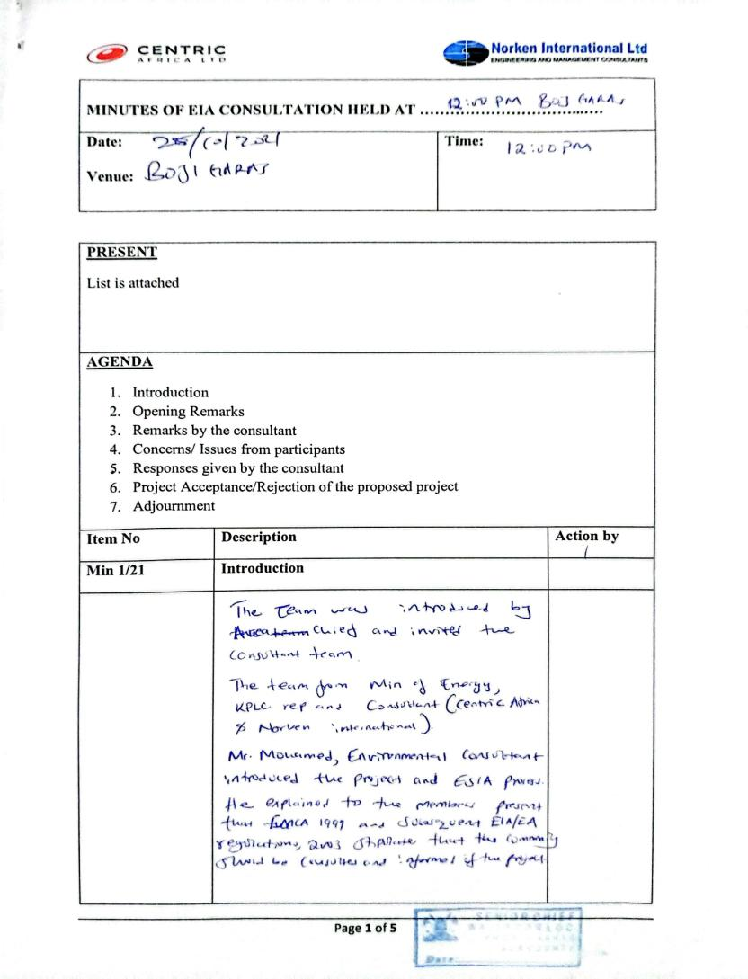
2. 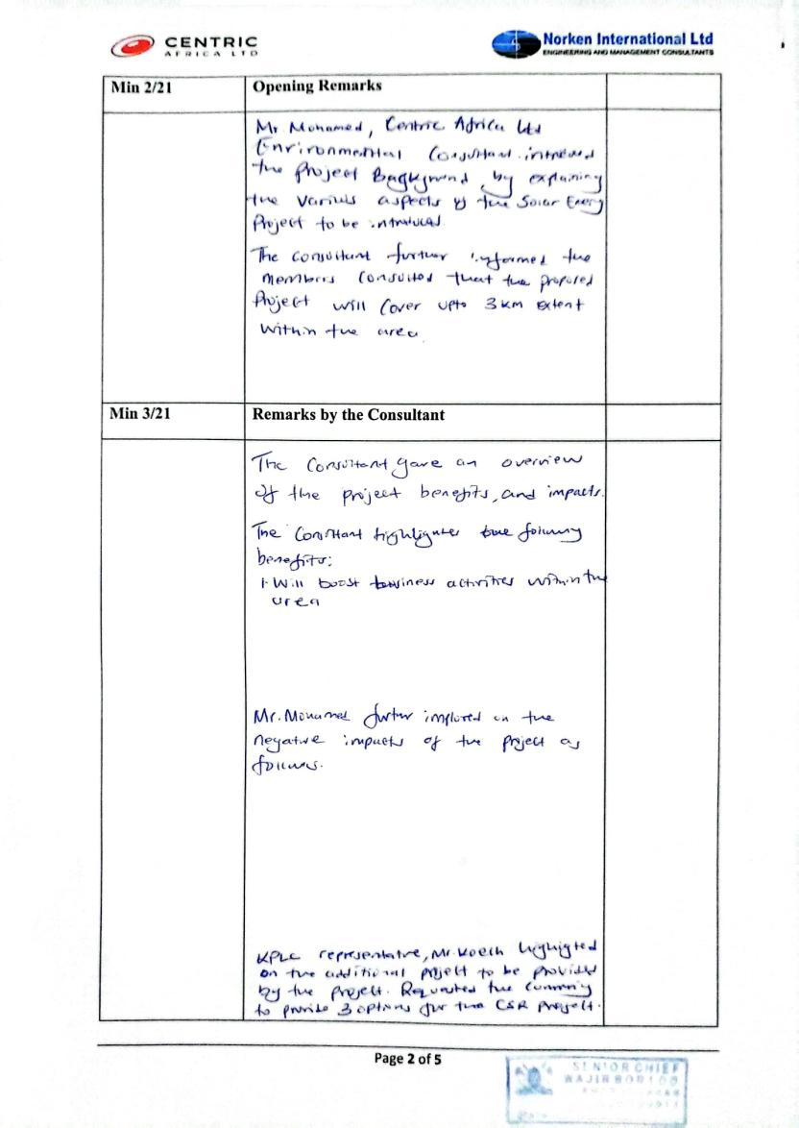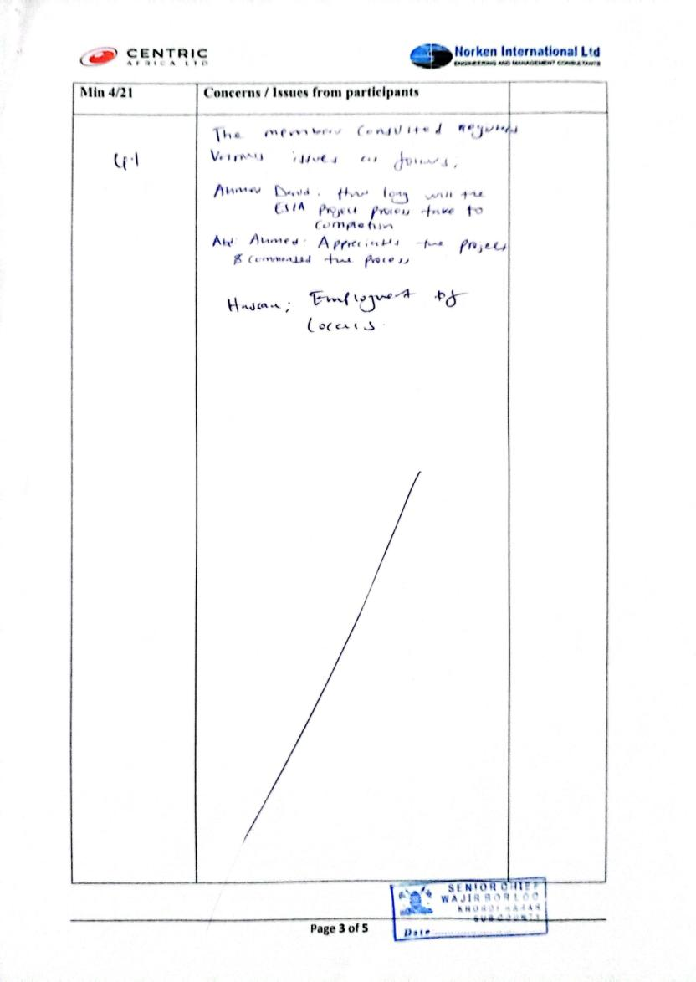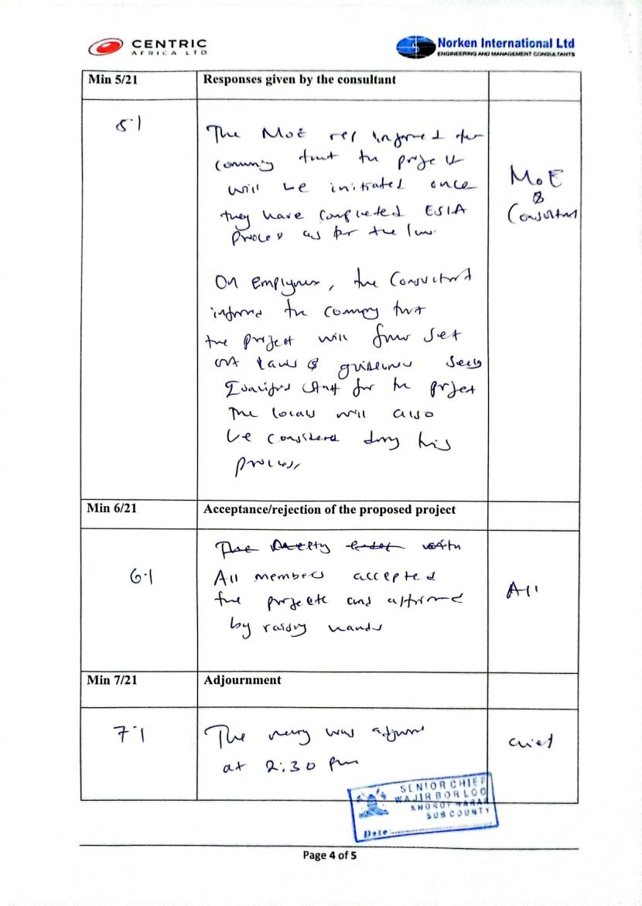

## List of Attendance - ESIA

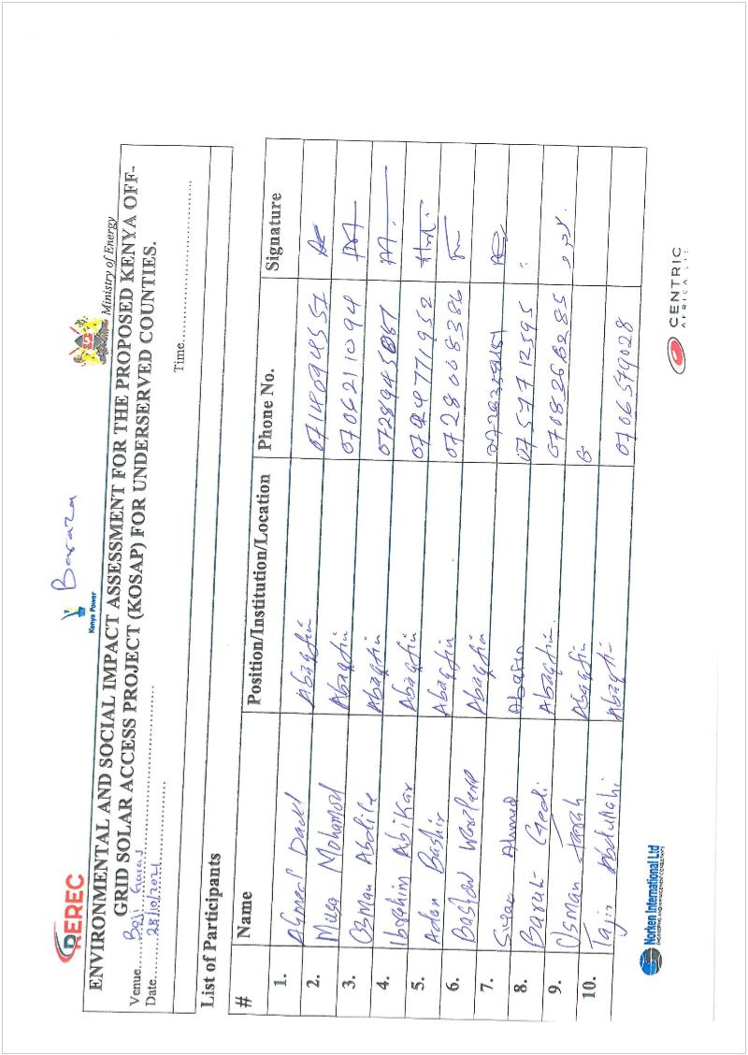

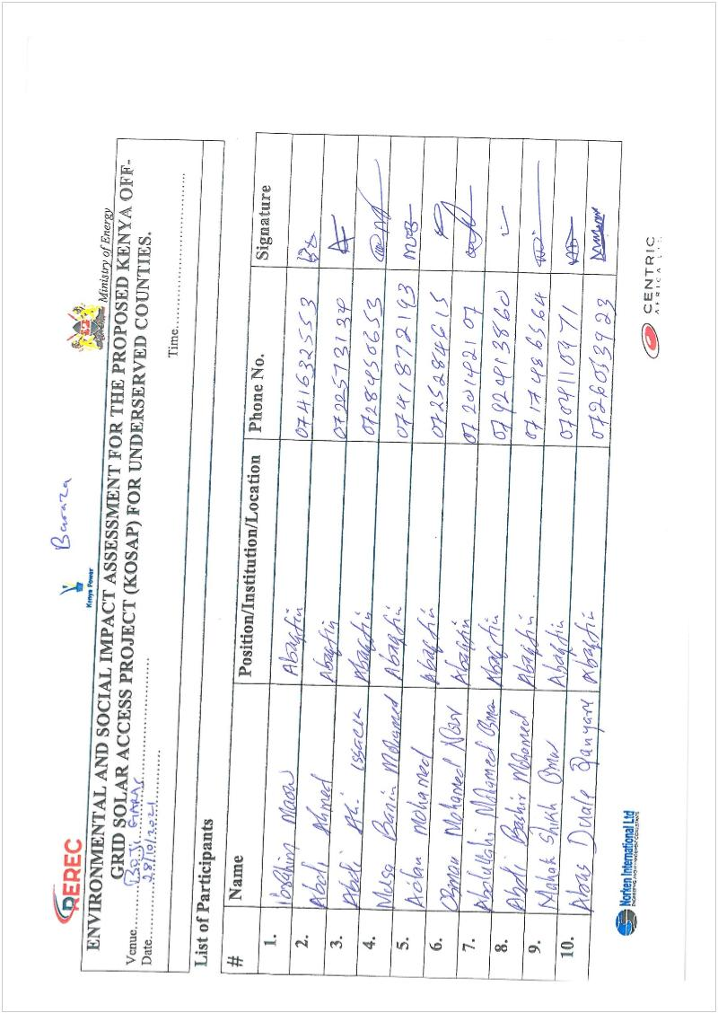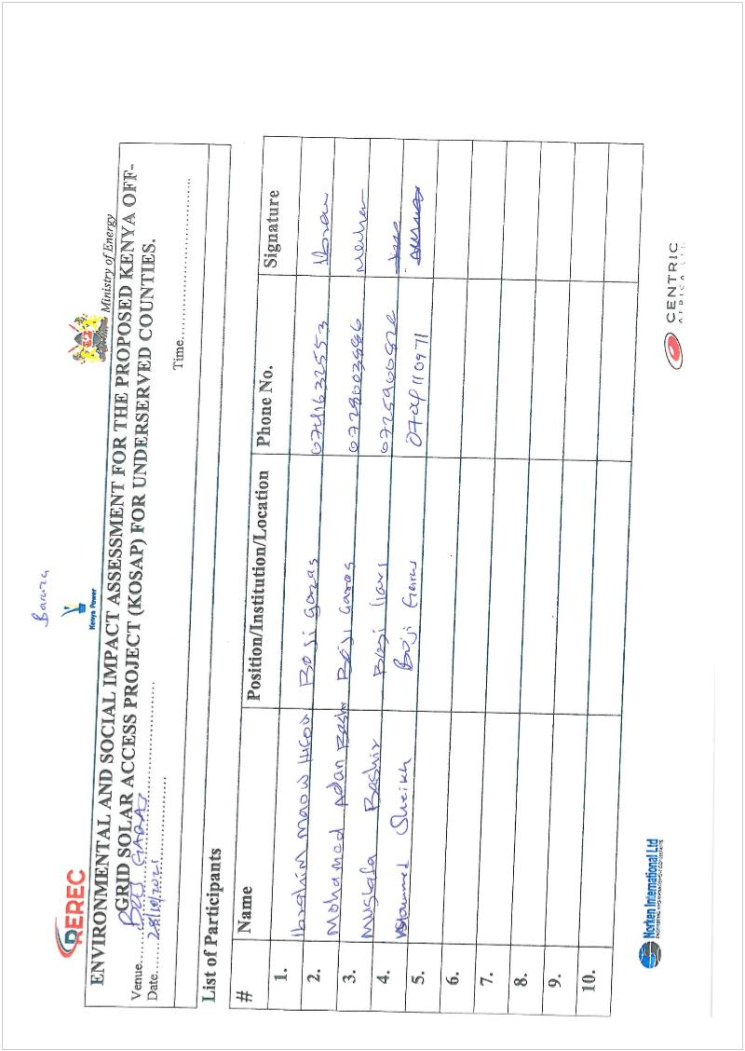

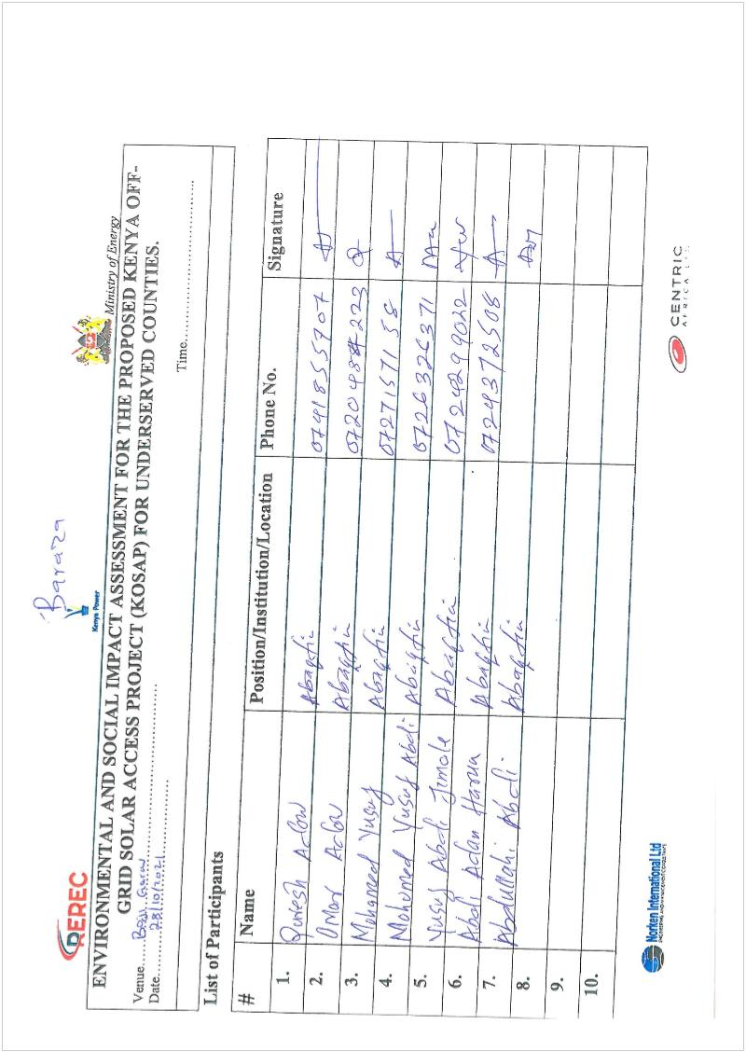

**Men FGD List**

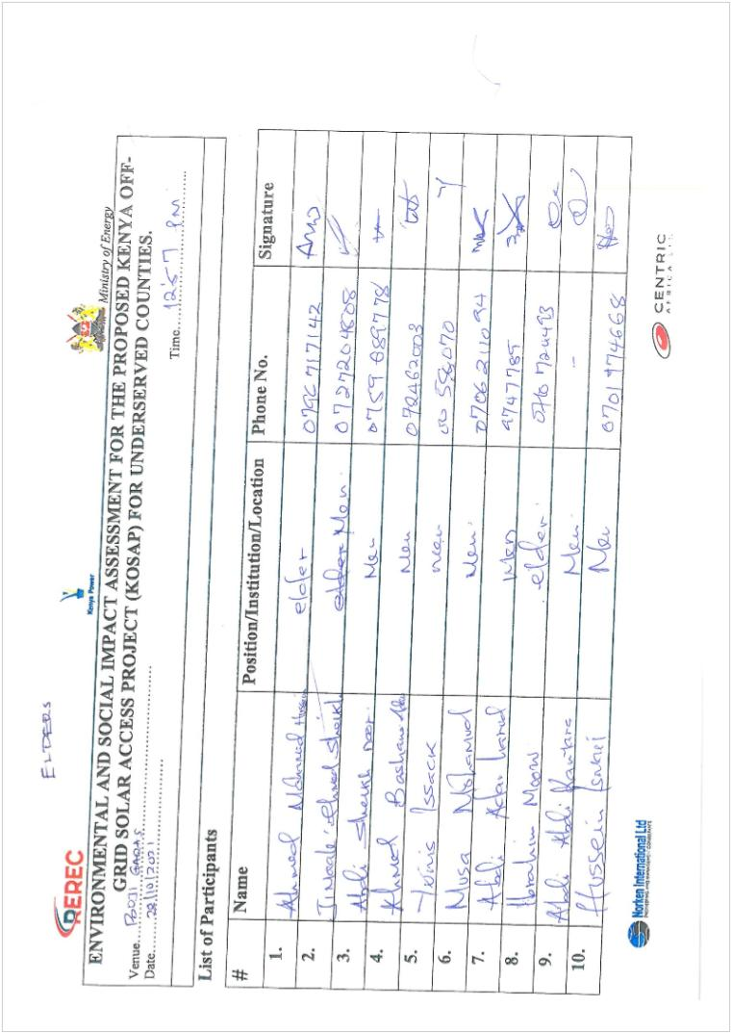

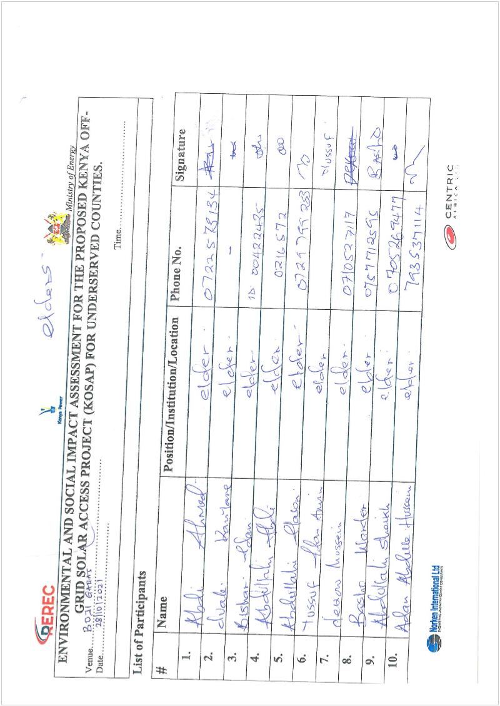

**Women FGD List**

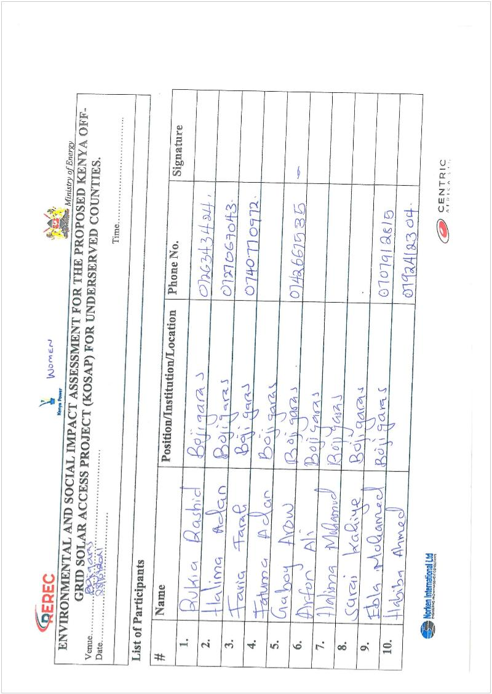

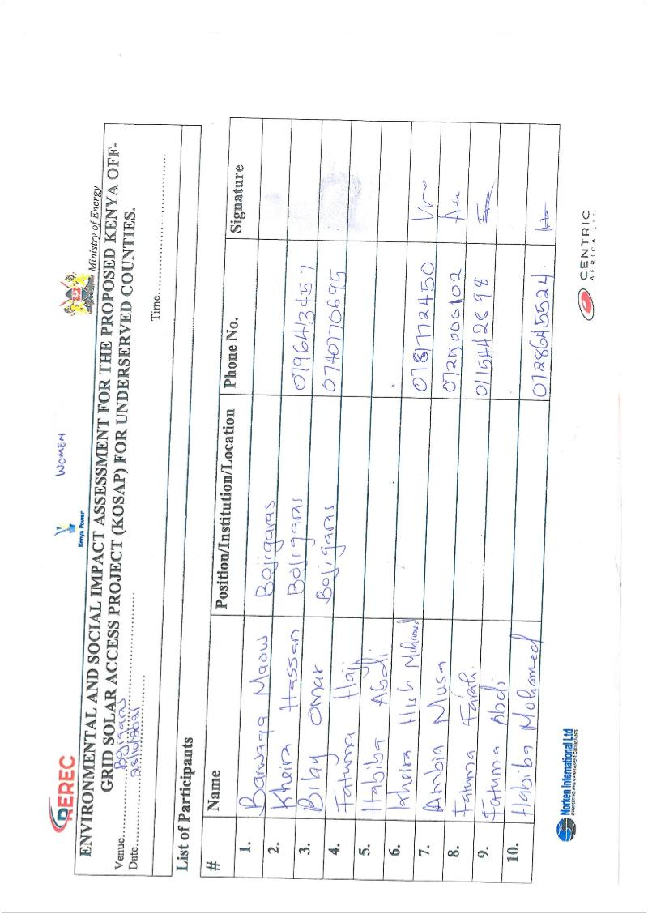

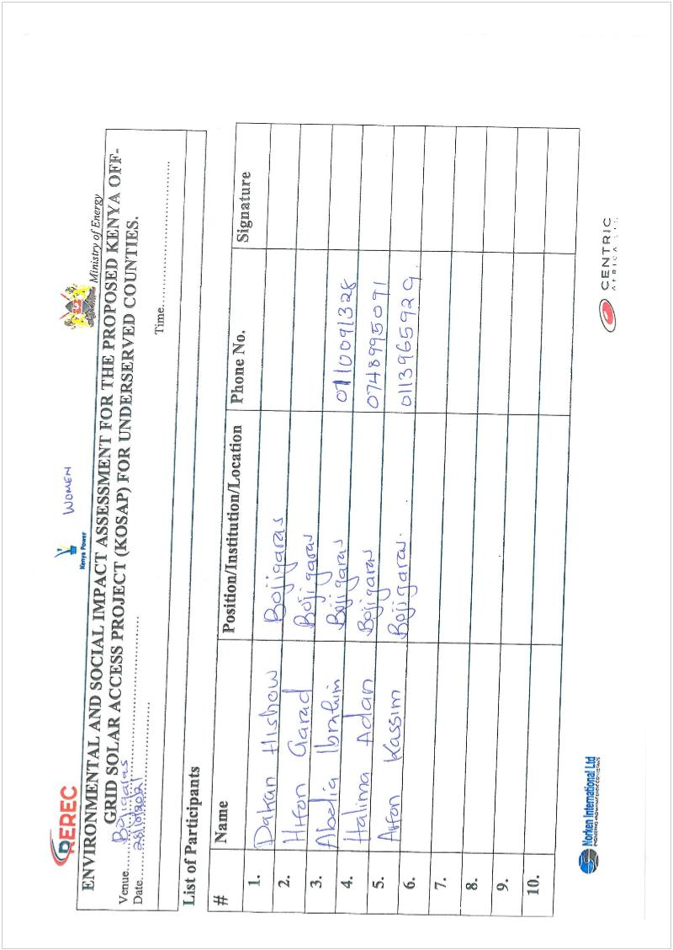

**Youth FGD List**

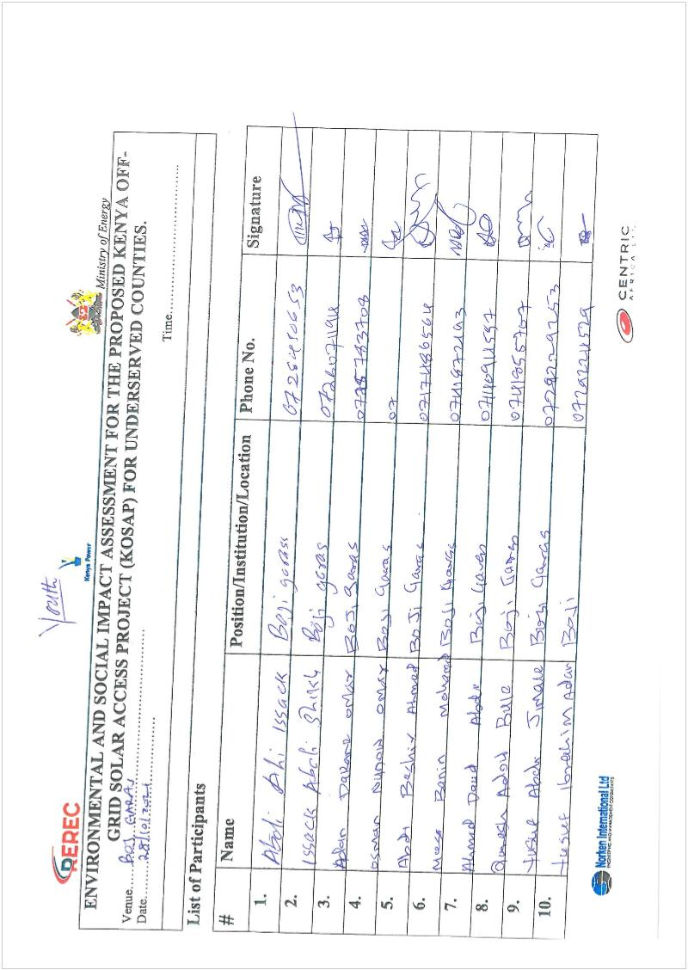

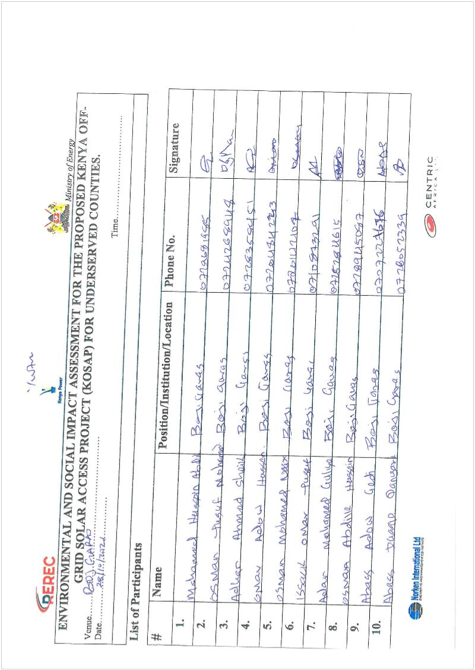

## Minutes of community consultative meeting leading to land acquisition

**Minutes of community consultative meeting leading to land acquisition**

|  |
| --- |
| **Project:** Proposed Solar Mini-grid at Bojigaras |
| **Venue** **of** **meeting**-Bojigaras town center |
| **Sub- county**-Wajir East |
| ***Date:3/6/2021*** |

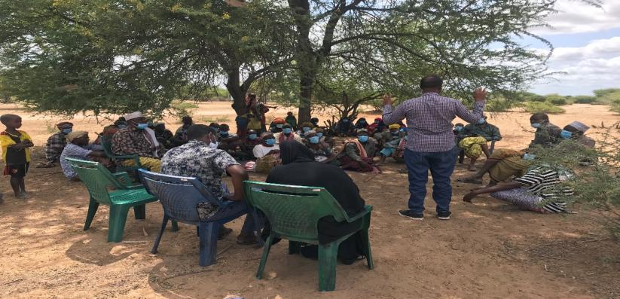

**Overview**

The purpose of the exercise was to inform the community of the objectives of the Project, the different components under Kosap, the need to acquire land, the acceptability of the project, Grievance Redress Mechanism for the project as well as the formation of the GRM committee.

The team visited Boji Garas on 4th June. They were received by the Chief and a Representative from the office of the Member of Parliament of Wajir East who had been notified by the CREO about the visit. Focus Groups were also successfully held and the GRM committee selected

**AGENDAS**

1. Preliminaries
2. Overview and description of the project
3. Positive and Negative Impacts of the project
4. Mitigations measures
5. Technical aspects of the project
6. Process of acquiring land
7. Grievance Redress Mechanism for the project
8. Plenary session
9. Focus Group discussions
10. Environmental and social screening of the site

**Minute 1: Preliminaries**

The area chief opened the meeting with a word of prayer, Appreciated and Welcomed the Kosap team as he assured the team of full support. He then handed over to the MP representative as he gave a brief introduction about the projects as wells as the benefits of the project to the community. He also urged the community to fully support and care for the project once it implemented fully.

The Team were welcomed Well by the elders and the community at Large. The MP representative then invited the Director Adan Salat to take over

The director Adan thanked the Community for coming out in Large Numbers, Salat introduced the project team as shown in the table below.

**KOSAP Project Team**

|  |  |  |
| --- | --- | --- |
| **S/No** | **Names** | **Position** |
| 1 | Adan Salat | Director Natural Resource |
| 2 | Wilfred Koech | Environmental and Social specialist-KPLC |
| 3 | Fahma Yusuf | County Renewable Energy Officer |
| 4 | Joselyne Masiga | Social expert-REREC |
| 5 | Rachel Kisangani | Planner-KPLC |
| 6 | John Kuria | Surveyor-KPLC |
| 7 | Bashir | Surveyor-County |
| 8 | Kennedy Gachau | Engineer-KPLC |

**Minute 2: Overview and Description of the project**

He then gave a brief history of the project, He explained that the Kenya Off-Grid Solar Access Project (KOSAP) is a flagship project of the Ministry of Energy, financed by the World Bank. The projects aim at providing electricity to parts of the country that are not served by the national grid.

The project is jointly implemented by the Ministry of Energy, the Kenya Power and Lighting Company (KPLC) and the Rural Electrification and Renewable Energy Corporation (REREC).

The project is critical in achieving the Governments of Kenya’s goal of ensuring that every part of the country has access to energy, and how the County as whole will benefit a lot from the project as the County will be having 30 Minigrid sites and Wajir East will be getting 4 Minigrids of which Boji Garas was among them. He explained that the agenda of the visit was; screening of the proposed generation site to confirm whether it meets the technical, environmental specification, the need to set up grievance redness committee, focus group discussions and the process of acquiring the land.

**Minute 3. Positive and Negative Impacts of the project**

Wajir County faces lots of power outages thus power still remains a need. The CREO asked the community to identify some of the reasons why they think electricity will be of help to them

The community Explained on how the area remains underdeveloped due to the lack of electricity. The area also faces insecurities especially during the Night,

Most of the health centers remain nonoperational and the patients have to be transported all the way to Wajir county to get further help. She covered some of the Negative aspects that can arise.

Benefits of the projects explained were as follows.

* Job opportunities. Through upcoming businesses as well as job creations at the power station and during the implementation of the project (construction phase) such as purchasing building materials like sand, gravel, stones and cement from the local community. Materials that will be available within the community for sale will be purchased by the contractor
* Improvements in terms of Education, Whereby the students can be able to read even during the night times, and also powering of their gadgets such as the laptops
* Better Health services such as powering of the health centers that are non-operational especially at night and storage of the drugs
* Solarization of the boreholes so the communities can have an easy access to water anytime of the day
* Powering of Homes and advanced communication, which involves discarding kerosene lamps and powering of gadgets such as telephones that enhance communication
* Enhanced Security through street lightening.

Negative impacts Explained are as follows

* Accidents during the construction phase
* Gender based Violence
* Pollution such as noise, air through emission of dust as well as solid waste*Construction phase*
* Deforestation through vegetation clearance
* Occurrences of minor crimes such as theft of building materials

Although there are some of the expected negative impacts of the project the project will ensure another meeting which will be held for Environmental and Social Impact Assessment for the proposed site which will be submitted to the National Environmental and Management Authority (NEMA) for review. NEMA officers will undertake site visits to inspect and confirm that an Environmental and Social Impact Assessment had been done on the project and assess the community engagement on the proposed project. Subsequent to this the Contractor would then commence the construction of the mini-grid

**MIN 4. Mitigation measures**

The CREO further explained the mitigation measures to be put to order so as to minimize further damage as stated below

* Deforest only the areas that are needed or clear up a small portion only for the to put up the mini-grid and the back-up generators.
* Once the construction ends the contactor ensure Reforestation and monitoring the process of regulations that are meant to protect biodiversity
* All solid wastes should be disposed appropriately
* All workers are encouraged to put on proper personal protective equipment like gloves, overalls, helmet, safety shoes
* Creating awareness through gender campaigns and rights advocating and in case any occurs it should be reported through the GRM committee as well as to the county offices through the CREO.
* Observation of the community guidelines and rules, this applies to the contractors.
* Noise should only be limited to the daytime hours and no work should be done at night
* Contractors should use materials and products that are Environmentally friendly
* Recruitment of local workforce to the extent possible especially unskilled and semi-skilled jobs

The community were also told to observe public safety measures as follows

* Always engage a certified technician during the wiring process
* Not touching Sockets and naked wires with wet hands
* Report any electricity accident to the station or to the Engineer head of the station
* There should not be any illegal connections
* Power cables and wires shouldn’t be used for other purposes such as hanging of clothes etc.,
* Wires/gadgets should be kept away from children and livestock.

**MIN 5. Technical Aspects of the project**

Kennedy Gachau explained that the technical aspects of the Mini grids will entail the installation of the solar PV panels, lithium batteries and diesel backup unit that will be running for support

Once the Minigrids are operational there shall be a connection fee of 1000 for every homestead under KPLC after which Every homestead shall pay their monthly bills depending on how power was consumed through the tariff employed which will be the same as other KPLC customers. The use of tokens will also be employed. Kennedy invited Rachael Kisangani to talk about the process of land allocation

**MIN 6: Process of Acquiring Land**

Rachael gave a brief explanation of the process of acquiring the land, The land donated shall have to be at the Centre to reach every corner of the town and also to minimize the losses, it should also be registered under public facility and should be free from disputes.

The community were also requested to allow advance possession of the land before the process of registration is complete and since the process of land allocation takes time the community were also requested to allow contractors to work on the ground as the process of acquiring land officially continues.

Rachiel also informed the community that, the surveyors will pick the GPS points of the agreed area by the elders so that the portion acquired for the solar Mini-grid be later physically demarcated as the generation unit.

**MIN 7:** **Grievance Redress Mechanism for the project**

The Director and the Representative from the MP once again covered on the benefits of a set aside Grievance readiness Mechanism committee which will be the channel to raise any grievances.

He then explained that GRM committee will help solve the grievances arising from the project. The committee shall comprise of representatives from the men, women, youths and a representative from persons with a disability.

He explained that GRM involves different stages,

1. Locational grievance redress committee (Elders, youth representatives, women groups representatives, special groups, etc.)
2. County Grievance Redress committee comprises of the county working group. The CGRC shall help solve complaints that have been forwarded and are unable to be resolved at the locational/project level
3. National Grievance Redress Committee (Ministry of energy and implantation partners, KOSAP implementation team.)

4.Court of law

The community was also told that the members of the Committee will be required to volunteer with no payments. The committee was elected comprising a representative of men, women, youth and special needs in the society.

**MIN 8. Plenary session**

The director then winded the meeting as the community were given time to comment or raise any questions before dispersing to different groups for the focus groups.

|  |  |  |
| --- | --- | --- |
| **Name** | **Question/Remarks** | **Feedback** |
| Abdirahman Issack | Will the ministry compensate for the piece of land donated? | The director explained that the community should donate the piece of land and there will be no compensations whatsoever |
| Habiba Maalim | Appreciates the team and assures the team of full support |  |

**MIN 9: Focus group Discussion**

The focus groups were led by;

|  |  |
| --- | --- |
| **Men** | Adan salat and Wilfred |
| **Youth** | Bashir and Joselyne Masiga |
| **Women** | Fahma Yussuf |

***Focus group for women***

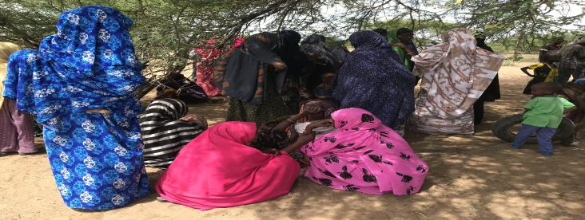

***(Image of the female focus group discussion)***

The women gathered up for the focus group as Fahma called the meeting to an order and thanked the women for turning up in good numbers. She explained why there was need to bring up focus groups for the different groups so as to have a one-on-one discussion as women and get explanation to what they didn’t understand and to freely express themselves.

She explained the objectives of the visit which was sensitization of the community on the project’s objectives, components, the need to acquire land for the Minigrids and the formation of GRM committee.

She further explained the meaning of a Minigrid and gave a brief summary of the project. She covered on the positive and negative impacts of the project and their mitigation measures, the safety precautions and the land acquisition process. She urged the women to be very careful with their children so as to avoid any electrical accidents such as keeping gadgets, switches and wires away from children. Once their phones are charged the switches should be turned off.

She also emphasized on the need for the women to have a representative to be part of the project’s GRM committee who would represent their views/issues.

Further the women were enlightened on how to make use of the economic opportunities that will arise during project implementation such as opening of business such as hotels.

The Creo also pepped up on the need to educate their girls and the importance of education. The women should ensure all their children get access to proper education to build on their futures.

They were also educated on Gender based violence issues such as the different forms of GBV, proper means for addressing any cases, ways in which a project can worsen existing GBV risks or create new risks.

They were encouraged to be more vigilant and take of young girls, educate them on the risks anticipated and report any complaints such as incidences of GBV).

They understood and promised to work with the project and make use of the opportunities

**Focus group for Men**

Adan Salat and Wilfred called the meeting to an order and thanked the men for turning up in good numbers informed the men of how important it was to hold the separate discussions and the importance of public participation so as it helps build consensus and enables people to make informed choices regarding projects.

They explained the agenda of the visit which was to; undertake an environmental and social screening of the proposed site to check suitability in terms of environmental, technical, social and health requirements. The second objective was to undertake community engagement to sensitize the community on the project. The third objective was on land acquisition and the need for a project grievance redress mechanism.

A summary of the project in terms of its positive and negative impacts and their mitigation measures was repeated and the men were encouraged to take up jobs during project implementation process.

He also explained the need for the men to select representatives to the project committee who would represent their views/issues to the committee for redress.

The elders said they welcome and support the project since it brings positiveness to the society. The discussion was then opened up for questions

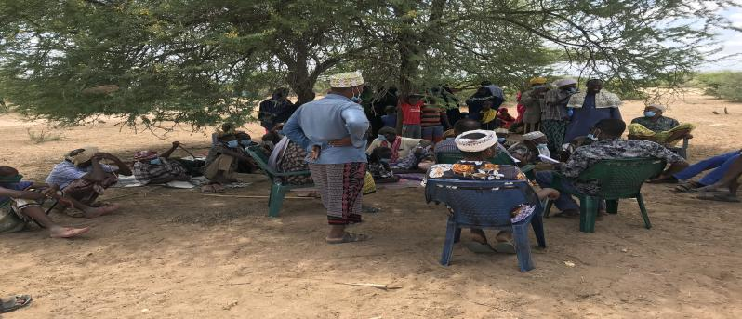

**(Image of the Men focus group discussion)**

**Focus group for Youth**

The group was led by Joselyne Masiga and Bashir Kheyr. They spoke on the purpose of the visit. They explained that the team’s Agendas as discussed earlier was to undertake community engagement so as inform the community on the importance of the project, The benefits it’s expected to bring to the community and the town at large as well as the need to donate land for the construction of the Minigrid. Once the land is donated the team will then do Environmental, technical, social screening to see the stability of the project once it commences. They further explained that positive and negative impacts of the projects and how the negative aspects can be mitigated.

The youths were also encouraged to take up upcoming tasks and make use of that opportunity well such as opening businesses such as welding places barber shops among others. They were informed that it was their right as Bojigaras members to work under that site therefore they shouldn’t hesitate.

Joselyne explained on the need for the youth to select a representative that will be part of the GRM committee.

Since the Youth were much educated, they understood the agendas and question and answer session was now opened.

|  |  |  |
| --- | --- | --- |
| **Name** | **Question** | **Answer** |
| Ahmed Mohamed | Will the committee be paid for any services conducted? | Joselyne Explained that there will be payments for the selected members and it will be on voluntary basis |

Mr. Bashir then concluded by thanking the youth for their attention and support

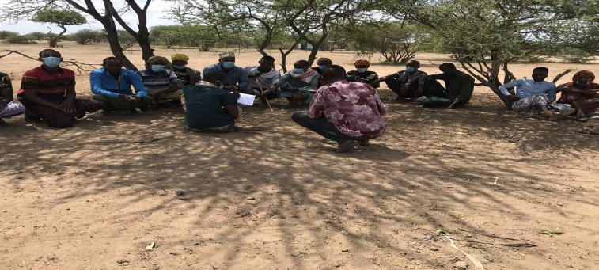

(**Image of the Youth focus group discussions)**

**MIN 10; Environmental and social screening of the sites**

The Team and the Elders after the meeting went ahead to view and evaluate the site set aside piece of land. The surveyors were tasked to pick GPS points of the area after agreements were reached which later will be demarcated, and the exact measurements be known to the community members. The area set aside was 0.834 Hectares which depended on the no of beneficiaries as well as the size of the town.

The meeting came to an end as the chief thanked the elders for the immense support and care. The team were then requested to make sure the project comes faster with no delay.

***Remarks***

|  |
| --- |
| The community willingly donated their land |
| They assured the team of their full support |
| GRM committee was also selected |
| Through the focus groups it came out well that every member of the community understood the purposes of the visit and bow to work with the project |

## List of Attendance – Land Identification

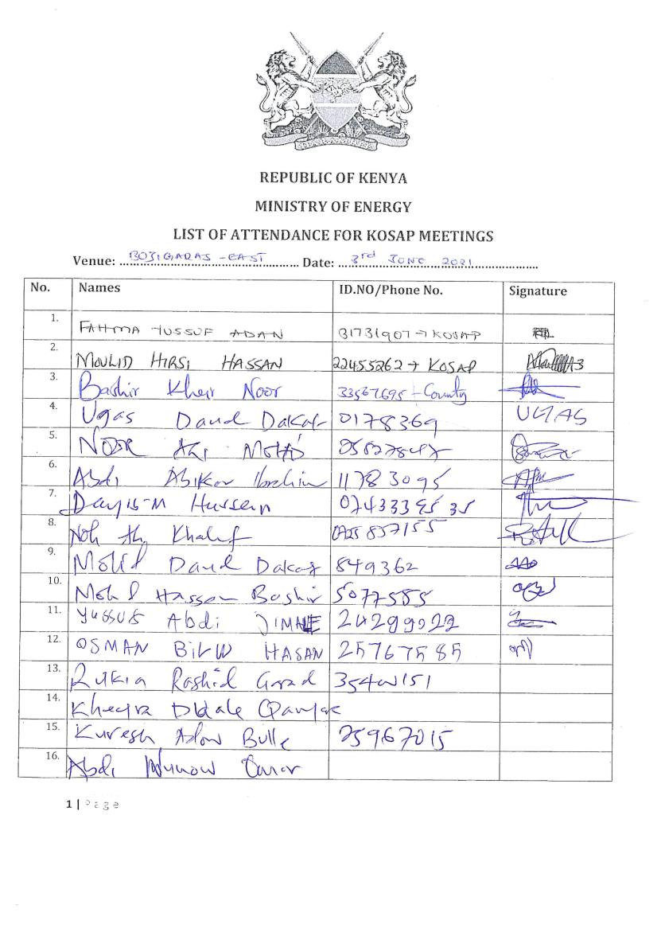

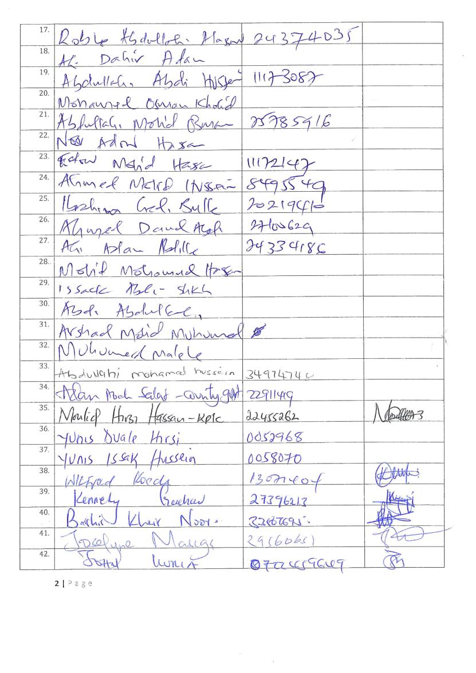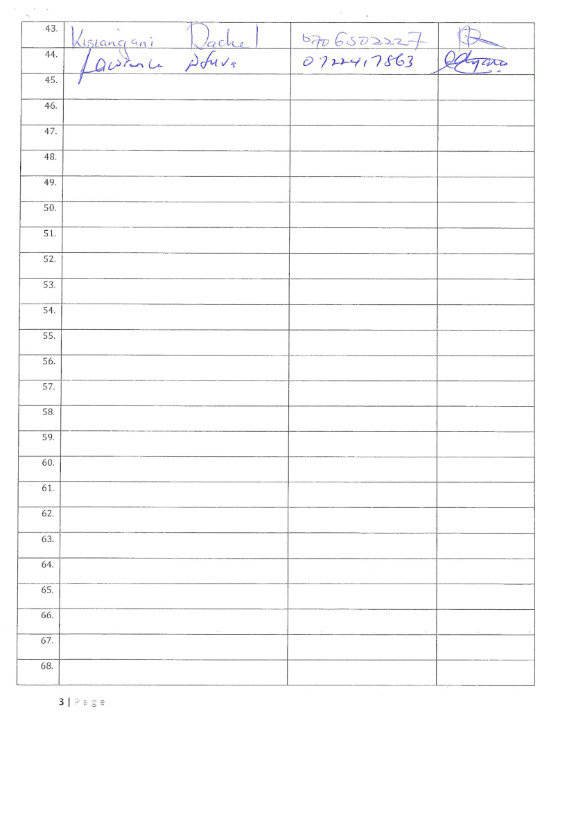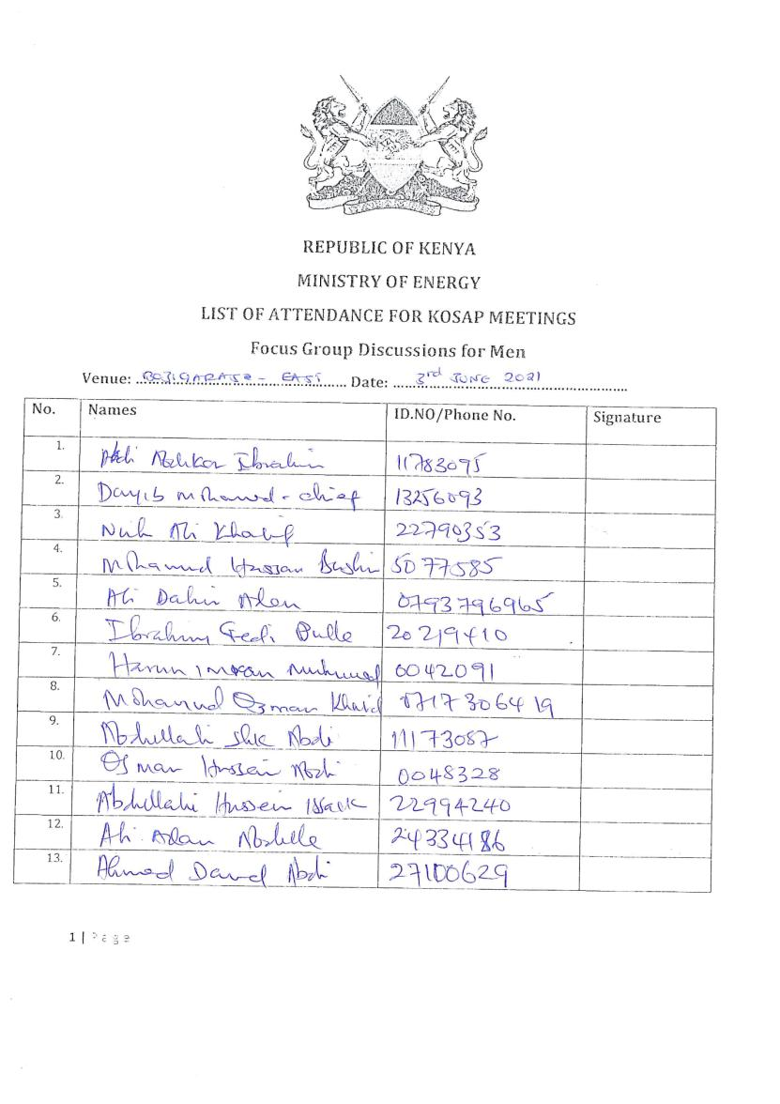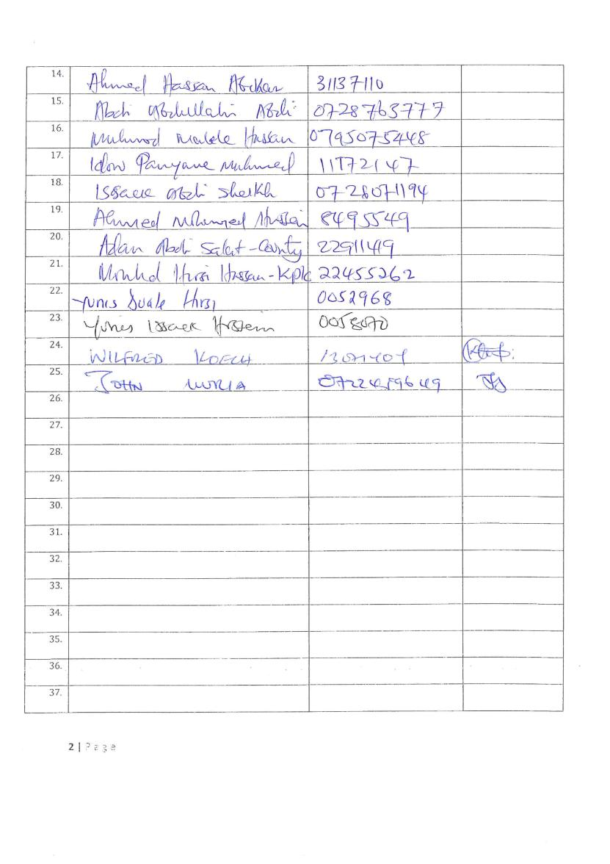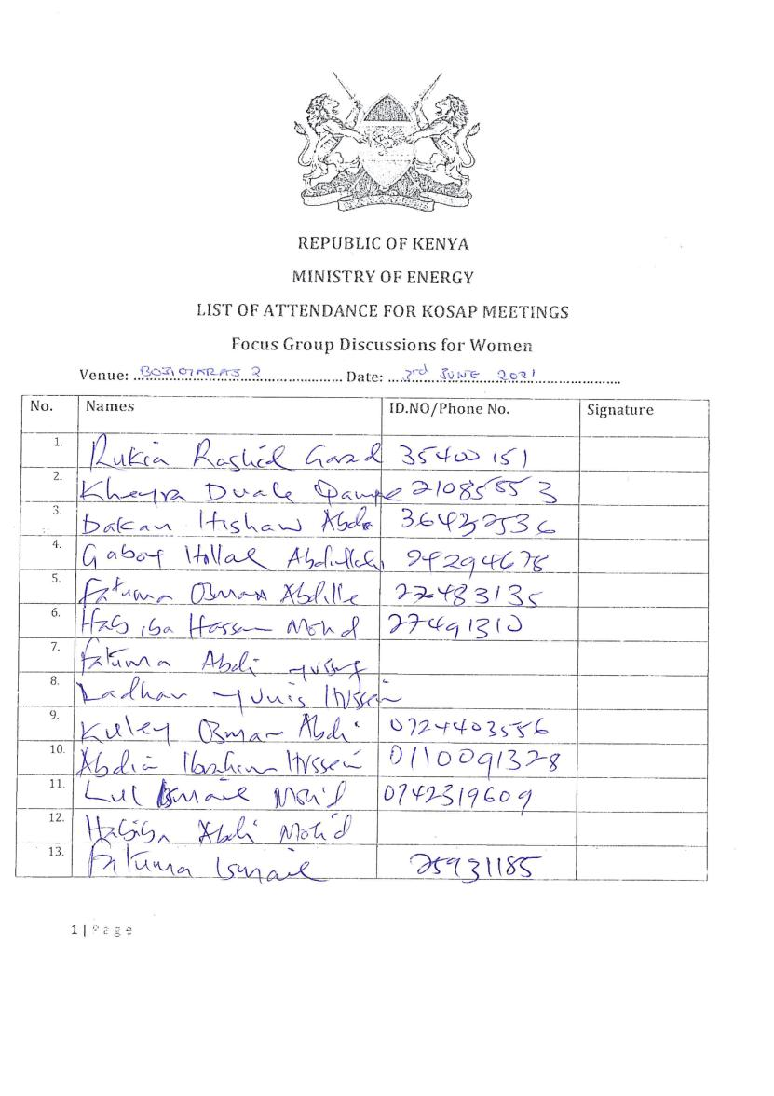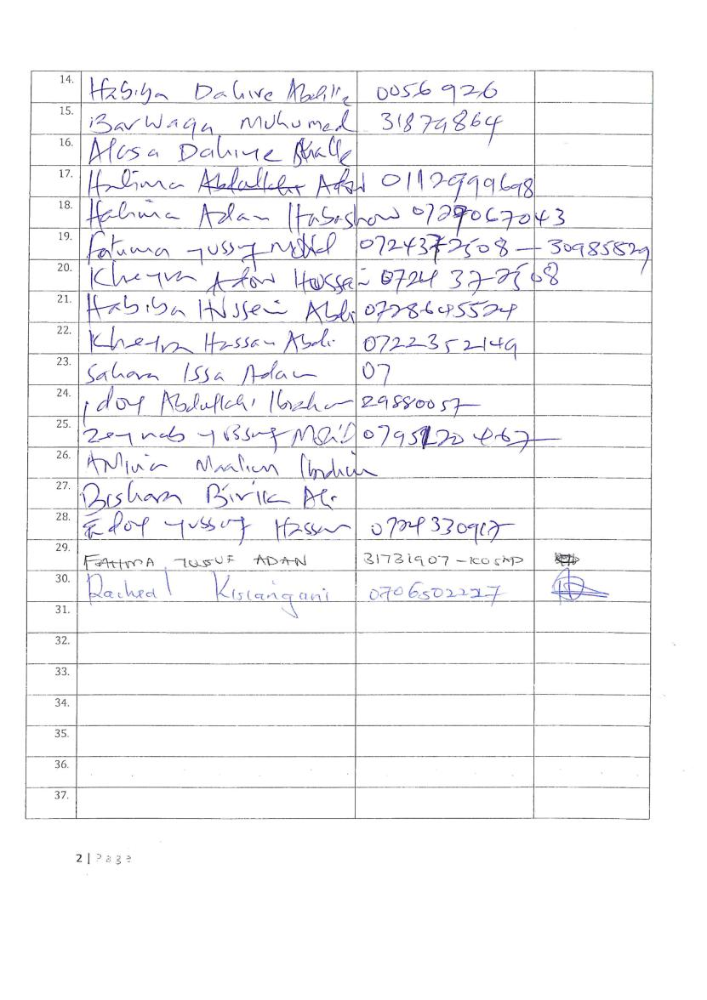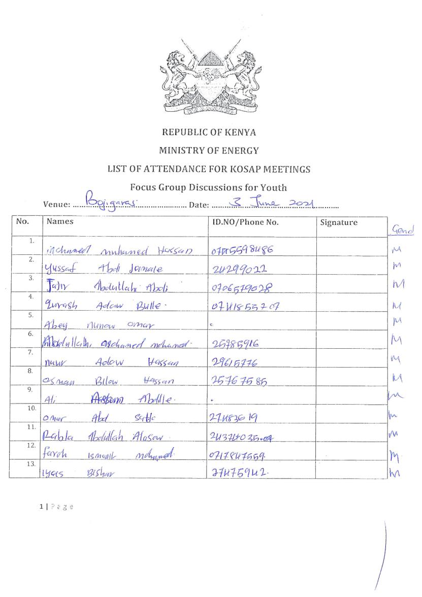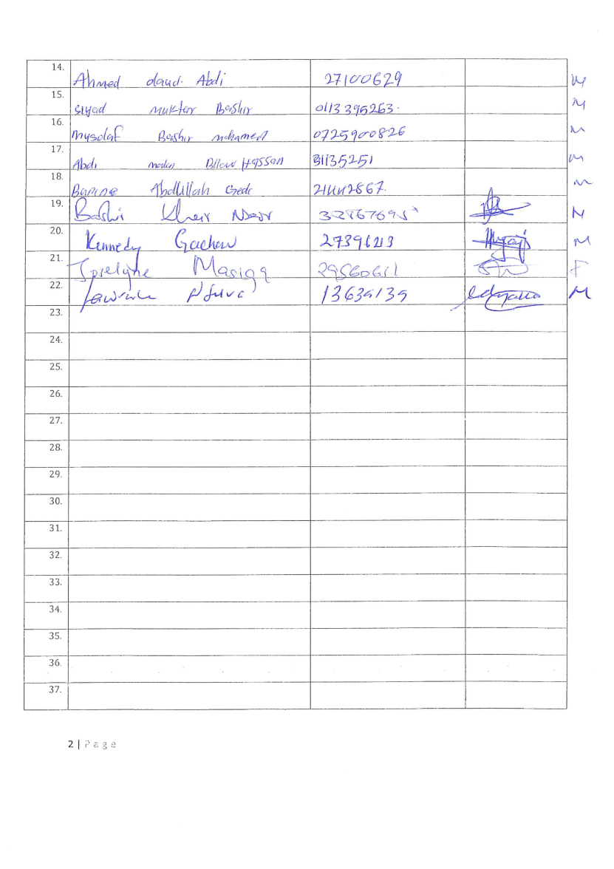

## Abbreviated Resettlement Action Plan (A-RAP)

1. **Boji Garas Sub-project Site**

The Boji Garas sub-project site is on unregistered community land and held in trust by the County Government of Wajir on behalf of the community, in line with the Community Land Act 2016. The proposed site is uninhabited, has no structures, community facilities, or encumbrances, and is part of the land owned by the Boji community for nomadic pastoralism. Consultations leading to the identification and selection of the sub-project site are captured in the Environmental and Social Screening report for Boji Garas. *Refer to Chapter 3 of the ESIA for the comprehensive socio-economic profile.*

1. **Actual Census Survey of PAPs and Valuation of Affected Assets**

The number of project-affected persons (PAPs) is 1917 (approximately 269 households). The land acquisition-related impacts are loss of land and pasture. Mitigation measures include in-kind compensation for loss of land and pasture, and designing power distribution lines to avoid impacting trees, crops, structures, and community facilities. No physical displacement is anticipated; however, there is minimal loss of pasture occasioned by the acquisition of land utilized by the community for grazing. The 0.834 Hectares identified for the sub-project will be acquired compulsorily by the National Land Commission (NLC). The proposed site will be valued and compensated in line with the provisions of the Resettlement Policy Framework (RPF) prepared under KOSAP. *Refer to section 2.2 of the ESIA for the sketch map of the site.*

1. Compensation Measures Agreed with the PAPs and other Resettlement Assistance to be Provided

The proponent requested the community identify three priority projects, whereby one out of the three would be provided as in-kind compensation for loss of land and pasture. The Boji Garas community proposed assistance with construction of an underground water tank, supply equipment & medicine at the health center and improve security in the area. The value of the priority community project will be proportional to or higher than the value of land under acquisition. In addition, loss or damage to crops, trees, structures, and community facilities will be compensated in line with the provisions of the RPF, and as summarized in the entitlement matrix below.

**3.1 Entitlement Matrix**

|  |  |  |  |
| --- | --- | --- | --- |
| **Types of Impact** | **Person(s) Affected/Eligible for Compensation** | **Compensation/Entitlement/Benefits** | **Responsible organization** |
| 1. **Loss of Land** |  |  |  |
| Loss of unregistered community land. | Community. | Compensation in-kind as prioritized by the community. | KPLC |
| Loss of land in unregistered group ranches. | Group ranch members. | Compensation in-kind as prioritized by the community. |
| Loss of land in registered group ranches. | Group ranch members. | Compensation in-kind as prioritized by the community. |
| Loss of land owned by the National Police, county governments and the Ministry of Interior | Government agencies. | No compensation for public land allocated to another government body. |
| Loss of land owned by the Kenya Forest Service (KFS) and Kenya Wildlife Service (KWS). | Government agencies. | No compensation for public land allocated to another government body. However, payment of conservation fees to KWS and KFS as stipulated under their respective regulations is foreseen. |
| 1. **Loss of Use on Land** |  |  |  |
| Loss of use on public land (e.g., grazing, farming etc.). | Communities utilizing public land. | Communities do not own public land; however, they utilize public land with consent from the relevant agencies. The project will implement the infrastructure project prioritized by the community as compensation for the loss of public land use. | KPLC |
| Loss of use on unregistered community land, unregistered group ranches and registered group ranches ( e.g., grazing, farming etc.). | Communities utilizing unregistered community land, unregistered group ranches, and registered group ranches. | Compensation in-kind as prioritized by the community. |
| 1. **Loss of /Damage to Assets on Land** |  |  |  |
| Trees | Community members on unregistered community land; community members utilizing public land; members of registered and unregistered group ranches and government entities. | During detailed design for power distribution lines and construction of the mini grid and community project, any crops, structures, trees, and community facilities shall be avoided to the extent possible. However, loss or damage to the above will be compensated/restored at full replacement cost,[2] in line with the provisions of the RPF. | KPLC |
| Crops |
| Structures |
| Community facilities e.g., water sources (earth pans, boreholes etc.). | Community members on unregistered community land, community members utilizing public land, and members of registered and unregistered group ranches. |

4. Consultations with PAPs About Acceptable Compensation Options and Alternatives that have been Considered

Detailed consultations with PAPs on land acquisition and compensation, including the modalities of acquiring land and compensation options, were undertaken during the Environmental and Social Screening, Environmental and Social Impact Assessment, and the NLC land valuation process. The following sections provide a summary of the consultations.

**4.1 Engagement of Project -Affected Persons (PAPs)**

Local administration and County Renewable Energy Officers (CREOs) supported the proponent and implementing agency (IA) to mobilize community members and other stakeholders for public consultations and engagement activities. National and county government entities, community segments (men, women, youth, elders, persons with disability, vulnerable and marginalized groups, etc.), NGOs, and local leaders were engaged through key informant interviews, community meetings, and focus-group discussions. The proponent and IA implemented appropriate measures to ensure PAPs effectively participated in the consultations. *Refer to Chapter 6 of the ESIA on public consultation and engagement.*

Once the compensation award and Bill of Quantities (BoQs) are known, the Implementing Agency (IA) will engage the community and agree on the community project to be executed as in-kind compensation. During these consultations, the IA and the community will define the roles and responsibilities of the community in monitoring the implementation of in-kind compensation and maintenance once the IA hands it over to the community. Thus, the IA and the community will effect an agreement to be signed by the local leadership; representatives of the Grievance Redress Committees at the locational, county, and national levels; A-RAP Implementation Committee, and Implementing Agencies.

**4.2 Identification of Community Representatives**

The Boji Garas Locational Grievance Redress Committee (LGRC), constituting a chairperson, secretary, and three members, was formed through community consensus. The committee’s membership comprises men, women, youth, persons with disabilities, and ethnic minorities. The LGRC is responsible for engaging PAPs and resolving complaints. Refer to Chapter 6 of the ESIA on the Grievance Redress Committees. Further, the community will constitute the A-RAP Implementation Committee responsible for coordinating community engagements on the A-RAP and monitoring the implementation and closure of the A-RAP. The representation of the committee will consider gender, vulnerability, and intergenerational sensitivities.

**4.3 Summary of Consultations on Land Acquisition and Compensation Options**

|  |  |  |  |  |  |
| --- | --- | --- | --- | --- | --- |
| **Date** | **Objective** | **Implementing**  **Entities** | **Land Acquisition and Compensation Aspects**  **Discussed** | **Key Issues Raised** | **Responses**  **Given** |
| June 3rd 2021 | Environmental and Social Screening.  Voluntary land donation (VLD).  Constitution of the Locational Grievance Redress Committee (GRC). | Ministry of Energy (MoE)  Kenya Power (KPLC)  Rural Electrification and Renewable Energy Corporation (REREC) | Site identification and land allocation for the sub-project.  Criteria for VLD.  Community entitlements (forms of compensation and implications for each). | Will the ministry compensate for the piece of land donated? | The community should donate the piece of land and there will be no compensations whatsoever |
| October 28th 2021 | Environmental and Social Impact Assessment. | Consultants  MoE  KPLC  REREC | Land acquisition through compulsory acquisition (not voluntary land donation).  Selection of three priority community projects, whereby one is to be implemented as in-kind compensation for land. | The Boji Garas community proposed assistance with construction of an underground water tank, supply equipment & medicine at the health center and improve security in the area. | The proponent has set aside KES 1 million to implement the priority in-kind compensation project.  The value of the project will be proportional to or greater than the value of land.  NLC will determine the value of land. |
| May 2023 | Compulsory Land Acquisition. | NLC | Site inspection and inquiries.  Land valuation.  Award of compensation. |  |  |

5. Institutional Responsibility for Implementation of the ARAP

|  |  |
| --- | --- |
| **Entity** | **Role** |
| Ministry of Energy | * Coordinate A-RAP implementation and provide budget for in-kind compensation. |
| National Land Commission | * Implement the statutory process for compulsorily land acquisition, including site gazettement and inspections, inquiries, valuation, and award of compensation. |
| Kenya Power | * Monitor all land acquisition and compensation aspects (including A-RAP closure), complemented by a third-party monitor. * Provide budgets for stakeholder engagement, grievance management, and monitoring, including the facilitation of the Land Acquisition and Compensation Implementation Committee, and the Grievance Redress Committee. |
| Mini-grid Contractor | * Implement in-kind compensation concurrently with the solar mini-grid project. |
| Supervising Consultant | * Monitor and report on implementation of in-kind compensation, and overall project compliance with social safeguards. |
| Grievance Redress Committees | * Formed at the locational, county, and national levels, and responsible for resolving complaints, including A-RAP related grievances. |
| A-RAP Implementation Committee | * Coordinate A-RAP engagements at the community level, monitoring A-RAP implementation and closure. |
| Affected Community | * Responsible for the operation and maintenance (O&M) of in-kind compensation project. An agreement stipulating the O&M roles and responsibilities of the community will be effected. |

6. Procedures for Grievance Redress

The Project procedures for grievance redress were established through a public consultation process and informed by the existing conflict resolution structures in the community. The Grievance Redress Mechanism (GRM) comprises tiers at the project, county, and national levels. *Refer to Chapter 7 of the ESIA for a detailed GRM.*

7. Implementation Timetable and Budget for the ARAP Implementation

**7.1 Timelines**

The proponent will commission the community project by May 25th, 2025, before operationalizing the mini-grid. The mini-grid contractor will implement the mini-grid and the community project simultaneously. The Supervision Consultant and IAs will implement a commitment register to ensure the mini-grid contractor can achieve the agreed-upon milestones. The register will be complete with clear and practical timebound indicators, which can be monitored by all parties – the PAPs, IAs, the Ministry, third-party monitor, and the Bank.

**7.2 Budget**

The proponent has set aside KES 1 million for the community project (budget captured in the ESMP). The compensation award from NLC and the Bill of Quantities will inform the final cost of the community project. The costs for in-kind compensation, stakeholder engagement, grievance management (including the facilitation of the GRCs and the A-RAP Implementation Committee), and monitoring are covered under the project.

## Firm and Lead Expert’s EIA Practicing License

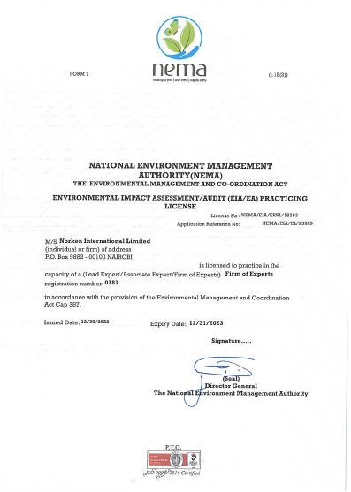

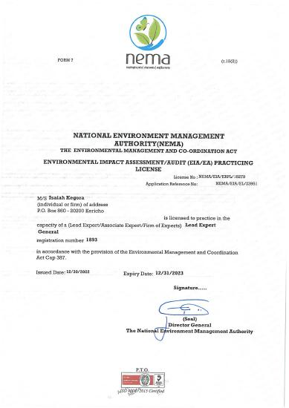

1. () As per the Energy Act of 2019, this role will now be performed by the Energy and Petroleum Regulatory Authority (EPRA).
2. A cost basis that will yield compensation sufficient to replace assets, plus necessary transaction costs associated with asset replacement).