|  |  |  |  |  |  |  |  |
| --- | --- | --- | --- | --- | --- | --- | --- |
| Coat of Arms (True colour) | | **MINISTRY OF ENERGY**  **Nairobi**  Republic of Kenya | | | | | |
| The World Bank Logo | evolution history and meaning, PNG | **Investment Project Financing Kenya: Off-grid Solar Access Project for Underserved Counties (P160009)** | | | | | | |
| logo6 | | | | | | | |
|  | | | | | | | |
|  | **KENYA OFF-GRID SOLAR ACCESS PROJECT (KOSAP) FOR UNDERSERVED COUNTIES** | | | | | | |
|  | **Component 1: Mini-grids for Community Facilities, Enterprises, and Households** | | | | | | |
|  |  | | | | | | |
|  | **ESIA REPORT FOR THE PROPOSED MADAGHISI OFF-GRID SOLAR PROJECT** | | | | | | |
|  | **2023** | | | | | |  |
|  |  | | | | | |  |
|  |  | |  |  | |  | | |
| image002 | |  | | |  | | | |

# CERTIFICATION

This ESIA project report for the proposed Madaghisi Off-Grid Solar Projectwas prepared in accordance with the Environmental Management and Coordination Act (EMCA), 1999 and the Environmental (Impact Assessment and Audit) regulations, 2003 and their subsequent amendments EMCA (amendments), 2015 and EIA/EA regulations (amendments), 2019, the World Bank operational procedures (OP) and Environmental Safeguards Standards (ESS) for submission to the National Environment Management Authority (NEMA). We hereby certify that to the best of our knowledge and belief, the information and particulars provided in this report are correct and true.

|  |  |
| --- | --- |
|  |  |
| P. O. Box 9882 - 00100  Nairobi, Kenya  Tel. 254 020 2248762  Registration No. of Firm of Experts: 0181 | P.O. Box 102081-00101  Nairobi, Kenya  Tel. +254718068517  Registration No. of Firm of Experts: 7112 |

**Name and Address of Firm of Experts:**

**Name and Address of Firm of Experts:**

Signed: ____________________________ Date: _____________________

Isaiah B. Kegora

Lead EIA/EA Expert (NEMA Reg. No 1893)

For: Norken International Ltd & Centric Africa Ltd

**Name and Address of the Proponent:**

Ministry of Energy,

P.O. Box 30582-00100,

Kawi Complex, Nairobi, Kenya

Signed: ____________________________ Date: _____________________

Rodney I. Sultani

Project Co-ordinator – KOSAP

*Disclaimer:*

*This ESIA report is strictly confidential to MoE (the Proponent) and any use of the materials thereof should strictly be in accordance with the agreement between the Proponent and the consultants; Norken International Limited and Centric Africa Limited (the Environmental Impact Assessor). It is, however, subject to conditions in the Environmental (Impact Assessment and Audit) Regulations, 2003 under the Kenya Gazette Supplement No. 56 of 13th June 2003.*

CONTENTS

CERTIFICATION i

LIST OF TABLES viii

LIST OF PLATES ix

LIST OF FIGURES x

EXECUTIVE SUMMARY xiii

1 INTRODUCTION 1

1.1 Context 1

1.2 Project Overview 2

1.3 Purpose and Scope of Work 3

1.4 ESIA Methodology 3

1.4.1 Screening and Scoping 3

1.4.2 Environmental Impact Assessment 3

1.4.3 Environmental and Social Management and Monitoring Plan (ESMMP) 5

1.4.4 Target Group for the ESIA Report 7

1.4.5 Screeening and ESIA Study Team 7

1.5 Limitations/Uncertainties 8

1.6 Layout of the Report 9

2 PROJECT DESCRIPTION 10

2.1 Introduction 10

2.2 Project Location 11

2.3 Description of Project Facilities, Components and Activities 13

2.3.1 Project Components 13

2.4 Resource Requirement 16

2.4.1 Workforce Requirement 16

2.4.2 Water Requirement and Source 17

2.4.3 Raw Material Requirement 17

2.4.4 Power Requirement 17

2.4.5 Fire Safety and Security 17

3 Analysis of Alternatives and Project Justification 19

3.1 Land identification criteria 19

3.2 Power Scenario in Madaghisi 19

3.3 Alternative Sources of Energy 19

3.4 Zero or No Project Alternative 20

3.5 Alternate Location for Project Site 20

3.6 Analysis of Alternative Construction Materials and Technology 22

3.7 Solid waste Management Alternatives 22

3.8 Conclusion 23

4 APPLICABLE AND REGULATORY FRAMEWORK 24

4.1 Introduction 24

4.2 Kenya Electricity Supply Industry (ESI) 24

4.3 National Legal Framework rEVIEW 25

4.3.1 Administrative Framework 44

4.4 International Safeguards requirements 4-46

4.5 Licenses and Permits Required 4-47

5 BASELINE SETTINGS - ENVIRONMENT, ECOLOGY AND SOCIAL 50

5.1 Area of Influence 50

5.1.1 Project Footprint Area 51

5.1.2 Study Area 51

5.2 Environment Baseline 51

5.2.1 Land Use 51

5.2.2 Topography 53

5.2.3 Hydrogeology and Drainage 53

5.2.4 Ecology 53

5.2.5 Water Resources 55

5.2.6 Soil Type 56

5.2.7 Climate and Meteorology 57

5.3 Socio-economic Environment 57

5.3.1 Socio-economic status of Study Area 57

6 STAKEHOLDER ENGAGEMENT 61

6.1 Stakeholder Consultation and Disclosure Requirement for the Project 61

6.2 Stakeholder Characterisation and Identification 61

6.2.1 Stakeholder Mapping 61

6.3 Stakeholder Analysis 62

6.4 KEY FEEDBACK RECEIVED DURING COMMUNITY CONSULTATIVE MEETING LEADINS TO LANd IDENTIFICATION AND GRC CONSTITUTION – SCREENING LEVEL 63

6.4.1 Positive Impacts/Benefits of the Project 64

6.4.2 Negative impacts of the project 65

6.4.3 Land requirements for the project 66

6.4.4 Grievance Redress Mechanism 67

6.4.5 Plenary session 67

6.4.6 FOCUS GROUP DISCUSSION 68

6.5 KEY FEEDBACK RECEIVED DURING esia STAKEHOLDER CONSULTATION PROCESS 72

6.6 summary FEEDBACK RECEIVED DURING focused group discussion 74

7 IMPACT ASSESSMENT AND MITIGATION MEASURES 77

7.1 Introduction 77

7.2 Impact Assessment Methodology 77

7.3 Defining Impact 77

7.4 ASSESSMENT OF SIGNIFICANCE 77

7.5 Magnitude of Impact 80

7.6 Sensitivity of Resources and Receptors 80

7.7 Likelihood 81

7.8 Definition of mitigation measures 81

7.9 Assessing residual impacts 82

7.10 Positive Impacts During Construction Phase 82

7.10.1 Creation of Employment Opportunities 82

7.10.2 Improving local economy 83

7.11 Positive Impacts during Operation Phase 83

7.11.1 Quality, Reliable Power Supply 83

7.11.2 Employment Creation 84

7.11.3 Reduction of Pollution Associated with Thermal Power Generation, Kerosene and Wood Fuel Usage: 84

7.11.4 Improvement of Local and National Economy 84

7.11.5 Education 85

7.11.6 Health Benefits of the Project 85

7.11.7 Improved Standard of Living 85

7.11.8 Security 85

7.11.9 Communications 86

7.12 Positive Impacts during Decommissioning Phase 86

7.12.1 Employment Opportunities 86

7.12.2 Site Rehabilitation 86

7.13 Negative Impacts during Pre-construction Phase 86

7.13.1 Land Take 86

7.14 Key Environmental Impacts – Construction phase 87

7.14.1 Vegetation Clearance 87

7.14.2 Soil Erosion Impact 88

7.14.3 Pollution from Solid Waste Generation 88

7.14.4 Noise and vibration 89

7.14.5 Impacts from Hazardous Materials 90

7.14.6 Fire Hazards 91

7.14.7 Impacts of construction material sourcing (e.g., quarrying) 91

7.14.8 Increased Water Demand 91

7.14.9 Energy Consumption 92

7.14.10 Occupational Health and Safety Impacts 92

7.14.11 Impact on Topography 93

7.14.12 Impact on Soil Environment 94

7.14.13 Impact on Air Quality 95

7.14.14 Impact on Ambient Noise 96

7.14.15 Assessment Criteria for Impact on Ambient Noise 96

7.14.16 Visual Intrusions and Changes in Landscape Impact 97

7.15 Key Social Impacts – Construction Phase 99

7.15.1 Land Uptake-Communal land 99

7.15.2 Impact on Occupational Health and Safety 100

7.15.3 Impact on local economy and employment 101

7.15.4 Community Health and Safety 102

7.15.5 Labour Influx 103

7.15.6 Child labour 104

7.15.7 Impacts on Cultural Heritage 105

7.15.8 Gender Based Violence, SEA & SH 106

7.15.9 Exclusion of VMGs, Vulnerable Individuals and Households 107

7.15.10 Risk of Communicable Diseases; HIV/AIDS 108

7.15.11 Risks related to Inadequate Stakeholder Engagement 109

7.15.12 Community Safety -Access to Site by General Public 109

7.15.13 Increase in competition for scarce resources and strain on public utilities 110

7.15.14 COVID-19 amongst workers and the community 110

7.16 Key Environmental impacts – Operation phase 111

7.16.2 Impact on Water Environment 113

7.16.3 Landscape and Visual Impacts 114

7.17 Key Ecological Impact- Operation Phase 114

7.17.1 Collision and Electrical hazards from Distribution Infrastructure 114

7.18 Key Social Impacts – Operations Phase 115

7.18.1 Impact on Economy and Employment 115

7.18.2 Occupational, Health and public safety Impacts 115

7.19 Key environmental impacts – Decommissioning Phase 116

7.20 Key Social Impacts – Decommissioning Phase 116

7.20.1 Impact on Economy and Employment 116

7.21 Cumulative Impacts 117

7.21.1 Cumulative Impact Assessment 117

8 ENVIRONMENTAL AND SOCIAL MANAGEMENT AND MONITORING PLAN (ESMMP) 119

8.1 Environmental And Social Management and Monitoring Plan 119

8.2 Monitoring 119

8.3 Plan Monitoring 120

8.4 Environmental and Social Monitoring by Contractors 120

8.5 Management Plan during Construction Phase 170

8.5.1 Construction Management Plan 170

8.5.2 Rehabilitation and Site Closure Plan 171

8.5.3 Local Recruitment Plan 171

8.5.4 Workplace Health and Safety Plan 172

8.5.5 Community Health and Safety Plan 172

8.5.6 Emergency Preparedness Plan 173

8.5.7 SEA/SH Prevention and Response Action Plan 173

8.5.8 Stakeholder Engagement Plan 173

8.5.9 Labor Influx Management Plan 174

8.5.10 Grievance Redress Mechanism 174

9 IMPACT SUMMARY AND CONCLUSION 179

9.1 Introduction 179

9.2 Summary of impacts identified and assessed 179

9.2.1 Construction Phase Impacts 179

9.2.2 Operational Phase Impacts 179

9.3 sa and VMGP Conclusion 179

9.4 Conclusion AND RECOMMENDATIONS 180

10 APPENDICES 181

APPENDIX 1 – PUBLIC MEETING PARTICIPANTS’ REGISTER 182

APPENDIX 2 – MINUTES OF THE PUBLIC MEETING 192

APPENDIX 3 – MINUTES OF COMMUNITY CONSULTATIVE – FIRST MEETING IN 2021 196

APPENDIX 4 ABBREVIATED RESETTLEMENT ACTION PLAN (A-RAP) 209

APPENDIX 5 – NEMA LICENCES 214

# LIST OF TABLES

Table 1: Summary of Pre-construction Impacts xvi

Table 2: Summary of Construction Phase Impacts xviii

Table 3: Summary of Operation Phase Impacts xviii

Table 4: Summary of Decommissioning Impacts xix

Table 5: Structure of the ESIA Report 9

Table 6: Summary Information of the proposed Madaghisi Solar Mini-grid 10

Table 7: Legal framework National 26

Table 8: World Bank Operational OPs to the proposed project in Madaghisi site 4-45

Table 9: Project Permit and License Requirements 47

Table 10: Soil Analysis results 55

Table 11: Summary of demographic profile 56

Table 12: Identified Stakeholders 61

Table 13: Stakeholder Significance and Engagement Requirement 61

Table 14:Summary of Stakeholder Influence 62

Table 15: FGD dates and attendance 73

Table 16: Categories of Significance 77

Table 17: Overall Significance Criteria for Environmental Impacts 78

Table 18: Explanation of Terms Used for Likelihood of Occurrence 80

Table 19 Environmetal Social Management And Monitoring Plan. 121

# LIST OF PLATES

Plate 1: Madaghisi shopping centre 12

Plate 2: Project area flora presentation 54

Plate 3: Project area fauna presentation 54

Plate 4: Dry water pan beside the project site 55

Plate 5: Borehole besides project site. 55

Plate 6: Madaghisi shopping centre 57

Plate 7: Incomplete Madaghisi dispensary 58

Plate 8: Stakeholders engagement process 73

# LIST OF FIGURES

Figure 1: Summary of Environmental and Social Impact Assessment Methodology 7

Figure 2: Project Location 12

Abbreviations

**ACRONYM DEFINITION**

**ADR** Alternative Dispute Resolution

**AoI** Area of Influence

**CBOs** Community Based Organizations

**CoK** Constitution of Kenya

**CDI** County Development Index

**CEMP** Construction Environmental Management Plan

**CGRCs** County Grievance Redress Committees

**CRA** Commission on Revenue Allocation

**CSR** Customer Social Responsibility

**CIDP**  County Integrated Development Plan

**CPS** Country Partnerships Strategy

**DOSHS** Directorate of Occupational Safety and Health Services

**EHS** Environment Health and Safety

**EIA** Environmental Impact Assessment

**EPRA** Energy Petroleum Regulatory Authority

**EPT** Energy and Petroleum Tribunal

**EPRA** Energy and Petroleum Regulatory Authority

**ESI** Electrical Supply Industry

**ESIA** Environmental and Social Impact Assessment

**ESMF** Environmental and Social Management Framework

**ESMP** Environmental and Social Management Plan

**ESMMP** Environmental and Social Management and Monitoring Plan

**EMCA** Environmental Management and Coordination Act

**EMF** Electromagnetic Field

**FGD** Focus Group Discussions

**GDC** Geothermal Development Company

**GoK** Government of Kenya

**HDPE** High Density Poly Ethylene

**IAs** Implementing Agencies

**IPPs** Independent Power Procedures

**IPs** Indigenous Peoples

**JV** Joint Venture

**KETRACO** Kenya Electricity Transmission Company

**KII** Key Informant Interviews

**KOSAP** Kenya Off-Grid Solar Access Project

**KPLC** Kenya Power and Lighting Company

**LEP** Labour and Employement Plan

**LGRCs** Local Grievance Redress committe

**MGs** Mini Grids

**MOE** Ministry of Energy

**MSDS** Material Safety Datasheet

**NEMA** National Environmental Management Authority

**NGOs** Non-Governmental Organizations

**NLC** National Land Commission

**NTSA** National Transport and Safety Authority

**OHS** Occupational Health and Safety

**OM** Operation and Maintenance

**OP** Operational Policies

**PAD** Project Appraisal Document

**PAPs** Project Affected Persons

**PCU** Project Co-ordination Unit

**PPAs** Power Purchase Agreements

**PPEs** Personal Protective Equipment

**PV** Photo-voltaic

**REREC** Rural Electrification and Renewable Energy Corporation

**RPF** Resettlement Policy Framework

**SA** Social Assessment

**SEA** Strategic Environmental Assessment

**SERC** Standards and Enforcement Review Committee

**SHS** Solar Home Systems

**SIA** Social Impact Assessment

**SOP** Safe Operation Procedure

**STDs** Sexually Transmitted Diseases

**STI** Science, technology and innovation

**SMMP**  Social Management and Monitoring Plan

**ToR** Terms of Reference

**VMGF** Vulnerable and Marginalised Groups Framework

**VMGs** Vulnerable and marginalized groups

**VMGP** Vulnerable and Marginalised Group Plan

**WB** World Bank

**WMP** Waste Management Plan

**WRA** Water Resources Authority

# EXECUTIVE SUMMARY

**E1- Introduction and Project Brief**

The Ministry of Energy (MOE) hereinafter refer to as proponent is implementing the Kenya Off-Grid Solar Access Project (KOSAP) in 14 underserved counties in Kenya. The aim of the project is to provide clean and modern energy services through off-grid solar solutions. The Proponent is coordinating the implementation of the project through the implementing agencies; Kenya Power (KP) and the Rural Electrification and Renewable Emergency Corporation (REREC). The project is funded by the World Bank Group with $150 million and a $5 million grant from the Carbon Initiative for Development. The goal of the project is to bring electricity to around 250,000 households, 476 community facilities, and 380 boreholes in the target counties, benefiting low-income groups. It also includes the sale and installation of 150,000 efficient cook stoves. The project focuses on marginalized areas based on the County Development Index (CDI) and aims to address infrastructure deficits, lack of access to roads, electricity, water, and social services in these underserved counties. To ensure sustainability, the project relies on public funding, local community participation, and the institutional capacity of KP, REREC, and the MOE.

The KOSAP consists of four main components. The first component, focuses on the implementation of mini-grids to provide electricity to community facilities, enterprises, and households in areas where mini-grids are the most cost-effective option. The second component, aims to electrify households through standalone solar systems in areas without load clusters where standalone systems are the best technical and financial solution. The third component, supports the electrification of public institutions and community facilities using standalone solar systems. It also includes the installation of solar PV-powered water pumps for consumptive purposes. Lastly, the fourth component, provides funding for implementation support, technical assistance, and capacity building activities to ensure the sustainability and impact assessment of the interventions carried out under the other components of KOSAP.

In Garissa County, one of the target counties, the Proponent is proposing to develop 17 No. mini grid facilities including Madaghisi Mini Grid discussed in this report. In order to adhere to both national and donor requirements, the Proponent engaged the services of the consortium of Norken International Limited and Centric Africa Limited to undertake the ESIA. The ESIA has been conducted following the requirements outlined in the Environmental Management and Coordination Act (EMCA) 1999 and its amendments, as well as international environmental and social policies such as the World Bank's OP 4.01 on environmental assessment.

**E- 2 Project Categorisation and Justification**

The proposed project aligns with the category of off-grid projects supported by the World Bank in providing electricity to communities located far from the national grid. These projects operate independently of a national or regional grid and have valuable experience in designing sustainable off-grid electrification initiatives for economically disadvantaged communities. This context provides guidance for the development of the Madaghisi mini-grid project.

In the Kenyan context, the project aligns with Kenya's Vision 2030 and the national target of achieving universal access to electricity. By bringing electricity to remote, low-density, and traditionally underserved areas like Madaghisi, the K-OSAP aims to bridge the access gap and provide equal opportunities for all Kenyan communities.

The Environmental Management and Coordination Act (EMCA) of 1999, as amended in April 2019 through Legal Notice No. 31, categorizes solar power farms and plants as medium-risk projects. This categorization establishes a framework for assessing and managing the environmental and social impacts associated with such projects. As the Madaghisi site falls under the category of a solar power facility, it is subject to the regulations and guidelines outlined by the Kenyan legislative framework.

**E- 3 Approach and Methodology**

The Environmental and Social Impact Assessment (ESIA) for the proposed project followed a structured process, beginning with kick-off meetings and online discussions involving the Proponent, Implementing agencies, and the World Bank Environmental and Social Safeguard Team. These consultations were instrumental in establishing the project's scope, deliverables, timeline, and methodology. Subsequently, screening and scoping exercises were conducted to evaluate potential social and environmental risks. A thorough desk-based review was also undertaken to assess existing project documentation, legal requirements, and relevant plans.

The study employed a comprehensive approach to gather primary and secondary data for the project. Both qualitative and quantitative methods were utilized, with secondary data obtained through literature reviews. Primary data collection involved various techniques, including physical observations, photography, interviews, and stakeholder consultations. This comprehensive approach enabled a comprehensive examination of the project's environmental and social aspects, ensuring a holistic understanding of its potential impacts.

The study further involved the identification and assessment of potential impacts throughout the project's life cycle. Key areas of evaluation included land use, water resources, biodiversity, air quality, noise levels, community health and safety, and socio-economic conditions. To mitigate adverse effects, the study developed environmental and social management and monitoring plan, aiming to address both positive and negative impacts that may arise from the project. These measures aimed to ensure the project's sustainability and enhance its overall environmental and social performance.

**E-4 Proposed Project**

The Madaghisi Mini Grid project aims to provide electricity to approximately 362 residential and 4 nonresidential consumers in Madaghisi Village at Madaghisi sub-location, Damaseye Ward in Garissa County. The project will utilize solar photovoltaic panels, a Battery Energy Storage System, and a Diesel Generator to generate electricity.

The project will utilize solar panels with a capacity of 84 kWp to capture solar energy. Solar power, a clean and renewable source, is harnessed effectively to meet the energy needs of the community. A battery with a capacity of 272 kWh will store excess solar energy, ensuring a continuous and stable power supply, even during periods of low solar irradiation. The project includes a PV inverter with a capacity of 70 kW, which converts DC electricity generated by the solar panels into AC electricity suitable for consumer use. With a capacity of 59 kW, the battery inverter charger manages the energy flow to and from the battery storage system, optimizing the performance of the system.

A diesel generator with a capacity of 50 kVA is integrated into the system to provide backup power during periods of low solar generation or high demand. A 2,000-liter fuel tank is provided to store diesel fuel for the generator, ensuring uninterrupted power supply during extended periods of low solar generation. The project is designed to meet a monthly energy demand of 8,945 kWh, effectively addressing the specific energy needs of the community. A daily energy demand of 298 kWh is proposed, ensuring a consistent and reliable power supply for various applications.

The system is tailored to accommodate a peak demand of 35 kW, effectively addressing high-demand periods and ensuring uninterrupted access to electricity. An 8-kilometer low voltage power distribution network will be established to efficiently transmit electricity to consumers. This network ensures a stable and reliable power supply while minimizing energy losses. In this project, no medium voltage network is required, as the focus is on low voltage distribution.The estimated cost of the project is around USD 491,001.00

The project consists of two main components: Hybrid Mini-Grids and power line reticulation lines. The Hybrid Mini-Grids will combine solar panels and diesel power generation. These energy sources will be integrated through a centralized photovoltaic plant connected to a 3-phase AC busbar line. The configuration is designed to prioritize direct supply from the solar generator during daylight hours, reducing reliance on battery storage. The battery storage will primarily be used when solar generation is low or demand is high. The construction of power line reticulation lines will ensure the efficient distribution of electricity to residential, commercial, and other consumers, ensuring a reliable and efficient power supply.

To develop the Mini Grid, NLC will compulsorily acquire approximately 2.254 hectares of land from the community through the National Land Commission. This land is part of the community's designated public purposes area. The Proponent engaged with the community during the land acquisition process, and there were no objections to transferring 2.254 hectares of land to Kenya Power and Lighting Company (KPLC) for the management of the solar mini-grid. In accordance with the World Bank's Operation Procedure 4.12 on Involuntary Resettlement, an abbreviated Resettlement Action Plan (A-RAP) was prepared, outlining the principles and procedures for land acquisition and compensation (***Annex 4***). This plan is annexed to the project report for reference.

**E-5 Analysis of Alternatives**

Solar energy is identified as a non-polluting and site-specific option, and the proposed site for Madaghisi MG is chosen as the most suitable location for the mini-grid based on factors such as sunlight availability and the community's lack of grid connectivity. The use of wind power, thermal power, fossil fuels, and power import from neighboring countries are considered as alternative methods of power generation but are found to have limitations or environmental concerns. Solar energy is favored due to its low production costs, versatility, clean nature, and economic savings. The "No Project" alternative is deemed unfavorable as it would maintain the current lack of electricity access and hinder socio-economic development. The project will be constructed using modern materials and technology, with a focus on public health, safety, security, and environmental requirements. The technology will involve a Battery Energy Storage System.

**E-6 Baseline Information**

The project area in Madaghisi Sub-location, Garissa County, exhibits a semi-arid climate with irregular rainfall patterns and scarce natural resources. Water scarcity poses a significant challenge, affecting both the local population and livestock. The vegetation predominantly comprises drought-tolerant shrubs, thorny bushes, and arid-adapted grasses. Overgrazing and deforestation have resulted in land degradation and soil erosion, further exacerbating the environmental issues. Agricultural practices face hurdles due to limited fertile soils and inadequate irrigation infrastructure. The region is also prone to natural hazards like flash floods and sandstorms.

The topography of the project area is diverse, featuring vast plains, scattered low-lying hills, and occasional rocky outcrops. It is part of a semi-arid landscape with undulating terrain. The flat plains offer space for livestock grazing, while the hills provide some relief and shelter. However, the irregular topography poses challenges to agriculture and water management, influencing water runoff and drainage patterns. Overall, the project site is relatively flat.

The area is characterized by high levels of poverty, unemployment, and limited access to essential services such as education and healthcare. Livestock herding and small-scale enterprises are the primary economic activities, but opportunities for economic growth are constrained. Gender disparities persist, with women having limited decision-making power and economic empowerment. Infrastructure development, including roads, electricity, and water supply, is insufficient to meet the needs of the community.

**E-7 Legislative regulatory Framework**

The evaluation, planning, and implementation of the proposed project is guided by the World Bank's Environmental and Social Framework, the national legislative framework, and the project's safeguard instruments. These measures aim to ensure environmental sustainability, protect the rights and needs of indigenous peoples and marginalized groups, and minimize adverse impacts through effective management and mitigation measures.

The Government of Kenya established the Environmental Management and Coordination Act (EMCA) in 1999, providing a legal framework for environmental management. EMCA takes precedence over other sectoral laws related to the environment. In 2013, the government formulated a national Environmental Policy with the goal of promoting sustainable management and use of the environment.

Collaboration and consultation among government agencies and stakeholders are essential for coordinating environmental management effectively. Key institutions in Kenya responsible for environmental issues include the National Environment Management Authority (NEMA), County Environment Committees, National Environmental Complaints Committee, National Environment Action Plan Committee, Standards and Enforcement Review Committee, National Environment Tribunal, and National Environment Council (NEC).

The project also adheres to the World Bank Safeguard Policies, which aim to improve decision-making processes, promote sustainable project options, and involve affected people in consultations. The applicable operational policies for this project include Environment Assessment, Natural Habitats, Indigenous Peoples, and Involuntary Resettlement. The Environmental and Social Impact Assessment (ESIA) considers these policies and addresses potential environmental and social concerns.

Additionally, the ESIA references other Safeguard Instruments prepared under the Kenya Off-Grid Solar Access Project (KOSAP), including the Environmental and Social Management Framework (ESMF), Resettlement Policy Framework (RPF), and Vulnerable and Marginalized Groups Framework (VMGF). These instruments provide procedures and guidelines for assessing and managing environmental and social aspects specific to the proposed subprojects under KOSAP.

**E-8 Stakeholder Engagement**

It is important to highlight that two forms of stakeholder engagement were carried out for the project. The first form as noted earlier, focused on the acquisition of land for the project and involved the Proponent and the implementing agency (KP). The second form of engagement was conducted specifically for the Environmental and Social Impact Assessment (ESIA) study.

For the ESIA study, various methods were employed to engage stakeholders, taking into consideration their different categories. Face-to-face discussions were held with government officials and key stakeholders, while separate focused group discussions were conducted with men, women, and youth. Additionally, a public baraza or meeting was organized to allow community members to participate.

During the ESIA stakeholder engagement public meeting, which took place on October 20, 2021 at Madaghisi Chiefs office and a total of 65 stakeholders attended the meeting. The meeting provided an opportunity to discuss project details, including the preliminary design, positive and negative impacts, and mitigation measures. Stakeholders were encouraged to share their views and provide feedback on the project.

Some of the concerns raised by stakeholders included the type of fence to be constructed around the project site, the treatment of the community regarding the land acquired for the mini-grid construction, and the connection of community boreholes to electricity. The study team addressed these concerns by assuring stakeholders that a chain-link fence supported by concrete poles would be constructed. They also stated that additional projects would be undertaken for the community as compensation, based on their priorities. Furthermore, public facilities such as schools, health centers, and boreholes would be connected to the electricity supply.

**E-10 – Impacts and Mitigation Measures**

The Environmental and Social Impact Assessment (ESIA) for the proposed Solar Mini-grid project has identified both positive and negative impacts across its different phases: pre-construction, construction, operation, and decommissioning. In the construction phase, positive impacts include local employment opportunities, boosting local businesses, and sourcing materials locally. During the operation phase, positive impacts encompass reliable power supply, economic improvement, education, health benefits, improved living standards, and enhanced security and communication. Similarly, the decommissioning phase offers positive impacts such as local employment and sourcing.

On the negative side, the pre-construction phase involves minor impacts like land acquisition, while the construction phase encompasses various minor to moderate impacts such as vegetation clearance, soil erosion, dust emissions, and occupational health and safety concerns. Challenges related to stakeholder engagement, labor influx, child labor, and exclusion of vulnerable individuals are also anticipated. In the operation phase, negative impacts include waste generation, increased oil consumption, fire outbreaks, occupational health and safety concerns, and inadequate stakeholder engagement. Issues of exclusion, inadequate grievance management, and public health concerns may arise as well.

During the decommissioning phase, negative impacts primarily relate to solid waste generation, noise and vibration, and challenges in stakeholder engagement, labor influx, child labor, gender-based violence, and exclusion of vulnerable individuals and households.

Tables 1 to 4 below present summaries of anticipated impacts and their corresponding levels of significance, both pre- and post-mitigation.

*Table 1: Summary of Pre-construction Impacts*

| **Impact** | **Significance Of Impact (Pre-Mitigation)** | **Residual Impacts (Post-Mitigation)** |
| --- | --- | --- |
| Land acquisition | Minor | Negligible |
| Way leaves | Minor | Negligible |
| Stakeholder identification and consultations | Major | Minor |

*Table 2: Summary of Construction Phase Impacts*

| **Impact** | **Significance Of Impact (pre-mitigation)** | **Residual Impacts (Post-Mitigation)** |
| --- | --- | --- |
| Impacts on Local Economy and Employment | Positive | Positive |
| Change in land use | Moderate | Negligible |
| Topography | Minor | Negligible |
| Soil environment | Minor | Negligible |
| Air Quality | Moderate | Negligible |
| Ambient noise | Minor | Negligible |
| Visual intrusion and change in landscape | Minor | Negligible |
| Waste generation and soil contamination | Minor | Negligible |
| Impact on water environment | Minor | Negligible |
| Impacts from hazardous materials | Minor | Negligible |
| Fire hazards | Moderate | Minor |
| Impacts of construction material sourcing | Moderate | Minor |
| Energy consumption | Negligible | Negligible |
| Occupational safety and health | Moderate | Minor |
| Community safety and health | Moderate | Minor |
| Labor influx | Minor | Negligible |
| Child labor | Minor | Negligible |
| Cultural heritage | Minor | Negligible |
| Gender based violence, SEA and SH | Minor | Negligible |
| Exclusion of VMGs, Vulnerable individuals and households | Major | Minor |
| Risk of communicable diseases | Minor | Negligible |
| Increased water demand | Negligible | Negligible |
| Forced labor | Minor | Negligible |

*Table 3: Summary of Operation Phase Impacts*

| **Impact** | **Significance Of Impact (Pre-Mitigation)** | **Residual Impacts (Post-Mitigation)** |
| --- | --- | --- |
| Impact On Economy and Employment | Positive | Positive |
| Quality, reliable power supply | Positive | Positive |
| Reduction of pollution associated with thermal power generation, kerosine and wood fuel usage | Positive | Positive |
| Education | Positive | Positive |
| Health benefits | Positive | Positive |
| Improved standard of living | Positive | Positive |
| Security | Positive | Positive |
| Communication | Positive | Positive |
| Soil environment | Minor | Negligible |
| Waste generation and management | Minor | Negligible |
| Water environment | Negligible | Negligible |
| Landscape and visual impacts | Minor | Negligible |
| Increased oil consumption | Minor | Negligible |
| Increased storm water flow | Minor | Negligible |
| Fire outbreaks | Moderate | Minor |
| Water demand | Negligible | Negligible |
| Sanitary waste | Negligible | Negligible |
| Flooding | Negligible | Negligible |
| Noise and Vibration | Negligible | Negligible |
| Electric and magnetic fields (EMFs) | Negligible | Negligible |
| Dust Emission | Negligible | Negligible |
| Vehicle Exhaust emission | Minor | Negligible |
| Collision and electrical hazards from distribution infrastructure | Minor | Negligible |
| Occupational safety and health | Moderate | Minor |
| Community safety and health | Moderate | Minor |
| Gender based violence, SEA and SH | Minor | Negligible |
| Exclusion of VMGs, Vulnerable individuals and households | Major | Minor |
| Risk of communicable diseases | Minor | Negligible |
| Shocks and electrocution to the PAPs | Moderate | Minor |
| Risks related to poor and inadequate stakeholder engagement (conflict) | Minor | Negligible |

*Table 4: Summary of Decommissioning Impacts*

| **Impact** | **Significance Of Impact (Pre-Mitigation)** | **Residual Impacts (Post-Mitigation)** |
| --- | --- | --- |
| Employment opportunities | Positive | Positive |
| Site rehabilitation | Positive | Positive |
| Soil environment | Minor | Negligible |
| Air quality | Moderate | Negligible |
| Ambient Noise | Minor | Negligible |
| Waste generation and soil contamination | Minor | Negligible |
| Occupational safety and health | Moderate | Minor |
| Gender based violence, SEA and SH | Minor | Negligible |
| Exclusion of VMGs, Vulnerable individuals and households | Major | Minor |
| Risk of communicable diseases | Minor | Negligible |

**E-11 Environmental and Social Management and Monitoring Plan**

A comprehensive set of mitigation measures in the form of an Environmental and Social Management and Monitoring Plan (ESMMP) have been prepared for the project. The ESMMP serves as a comprehensive framework for the integrated management of all environmental and social impacts throughout the project's lifecycle. It has been prepared to ensure that the social and environmental impacts and risks identified during the Environmental and Social Impact Assessment (ESIA) process are appropriately managed during the construction, operations, and decommissioning phases of the project. It specifies the mitigation and management measures that the project proponent and contractor are committed to implementing and outlines how organizational capacity and resources will be mobilized to achieve these measures. The ESMMP also ensures compliance with the relevant laws, regulations within Kenya, as well as the environmental and social sustainability requirements of the World Bank's Operational Policies (OPs).

These measures emphasize a proactive approach, prioritizing prevention rather than reaction. They encompass various aspects such as proper waste handling and disposal to prevent pollution, engaging stakeholders to address grievances, providing personal protective equipment (PPE) for workers, ensuring adequate supervision, and emphasizing good workmanship from the contractor. Specific plans are also outlined to address specific issues that may arise. The ESMMP also highlights environmental performance indicators that should be regularly monitored. Monitoring serves as a means to detect and draw attention to any changes or problems in environmental quality. It involves continuous or periodic reviews of the ESMMP implementation progress, allowing for adKwjustments and improvements as necessary.

While accommodating the recommended mitigation measures to the extent practical and economically viable, the project proponent and contractor should ensure that the measures do not compromise the economic viability of the project or have long-lasting adverse impacts on the environment.

For the mitigation measures to be successful, it is imperative that the Kenya Power and Lighting Company (KPLC) allocates sufficient resources for the implementation of the ESMMP. Adequate resources will enable the proper execution of the proposed measures and ensure their effectiveness in minimizing the identified negative impacts.

Following the project's commissioning, it is mandatory to conduct statutory Environmental and Safety Audits in accordance with national legal requirements. These audits serve to evaluate the environmental performance of the site operations and assess their compliance with the recommended mitigation measures.

**E- 12 Conclusion**

Based on the assessment findings, the consultant concludes that there are no substantial reasons to hinder the proposed project from progressing to the next stage of planning and development. However, this progression is conditional upon the implementation of the recommended mitigations and the monitoring of potential environmental and socio-economic impacts as outlined in the ESMMP.

It is in the opinion of the Environmental expert that the anticipated negative impacts can readily and effectively be mitigated and on the whole the proposed project does not pose any significant threat to the Environment and may be licensed to proceed

**E.13 Conclusion**

Implementation of the mitigation measures proposed for all the identified impacts, is expected to reduce the significance of the impacts to minor or negligible level. The mitigation measures provided and the management of residual impacts are presented in a set of Management Plans in the ESMMP which has been described as a vehicle for the continued integrated management of all such impacts.

An Environmental and Social Management and Monitoring Plan (ESMMP) has been prepared to ensure that social and environmental impacts and risks identified during the ESIA process are effectively managed during the construction, operations and decommissioning phases of the Project. The ESMMP specifies the mitigation and management measures to which the Project Proponent and the Contractor will be committed to and shows how the Project will mobilize organizational capacity and resources to implement these measures. The ESMMP also shows how mitigation and management measures will be scheduled and will ensure that the Project complies with the applicable laws and regulations within Kenya, as well as the requirements of WB’s OPs on environmental and social sustainability.

The Project Proponent and Contractor should accommodate the mitigation measures recommended during the ESIA process to the extent that is practically possible, without compromising the economic viability of the Project or having a lasting impact on the environment. In summary, based on the findings of this assessment, the consultant finds no reason why the proposed Project, should not be moved to the next stage of Project planning and development, contingent on the mitigations and monitoring for potential environmental and socio-economic impacts as outlined in the ESMMP.

**Recommendations**

* The KPLC and the contractor must adhere to relevant legal and regulatory framework to ensure compliance and success of the project
* Adherence to the mitigation measures as spelt out in the ESMMP and monitoring of the same is mandatory to ensure environmental and social sustainability of the project.
* Cultivate and maintain a good working relationship with the community members
* Ensure social inclusion of the vulnerable groups by paying attention to the most vulnerable and provide ready boards as spelt
* Contractor to plant a minimum of 200 trees to promote environmental sustainability
* Environmental Audits should be carried annually or as prescribed by the Authority during the operational phase and submission of report to NEMA.
* Diligence on the part of the contractor and proper supervision by the KPLC is crucial for mitigating the potential impacts and ensuring structural strength, safety, and efficient operation of the project.

The expert is of the opinion that on purely ‘environmental’ grounds (i.e., the project’s potential socio-economic and biophysical implications) the application as it is currently articulated in the applicant’s proposal should **be approved** provided the essential mitigation measures are implemented. It is in the opinion of the Environmental expert that the anticipated negative impacts can readily and effectively be mitigated and on the whole the proposed project does not pose any significant threat to the Environment and may be licensed to proceed.

# INTRODUCTION

The Ministry of Energy (MOE) Kenya is coordinating the implementation of the Kenya Off-Grid Solar Access Project (KOSAP) to provide access to clean and modern energy services through off-grid solar to 14 underserved counties. Mandera, Wajir, Narok, Tana River, Samburu, Isiolo, Marsabit, West Pokot, Turkana, Taita Taveta, Kwale, Kilifi and Lamu.

K-OSAP directly promotes the achievement of these objectives by supporting the use of solar and clean cooking Solutions to drive electrification of households (including host communities), enterprises, community facilities, and water pumps in Garissa county as one of the counties in Kenya that have been defined as “marginalized areas” based on the County Development Index (CDI) by the Commission on Revenue Allocation (CRA). According to the CRA as the communities in the marginalized areas have been excluded from social and economic life of Kenya for different reasons” (CRA, 2013).

Garissa County and other identified underserved counties, collectively represent 72% of the Country’s total land area and 20% of the Country’s population, including historically nomadic societies that even today continue to rely on pastoralism. Their population is highly dispersed, at a density four times lower than the national average. They present profound infrastructure deficits, including lack of access to roads, electricity, water, and social services. There is also significant insecurity in certain areas, giving rise to substantial numbers of displaced persons and livelihood adaptations that further undermine economic prosperity.

## Context

This ESIA report has been prepared based on Site visit baseline survey, desktop survey, documentation review, consultation with stakeholders and in accordance Environmental Management and Co-ordination Act (EMCA), 1999 and its amendments; the Environmental Management and Coordination (Amendment) Act, 2015 and World Bank’s Environmental and Social Operational policies. The study has also assessed the requirement of the project with respect to the local and national regulations relevant to the project.

Norken International Limited in Joint Venture with Centric Africa Limited were appointed by Ministry of Energy to undertake consultancy services for the Environmental and Social Impact Assessment (ESIA), Social Assessment (SA) and Vulnerable and Marginalized Groups Plan (VMGP) as per the standard TOR and NEMA and WB Operational policies. The two firms are licensed by National Environment Management Authority (NEMA) to undertake environmental impact assessment studies. As reported, land acquisition has not resulted in any economic or physical displacement and no resettlement is envisaged for the proposed project.

Due to the remoteness and sometimes dispersed nature of the target populations and considering the lifestyles and socio-economic status of those residing in underserved Counties, the Project is designed to address low affordability of the potential users, and sustainability of service provision. Therefore, sustainability of the proposed approach to energy access expansion beyond the Nationally owned power network is predicated on two primary factors - public funding, local community participation; and institutional capacity of Kenya Power and, Rural Electrification and Renewable Energy Corporation (REREC) and the Ministry of Energy (MOE) as the implementing agencies.

The project components are:

* Component 1- US$40M: Mini-grids for Community Facilities, Enterprises, and Households -This component will support electrification of areas where electricity supply through mini-grids represents the least cost option from a country perspective.
* Component 2- US$48M: Stand-alone Solar Systems and Clean Cooking Solutions for Households; This component will support electrification of households using stand alone solar systems in areas where load clusters do not exist and the best technical and financial solution is standalone solar systems.
* Component 3- US$40M: Stand-alone Solar Systems and Solar Water Pumps for Community Facilities; This component will support electrification of public institutions and community facilities using standalone systems. This component will also support the installation of solar PV-powered water pumps for consumptive purposes.
* Component 4- US$22M: Implementation Support and Capacity Building; This component will finance various technical assistance and capacity building activities to ensure the sustainability and measure the impact of the interventions devised and implemented within the other components of K-OSAP.

The MOE provides overall coordination of the project as well as lead in the implementation of components 2 and 4. Components 1 and 3 (a&b) will be implemented by the Kenya Power and Lighting Company (KPLC) and the Rural Electrification and Renewable Energy Corporation (REREC), respectively. KP will be responsible for implementation of a total of 99 mini-grid sites including the Madaghisi mini-grid which is the subject of this report while REREC will be responsible for a total of 57 mini-grids.

## Project Overview

The project site is located in Madaghisi sub-location, Madaghisi location, Damaseye Ward in Garissa County at latitude 0°09'48.9"N and longitude 40°25'39.5"E. The proposed solar mini grid will be located on a 2.254 Hectares piece of land. The solar mini grid will comprise Solar panels, batteries, inertors, perimeter fence and 8.0 kilometers distribution line to cover a radius of approximately 1.5 km. The project is expected to serve 366 consumers of which 362 are residential and 4 are non residential.

## Purpose and Scope of Work

This report discusses the environmental and social baseline within which the proposed solar power project is commissioned and assesses the potential adverse and beneficial impacts that the project could have, along with suitable mitigation measures and an Environmental and Social Management and Monitoring Plan (ESMMP) for the project. The report also evaluates the potential environmental and social risks associated with the project and recommends mitigation measures to avoid adverse impacts for the remainder of the project’s lifecycle. The project has to comply with international standards( World Bank Environmetal and Social Operational Policies) along with applicable national, and local regulations.

## ESIA Methodology

### Screening and Scoping

Evaluation of ESIA procedure was undertaken as a fundamental procedure to implementation of the solar power minigrid development project which is systematically mainstreamed into the project’s Cycle. World Banks Social OPs underpin and demonstrate this commitment. The main aim of this is to enhance positive social opportunities and benefits as well as ensure that adverse social and environmental risks and impacts are avoided, minimized, and mitigated.

### Environmental Impact Assessment

The steps below were followed in the preparation of this ESIA Report .

##### Kick-off Meeting

The Consultant had a brief kick-off meeting with the Proponent on 12th July 2021 followed by subsequent online meetings and discussion on various aspects of the project up to 5th August, 2021. The meetings addressed varied deliverables and thresholds to be achieved and maintained during this assessment in terms of scope of work, deliverables, timeline and the methodology. All communication and meetings were done online.

##### Desk based review and baseline assessment

A comprehensive description of the KOSAP Component 1: project includes a desktop review of all the existing project documentation provided by the Proponent including: the Project Appraisal Document and the four main safeguard framework documents prepared under KOSAP- these are Social Assessment, Vulnerable and Marginalized Group Framework, Resettlement Policy Framework and the Environmental and Social Management Framework.

##### Project Description

The consultant has concisely described the project location including its geographical, ecological and the general layout of associated infrastructure including maps at an appropriate scale where necessary. Location of all project related development sites, including proximal offsite investments; general layout; flow diagrams/drawings of facilities/operation design basis, size, capacity, flow-through of unit operations, including pollution control technology included if any; pre-construction activities and construction activities; construction schedule; staffing size and support; facilities and services around; commissioning, operation and maintenance activities and plan.

##### Baseline Condition

This entails description and collection of relevant primary data within the project site’s bio-physical, socio-economic and cultural profile with respect to the biodiversity profile, land use types, cultural heritage and practices, social and economic issues likely to be affected, expected project activities to be involved during the design, construction and operation of the proposed facility. The information also includes description of the community social structure, employment and labour market, sources and distribution of income, cultural/religious sites and properties, vulnerable groups and indigenous populations. This also covers description of the sites’ physical environment including their topography, land cover, geology, climate and meteorology, air quality and hydrology. This entailed use of secondary data sources and for some specific environmental parameters the deployment of specialized equipment to measure and record the environmental readings as primary data for analysis and inclusion in the ESIA report. The ecological and biophysical environment will focued on describing the flora and fauna resident in the Garissa county and at the mini-grid site level. This was be based on sobservation of flora and fauna, KPIs on local indigenous knowledge on historical and current status of rare, endemic and endangered plant and animal species known to occur in the project area. Vegetation assessment was done to gain an understanding of the mini-grid sites habitat type. This has provided for an in depth description of existing land use type and their linked socio-economic activities.

##### Impact Assessment (IA) Prediction

The anticipated impacts generated by the project and subsequent evaluation of their significance is provided by this report. A suite of field data collection methods was deployed including public forums discussions, Focus Group Discussions, Key Informant Interviews incorporating questionnaires for social risks assessment. Based on the outcome of the evaluation, the need for emphasis on critical areas was discussed. In order to accomplish this task an initial listing of the range of all issues and concerns identified during the study has been undertaken subsequently followed by analysis of the identified potential environmental and social impacts in terms of type (direct, indirect, cumulative, positive, negative), magnitude (local, widespread, random, severity) and duration (temporary, permanent, long term, short term). Consequently, an evaluation system was used to categorize these impacts and evaluate them. This aided in determining the significance of the identified potential impacts in relation to established criteria or standards, geographic extent of effects, cumulative nature of the impact, community tolerance and preferences, etc. This culminated into generation of a short list of the most critical issues in terms of environmental, ecological and social impacts both positive and negative associated which the different phases of the project activities that are likely to affect the baseline environmental and social conditions presently occurring at the mini-grid sites.

Socio-cultural risks linked to Component 1 of KOSAP were identified during the assessment. These include, Labour influx, Gender Based Violence, Sexual Exploitation and Abuse, workplace Sexual Harassment, Spread of HIV/AIDS, STDs & other communicable diseases, Gender biases and inequality exclusion of vulnerable and marginalized groups (VMGs) and vulnerable individuals and households from accessing project decision making and governance structures, engagement processes, opportunities and benefits. The vulnerable individuals and households identified included: the poor, elderly persons, PWDs, the sick, poor women, Poor female headed households, child-headed households. The VMG’s include ethnic minority communities that are present in Madaghisi area.

The impacts and risks were identified in relation to free, prior and informed comprehensive stakeholder consultations on land acquisition for construction of mini-grid, contractor’s facilities e.g., yard and workers camp site, way leave acquisition for the power line distribution network; restricted access to grazing lands, water resources, soils and tree resources, economic/livelihoods displacement etc.

### Environmental and Social Management and Monitoring Plan (ESMMP)

The ESMMP as the implementation instrument of the ESIA has captured all the parameters that need to be monitored on a routine basis. The parameters are indicated in an Environmental and Social Management and Monitoring Plan (ESMMP) matrix, a detailed description of the implementation and monitoring program.

The ESMMP has a detailed arrangement of responsibilities for managing and monitoring the implementation of mitigation measures and the impacts of the project during construction, operation and decommissioning. This include: a description of monitoring methodology, specific operations, and features to be monitored, monitoring reporting relationships and arrangements to ensure that monitoring is effective. Simple and straightforward monitoring processes established for ease of implementation through out the project cycle. This Plan follows through a description of the impacts and areas affected, key mitigation measures, monitor-able indicators, timeframe, responsibilities, and budget implications.

The ESMMP include an implementation schedule and budget cost estimates for the mitigation measures. It also describes institutional arrangements with regard to the implementation of the ESMMP among the implementing agencies, and the mini-grid contractor(s). This has specific responsibilities, procedures and resources required by each institutional actor engaged in implementing the ESMMP.

The “Chance Find Procedures” has also been included in the ESMMP as part of prevention and mitigation measures that will be implemented in the event physical cultural resources are encountered during project implementation.

Additionally, the ESMMP has a component on contracting management that will ensure the implementation of the ESMMP by all contractors and subcontractors. A contracting mechanism is included in the ESMMP to incentivize contractors and their subcontractors to comply with the ESMMP or alternatively penalize them for failure to comply with the ESMMP. It also includes contractor clauses that will cover worksite health and safety, the environmental and social management of construction sites; labour camps/out of area workers, HIV/AIDS and other Sexually Transmitted Diseases (STDs), stakeholder engagement plans, grievance redress mechanism, child protection, gender equity and sexual harassment, labour rights and the employment of community members. The ESMMP also have a budget to guide the contractor on resources required for the implementation and monitoring of the ESMMP.

Specific issues covered in the project report include but are not limited to:

* Name of the proponent, address and contact person
* Title of the project
* Objectives and scope of the project
* Nature of the project;
* Location of the proposed project, including the physical area that may be affected by the project’s activities;
* Types of activities that will be undertaken during the project construction, operation and decommissioning phases;
* Design of the project;
* Materials to be used, products and by-products, including waste to be generated by the project and the method(s) of their disposal;
* Potential environmental impacts of the project;
* Economic and social impacts to the local community and the nation in general;
* Views of the public/potentially affected people about the project; and
* An Environmental and Social Management and Monitoring Plan (E&SMP) for the entire project cycle to include mitigation measures to be taken during and after implementation of the project and an action plan for the prevention and management of foreseeable accidents during the project cycle.
* An Environmental and Social Management and Monitoring Plan *(ESMMP)*

Figure 1 is a summary of the methodology the consultant adopted in undertaking environmental and social impacts assessment for the proposed Madaghisi ESIA project.

Figure 1: Summary of Environmental and Social Impact Assessment Methodology

### Target Group for the ESIA Report

The ESIA Report has been prepared for use by different stakeholders to be involved in the construction and operation of the proposed Mini-Grids project. This report contains useful information on policies and procedures to be adhered to, implementation modalities, analysis of potential environmental and social impacts and suggested mitigation measures at various stages of project activities. The information will be useful in planning, implementation, management and maintenance of the project.

In this regard, the report is useful to the following stakeholders:

* Engineers to be involved in preparation of designs and plans for the proposed solar Mini-grid.
* Contractors to be engaged in the construction works for the project
* MOE and other relevant government ministries and implementing agencies such as; KPLC, etc.
* County Government of Garissa
* Funding agencies
* Project affected persons and other stakeholders

### Screeening and ESIA Study Team

This ESIA process was conducted by 2 teams of experts that comprised the following professionals

**Team 1 – 24/06/2021-first round of detailed consultations with the community was done during the screening process and it involved disseminating the project information to the community, site identification and screening for the mini-grid and constitution of the GRM and selection of GRM committee.**

|  |  |  |
| --- | --- | --- |
| **S/No** | **Names** | **Position** |
| **1** | Engineer Benson Mwakina | Ministry of Energy -MOE |
| **2** | Dorothy Kagweria | Environmental Social safeguards Expert-MOE |
| **3** | Muriuki Marangu | Property Officer KPLC |
| **4** | George Nyambane | Surveyor Garisaa County |
| **5** | Amin Bishar | County Business manager Garissa |
| **6** | Dr.Adan Mohamed | Chief Officer Garissa County |
| **7** | Urbanus Muthoka | Surveyor-KPLC |
| **8** | Simon Mwangangi | Environmental and Social specialist-KPLC |
| **9** | Onesmus Maina | Engineer-KPLC |
| **10** | Samuel Mbugua | Environmental and Social specialist-KPLC |

**Team 2 -30/09/2021- ESIA study.**

|  |  |  |
| --- | --- | --- |
| **NAME** | **Position** | **ORGANISATION** |
| **Simon Mwangangi** | Environmental and Social Specialist | ESS KPLC |
| **Hottensia Kabuki** | Social Specialist-KPLC | Norken International Limited /Centric Africa Limited |
| **Allan Owino** | Environmental and Social Specialist-KPLC | Norken International Limited /Centric Africa Limited |
| **Umulkheir Abdi** | Environmental Specialist | Norken International Limited /Centric Africa Limited |
| **Martin Gitonga** | Environmental Specialist | Norken International Limited /Centric Africa Limited |

## Limitations/Uncertainties

The limitation experienced during the study are illustrated below.

* Risk of being infected or transmitting COVID-19. The teams had to adopt preventive measures by wearing face mask and providing the community members with face mask and sanitizers during the public meetings and interactions.
* The changes that may occur in baseline conditions, due to external factors over the lifetime of the project;
* Uncertainty related to Proponent’s policy initiatives that might influence the assessment of future baseline and post-development conditions;
* Uncertainty in design information which should be dealt with by the definition of design parameters for the development by the Contractor and Proponent.
* Uncertainty in relation to project planning and implementation as the detailed program and means of construction may be influenced by the choice of Contractor and the detailed design of the development; and Uncertainty in the understanding of who the VMGs are, and their population.

## Layout of the Report

*Table 5: Structure of the ESIA Report*

|  |  |  |
| --- | --- | --- |
| **SECTION** | **TITLE** | **DESCRIPTION** |
| ***Section 1*** | Introduction | Introduction to the Project and ESIA scope and methodology adopted. |
| ***Section 2*** | Project Description | Technical description of the Project & related infrastructure and activities. |
| ***Section 3*** | Applicable Legal and Regulatory Framework | Discusses the applicable environmental and social regulatory framework and its relevance for the Project. |
| ***Section 4*** | Environmental, Ecology and Social Baseline | Outlines Environmental, Ecology and Social Baseline status in the study area of the Project |
| ***Section 5*** | Stakeholder Engagement and Grievance Redress | Provides an overview of the stakeholder engagement activities undertaken during the ESIA, stakeholder categorization and profiling Additionally, it details the provision of Grievance Redress Mechanism for the project |
| ***Section 6*** | Impact Assessment and Mitigation Measures | This section includes details of identified environmental impacts and associated risks due to Project activities, assessment of significance of impacts and presents mitigation measures for minimizing and /or offsetting adverse impacts identified. |
| ***Section 7*** | Environmental and Social Management and Monitoring Plan | Outline of the ESMMP taking into account identified impacts and planned mitigation measures and monitoring requirements. |
| ***Section 8*** | Impact Summary and Conclusion | Summary of impacts identified for the Project and conclusion of the study. |

# PROJECT DESCRIPTION

## Introduction

This section provides a description of the Project in terms of location, facilities and associated Project infrastructure and activities during the Project lifecycle. It also presents the potential impacts on resources and receptors that could result from Project activities during the pre-construction, construction, operation and decommissioning stages.

Table 6 below provides a summary of the pertinent information of the proposed Madaghisi solar mini grid;

*Table 6: Summary Information of the proposed Madaghisi Solar Mini-grid*

| **S. NO.** | **PARTICULARS** | **DESCRIPTION** |
| --- | --- | --- |
| 1. | Project location | The project is located in Madaghisi sub-location, Damaseye Ward in Garissa County. Geographically, the site is is located on latitude 0°09'48.9"N and longitude 40°25'39.5"E.  The length of distribution line will cover a radius of approximately 1.5 km. The project site is approximately 301m from the Garissa Daadab Road and approximately 469.33m from Madaghisi Primary School. |
| 2 | Land Size/Tenarure | The proposed solar mini grid will be located on a 2.254 Hectares piece of land. The land is unregistered community land |
|  | Approx. population | 15000 |
|  | Households | 2000 |
|  | Dominant ethnic group | Somali Community |
|  | Other minor ethnic groups | Kamba |
| 3. | PV Capacity | - 84 kWp |
| 4. | LV Network | 8 km |
| 5. | MV Network | 0 km |
| 6. | Target Consumers | 366 (362 Residential and 4 Non Residential) |
| 7. | Climatic condition | In Garissa, the summers are short, sweltering, oppressive, and mostly cloudy; the winters are short, warm, humid, extremely windy, and partly cloudy; and it is dry year round. Over the course of the year, the temperature typically varies from 22.2°C to 36.7°C and is rarely below 21.1°C or above 37.78°C. |
| 9. | Site Conditions | The project site is generally in open area with minimal fauna and flora. |
| 10. | Road Accessibility | Murram road. |
| 11. | Nearest Airport | Daadab Airstrip at approximately 16.89 km |
| 12. | River/canal/nallah/ pond present in project footprint | None |
| 13. | Protected areas (National Park/ Sanctuary)/ Forest land within 10 kms | None |
|  | Vulnerabilty within the community | * Poor households (Over 100 households) * Poor female headed households (Approximately 50 households) * Orphans (Approximatly 60) * Persons Living with Disabilities (Approximatly 20) * The elderly (More than 100) |
|  | Existing grievance redress mechanisms | There are elders in the community who provide leadership and oversight to the community. These elders are responsible for dealing with conflicts or grievances or any issue in the community. Any of the grievances that is difficult to resolve is referred to the office of the Chief. Most of the grievances are solved by the elders and we rarely have any cases going to the chief. |

## Project Location

The project site is located approximately 301m from the Madaghisi shopping centre at Madaghisi sub-location, Madaghisi location, Damaseye Ward in Garissa County. Geographically, the site is located on latitude 0°09'48.9"N and longitude 40°25'39.5"E. The proposed power MG will be constructed on approximately 2.254 Hectares of land. The site is neighbooured by Madaghisi Primary and Madaghisi Trading Centre. The site soil is primarily sandy loam within the area

Figure 2 and Plate 1 below present the location of the proposed project site.

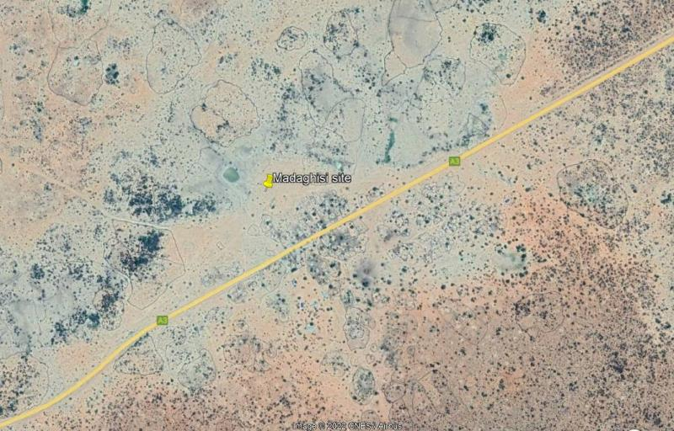

Figure 2: Project Location

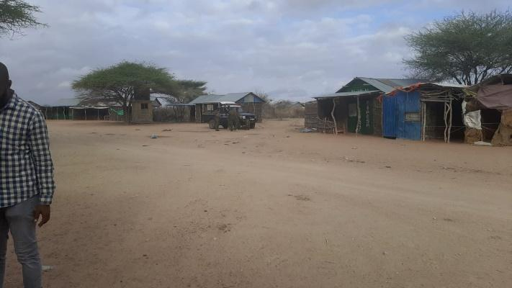

*Plate 1: Madaghisi shopping centre*

## Description of Project Facilities, Components and Activities

### Project Components

#### Solar PV modules

The project will use PV Array (DC-kW) 130 polycrystalline silicon module with three strings connected in series. Each string will have five sets of panels connected in series, with output converged at the six-way combiners. The life expectancy of the PV modules is estimated at 25-30 years.

**Solar Panels**: The project will utilize solar panels with a capacity of 84 kWp to capture solar energy. Solar power, a clean and renewable source, is harnessed effectively to meet the energy needs of the community.

**Battery Energy Storage System**: A battery with a capacity of 272 kWh will store excess solar energy, ensuring a continuous and stable power supply, even during periods of low solar irradiation.

**Inverters**: The project includes a PV inverter with a capacity of 70 kW, which converts DC electricity generated by the solar panels into AC electricity suitable for consumer use.

**Battery Inverter Charger**: With a capacity of 59 kW, the battery inverter charger manages the energy flow to and from the battery storage system, optimizing the performance of the system.

**Generator**: A diesel generator with a capacity of 50 kVA is integrated into the system to provide backup power during periods of low solar generation or high demand.

**Fuel Tank for Diesel Generator**: A 2,000-liter fuel tank is provided to store diesel fuel for the generator, ensuring uninterrupted power supply during extended periods of low solar generation.

#### Power Demand Metrics

**Monthly Energy Demand**: The project is designed to meet a monthly energy demand of 8,945 kWh, effectively addressing the specific energy needs of the community.

**Daily Energy Demand**: A daily energy demand of 298 kWh is proposed, ensuring a consistent and reliable power supply for various applications.

**Peak Demand**: The system is tailored to accommodate a peak demand of 35 kW, effectively addressing high-demand periods and ensuring uninterrupted access to electricity.

#### Power Distribution Network

**Low Voltage (LV) Network**: An 8-kilometer low voltage power distribution network will be established to efficiently transmit electricity to consumers. This network ensures a stable and reliable power supply while minimizing energy losses.

**Medium Voltage (MV) Network**: In this project, no medium voltage network is required, as the focus is on low voltage distribution.

**Transformer Step-up**: The project does not include a step-up transformer, as it is not required for voltage adjustment.

**Transformer Step-down**: Similarly, there is no provision for a step-down transformer, as the project is designed for low voltage distribution.

#### Battery Energy Storage System

The Battery Energy Storage System (BESS) will comprise of Lithium-ion Battery pack that conforms to IEC standards with warranty of 10 years, 3,000 cycles minimum. The Lithium-ion Battery Power Packs will be used to cater for required energy capacity, or equivalent as per approved design, minimum 80% DOD for Lithium-Ion. Batteries will be capable of at least C/4 charge and discharge rate.Batteries will be charged by Battery Inverter / Charger.

#### Inverters

The Inverters shall be designed for continuous, reliable power supply as per specification and shall have internal protection arrangement against any sustained fault in the feeder line and against lightning strikes in the feeder line. The inverters shall be capable of complete automatic operation including wake-up, synchronization & shut down independently & automatically.

#### Distribution lines

Madaghisi site will have a distribution line circuit of 8.0 km in total. Supply of concrete poles for the distribution lines will be based on detailed survey and accessories like phase plates, circuit plates, number plates, danger plates, anti-climbing devices as per KPLC requirements/specifications. Erection of the Poles, fixing of insulator strings, stringing of conductor and earth wires along with all necessary line accessories and earthing will be as per KPLC requirements/specifications.

#### Project Activities

The main project activities include site clearance and leveling, civil works and construction of utilities and structures for the facilities, installation and connection of the power plant.

#### Construction Procedures

The project will be constructed based on applicable standards of Kenya, environmental guidelines and health and safety measures in line with OSHA Act 2007.

The project inputs will include the following;

-Construction of raw materials will include solar modules, inverter, wires, metals, among others. All these will be obtained from licensed dealers and especially those that have complied with the environmental management guidelines and policies.

-Construction machines will include machinery such as trucks, and other relevant construction equipment. These will be used for the transportation of materials, clearing of resulting construction debris.

-A construction labour force of both skilled and non-skilled workers will be required.

**Construction activities will include the following:**

**-**Contractor mobilization;

**-**Site Preparation;

**-**Procurement of construction material from approved dealers and transport to the site.

**-**Storage of PV modules delivery and their installation;

**-** Laying of internal electrical connections;

**-** Installation of inverters, Battery Energy storage system.

#### Construction Contractor

The construction contractor is responsible for building the physical infrastructure required for the mini-grid project. In this case, the infrastructure includes the installation of solar panels, battery storage systems, a diesel generator, inverters, and the low voltage power distribution network.

Their specific responsibilities will include site preparation, installation of solar panels, setting up the battery storage system, configuring the diesel generator, and laying down the distribution network.

The construction contractor will be responsible for ensuring that the components are installed correctly and meet the required standards for safety and performance. They may also manage the workforce, logistics, and project timeline to ensure that construction proceeds smoothly and is completed within the specified timeframe.

#### Operation and Maintenance (O&M) Contractor

The O&M contractor will be responsible for the ongoing operation and maintenance of the mini-grid system once it is operational. The construction contractor will also double up as the O&M contractor

In this project, their responsibilities include monitoring the performance of the solar panels, battery storage system, and the diesel generator to ensure the continuous and reliable supply of electricity to the consumers. The O&M contractor must carry out regular maintenance tasks, such as cleaning and servicing solar panels, inspecting and maintaining the battery energy storage system, and ensuring the diesel generator is in good working condition for backup power needs. They are responsible for addressing any technical issues or faults that may arise, as well as responding to consumer complaints and inquiries related to the electricity supply. The O&M contractor plays a crucial role in maximizing the system's efficiency and longevity by ensuring all components operate optimally.

The contractor will be required to have their own Environment, Health, and Safety (EHS) policy and an EHS officer on site. In the context of the mini-grid project, it will outline the contractor's dedication to upholding safety standards, minimizing environmental impact, and adhering to legal requirements. The presence of an EHS officer on site will be equally essential. Their role will be to oversee and manage all EHS concerns directly at the project location.

#### Project Cost

The project cost is estimated at USD 491,001.00

***Note:*** *The Solar Mini-grid will be installed operated and maintained by the contractor for the first seven (7) years and then handed over to KPLC. So, for the seven years KPLC will be monitoring the operations of the contractor.*

#### Land Tenure

Madaghisi site is on unregistered Community Land. The community has since offered the land to the project proponent for minigrid construction.

#### Compensation Details

The proponent has inititated compensation process. An Abbreviated Resstlemrnt plan has been documented and appended to this report. Additionally, the community requested for the following projects.

* Water reticulation from the existing water sources to serve the community by installing solar powered pumps, dispensing unit and other amenities.
* Classrooms construction at the Madaghisi Primary school for use by the pupils from the community.
* Power connection to the amenities at the project area for use by the community for example the shopping centre and the school.

## Resource Requirement

### Workforce Requirement

Approximately 40 skilled, semi-skilled and unskilled labourers will be required at the construction stage. During the operation phase, about 15 no. staff will be required of which 8 will be skilled staff comprising : 0ne operations and maintenance head, 2 engineers, 5 technicians and 2 security guards. Unskilled staff will be approximately 5 and will be hired for grass cutting and module cleaning..

### Water Requirement and Source

#### Construction Phase

It has been estimated that approximately 50,000 Litres of water will be required per day for civil works during construction stage. Further, water will be required for workers at project site. However, this quantity of water requirement will vary depending on the mobilisation of construction workers at site. The water for the construction phase will be supplied by local water vendors.

#### Operation Phase

The water required during operation phase of the project will be mainly for washing the face of the solar modules, minimal water will be used for this purpose. The quantity of Water requirement during operational phase of the project is not known at this stage of the project. The water for the construction phase will be purchased from the vendors in the area.

As noted previously, approximately, employees (direct and contractual) will be working during operation phase. For this workforce, approximately 10,000 Litres of water will be required for domestic consumption.

### Raw Material Requirement

#### Construction Phase

The major raw materials required for the construction phase will be solar modules, fencing materials, construction materials like cement, sand and aggregate. The fencing materials and the construction materials will be sourced from the local hardware facilities. Solar Modules for the project along with associated structures will be obtained from suppliers in in the Country or if not availableimported from suppliers outside the country.

#### Operation Phase

There will be no major requirement of raw materials during operation phase. Only maintenance spares will be required at this phase.

### Power Requirement

Power requirement during the construction phase will be met through Diesel Generators sets. The exact number of Diesel Generator sets to be used, as well as the quantity of fuel, will be ascertained once the the project design is finalized.

### Fire Safety and Security

#### Construction Phase

Appropriate firefighting system and equipment shall be provided throughout the construction period. The fire extinguishers will be well distributed according to the fire risks and will be available in areas such as the site office, security area, storage yard etc. A comprehensive emergency response plan with all the emergency numbers will be well displayed at the project site.

#### Operation Phase

Suitable fire protection and fighting systems that will include portable fire extinguishers, automatic fire detection system and means of fire communication will be made available at the entire PV array area, inverter stations, main control room and switchyard.

The systems and equipment’s will align to the Kenyan Fire Reduction Rules of 2007. The Fire protection and fighting systems will be maintained and serviced after every 6 months. The team managing the site will be trained on Fire safety as per the requirement on Fire Risk reduction rules. Further the proponent will be required to undertake Annual OSH Audits, Fire audits and Risk assessment as per the requirement of OSHA 2007 and the relevant subsidiary legislation.

# Analysis of Alternatives and Project Justification

This section analyses the project alternatives in terms of site and technology. Solar projects are non -polluting energy generation projects which are site specific and dependent on the availability of solar irradiance resource. The current site selected is a high solar power potential site with high irradiation and consistent sunny days throughout the year.

## Land identification criteria

Minigrid Sites under KOSAP were selected based on a number of factors.

1.Geophysical Factors-Proximity to Hills-Shade effect, Soil erosion, Drainage of the area, Flooding etc.

2. Land identified is free from any dispute on ownership or any other encumbrances

3.Proximity to public utilities-Schools, Dispensaries, Places of worship and community settlements

4. No squatters, encroachers or other claims to the land

5.The Size of the Minigrid to be constructed and the optimal coverage of a Minigrid in terms of the number of people to be reached.

6. The Land identified should be on spaces set aside for public use within the community centres.

The land was identified by the beneficiary communities and confirmed by technical staff to be suitable for the sub-project and free from any environmental or health risks. The impacts on the Community will be marginal and will not result in displacement of households or cause loss of household’s incomes and livelihood.

The site identified was considered against the criteria highlighted above and was found suitable for Minigrid construction.

## Power Scenario in Madaghisi

This option involves maintaining the status quo.The no construct/no project alternative will not achieve the objectives of the project since the listed benefits will not be achieved. Failure to construct and operate the minigrid will lead to the failure of achieving one of the Kenya’s national long-term development policies that aims to transform Kenya into a newly industrializing, middle-income country, by providing a high quality of life to all its citizens by 2030 in a clean and secure environment. PAPs will be households, public and community institutions, enterprises and community facilities that cannot access electricity through the national grid and whose use of electricity will replace kerosene and other fuels for lighting and other activities like pumping water.

## Alternative Sources of Energy

The possible alternatives to electrical energy could be solar power, wind power, thermal power, fossil fuel and firewood. Power import from neighbouring countries is another option. Wind power is also a source of clean energy.

The problems in operation of wind power are lack of time series data of wind, trained human resources to intricate design of wind power etc. In addition, providing wind power for Madaghisi residents is technically and financially challenging.

Thermal power plants are associated with serious environmental problems like air pollution, waste pollution, noise pollution, temperature pollution etc. Besides coal and petroleum products, the basic input required for the conventional thermal power plants will have to be imported. Therefore, thermal power option based on coal and petroleum products is not a viable option for Madaghisi.

The use of firewood and solid waste for electricity generation by the use of thermal technology is another option. But the issue of air pollution and forest degradation already are environmental problems of serious concern which will further aggravate the natural environment. For these reasons, the thermal power options evaluated above seem inappropriate for Madaghisi on environmental as well as economic grounds.

Solar energy was a desirable option because:

* It has low energy-production costs
* Versatile installation
* It is a clean source of energy hence minimal impact on the environment air quality
* Economic savings.

## Zero or No Project Alternative

The No Project option in respect to the proposed project implies that the status quo is maintained. This option is the most suitable alternative from an extreme environmental perspective as it ensures non-interference with the existing conditions. This option will however, involve several losses both to Madaghisi centre and the community as a whole. The centre will continue to have no electricity and this will not help maximize usage and utilization of this centre. It will involve several losses both to Madaghisi village, Madaghisi Location and Garissa as a whole. The village and the surrounding area will continue to have no electricity and this will not help in maximizing and utilizing the area facilities. The No Project Option is the least preferred from the socio-economic and partly environmental perspective due to the following factors:

* The economic status of residents and the local people would remain unchanged.
* No employment opportunities will be created for Kenyans who will work in the project area.
* Increased rural poverty and crime in area.
* Discouragement for investors and loaners

From the analysis above, it becomes apparent that the No Project alternative is no alternative to the local people and the Government of Kenya.

## Alternate Location for Project Site

The identification of potential Mini-grid site for the proposed Madaghisi Solar Mini-grid involved site visits to the study area, preliminary site assessments and consultations among the concerned departments of the KPLC and MOE.

The community was requested to propose a piece of land 2-3 acres for the project. The appropriateness of potential Mini-grid sites identified by the KPLC during the initial site visits was assessed in terms of various suitability criteria and technical restrictions stipulated by KPLC, as outlined below:

* Load growth - the location of Mini-grid first and foremost is informed by the existing and also load growth of an area. Technical studies show that the area will experience load growth over time and there is need to supply electricity.
* Size – proposed potential sites need to be sufficient for the average size of Solar Mini-grid and associated auxiliary facilities. Therefore, the size acquired must meet the required size. The proposed site is 2.254 hectares.
* Topography – consideration is given to the topography of potential sites whereby flat or gently sloping topography is preferred. An ideal gradient for the natural ground is 1:100. A gentle slope facilitates surface drainage and movement of vehicles and people on-site during construction. A steep slope requires costly leveling (cut and fill) for the construction of the solar Mini-grid. In addition, a steep slope inhibits movement, makes vehicle access problematic and increases the potential for environmental impacts during construction as well as operation e.g., steeper slopes have higher surface water flow rates and therefore higher erosive potential. The proposed site is flat and cost-effective during construction.
* Hydrology – consideration is given to the proximity of potential sites to adjacent water courses and wetlands where there may be potential impacts in terms of erosion and siltation of water courses, as well as implications associated with storm-water control at the Solar Mini-grid site. The site is not close to water resources or wetland and so no impact to water sources through siltation. Further, construction of drainage is not complicated.
* Geology and soils – consideration is given to the soil type present within the potential site whereby stable soil and founding conditions are preferable. Less stable soils, i.e., shallow, dispersive soils and soils with poor drainage present an erosion hazard if not managed correctly, and also require the installment of additional, costly foundation infrastructure. The soils at the site are well drained.
* Flora and fauna – potential sites need to be assessed in terms of their ecological value at both a macro and micro scale i.e., within the site and the environment surrounding the site. Both a faunal and floral investigation may be required, with particular emphasis on ensuring the protection of endemic and red data species and their habitat, should they be present. An identified site that has a high ecological value may be excluded from the list of potential sites. The site is not of a high ecological value.
* Visibility – highly visible sites i.e., on a ridge / elevated terrain are considered less favorable in that they have a high visual impact on the surrounding landscape. Sites that are hidden or out of site e.g., behind a hill, may be considered more suitable; the site is on flat part near chief’s office and may not create sharp visual impact because it is not on an elevated point.
* Access – it is preferable that potential sites are located in close proximity to existing public roads so as to avoid the need for construction of new access roads of considerable length. Access is also important particularly as it relates to the transportation of the solar panels, batteries and generator to the site, which are heavy weights and requires the use of a low-bend vehicle. As such, long access routes with sharp bends are to be avoided and the site should not be located in an area that has excessively steep inclines or declines that could hinder access, particularly during periods of heavy rainfall; the site is well accessible as it along the road.
* Adjacent land use – adjacent land use has implications for access and required clearances for the power lines extending from the solar plant site, i.e., it is important that the land surrounding the Mini-grid is relatively clear of obstructions which might otherwise inhibit / obstruct the path of the power lines out of the Mini-grid. Current and future development planning of adjacent land use should therefore also be considered. The site and the developments around do not pose a hindrance for incoming and outgoing feeders.
* Public acceptability – public acceptance criteria relate to such issues as the possible adverse impact on public health, quality of life, and local land and property values. During the public consultations there was overwhelming support for the project with mitigation measures being put in place for the negative impacts.

Based on the above-mentioned suitability criteria and technical requirements, the proponent decides to put up the Solar Mini-grid within Madaghisi. Relocation option to a different site is an option available to the proponent. The project proponent can look for alternative land to accommodate the scale and size of the project. However, this will be a costly venture, may take a long time although there is no guarantee that the land would be available in the targeted area. It is recommendable that the proponent be allowed to install the project in the proposed site

## Analysis of Alternative Construction Materials and Technology

The proposed project will be constructed using modern, locally and internationally accepted materials to achieve public health, safety, security and environmental aesthetic requirements. The materials will include all consumables, tools, testing instruments or any other equipment required for successful commissioning of the project.These may not be desirable from a cost and durability perspective. The technology to be adopted will be the most economical and one sensitive to the environment. The technology will involve a Battery Energy Storage System (including battery Inverter and charger).

## Solid waste Management Alternatives

A lot of solid wastes will be generated from the proposed project site. An integrated solid waste management system is recommendable. First, the proponent will give priority to reduction at source of the materials. This option will demand a solid waste management awareness program in the management and the staff. Recycling and reuse options of the waste will be

the second alternative in priority. This will call for a source separation program to be put in place. The third priority in the hierarchy of options is combustion of the waste that is not recyclable. In this regard, a NEMA registered solid waste handler would have to be engaged. This is the most practical and feasible option for solid waste management considering the delineated options.

## Conclusion

The proposed project should be approved to support the local community based on

community need assessment and alternatives discussed above.

# APPLICABLE AND REGULATORY FRAMEWORK

## Introduction

This Chapter outlines the existing national and international environmental and social legislation, policies and institutions applicable to energy generation that guide the development of the Project.

As Kenya is a signatory to various international conventions and laws, national projects need to be aligned with their requirements; relevant international conventions and laws are therefore presented in this chapter.

Finally, a summary of the World Bank (WB) Environmental and Social operational policies. relevant to this Project are presented.

## Kenya Electricity Supply Industry (ESI)

The Kenya Electricity Supply Industry (ESI) is one of the sub-sectors in the energy sector which the Ministry of Energy and Petroleum oversees on behalf of the Government of Kenya (GoK). Relevant stakeholders in the ESI are briefly described below.

* **Kenya Power Company:** responsible for distribution and retail supply of electrical energy to end users. Kenya Power purchases power in bulk from the Kenya Electricity Generating Company Limited (KenGen) and the Independent Power Producers (IPPs) through bilateral contracts or Power Purchase Agreements (PPAs) approved by the Energy and Petroleum Regulatory Authority (EPRA).

KPLC will be responsible for implementing the project, construction of the generation systems and distribution network for the Madaghisi site. Supply of power will be through KPLC and same tariffs will be charged for each category.

* **The Energy and Petroleum Regulatory Authority (EPRA):** established by the Energy Act of 2019. The EPRA’s mandate extends beyond electricity and includes natural gas (including petroleum), renewables and all other forms of energy. The generation, transmission, distribution, supply, import and export of electricity can only be carried out by parties in possession of a license or a permit issued by the EPRA. In the event that the capacity involved is for own use and less than 1 MW, authorization is not required. Although the generated electricity is expected to be less than 1 MW (0.3 – 1 MW), the fact that the generated electricity is intended for use in a factory and there is a possibility for connection to the national grid and sale of excess power to the government, the project requires a license from the EPRC to generate electricity as stipulated in the Energy Act, 2019.

The Energy and Petroleum Regulatory Authority (Authority) together with industry stakeholders have developed the Draft Energy (Mini-Grid) Regulations, 2021 (the ‘Regulations’). The Regulations have been developed within provisions 10, 11 and 208 of the Energy Act, 2019 (the ‘Act’) and shall constitute Regulations to the Act. The Regulations will amongst others, provide guidance to mini-grid developers and other stakeholders on the tariff approval and licensing requirements. This will be directly applicable to the Madaghisi site.

* **Ministry of Energy and Petroleum:** aims to facilitate provision of clean, sustainable, affordable, reliable, and secure energy services for national development while protecting the environment.

The ministry will be responsible for not only implementing the community projects like water and cooking stations from the proposed project but also the overall coordination of project implementation and oversight.

* **The Rural Electrification and Renewable Energy Corporation (REREC):** is established under Section 43 of the Energy Act, 2019 as a corporate body. The Corporation is the successor to the Rural Electrification Authority established under section 66 of the Energy Act No. 12 of 2006 (now repealed) and subject to this Act, all rights, duties, obligations, assets and liabilities of the Rural Electrification Authority existing at the commencement of this Act is to be automatically and fully transferred to the Corporation and any reference to the Rural Electrification Authority in any contract or document shall, for all purposes, be deemed to be a reference to the Corporation.

## National Legal Framework rEVIEW

The applicabe legal framework is illustrated in table 7 below.

*Table 7: Legal framework National*

| **No** | **Legislation/**  **Guidelines** | **Description of the Legislation/Guideline** | **Relevance of the legislation/regulations in terms of license, permits, and other requirements** |
| --- | --- | --- | --- |
|  | **NATIONAL POLICY FRAMEWORK** | | |
|  | Vision 2030 | Kenya Vision 2030 is the current national blueprint for development from its inception in 2008 until the milestone year of 2030. This plan is the national long-term development policy that aims to transform Kenya into a newly industrialised, middle-income country by 2030. The Vision is comprised of three key pillars (economic, social, and political), two of which are projected to be positively affected by project implementation. | Under Vision 2030, Energy is identified as one of the key sectors that form the foundation for sociopolitical and economic growth. Promoting equal opportunities across the entire Kenyan territory and enhancing access to competitively priced, reliable, quality, safe and sustainable energy is essential to the achievement of this vision. |
|  | The Poverty Reduction Strategy Paper (PRSP) of 2001 | The PRSP has the twin objectives of poverty reduction and enhancing economic growth. The paper articulates Kenya ‘s commitment and approach to fighting poverty; with the basic rationale that the war against poverty cannot be won without the participation of the poor themselves. | * The proposed project aims at provision and access of renewable electricity geared towards improved economic performance and thus will contribute to poverty alleviation in the project area. |
|  | National Environmental Action Plan (NEAP) of 1994 | The NEAP for Kenya was prepared in mid 1990s. It was a deliberate policy whose main effort is to integrate environmental considerations into the country ‘s economic and social development. The integration process was to be achieved through multi-sectoral approach to develop a comprehensive framework to ensure that environmental management and the conservation of natural resources forms an integral part of societal decision-making. | * The NEMA does not approve a development project unless the impacts of the proposed project are evaluated and mitigation measures proposed for incorporation in the project ‘s development plan, which is in line with the requirements of the NEAP. * The project will be reviewed by NEMA for approval before implementation. |
|  | Environmental and Development Policy (Session Paper No.6 1999) | As a follow-up to the foregoing, the goal of this policy is to harmonize environmental and developmental goals so as to ensure sustainability. The paper provides comprehensive guidelines and strategies for government action regarding environment and development.  The Government will:  1. Ensure Strategic Environment Assessment (SEA), Environmental Impact Assessment, Social Impact Assessment and Public participation in the planning and approval of infrastructural projects.  2. Develop and implement environmentally-friendly national infrastructural development strategy and action plan.  3. Ensure that periodic Environmental Audits are carried out for all infrastructural projects | The proponent:   * is undertaking an Environmental Impact Assessment, Social Impact Assessment and Public participation as part of the planning and approval of infrastructural projects. * Will ensure that periodic Environmental Audits are carried out for the project |
|  | The National Energy and Petroleum Policy 2015 | The overall objective of the energy and petroleum policy is to ensure affordable, competitive, sustainable and reliable supply of energy to meet national and county development needs at least cost, while protecting and conserving the environment. This policy stipulates the transformation of the Rural Electrification Authority (REA) to Rural Electrification and Renewable Energy Corporation (REREC) to be the lead agency for development of renewable energy resources. | The policy is relevant to the project in the sense that the project will provide sustainable and reliable energy supply and measures will be put in place to protect and conserve the environment during its development. REREC will be in charge of the development of the minigrid and maintenance. |
|  | The Gender and Development Policy (Sessional paper no.2 2019) | The overall goal of this policy is to achieve gender equality by creating a just society where women, men, boys and girls have equal access to opportunities in the political, economic, cultural and social spheres of life.  The anticipated outcome of this policy as enshrined in the Constitution that aligns to the project include:  a) Equality and economic empowerment will be of both genders,  b) Women and men will have equality of opportunity to participate in decision making and to contribute to the political, social, economic and cultural development agenda;  c) Sexual and Gender based Violence will abate and men, women, boys and girls will live with dignity | * In the absence of appropriate measures, the project can exacerbate gender inequalities and sexual and gender based violence. In adherence to this policy, measures will be put in place to :   + ensure gender inclusivity in decision making, employment opportunity and access to the energy generated from the Mini-Grid   + mitigate social risks including sexual and gender based violence, and any form of discriminations |
|  | The HIV/ AIDS Policy 2009 | In summary, the policy aims at:  i. Establishing and promoting programmes to ensure non-discrimination and non- stigmatization of the infected;  ii. Contributing to national efforts to minimize the spread and mitigate against the impact of HIV and AIDS;  iii. Ensuring adequate allocation of resources to HIV and AIDS interventions; | * The proposed project is to be implemented in the a rural setting at Madaghisi area. The area is not economically empowered hence few HIV/AIDS prevention resources are available. This policy shall provide a framework to both the project proponent and contractor to address issues related to HIV/AIDS during the entire project phase. |
| NATIONAL LAWS AND LEGISTLATIONS | | | |
|  | The Constitution of Kenya, 2010 | The Constitution of Kenya promulgated in 2010 is the supreme law of the republic and binds all persons and all State organs at all levels of government. The Constitution provides the broad framework regulating all existence and development aspects of interest to the people of Kenya, and along which all national and sectoral legislative documents are drawn | The proposed project complies with the Constitution by proposing a structure in its ESIA on how to deal with Social, Health, safety and environmental issues for sustainable development. |
|  | ENVIRONMENTAL MANAGEMENT AND COORDINATION ACT, 1999 (AND THE AMENDMENTS OF 2015) | The EMCA is a framework environmental law in Kenya. This Act (assented to on January 14, 2000) provides a structured approach to environmental management in Kenya. With the EMCA coming into effect, the environmental provisions within the sectoral laws were not superseded; instead, the environmental provisions within those laws were reinforced to better manage Kenya’s ailing environment. | The proposed project will be undertaken in accordance with relevant sections of the EMCA, specifically Clauses 58 – 63. These sections of the Act are operationalised by subsidiary legislation promulgated under the Act and specifically Legal Notice (L.N.) 101: Environment (Impact Assessment and Audit) Regulations, 2003. |
|  | L.N. 101: EIA/EA REGULATIONS, 2003 AND 2016 AMENDMENTS | These regulations provide the framework for undertaking EIAs and EAs in Kenya by NEMA licensed Lead Experts and Firms of Experts. An EIA or EA Study in Kenya is to be undertaken by a firm duly licensed by the National Environmental Management Authority (NEMA). The EIA/EA Regulations also provide information to project proponents on the requirements of either an EIA or EA as required by the EMCA. | * The proposed project is subject to relevant provisions of these regulations and subsequently, the ESIA has been undertaken in accordance with the requirements. |
|  | L.N. 120: WATER QUALITY REGULATIONS, 2006 | These regulation provides for the sustainable management of water used for various purposes in Kenya. For effluent discharges into the environment and aquatic environment, a Proponent needs to apply directly to the NEMA. For discharges into public sewers, a Proponent needs to apply for the license to the relevant county. The regulation contains discharge limits for various environmental parameters into public sewers and the environment. | * These regulations will apply to the proposed project during the construction and operational phases. The contractor will be required to properly manage the effluent from construction activities in accordance with the above regulations prior to discharge into the environment. |
|  | L.N. 121: WASTE MANAGEMENT REGULATIONS, 2006 | These regulations are comprehensive and cover the management of various kinds of waste in Kenya. Generally, it is a requirement under the regulations that a waste generator segregates waste (hazardous and non-hazardous) by type and then disposes the them in an environmentally acceptable manner. Under the regulation, it is a requirement that waste is transported using a vehicle that has an approved “Waste Transportation License” issued by NEMA. Wastes generated in Kenya must be disposed of in a licensed disposal facility. Such a facility will require annual environmental audits to be undertaken by NEMA registered Lead Experts.  The regulation requires that prior to generating any hazardous waste, a proponent shall undertake an EIA Study and seek approval from the NEMA. Labelling of hazardous wastes is mandatory under the regulation and the specific labelling requirements are provided in Rule 18. The treatment options for hazardous waste disposal provided in Rule 19 include incineration or any other option approved by the NEMA. | * During the construction and operation phases, the proposed project will generate various streams of wastes. For the most part, it is expected that the wastes will be non-hazardous in nature and can be disposed of in accordance with these regulations. |
|  | L.N. 61: NOISE AND EXCESSIVE VIBRATION CONTROL REGULATIONS, 2009 | The general prohibition of these regulations states that no person shall make or cause to be made any loud, unreasonable, unnecessary, or unusual noise which annoys, disturbs, injures, or endangers the comfort, repose, health, or safety of others and the environment.  The regulations further provide factors that will be considered in determining whether or not noise and vibration is loud, unreasonable, unnecessary, or unusual. | * Rules 13 and 14 of the regulations define the permissible noise levels for construction sites. These noise limits will be applicable to the proposed project. |
|  | LICENSES AND PERMITS REQUIRED UNDER THE EMCA | The subsidiary legislations under the EMCA are partially monitored through the use of permits and licenses. Subsequently all licenses and permits required during the construction phase shall be the responsibility of the individual contractors and their agents. During the operational phase, all permits and licenses required to operate the project will be the responsibility of the proponent. | The subsidiary legislations under the EMCA requires some or all the following types of permits to be available for inspection during the construction and operational phases of the project:   * Effluent Discharge License under Legal Notice 120: The Environment Management and Coordination (Water Quality) Regulations 2006; * Waste Transport License under Legal Notice 121: The Environment Management and Coordination (Waste Management) Regulations 2006 for disposal of all types of wastes; and * Noise Permit under Legal Notice 61: The Environment Management and Coordination (Noise and Excessive Vibration Control) Regulations, 2009. |
|  | OCCUPATIONAL HEALTH AND SAFETY ACT, 2007 | The Occupational Safety and Health Act (OSHA) was enacted to provide for the health, safety and welfare of persons employed in workplaces, and for matters incidental thereto and connected therewith.  Part II of the Act provides the General Duties to which the occupier must comply with respect to health and safety in the workplace. Such duties include undertaking safety and health (S&H) risk assessments, S&H audits, notification of accidents, injuries and dangerous occurrences. A number of sections under this part shall be applicable to the proposed project.  Part IV deals with the enforcement provisions that Directorate of Occupational Safety and Health Services (DOSHS) has under the Act. It discusses the instances when Improvement and Prohibition Notices can be issued as well as the powers of Occupational S&H officers. This part of the Act will be mandatory for the occupier to comply with for the proposed project.  Part V of the Act requires all workplaces to be registered with the DOSHS. This part will be applicable for the proposed project as the Occupier will have to apply for registration of their project with the DOSHS on completion of the construction phase and before the operational phase of the project.  Part VI of the Act lists the requirements for occupational health provisions which include cleanliness, ventilation, overcrowding, etc. This section of the Act will apply to the Occupier during the operational phase of the project.  Part VIII of the Act contains provisions for general safety of a workplace, especially fire safety. This part of the Act will apply to the proposed project during the design, construction, and operational phases.  Part X of the Act deals with the General Welfare conditions that must be present during the construction and operational phase of the project. Such conditions include first aid facilities, supply of drinking water, accommodation for clothing, ergonomics, etc. This part of the Act will apply to the proposed project during the construction and operational phases.  Part XI of the Act contains Special Provisions on the management of health, safety, and welfare. These include work permit systems, PPE requirements and medical surveillance. Some sections of this part of the Act will be applicable to the proposed project during the construction and operational phase.  Part XIII of the Act stipulates various fines and penalties associated with non-compliance with the Act. It includes those fines and penalties that are not included in other sections of the Act and will be important for the Occupier to read and understand the penalties for non-compliance with S&H provisions.  Part XIV of the Act is the last section of the Act and contains miscellaneous provisions which are not covered elsewhere in the Act. Some sections under this part of the Act will apply to the proposed project and it is in the interest of the occupier to read, understand, and ensure compliance. | The proposed project will be undertaken in compliance with the OSHA-2007 during the construction, design, and operational phases.  During the construction phase, the contractors will be required to fully comply with the requirements of Legal Notice 40 titled: Building Operations and Works of Engineering Construction Rules, 1984 (BOWEC). Each contractor will develop and implement a formal construction health and safety plan for the entire construction phase duration in alignment with the OSHA and international health and safety best practices. |
|  | L.N. 31: The Safety and Health Committee Rules, 2004 | These rules came into effect on April 28, 2004, and require that an Occupier formalise a S&H Committee if there is a minimum of 20 persons employed in the workplace. The size of the S&H Committee will depend on the number of workers employed at the place of work.  For the Proponent and Contractor, the OSHA and the S&H Committee Rules 2004 are important as they require compliance with the following measures:   * + Posting of an Abstract of the Factories and Other Places of Work Act in key sections of each area of the factory or other workplace;   + Provision of first aid boxes in accordance with Legal Notice No. 160 of 1977;   + Ensuring that there are an appropriate number of certified first aiders trained by an approved institution and that the certification of these first aiders is current;   + Provision of a General Register for recording, amongst other things, all incidents, accidents, and occupational injuries;   + Appointment of a S&H Committee made up of an equal number of members from management and workers based on the total number of employees in the workplace;   + Training of the S&H Committee in accordance with these rules; and   + Appointment of a S&H management representative for the Proponent. | The contractor will be required to constitute Health and Safety Committee to oversee safety and health at the construction site. The number of the committee members will be didacted by the number of staff hired by the contructor. The S&H Committee must meet at least quarterly, take minutes, circulate key action items on bulletin boards, and may be required to send a copy of the minutes to the DOSHS provincial office.  Appropriate recordkeeping including maintenance of all current certificates related to inspection of critical equipment such as cranes, air compressors, lifts, pulleys, etc. Such inspections need to be undertaken by an approved person registered by the Director of the DOSHS. |
|  | L.N. 24: Medical Examination Rules, 2005 | These rules provide for Occupiers to mandatorily undertake pre-employment, periodic, and termination medical evaluations of workers whose occupations are stipulated in the Eighth Schedule to the OSHA and the First Schedule to this Rules. Workers that fall under the above two schedules are required to undergo medical evaluations by a registered medical health practitioner duly registered by the DOSHS. | Some construction activities such as metal cutting and grinding, repair or maintainance of construction equipment could expose the construction workers during construction phase and operations and maintenance workers during operation phase to physical and chemical hazards The contractor should that the workers exposed to such hazards undergo requisite medical examinations as required by these rules |
|  | L.N. 25: Noise Prevention and Control Rules, 2005 | The rules set the permissible level for occupational noise in any workplace (which includes construction sites) as follows:  • 90 dB(A) over an 8-hour time weighted average (TWA) period over 24-hours; and  • 140 dB(A) peak sound level at any given time.  Additionally, the rules set permissible limits for community noise levels emanating from a workplace as follows:  • 50 dB(A) during the day; and  • 45 dB(A) at night.  The Proponent is to ensure that   * any equipment brought to the site for use shall be designed or have built-in noise reduction devices that do not exceed 90 dB(A). * those employees that may be exposed to continuous noise levels of 85 dB(A) are medically examined as indicated in Regulation 16. If found unfit, the occupational hearing loss to the worker will be compensated as an occupational disease. | It is expected that during the construction phase of the project, there may be plant equipment that exceeds the threshold levels of noise stipulated under the Rules. It will therefore be incumbent on the contractor and his or her sub-contractors to ensure that their equipment is serviced properly and/or use equipment that complies with the threshold noise values given above. Alternatively, each contractor will be required to develop and implement a written hearing conservation programme during the construction phase. |
|  | L.N. 59: Fire Risk Reduction Rules, 2007 | A number of sections of the rules apply to the proposed project as enumerated below.  • Regulation 5 requires Proponents to ensure that fire resistant materials are used for construction of new buildings. A number of minimum specifications of materials are provided in this rule.  • Regulation 6 requires that all flammable materials be stored in appropriately designed receptacles. Some of the flammable materials anticipated at the project site including; fossil fuel using running construction equipment and vehicles (during construction phase ) and stand by generator (operation phase)  • Regulation 7 requires that all flammable storage tanks or flammable liquid containers be labelled with the words “Highly Flammable” in English or Swahili. It is therefore practical for the Proponent to use a system similar to the Hazardous Material Identification System of labelling their product containers. The regulation requires a Proponent to consult the product’s MSDS for appropriate labelling requirements.  • Regulation 8(3) requires a Proponent to have a Spill Prevention, Control, and Countermeasures (SPCC) plan. This may be important if there will be chemicals stored in the refuelling area at the construction site.  • Regulation 16 requires Proponents to ensure that electrical equipment is installed in accordance with the respective hazardous area classification system. It is also a requirement that all electrical equipment is inspected every six months by a competent person and the Proponent is required to keep records of such inspections.  • Regulation 22 provides a description of the functions of a fire-fighting team.  • Regulation 23 requires Proponents to mandatorily undertake fire drills at least once a year.  • Regulation 33 requires Proponents to have adequate fire water storage capacity. As a minimum this regulation requires Proponents to have at least 10 cubic meters of dedicated fire water storage capacity.  • Regulation 34 requires Proponents to develop and implement a comprehensive written Fire Safety Policy. This policy should contain a Fire Safety Policy Statement signed by the CEO, a Fire Safety Policy Manual and a brief summary of the Fire Safety Policy of the company.  • Regulation 35 requires a Proponent to notify the nearest Occupational S&H area office of a fire incident within 24 hours of its occurrence and a written report sent to the Director of DOSHS within 7 days. | The proponent is expected to comply with the requirements of L.N. 59: Fire Risk Reduction Rules, 2007 by   1. Carrying out, and record, a fire risk assessment identifying any possible dangers and risks. 2. Reducing, or where possible remove, the risk of fire and take precautions to deal with the remaining risks. 3. PuTting in place protection measures if there are flammable or explosive materials used or stored on the premises. 4. Developing an emergency plan should a fire occur which includes evacuation procedures etc |
|  | THE ENERGY ACT, 2019 | The Energy Act deals with all matters relating to all forms of energy including the generation, transmission, distribution, supply, and use of electrical energy, as well as the legal basis for establishing the systems associated with these purposes. The Energy Act also established Energy and Petroleum Regulatory Authority (EPRA) in place of the Energy Regulatory Commission (ERC), whose mandate is to regulate all functions and players in the energy sector. One of the duties of the EPRA is to ensure compliance with environmental, health, and safety standards in the energy sector, as empowered by Section 99 of the Energy Act, 2019. In this respect, the following environmental issues will be considered before approval is granted:   * The need to protect and manage the environment and conserve natural resources; and * The ability to operate in a manner designated to protect the health and safety of the project employees, the locals, and other potentially affected communities.   An ESIA approved by NEMA must support licensing and authorisation to generate and transmit electrical power.   * Part VI Section 121 (1a) stipulates that the EPRA shall, before issuing a license, take into account the impact of the undertaking on the social, cultural or recreational life of the community. * Part VI Section 121(1b) stipulates that the EPRA shall, before issuing a license, take into account the need to protect the environment and to conserve natural resources in accordance with the Environmental Management and Coordination Act. * Part VI Section 136 (1a) stipulates that it shall be the duty of a transmission licensee to operate, maintain (including repair and replace if necessary) and protect its transmission grid to ensure the adequate, economic, reliable and safe transmission of electricity; and | The proponent is in line with the Energy act regultions in the following ways;   * The proponent has identified an available site * alignment of the Mini-Grid Project to County development plans; * the Mini-Grid proponent has the technical and financial capability to conduct the project * The proponent has conducted the necessary engagement with the community. |
|  | THE ENERGY (SOLAR PHOTOVOLTAIC SYSTEMS) REGULATIONS, 2012 | These regulations shall apply to a solar PV system manufacturer, importer, vendor, technician, contractor, system owner, a solar PV system installation and consumer devices.  The Regulations prohibits any person from designing or installing any solar PV system unless he/she is licensed by EPRA. | The Regulations regulates, the design and installation of PV systems. The Proponent will ensure that persons engaged in the the designing and installation of the Mini-Grid are licensed by EPRA |
|  | THE PUBLIC HEALTH ACT (CAP. 242) | The Act prohibits the project proponents from engaging in activities that cause environmental nuisance or those that cause danger, discomfort or annoyance to inhabitants or is hazardous to human and environmental health and safety. | The proponent will be in line with the regulations of this act and will ensure suppression of infectious diseases and maintain proper sanitation during all the phases of the project. |
|  | COMMUNITY LAND ACT, 2016 | This Act is critical for the proposed project is within community land. Section 6(1) of the Act provides that ‘county governments shall hold in trust all unregistered community land on behalf of the communities for which it is held’. Furthermore, Section 6(2) maintains that ‘the respective county government shall hold in trust for a community any monies payable as compensation for compulsory acquisition of any unregistered community land’. Therefore, the proposed road project can access land or water resources in community land that may be unregistered and pay compensation to the County Government which the law authorizes to hold such monies in trust for the communities.  Section 30(1) states that ‘Every member of the community has a right to equal benefit from community land’. Section 26(1) provides that ‘a community may set aside part of the registered community land for public purposes’ and Sub-section (2) holds that ‘where land is set aside for public purposes under Sub-section (1), the (Land) Commission shall gazette such parcel of land as public land’. This provisions offer a window for the proposed project to acquire land for project works legally for communities as necessary and to convert the same into public land. This is useful for the project as once done powerful groups will not have opportunity to exclude them on account of their socio - economic statuses. In any event, Section 35 holds that, ‘subject to any other law, natural resources found in community land shall be used and managed-  (a) Sustainably and productively;  (b) For the benefit of the whole community including future generations;  (c) With transparency and accountability; and  (d) On the basis of equitable sharing of accruing benefits’.  The concept of community land has been defined broadly enough to include VMGs. Women, children, old people and future generations have been thought of as PAPs and thus their rights secured in this Act | The proposed project site falls on an unregistererd community land and the land belongs to the Somali community. The community has since offered to the land in kind for project use. The establishment of the minigrid will convert communal land to industrial use for long term. Further, based on community need assessment the proponent will undertake in kind development project to support the community water needs.  The proponent should adhere to the provision of this legistalation |
|  | HIV AIDS PREVENTION AND CONTROL (CAP 246A) | This Act is to promote public awareness about the causes, modes of transmission, consequences, means of prevention and control of HIV and AIDS. It also seeks to positively address and seek to address conditions that aggravate the spread of HIV infection. | Like other projects, the proposed project is expected to attract new people to the project area seeking employment. This can lead to increased transmission of HIV/AIDS and other sexually transmitted diseases (STDs) as they engage in sexual relationships amongst themselves and/or local community members. In line with the requirements of this Act, the Contractors will create awareness and sensitize the workers and other persons on the risks of infections to foster prevention and control. |
|  | THE PHYSICAL AND LAND USE PLANNING ACT, 2019 | This Act of Parliament makes provision for the planning, use, regulation and development of land and for connected purposes.  The objects of this Act related to the project include;  (a) the principles, procedures and standards for the preparation and implementation of physical and land use development plans at the national, county, urban, rural and cities level;  (b) the procedures and standards for development control and the regulation of physical planning and land use; (d) a framework for the co-ordination of physical and land use planning by county governments;  (c) a framework for equitable and sustainable use, planning and management of land; | The proposed site is not in contravention of any Zoning regulations. The project site is within unregistered community land; necessary county approvals will be sought by the proponent eg. project design approval and change of use. The approvals shall be issued by the Physical planner in the department of Lands, Housing and Urban Development – Garissa County. |

### Administrative Framework

In 2001, the Government established the administrative structures to implement the Environmental Management and Co-ordination Act of 1999 (EMCA). The main administrative structures are described in the following sections:

|  |  |
| --- | --- |
| **Stakeholders** | **Role** |
| ***NEC*** | The **National Environmental Council** is responsible for policy formulation and directions for the purposes of EMCA. The Council also sets national goals and objectives and determines policies and priorities for the protection of the environment.  *The proponent should ensure that the project abides by the set goals and objectives of the Council*. |
| ***NEMA*** | The responsibility of NEMA is to exercise general supervision and co-ordination over all matters relating to the environment and to be the principal instrument of Government in the implementation of all policies relating to the environment.  *This ESIA has been prepared for submission to NEMA for review and approval prior to the commencement of the Project activities, in compliance to the EMCA.* |
| ***PCC*** | EMCA has also established a Public Complaints Committee, which provides the administrative mechanism for addressing environmental harm. The Committee has the mandate to investigate complaints relating to environmental damage and degradation. The members of the **Public Complaints Committee** include representatives from the Law Society of Kenya, NGOs, and the business community.  *The proponent should address all issues arising from the Project in accordance with the above requirements, including a clear policy of stakeholder engagement and feedback.* |
| ***WRA*** | Water Resources Authority is responsible for regulation of water resources issues such as water allocation, source protection and conservation, water quality management and pollution control and international waters. One of its functions among others is to receive water permit applications for water abstraction, water use and recharge and determine issue, vary water permits; and enforce the conditions of those permits as well as formulate and enforce standards, procedures and Regulations for the management and use of water resources and flood mitigation.  *The project area experiences serious water scarcity. The proponent will have to outsource water for use during the construction period* |
| ***The Energy and Petroleum Regulatory Authority (EPRA):*** | Established by the Energy Act of 2019. The EPRA’s mandate extends beyond electricity and includes natural gas (including petroleum), renewables and all other forms of energy. The generation, transmission, distribution, supply, import and export of electricity can only be carried out by parties in possession of a license or a permit issued by the EPRA. In the event that the capacity involved is for own use and less than 1 MW, authorization is not required. Although the generated electricity is expected to be less than 1 MW (0.3 – 1 MW), the fact that the generated electricity is intended for use in a factory and there is a possibility for connection to the national grid and sale of excess power to the government, the project requires a license from the EPRC to generate electricity as stipulated in the Energy Act, 2019.  The Energy and Petroleum Regulatory Authority (Authority) together with industry stakeholders have developed the Draft Energy (Mini-Grid) Regulations, 2021 (the ‘Regulations’). The Regulations have been developed within provisions 10, 11 and 208 of the Energy Act, 2019 (the ‘Act’) and shall constitute Regulations to the Act. The Regulations will amongst others, provide guidance to mini-grid developers and other stakeholders on the tariff approval and licensing requirements. This will be directly applicable to the Tuum site. |

* 1. **International Safeguards requirements**

The table below shows the applicability of World Bank Operational OPs to the proposed project in Madaghisi site;

*Table 8: World Bank Operational OPs to the proposed project in Madaghisi site*

|  |  |  |  |
| --- | --- | --- | --- |
| **S.No.** | **Safeguard Policy** | **Objective** | **Applicability** |
|  | Environment Assessment (Operational Policy, OP/BP 4.01) | The objective of this policy is to ensure that Bank-financed projects are environmentally sound and sustainable, and that decision-making is improved through appropriate analysis of actions and of their likely environmental impacts. This policy is considered to be the umbrella policy for the Bank’s environmental ‘safeguard policies. | The policy is applicable to this project because there are environmental and social concerns associated with the construction and operation of the proposed project. In response, REREC has commissioned and Environmental impact assessment in order to identify and address the potential impacts to a level that is acceptable. |
|  | Natural Habitats (Operational Policy, OP/BP 4.04) | This policy recognizes that the conservation of natural habitats is essential to safeguard their unique biodiversity and to maintain environmental services and products for human society and for long-term sustainable development. The Bank therefore supports the protection, management, and restoration of natural habitats in its project financing, as well as policy dialogue and economic and sector work. The Bank supports, and expects borrowers to apply, a precautionary approach to natural resource management to ensure opportunities for environmentally sustainable development. Natural habitats are land and water areas where most of the original native plant and animal species are still present. Natural habitats comprise many types of terrestrial, freshwater, coastal, and marine ecosystems. They include areas lightly modified by human activities but retaining their ecological functions and most native species. | The proposed project may be in or close to areas with natural unique flora and fauna though the component is unlikely to have significant negative impacts on natural habitat. Works will nevertheless be implemented in an area in Madaghisi that may not negatively affect diverse flora, fauna, and avifauna. The area is dependent on pastoralism. Additionally, caution will be taken to ensure minimum disruptions to habitats as guided by the ESMMP. |
|  | Indigenous Peoples (Operational Policy 4.10) | The objective of this policy is to (i) ensure that the development process fosters full respect for the dignity, human rights, and cultural uniqueness of indigenous peoples; (ii) ensure that adverse effects during the development process are avoided, or if not feasible, ensure that these are minimized, mitigated or compensated; and (iii) ensure that indigenous peoples receive culturally appropriate, gender and inter-generationally inclusive social and economic benefits. | The policy is applicable because the inhabitants of Madaghisi who are Somalis and are classified as a marginalized groups in Kenya. The Somali are main inhabitants of Madaghisi and the minority are the Kambas who are also the marginalized. The proponent will continue to engage the PAPs in a culturally appropriate way and allow for decision making in a free, prior and informed consent manner throughout the phases of the project. |
|  | Involuntary Resettlement (Operational Policy, OP/BP 4.12) | The objective of this policy is to (i) avoid or minimize involuntary resettlement where feasible, exploring all viable alternative project designs; (ii) assist displaced persons in improving their former living standards, income earning capacity, and production levels, or at least in restoring them; (iii) encourage community participation in planning and implementing resettlement; and (iv) provide assistance to affected people regardless of the legality of land tenure. | The policy is triggered for the entire project because there is land acquisition for the Mini-grid, Wayleaves, contractor facilities and worker’s camps. |

## Licenses and Permits Required

The subsidiary legislation under the EMCA is partially monitored through the use of permits and licenses. Subsequently all licenses and permits required during the construction phase shall be the responsibility of the individual contractors and their agents. During the operational phase, all permits and licenses required to operate the project will be the responsibility of the proponent.

Before the contractor mobilizes to the site, there are certain permits that he will need to put in place. Some permits may be obtained during construction since they will be determined as need arises. Table 9 overleaf lists the environment-related permits required for this project.

**Table 9:** **Project Permit and License Requirements**

| No. | Relevant activity | Statute | Permit and License Requirement | Competent Authority | Responsible Agency for Obtaining Clearance | Date of Acquisition | Duration |
| --- | --- | --- | --- | --- | --- | --- | --- |
| Pre-Construction Stage | | | | | | | |
| 1 | Construction and operation of the solar mini grid | Environmental Management and Coordination Act (EMCA) Cap 387, Rev 2018 | Need to submit ESIA report to obtain EIA license | NEMA | Proponent | Upon approval of ESIA report | Max 90 Days from date of submission of ESIA Report |
| 2 | Construction activities | Occupational Safety and Health Act (OSHA), 2007 | Need to apply registration of premises | DOSHS | Contractor | Before commencement of construction | 1 – 4 weeks |
| 3 | Setting up of construction camp sites | Environmental Management and Coordination Act (EMCA) Cap 387, Rev 2018 | Need to submit Project report for the Camp Sites to obtain EIA License | NEMA | Contractor | Before commencement of construction | 1– 1.5 months |
| 6 | Storage, transport and disposal of ordinary domestic and office waste | Environmental Management and Coordination Act (EMCA) Cap 387, Rev 2018 | Need to obtain waste license through submission of Waste Management Plan | NEMA | Contractor | Before commencement of construction | 1 – 1.5 months |
| 7 | Storage, transport and disposal of hazardous waste | Environmental Management and Coordination Act (EMCA) Cap 387, Rev 2018 | Need to obtain hazardous waste license through submission of Waste Management Plan | NEMA | Contractor | Before commencement of construction | 1 – 1.5 months |
| Construction stage | | | | | | | |
| 4 | Food handling in the campsite | Public Health Act | Obtain Food Handler Certificate | County Government | Contractor | Before handling of food in the campsite | 6 months |
| 5 | Workplace registration | Occupational Safety and Health Act, 2007 | Apply for Registration of a Workplace | DOSHS | Contractor | Before utilizing the campsite | Annual |

# BASELINE SETTINGS - ENVIRONMENT, ECOLOGY AND SOCIAL

## Area of Influence

The Area of Influence (AoI) of the project comprises of the project site and the surrounding area, where the influence of the project activities is anticipated. The areas likely to be affected by the project and its associated activities include:

* The areas where project activities and facilities operated and managed by the Ministry of Energy, Kenya Power and Lighting Company (KPLC), will be established,
* Project site where project components such as solar modules, control room and transmission line to power grid sub-stations; and any other selected CSR project, such as the construction water abstraction and distribution points will be established
* Areas where impacts from unplanned but predictable developments caused by the project that shall occur later or at a related location such as increase in traffic on the approach road;
* Areas where there is biodiversity or on ecosystem services upon which affected communities’ livelihood are dependent; and
* Areas where associated facilities will be established e.g. approach road construction and widening of existing road.

Further to this, the AoI with respect to the environmental and social resources was considered based on the following reach of impacts:

**Air Quality**

* Impact on ambient air quality from vehicle exhaust;
* Impact of air pollutants emission from construction activities and
* Dust fall- typically up to 200 m from construction activities

**Noise**

* Noise impact area (defined as the area over which an increase in environmental noise levels due to the project can be detected) - typically 500 m from operations and 200 m from the access road

**Water**

* Surface water body- typically 500 m upstream and downstream of water intake point and downstream of discharge point
* Other surface water bodies within 1 km of the project footprint
* Groundwater in 1-2 km radius of project footprint

**Flora and Fauna**

* The direct footprint of the project comprising the project site
* The areas immediately adjacent to the project footprint within which a zone of ecological disturbance is created through increased dust, human presence and project related activities (e.g., trampling, water intake/outfall, transportation). This kind of disturbance has been estimated to occur within the project footprint and surrounding areas of about 500 m to 1 km from the activity areas. Based on the above the AoI for environmental studies was limited to 5 km from the project site.

**Socio-economic/Social**

The AoI for social receptors was fixed to include 2 km radial zone which has been developed based on the reconnaissance site visits and stakeholder consultations with the local community. The AoI for development of the social baseline is within Madaghisi Village which according to the administrative structure falls within Madaghisi Location. The socio-economic information presented in this report has drawn from primary socio-economic survey and the Population and housing census 2019, Kenya Bureau of Statistics (KBS).

### Project Footprint Area

The proposed solar microgrid station is in Madaghisi Village, Madaghisi Sub location, Damaseye Sub County in Garissa County. The proposed project site is approximately 301 m from the Madaghisi shopping centre. The area is characterised by sandy loam soils.

Land in the study area is primarily communal

### Study Area

The project site is located in Madaghisi Village, Madaghisi Sub location, Dadaab Sub County in Garissa County. Based on the secondary information of the region, the sampling locations were identified to obtain the representative baseline information. Soil sampling locations were selected based on the land use and land cover of the study area. In addition, special emphasis is given to areas within 1.5 km radius of the project site and distribution lines.

## Environment Baseline

### Land Use

Madaghisi site is an unregistered community land in Madaghisi sub-location, Damaseye Ward in Garissa County. The length of distribution line will cover a radius of approximately 1.5 km. The project site is approximately 301m from the Garissa Daadab Road and approximately 469.33m from Madaghisi Primary School. Madagisi is a semi-arid area with no vegetation cover, and its primary economic activity is livestock keeping. Due to the arid climate and lack of vegetation, the land use in Madagisi is mainly dedicated to supporting livestock and ensuring their survival in the harsh conditions.The majority of the land in Madagisi is used as grazing areas for livestock such as cattle, sheep, and goats. The sparse vegetation that can withstand the arid climate serves as forage for the animals. Livestock owners often practice rotational grazing to prevent overgrazing and allow the limited vegetation to regenerate.

Water resources are crucial in a semi-arid area like Madagisi, and land use also includes the establishment of watering points and watering holes for the livestock. These areas are strategically located to provide access to water for the animals, ensuring their survival in the arid conditions. At the project site waterring points were more that 1.5 km away. In some cases, land in Madagisi may be used for the construction of infrastructure related to livestock keeping. This can include livestock shelters or enclosures to protect the animals from extreme weather conditions or predators.

Given the limited vegetation cover, land use for other economic activities such as agriculture or industrial development is nonexistent in Madagisi. The region's harsh climate and lack of water resources make it challenging to support crops or other forms of economic activity beyond livestock keeping.

Overall, Madagisi's land use primarily revolves around sustaining and managing livestock in the semi-arid environment. The focus is on maximizing the use of available grazing areas, ensuring access to water, and implementing sustainable practices to maintain the livestock's well-being in the challenging conditions.

During the assessment, it was observed that so many cattle had died along the roads due to severe droughts in the project area. These community’s livelihoods will not be affected by the project. This is because the land identified by the community to set up the mini-grid had already been set aside for community facilities/services. The total estimate of the land proposed for the mini-grid is 2.254 hectares. There was no farming in the area due to the long period of drought in the area. Therefore, livelihoods are not affected, and no livelihood restoration measures are needed. The PAPs of Madaghisi mini-grid live permanently in the area and are the main users of the land.

An abbreviated Resettlement Action Plan (A-RAP) outlining the principles and procedures for land acquisition and compensation is annexed to this ESIA (***Annex 4***). An A-RAP applies where affected persons are not physically displaced, and less than 10% of their productive assets are lost, or fewer than 200 people are displaced. In the case of KOSAP sub-projects, there is no physical displacement of affected persons, and the foreseen impacts on livelihoods, such as grazing occasioned by mini-grid construction, wayleaves acquisition, and implementation of community projects, are considered minor. A-RAPs will be implemented for sub-project sites on the unregistered community land

The proposed project will supply power within a small radius of about 1.5 km. Preliminary estimates indicate that the following villages will be supplied, namely; Madagisi and Damaseye. The main tribe in these villages is the Somali Community. Other community members from the area include the Meru and Kamba. The area is majorly arid, with a sparse population within the area.

The land in the county is community owned and belong to the people which is recognized not just as a commodity for trade, but also as a principal source of livelihood. In urban centres, people have acquired individual plot and majority of them have been given allotment letters to own the plots. In rural areas subdivision of land has not been done hence land is used communally by the people in their unique way. Community land comprises land registered in the name of group representatives, transferred to a specific community and land held, managed or used by communities as community forests, grazing areas. The Madaghisi market is within the project area and the area is also comprised residential houses. Main institutions in the project area include Madaghisi primary school. The area is majorly semi-arid with a sparse population within the area.

### Topography

The topography within 2 miles of Garissa contains only modest variations in elevation, with a maximum elevation change of 144 feet and an average elevation above sea level of 489 feet. Within 10 miles also contains only modest variations in elevation (456 feet). Within 50 miles contains only modest variations in elevation (1,191 feet).

The area within 2 miles of Garissa is covered by grassland (40%), cropland (24%), artificial surfaces (18%), and trees (13%), within 10 miles by shrubs (45%) and grassland (39%), and within 50 miles by shrubs (44%) and grassland (37%).

The topography of the project site is an open area with very gentle slope

### Hydrogeology and Drainage

Geologically, major parts of the Daadab sub county is occupied by sedimentary rocks mainly sandstones/ quartz sand with vast deposits of sand along the river basin the is at a close proximity to the project site (1km northwards). The project site lies near the Madaghisi shopping centre and represent the similar geological formation of sandstone. The sandstone, shale and limestone are of sedimentary origin but are mostly hard and compact due to which the rocks behave similar to consolidated crystalline rocks and the aquifer are formed due to weathering and fracturing.

### Ecology

The project area located in Damaseye Ward, Daadab sub county in Garissa County, the area encompasses scarce tree species. Garissa County is principally a semi-arid area falling within ecological zone V-VI and receives an average rainfall of 275 mm per year. There are two rain seasons, the short rains from October to December and the long rains from March to May. Rainfall is normally in short torrential downpour making it unreliable for vegetation growth. The southern parts of the County such as Hulugho, Masalani and Bura receive more rainfall than the northern parts. Balambala and Fafi Constituencies practice rain-fed agriculture on small scale. During the dry season, there is a general migration of livestock from the hinterland to areas near River Tana where water is readily available. However, some pastoralists move with their livestock to adjacent counties of Tana River and Lamu in search of pasture. Much of the County’s livestock population are indigenous sheep, goats and cattle, found in the southern parts which receive more rain while camels occupy the drier north.

The project area is located in Dadaab sub county in Garissa County. The project site encompasses scarce tree species like Mathenge tree spp. The area’s ecological conditions are influenced by the soil type, altitude, vegetation, rainfall pattern and human activities. The dominant vegetation type in the area include shrubs and a little bit of grasslands. Grasslands are suitable for livestock rearing. Various plant species were identified at the project during the ESIA study. A Wathog was seen at the project area.

Lonian Swamp which is located at approximately 145Km North Eastern of the project area. A number of bird’s species were identified in the area during the impact assessment.

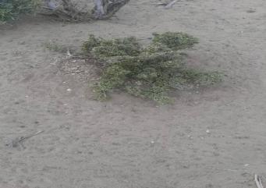 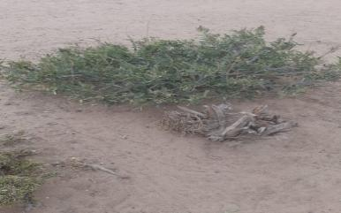

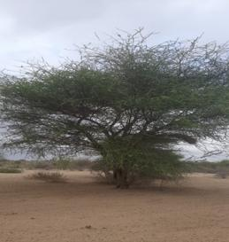 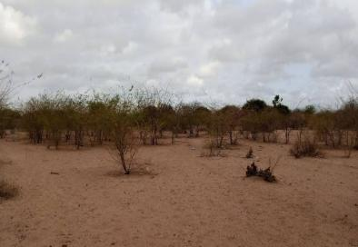

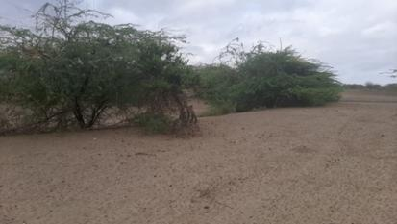

*Plate 2: Project area flora presentation*

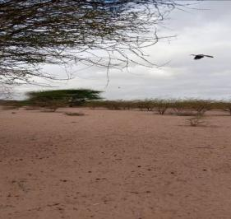 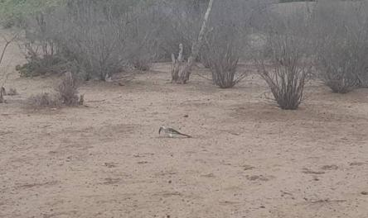

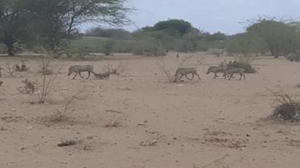

*Plate 3: Project area fauna presentation*

### Water Resources

The project area has no permanent rivers, however, there are a number of seasonal streams and water pans. Tana River runs on the South Eastern side of the project site. The project area had a dry water pan on co-ordinates 0°09'50.6"N 40°25'36.4"E. There was also a borehole beside the project site. The borehole was no longer in use.

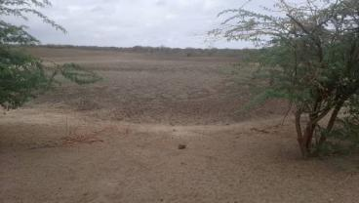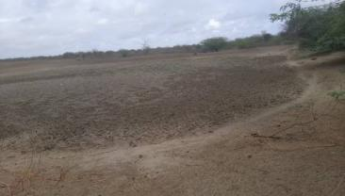

*Plate 4: Dry water pan beside the project site*

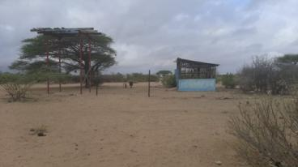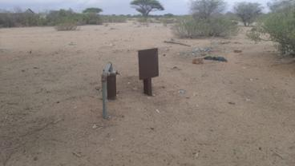

*Plate 5: Borehole besides project site.*

### Soil Type

The soils found in Garissa County are predominantly clay and loamy for the most part. Sandy soils are only found in a long narrow stretch from Modogashe to Dadaab because of the influence of the Ewaso Ngiro lagga and, and down south in Bura and Hulugho. The soils are deep to very deep. The soils are well drained for most part of upper Garissa from Balambala, Modogashe to Lagdera to Dadaab and Fafi and Township because clay to sandy silts are prevalent at the top in these areas. Lower Garissa from lower Fafi to the whole of Masalani and Ijara and Hulugho has soils with poor to very poor drainage. In these areas, black cotton soils are seen on top.

A soil sample was collected from the site and submitted to a NEMA designated Laboratory for for analysis of Petroleum Hydrocarbons. The results obtained and which are presented in table 8 below shows that the pollutants of concern were not detected in the sample. The further indicates that the site has not been impacted by petroluem hydrocarbons.

*Table 10: Soil Analysis results*

|  |  |  |  |  |
| --- | --- | --- | --- | --- |
| **Test** | **Method** | **Results** | **Units** | **Limit** |
| **BTEX** | | | | |
| Benzene | PQA/LIM/002 | <0.01 | mg/kg | <0.01 |
| Toluene | PQA/LIM/002 | <0.01 | mg/kg | <0.01 |
| Ethyl benzene | PQA/LIM/002 | <0.01 | mg/kg | <0.01 |
| Xylene | PQA/LIM/002 | <0.01 | mg/kg | <0.01 |
| **PAH** | | | | |
| Naphthalene | PQA/LIM/004 | <0.01 | mg/kg | <0.01 |
| Acenaphthylene | PQA/LIM/004 | <0.01 | mg/kg | <0.01 |
| Acenaphthene | PQA/LIM/004 | <0.01 | mg/kg | <0.01 |
| Fluorene | PQA/LIM/004 | <0.01 | mg/kg | <0.01 |
| Phenanthrene | PQA/LIM/004 | <0.01 | mg/kg | <0.01 |
| Anthracene | PQA/LIM/004 | <0.01 | mg/kg | <0.01 |
| Fluoranthene | PQA/LIM/004 | <0.01 | mg/kg | <0.01 |
| Pyrene | PQA/LIM/004 | <0.01 | mg/kg | <0.01 |
| Benzo(b)anthracene | PQA/LIM/004 | <0.01 | mg/kg | <0.01 |
| Chrysene | PQA/LIM/004 | <0.01 | mg/kg | <0.01 |
| Benzo(b)fluoranthene | PQA/LIM/004 | <0.01 | mg/kg | <0.01 |
| Benzo(k)fluoranthene | PQA/LIM/004 | <0.01 | mg/kg | <0.01 |
| Benzo(a)pyrene | PQA/LIM/004 | <0.01 | mg/kg | <0.01 |

### Climate and Meteorology

Garissa County has a relatively hot and dry climate throughout the year. The average temperature is greater than 27°C throughout the majority of the county. There is a strong south to north gradient of decreasing precipitation some southern parts of the county receiving greater than 1000 mm of precipitation per year, the central part of the county receiving around 500 mm, and the north/western parts of the country consistently receiving less than 250-500 mm. A small pocket of the north western part of the county receives less than 250 mm precipitation per year. As such, heat stress, dry spells, and drought are hazards that strongly contribute to agricultural risk in the county, especially in the more northern parts of the county. The Tana River runs along south-western boarder of the county where flooding along riparian areas are also a risk, especially due to periods of rain upstream in the Tana River.

## Socio-economic Environment

### Socio-economic status of Study Area

#### Demographic Profile

The demographic profile in terms of total population, number of households, household size and sex -ratio of the surveyed Damaseye Ward in study area has been discussed in section below and details are presented below

The project site is located in Daadab Subcounty, Damaseye ward. The project site is approximately 301m from the Madaghisi shopping centre. The project area‘s population is consisted of nomadic ethnic Somali pastoralists, who are mainly camel and goat herders. The project area has an estimated population of 15000 people and 2000 households with an estimate of 4 persons per household. The average gender ration for the population within the project area is estimated to be 60% female and 40% male. Table 9 below presents a summary of demographic profile of Madaghisi.

*Table 11: Summary of demographic profile*

|  |  |
| --- | --- |
| **Attribute** | **Magnitude/Number** |
| Approx. population | 15000 |
| Households | 2000 |
| Gender. | Male – 40%  Female – 60% |
| Ave. No. per household | 4 per household |
| Indigenous | Indigenous- 100%  Settlers – 0% |
| Vulnerable classes | Poor female headed households (100 households) |
| Dominant ethnic group | Somali |
| Primary religion | Islam |
| Other groups | Kamba |
| Employment (formal/Informal) | Formal – 5%  Informal – 95% |
|  |  |

#### Educational Infrastructure

As per the observation and information sought from the project area and from the public consultations, the area has only one school; Madaghisi primary school located at about 469.3m from the project site.

#### Occupation and Livelihood Profile

The main livelihood activities undertaken by people in Madaghisi village are pastoralism, business and farming only during rainy seasons. Business activities is undertaken at Madaghisi shopping centre which serves Damaseye ward and communities within Dadaab sub-county.

The main formal jobs at the area accumulates to 5%. The other 95% of the population is involved in informal employment.

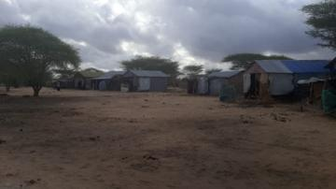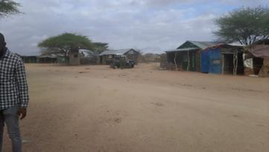

*Plate 6: Madaghisi shopping centre*

#### Land Use

Land in Garissa County is communally owned. In some areas, such township sub county land is partially demarcated and owners issued with allotment letters awaiting issuance of title deeds. Most of the land surrounding the proposed site is communal land and is used for rearing of domestic animals. This include Cattle, Camels, Goats and Sheep.

#### Social and Physical Infrastructure

The only public institution found in the project area is Madaghisi Primary school. The area had no functional health facility. There was an incomplete dispensary at the area. The existing dispensary is incomplete and was constructed with county government funding 2017 -2022. The incomplete dispensary in co-ordinates latitude 009’47.83N and longitude 40026’11.98 E

It was also reported that the local health risks are complicated by overcrowding. They include diarrhea, pulmonary issues, fever, measles, acute jaundice syndrome and cholera

The main source water is borehole. During the rainy seasons the people rely on Seasonal rivers, water pans and streams.

Roads connectivity within the area is poor and not regularly maintained and the main access road to the project site is a dirt road which branches off Garissa-Dadaab Road. The main forms of transport within the area are motor vehicles/matatus, pickups and Motor bikes and taxis.

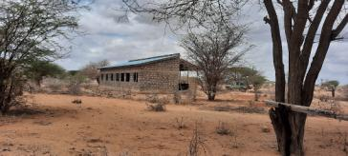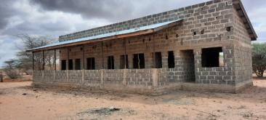

*Plate 7: Incomplete Madaghisi dispensary*

#### Vulnerable groups

According to the World Bank document-Vulnerability: A View from Different disciplines by Jeffry Alwang and Paul B. Siegel, a vulnerable group is a population that has some specific characteristics that make it at higher risk of falling into poverty than the others.

The categories of vulnerable groups identified at the project area include:

* Poor female headed households (100 households)

The vulnerable households can hardly access the basic needs and most of them really on well-wisher within the community. The project should consider such households for electricity connection. Most of them cannot afford the one thousand shillings’ connection fees.

#### Gender based vulnerability

The society in the project area is characterized by a patriarchal family structure. During the Female Focus Group Discussion and indepth interviews it was reported that the men are the main controllers of resources that include land and assets.

The main challenges that women and girls face in the community include inequality in education, early marriages, FGM and job discrimination.

The men are responsible for ensuring the financial security of the family. The women on the other hand are responsible for household activities such as fetching water, cooking, cleaning, taking care of the children. Female literacy was reported to be low.

#### Gender Based Violence

Gender based violence is one of the issues the women highlighted at the FGD. Family disputes are the main sources of GBV in the area.

#### Culture and heritage

No cultural site of significance was reported/observed within the project area. The area elders stated that there were cultural sites however the sites are more than 20km from the project area. Madaghisi is predominantly made up of the Somali community whose main economic activity is pastoralism.

The Somali community in the project area are a patriarchal society; men typically speak for women and make decisions in the family.

#### Religion in the project area

The community members are predominantly Islams with mosques and Madrasas within the locality.

#### HIV/AIDs prevalence

Garissa County has a population of 423,931 comprising of 51% males and 49% females. HIV prevalence in Garissa is (0.9%) lower than the national prevalence of 5.9% (Kenya HIV Estimates 2015). The county contributed 0.5% and 0.1% of the total new HIV infections in Kenya among children and adults respectively.

# STAKEHOLDER ENGAGEMENT

This section profiles the key stakeholders of the Madaghisi site solar project and assesses their potential concerns and levels of influence. The process of stakeholder engagement involved;

1. Stakeholder identification and analysis
2. Planning for the stakeholder engagement;
3. Disclosure of information;
4. Consultation with stakeholders
5. Addressing and responding to grievances; and
6. Reporting to stakeholders

## Stakeholder Consultation and Disclosure Requirement for the Project

The World Bank Environmental Social OPs 10 on Stakeholder Engagement and Information Disclosure emphasises on engagement in meaningful consultations with all stakeholders. The stakeholders should be provided with timely, relevant, understandable, and accessible information, and consult with them in a culturally appropriate manner, which is free of manipulation, interference, coercion, discrimination, and intimidation.

A documented record of stakeholder engagement, including a description of the stakeholders consulted, a summary of the feedback received, and a brief explanation of how the feedback was been explained in this chapter.

## Stakeholder Characterisation and Identification

Stakeholders are classified in the following two categories;

* **Primary Stakeholders**- Stakeholders who have a direct impact on or are directly impacted by the project.
* **Secondary Stakeholders**- Stakeholders who have an indirect impact or are indirectly impacted by the project.

### Stakeholder Mapping

Stakeholder mapping” is a process of examining the relative influence that different individuals andgroups have over a project as well as the influence of the project over them. The purpose of a

stakeholder mapping is to:

* Identify each stakeholder group;
* Study their profile and the nature of the stakes;
* Understand each group’s specific issues, concerns as well as expectations from the project
* Gauge their influence on the Project;

In line with the nature of the project and its setting in Madaghisi, the stakeholders have been identified and listed in the table given below;

*Table 12: Identified Stakeholders*

|  |  |  |
| --- | --- | --- |
| **Stakeholder Groups** | **Primary Stakeholders** | **Secondary Stakeholders** |
| Community | Local Labourers  Land sellers  Project PAPs | VMG’s  Local Community |
| Institutions | Faith Based Organisations  Education institutions  Community Based organisations |  |
| Government Bodies | County Government  District and local administration |  |

The significance of a stakeholder group is categorized considering the magnitude of impact (type, extent, duration, scale and frequency) or degree of influence (power and proximity) of a stakeholder group and urgency/likelihood of the impact/influence associated with the particular stakeholder group in the project context. The magnitude of stakeholder impact/influence is assessed taking the power/responsibility and proximity of the stakeholder group and the group is consequently categorized as negligible, small, medium or large. The urgency or likelihood of the impact on/influence by the stakeholder is assessed in a scale of low, medium and high. The overall significance of the stakeholder group is assessed as per the matrix provided in Table below.

*Table 13: Stakeholder Significance and Engagement Requirement*

|  |  |  |  |  |
| --- | --- | --- | --- | --- |
|  | | Likelihood of Influence on/ by Stakeholder | | |
| Low | Medium | High |
| Magnitude of impact | Negligible | Negligible | Negligible | Negligible |
| Small | Negligible | Minor | Moderate |
| Medium | Minor | Moderate | Major |
| Large | Moderate | Major | Major |

## Stakeholder Analysis

The Stakeholder influence and priority have both been primarily rated as:

* **High Influence**: This implies a high degree of influence of the stakeholder on the project in terms of participation and decision making or high priority to engage with the stakeholder;
* **Medium Influence**: Which implies a moderate level of influence and participation of the stakeholder in the project as well as a priority level to engage the stakeholder which is neither highly critical nor are insignificant in terms of influence; and
* **Low Influence**: This implies a low degree of influence of the stakeholder on the project in terms of participation and decision making or low priority to engage that stakeholder.

The intermediary categories of low to medium or medium to high primarily imply that their influence and importance could vary in that particular range subject to context specific conditions or also based on the responses of the project towards the community.

The coverage of stakeholders as stated above includes any person, group, institution or organization that is likely to be impacted (directly or indirectly) or may have interest/influence over project. Keeping this wide scope of inclusion in stakeholder category and the long life of project, it is difficult to identify all potential stakeholders and gauge their level of influence over project at the outset of the project. Therefore, the project proponent is advised to consider this stakeholder mapping as a live document which should be revised in a timely manner so as to make it comprehensive for any given period of time.

*Table 14:Summary of Stakeholder Influence*

|  |  |  |  |  |
| --- | --- | --- | --- | --- |
| Stakeholder Category | Relevant Stakeholders | Magnitude of Influence/Impact | Urgency/Likelihood of Influence | Overall rating of stakeholder rating |
| Primary Stakeholders | Community land owners | Medium | Low | Minor |
| Local Labourers and subcontractors | Small | Medium | Minor |
| County Government of Garissa, District and local administration | Medium | Low | Minor |
| FBOs, CBOs and Educational Institutions | Medium | Low | Minor |
| Secondary Stakeholders | VMGs | Small | Medium | Minor |
| Local Community | Medium | Low | Minor |

## KEY FEEDBACK RECEIVED DURING COMMUNITY CONSULTATIVE MEETING LEADINS TO LANd IDENTIFICATION AND GRC CONSTITUTION – SCREENING LEVEL

**Project:** Proposed Madaghisi Solar Mini-grid

**Venue of meeting**; Madaghisi Shopping Centre

***Date: 24/06/2021***

The Chief Malaghisi location called the meeting to order at 12:38 PM. The meeting began with a word of prayer from one community member. The language used to communicate was Kiswahili with a translator explaining to the community in the local Somali dialect. The chief welcomed all to the meeting and said the community is ready for the stakeholder engagement and asked them to participate actively so that the meeting would be fruitful.

The Chief welcomed the chief officer Garissa County Dr. Adan Mohamed to make his remarks and welcome the KOSAP project team to the ward. The Ward Administrator welcomed and thanked all for attending the meeting and asked the community to listen and participate in the consultation. He noted that the County government is in support of the projects that come to make the lives of the people better. He then invited Mr. Amin KPLC County business manager Garissa County to welcome the project team to talk to the community. Mr. Amin asked the community to feel free and participate in the engagement forums because they are part of the key stakeholders of the project.

Mr. Amin invited the project’s team leader Engineer Benson Mwakina from the Ministry of Energy (national government) to introduce the project team and proceed with the consultations. Engineer Mwakina asked the team to make brief introductions before they engage the community in different issues of the proposed project. Below is a list of KOSAP team members and Garissa county officials present.

### Positive Impacts/Benefits of the Project

Mr. Mwangangi explained that, every project has both positive impacts and negative impacts. Our assignment is to explain to you the impacts of the project so that you understand how the project will benefit you and the community at large. The project benefit both direct and indirect are as follows:

1. Better source of lighting- replacement of Kerosene lamp and small de-lite lamps with electricity lighting which is clean and has better lighting
2. Benefits to education- provide source of lighting which enables pupils and students to take advantage of longer hours of preps/study in homes. Electricity will be useful in availing power needed to enable use of radio and television sets. Once parents are able to buy these gadgets pupils can access electronic educational materials
3. Business opportunities-Power provides energy needed to power some gadgets that are difficult and expensive to power with generators. Access to electricity will therefore allow the community to take advantage of new business opportunities and enhance the existing ones e.g. Barber shops, salons, posho/maize mills, welding, photo copying, printing, fuel stations, milk coolers and fridges to preserve meat among others
4. Employment and wealth creation- community members will get opportunities to provide non-skilled and skilled labor during construction and operation phases
5. Local Material Supplies and other requirements- the proposed project provides opportunities to supply some materials available locally
6. Up Scaling Electricity Access to the off-grid areas- this area is far away from the grid and so the proposed project helps to reach such areas faster and in a cost effective manner as opposed to grid connections.

### Negative impacts of the project

Having discussed the benefits of the project, Mwangangi explained that projects also have negative impacts. He noted that the most important thing is to be able to mitigate the negative impacts so that they do not affect the community. He said ‘’the proposed solar Mini-grid will have the following negative impacts and also briefed the members on possible mitigation measures.

|  |  |  |
| --- | --- | --- |
|  | **Negative impact** | **Mitigation measures by contractor** |
|  | Vegetation clearance of the site identified. | * Clear only the areas that are needed to put up the mini-grid * After construction, do landscaping with grass to areas that have no electrical installation as opposed to living areas bare * Planting of trees |
|  | Land acquisition/take  As you had been briefed before the site identified should;  -must not result in displacement of community members  - We must avoid land that is currently settled or which has squatters.  -There will be an impact of forgoing the current land uses if any or future land uses for the sake of the project. | * The community should be willing and ready to live with this impact |
|  | Occupation safety and health hazards e.g. accidents, fall from heights, pricks by sharp objects | * Use of proper personal protective equipment like gloves, overalls, helmet, safety shoes * Allocating work according to skills * Toolbox talks to workers to identify hazards and risky activities |
|  | Labor influx. The nature of the project will require technical skills that may not be available in this community. This will require movement of construction workers (labor influx) into this community. Some risks that are involved with labor influx include social ills, cultural conflict, and insecurity among others. | * All workers will be sensitized to respect the locals culture, and conduct themselves according to the contractors code of ethics. The project shall have an established and operational Grievance Redress Mechanism accessible to community members * Reduction of labor influx by tapping into the local workforce |
|  | Risk of social conflict due to competition for resources and opportunities | * Awareness-raising among local community and workers on the need to have a good /cordial working relation * Consultations with and involvement of local communities in project planning * Provision of cultural sensitization awareness for workers regarding engagement with local community. * Recruitment of local workforce to the extent possible especially unskilled and semi-skilled jobs * Contactor shall make provision to provide resourcesneeded by the workers if the need for such resources may result to competition e.g. water * Working closely between contractor and the project grievance redress committee to address complains on time. |
|  | Communicable diseases (including STDs and HIV/AIDS) | * Education/awareness about transmission of diseases * Information campaigns on STDs among the workers and local community on ethics, morals, general good behavior and the need for the project to co-exist with the neighbors during the community and worker engagement forums. * Provide condoms to employees |
|  | Gender-based violence including sexual harassment and exploitation | * Information and awareness raising campaigns to you community members and specifically women and girls. * Mandatory awareness creation for workers on required lawful conduct in the community and legal consequences for failure to comply with laws * Report all complaints on gender-based violence or harassment through the GRM and also directly through CREO * Working closely and Instruction of local law enforcement to act on community complaints on time * Inclusion of GBV specific mitigation measures in the Environmental and Social Management and Monitoring Plan of contractor * Requirement of contractor to have code of conduct for the workers and to implement them |

### Land requirements for the project

Mr. Mwangangi told the community that one of the agendas of the project team’s visit was to progress land acquisition process for the proposed Mini-grid. He explained to the public forum that the proposed project will require about 2-3 acres of land. He explained that the piece of land identified will be screened for its Suitability for the purposes of the Community Mini-grid.

### Grievance Redress Mechanism

Mr Mwangangi explained that in a project, grievances may arise and it important to have a grievance redress mechanism that is known to all the community members and accessible with no costs to the community members.

Mr Mwangangi explained to the community that it is important to put in place a project grievance redress mechanism (GRM). He noted that the GRM to be set should borrow heavily from the existing conflict resolution structures in the community. He explained that the need for a GRM is to provide the community and other stakeholder’s opportunity to share project information and raise questions and grievances about the project. He told the community that they are free to raise any complain or request information about the project. He explained further that members of the project/ grievance redress committee will be chosen by the community members themselves. The committee chosen will be in charge of giving project information to the community and be a focal point for reporting project related issues of concern or grievances. He added that the composition of the committee should have representatives from all groups in the community including men, women, youth and persons with disability.

GRM team selected

|  |  |  |  |  |
| --- | --- | --- | --- | --- |
| **No.** | **Names** | **Represents** | **Id. No** | **Phone No.** |
|  | Fatuma Omar Shekhow | Women | 12912316 | 0725657587 |
|  | Ijabo Muhumed Daar | Women | 21091662 | 0792593315 |
|  | Mohammed Farah Omar | Men | 0034326 | - |
|  | Ador Abdulahi Yusuf | Youth | 23493429 | - |
|  | Mohammed Lotto Gababe | Men | 8503209 | - |
|  | Aden Ibrahim | Men | 8502422 | - |

### Plenary session

Mr Mwangangi made a brief summary of what had been discussed and invited the community members to ask questions or seek clarifications on the information shared. The questions raised and responses provided are presented in the table below.

|  |  |  |  |  |
| --- | --- | --- | --- | --- |
|  | **Name** | **Questions/suggestions** | **Response** | **Response by agency on how feedback will be used or acted upon** |
| 1. | Billow Said Diis | -Greetings  -we the community of Malaghisi are very happy with the project. Roads and Power are very important for the development of any Town. The community will cooperate with the government to ensure the project is a success. The community school has computers but it cannot operate because the area has no power. The area borehole is powered by diesel which is very expensive | **-** | - |
| 2 | Adow Abdulahi Yusuf | Greetings  We are very grateful for the project. we know how important power is for development so we don’t have any questions | **-** | - |
| 3 | Aden Ibrahim Kheri | Greetings  Most of the community members in this area are pastoralist that’s why you do not see many people in the meeting. Majority are out there with goats and camels looking for pasture. Our town is very populated and most youths don’t have jobs. The project will assist our youths get jobs |  |  |

### FOCUS GROUP DISCUSSION

1. **YOUTHS FGDs**

This FGDs were led Samuel Mbugua

He welcomed the youths present for the focus group discussion. He further explained to them the proposed project the government wants to implement in their neighborhood will be supplying electricity to the community. This electricity will be generated through solar panels and standby generator. This project is being funded by the World Bank and being implemented by Ministry of Energy through Kenya Power and Lighting Company and County Government of Garissa.

The youths noted were engaged on how the proposed project will be implement in the area and they identified the following positive impact the project will come along with as follows;

* Creation of direct and indirect employment for the community people
* Reduction of travel expenses since health services will be near them
* Clean source of energy (electricity) in their neighborhood
* Improvement of education standards
* Increase of the land value
* Improvement of the economy of the area
* Access to information and news since the community members will invest in the purchasing of the radios, Tvs, and internet services

Further the youths identified the negative impacts that the proposed Mini-grid will come up with in their neighborhood;

* Introduction of visual impacts due to the proposed mini grid and low voltage lines
* Clearing of vegetation on the proposed project site to create room for the construction of the Mini-grid
* Increase of population in the neighborhood especially during the construction phase
* Increase of crimes and other evil vices i.e. unwanted children, early pregnancies, spread of sexual transmitted diseases, petty theft.
* Mixing of various cultures of different people who will be working during the construction and operational phases of the proposed Mini-grid project.
* More intake of water during the construction and operational phases of the proposed Mini-grid
* Instance of air pollution will be witnessed during the operation phase of the proposed mini-grid.

The youth further identified various areas of involvement during the implementation and operation of the proposed Mini-grid which include;

* Taking up of employment opportunities both skilled and unskilled within the project site. These employment chances include; security, traffic marshals, drivers, masonry and casual work among others.
* They will assist in dispute resolutions on various conflicts that might arise during the construction and implementation of the proposed Mini-grid.
* Ensure there are equal oppournities to all community members especially during employment and supplying of construction materials for the proposed Mini-grid.
* Orientation of the construction team of the proposed Mini-grid into local community’s culture and religion so as to avoid confrontations with the construction team
* To be given an oppournities to supply the construction materials that are local available especially the sand, marram, hardcore, building stones, wood among others
* To be provided with an oppournities of transporting other materials and equipments that could be required for construction and operation of the Mini-grid.
* Need to be involved in the ESIA consultation to ensure the project is environmental friendly.
* Land identification
* Sub- contracting especially supply of building materials, transportation services, supply of fuel, supply of food items and water
* Offering translation services between the contractors and the local community
* To have a representation in the project implementation committee.

When youths were asked if they support the proposed project? All of the youths present were in full support of the proposed mini grid project and agreed that they will lobby other youths to support the project.

The Youth selected their GRM representatives for Malanghisi mini-grid as follows:

|  |  |  |
| --- | --- | --- |
|  | **Name** | **ID** |
| 1 | Ador Abdulahi Yusuf | 23493429 |

1. **Discussion on Women Focus Group**

The group was led by Dorothy who was able to explain why a separate discussion was put up in order for them to have the opportunity to freely express themselves.

She explained the agenda of the visit by the officers from National government and county government was to undertake an environmental and social screening of the proposed site to check suitability in terms of environmental, technical, social and health requirements.

The second objective was to undertake community engagement to sensitize the community on the project and the third objective was about land acquisition for the project and the need for a project grievance redress mechanism.

She gave a summary of the project in terms of its positive and negative impacts and their mitigation measures, the safety precautions and the land acquisition process. She also explained the need for the women to select a representative to the project committee who would represent their views/issues to the committee for redress.

She ensured all the women had understood their rights, roles and benefits concerning the project. Further the women were educated on how they can take up economic opportunities that will raise during project implementation. They were also given opportunity to air their issues/ questions and or /give suggestions to make the project implementation process better.

The discussions went further to bring out issues on how the women can take advantage of the project benefits rather than taking a back seat. She explained to them that they would benefit more from the electricity because they will be able to use clean energy to cook and also benefit from access to information through use of radios and TV that are powered by electricity enabling them to make informed choices on different issues such as nutrition, health, farming among others. They were also set to benefit if they could set up small businesses like salons, cold drink kiosks, cooling milk because it spoils easily, children will have time to study and enhanced security due to the fact that the area will be well lit among other benefits. Gender based violence issues were also discussed including; forms of GBV, rationale for addressing GBV, ways in which a project can worsen existing GBV risks or create new risks, the need to report and document any complaints against workers, report incidences of GBV while ensuring survivor centered approach (respect for the choices, wishes, rights and dignity of the survivor). The women were told to be more vigilant to ensure young girls do not fall prey to GBV incidences. The women were requested to keep talking to the girls on GBV risks and the need to raise alarm in case of risks factors early enough.

All the women were in agreement for the project to be brought to Malanghisi

1. GRM Representative for Malahgisi Mini-grid-

|  |  |  |  |
| --- | --- | --- | --- |
| **Serial No.** | **Name** | **ID NO.** | **Cell No.** |
| 1 | Fatuma Omar Shekhow | 12912316 | 0725657587 |
| 2. | Ijabo Muhumed Daar | 21091662 | 0792593315 |

**Q/A Sahal Ahmed**-We have left behind our goats grazing, stopped fetching firewood and selling our goods at the shops to come for this meeting. What do you have for us in return?

**Reponse**-We have requested the leadership of the community to have this meeting in order to inform you of the project, its benefits and how you intend to benefit. An important step in government projects. After the meeting everyone is free to go back and continue with their activities

**Q2:** How long will it take before the project begins-An average of 18Months

**Q3**:Will there be jobs for young men and women who are educated here in Malaghisi

**Response**-Unskilled labor will be reserved for the locals, skilled labor can only be given to those that are qualified

**Comment**-The connection fee should be Kshs 500/= and not Kshs 1,000/=

**Response**-the connection fee is highly subsides compared to other projects of similar nature within the country. The community is therefore encouraged to support the project and connect to power once the project is complete

1. **FOCUS GROUP DISCUSSION FOR MEN**

Simon Mwangangi called the Focus group discussion for Men into order and thanked the Men present for turning up for the meeting in good numbers and for their contribution in the Public Baraza.

A focus group discussion was held with men above 35 years of age. This categorization was based on the assumption that these men; as the heads of families and with a deeper understanding of the community set up, roles, entitlements and were also a foundation of knowledge helpful to the project team in understanding the community better. The main objective of this discussion was to assess whether men had understood the proposed project and its requirements and to provide an opportunity for them to air their issues/give their opinions on the project.

Simon Mwangangi from KPLC explained the importance of holding a separate discussion with them so that they would have an opportunity to freely express themselves and inform the Project team how they would wish to be involved in the project. Simon reminded the men that as the heads of families, they played a crucial role in ensuring the project was a success. He explained to the men that the essence of the environmental and social screening of the project site was to assess its suitability in terms of environmental, technical, social and health requirements. The second objective was to undertake community engagement to sensitize the community on the project. The third objective was to explain the land requirements for the project and the need for a project Grievance Redress Mechanism (GRM) for the project. This would be achieved through the formation of a Grievance Redress Committee (GRC) in which men required to select their representative. Simon went further and summarized the project by explaining its positive and negative impacts and their mitigation measures and the requirements for identifying land for the project. He also explained the need for the men to elect a representative to the GRC which also doubled as the project committee. The representative would present their views/issues to the committee for redress and further action to ensure that the interests and needs of men were factored through-out all the phases of the project.

The men were further explained of their role and responsibility in terms of protecting and ensuring security for the project and the need for community ownership of the project. Simon further told men in the meeting that the identified site would be fenced and would hence forth be referred to as land put aside by the community for energy development project.

Simon went ahead and asked the Men to give their views on how they wished to be involved in the project, to ask questions, give suggestions and or seek clarifications. Their responses and concerns were as follows.

The men confirmed they were in agreement to have the project brought to the community and said they will give support to the project as required.

There were no questions.

The following were elected to be representatives for men in the GRM/ Project committee.

* 1. Mohammed Farah Omar of ID No. 0034326
  2. Aden Ibrahim of ID No. 850422
  3. Mohammed Lotto Gababe of ID No 8503209

## KEY FEEDBACK RECEIVED DURING esia STAKEHOLDER CONSULTATION PROCESS

The general stakeholder consultation was done in a public meeting(Baraza) organized at the Madaghisi Chiefs office compound where there were a total of 65 in attendance. The meeting was chaired by the area chief assisted by the assistant chief and the “Nyumba Kumi” leaders.

The ESIA team spearheading the process included the following;

|  |  |
| --- | --- |
| **NAME** | **ORGANISATION** |
| **Simon Mwangangi** | ESS KPLC |
| **Hottensia Kabuki** | Norken International Limited |
| **Allan Owino** | Centric Africa Limited |
| **Umulkheir Abdi** | Norken International Limited |
| **Martin Gitonga** | Norken International Limited |

The feeback received during the stakeholder consultation process have been summarized below:

|  |  |  |  |  |  |  |
| --- | --- | --- | --- | --- | --- | --- |
| **No** | **NAME** | | **Organization/ Designation** | | **Issues/comments discussed** | |
| 1. | Mr. Mohammed Ali | | The area Chief | | He expressed his opinion regarding the project. He was concerned on the projects’ implementation and the entire timeline. | |
| 2. | Mr. Mohammed Farah | | Community member | | Mr. Mohammed Farah was appreciative of the project and requeated for the project to be implemenred as soon as possible. | |
| 3. | Mr. Faruma Omar | | Community member | | She was concerned on whether the project will provide the energy required to pump their water for domestic use. | |
| 4. | Mr. Jimale Noor | | Community member | | He was concerned on the animal feed after the site clearence is done. | |
|  | |  | |  | |

**Benefits of the Project**

* The community was in support of the project. They noted that the project will beneficial to the community as it will:
  + The electricity will assist in water reticulation to the community members at least to reduce the distance covered.
  + Lighting will improve the security situation
  + Employment opportunities will increase for both the youth, men and the women due to increase in business opportunities and during the project construction phase.
  + Medical services will improve
  + Business improvement

**Community Concerns**

* The community raised they following concerns:
  + Gender equality was raised in relation to the project especially on employment opportunities. They suggested that youths and women should be given priority;
  + Increase in HIV Aids due to interactions of the locals with the project’s technical staff from outside the project area

**Community Requests**

* The community requested the following from the project:
  + 1st Priority to be water reticulation from the existing borehole to the community members.
  + 2nd Priority to be completion of the construction of a ward at the Madaghisi dispensary.
  + 3rd Priority to be provision of lighting at the primary schoola and additional of class rooms.
  + The women especially women that they need jobs to support their children

|  |  |
| --- | --- |
| *Public participation “Baraza” Session* | |
|  |  |
|  |  |

*Plate 8: Stakeholders engagement process*

The table below presents the issues /comments raised by the stakeholders during the public meeting and the responses given by the Proponent and the Consultant.

## summary FEEDBACK RECEIVED DURING focused group discussion

The Focus Group Discussions were held with Men, Women and the Youth as indicated in Table 13;

*Table 15: FGD dates and attendance*

|  |  |  |  |
| --- | --- | --- | --- |
| **Group** | **Date** | **Attendance** | **Venue** |
| Men | 20th October 2021 | 8 | Madaghisi-Chief’s Office |
| Women | 20th October 2021 | 10 | Madaghisi-Chief’s Office |
| Youth | 20th October 2021 | 9 | Madaghisi-Chief’s Office |

The key concerns and expectations that were raised during the FGDs have been summarized below:

* + - 1. **Female Stakeholders’ Consultation and Participation**

The females’ participants in the FGD were 10 in number with an age range of 20 to 60. The meeting had only one widows. The following were their responses;

**The project perception**

The women indicated that it was their first time hearing of the project during the Baraza. They were however in support off the project.

**Women in Madaghisi community and their roles as reported by the FGD**

* Women and men don’t have equal opportunities in the community. They clarified that men have more opportunities in the community and at the workplaces,. However, this is not the case in education since both men and women have equal opportunities
* Wimen have been left to head the family as the men search for pasture.
* Women receive information about local issues and development or news through the local administrators.
* Women do not feel safe in Madaghisi community due to the rampant cases of domestic violence between married couples.

**Institutions/community Development**

* The main community development priorities/needs include.

1. Health-Improving the quality of health in the localty by completing the construction of the martenity ward.
2. Water-Improve the accessibility and availability through water reticulation.

**Education, literacy, and training of Women in Madaghisi**

* They denoted that about women go to school equally as men and the primary school is available at the project area while secondary school is in Dadaab and Madaghisi.

**Health care for Women in Madaghisi**

* Access to health care is difficult since there is not at the project area. The Madaghisi dispensary is still under construction.
* Environmental issues affecting health in the community is mainly lack of sanitary conditions-water and sanitary pads.

**Transport and communication**

* The main forms of transport are motorbikes and sometimes cars.

**Hygiene and waste management by Women**

* Some Women in Madaghisi do not access sanitary facilities and or products e.g., sanitary towels.
* The area possess pit latrines but most people have no access and resort to using the bush.
* The women manage the wastes by burning.

#### Male Stakeholders’ Consultation and Participation

* The male participants were 8 in number. The male participants are household heads. The following were the response during the male FGD.

**The project perception**

* The men indicated that they have heard about the project during the time the community gave out the land.
* The project will create employment.

**Role of Men as per the FGD**

* The findings showed that the roles of men is keeping livestock therefore looking for pastures and provide for the family.
* They also make critical desions for the community and protect it too.
* Men have control over most of the resources.

**Economy /income generation**

* Men generally earn their income through pastoralism, they heard and later sell livestock.
* Men contribute more income in the household as compared to women.

**Land use**

* The main land based activity in the area is grazing.
* The main animals kep include cows, goats, sheep and camels.

**Education, literacy, and training as per the FGD**

* Most men usually get to Secondary school compared to women

**Access to Water analysis by the male FGD**

* The women are responsible for searching water for domestic use.

**Access to Power**

* Sources of energy in Madaghisi
* For lighting – Torch
* Cooking -firewood
* Charging mobile-solar
* There was no reliable power supply in the area

**Transport and communication**

* The main forms of transport are motorbikes and matatus
* They have no internet services due to the poor network.
  + - 1. **Youth Stakeholders’ Consultation and Participation**
* The youth participants were 9 in number. The following opinions were provided by the youth participants during the FGD.

**The project perception**

* The youth disclosed that they heard about the project back in June 2021 when KPLC visited.
* They acknowledged that the project will have vast prositive impacts that include; improved security, creation of employment etc.

**Education, literacy, and training for youth FGD**

* An estimate of 60% of the youth has completed secondary education while 20% have completed Vocational/College level education.

**Recreation**

The main recreational games for the youth is football.

# IMPACT ASSESSMENT AND MITIGATION MEASURES

## Introduction

This section provides an assessment of potential environmental and social impacts from the proposed Projects as well as the proposed mitigation measures to avoid, reduce, remediate or compensate for potential negative impacts and to enhance positive impacts. A description of the assessment methodology used to assess the significance of potential impacts, taking into account impact magnitude and sensitivity of receptors and resources affected, is provided below. All the mitigation measures identified in this chapter have been collated into the Environmental and Social Management and Monitoring Plan (‘ESMMP’) matrix. This is including Occupational Health and Safety

* 1. **Impact Assessment Methodology**

An impact is essentially any change to a resource or receptor brought about by the presence of the Project component or by the execution of a Project related activity. In general, the assessment of impacts will proceed through an iterative process considering four key elements:

* Prediction of potential impacts and their magnitude (i.e., the consequences of the development on the natural and social environment);
* Evaluation of the importance (or significance) of potential impacts taking the sensitivity of the environmental resources or human receptors into account;
* Development of mitigation measures to avoid, reduce or manage the potential impacts or enhancement measures to increase positive impacts; and
* Assessment of residual significant impacts after the application of mitigation and enhancement measures.

Where significant residual impacts remain, further options for mitigation may be considered and impacts re-assessed until they are as low as reasonably practicable for the Project and would be deemed to be within acceptable levels:

* 1. **Defining Impact**

Impacts will be defined in a number of ways, including:

* Nature of impact: positive or negative;
* Type of impact: direct, indirect, or cumulative;
* Duration of impact: temporary, short-term, national, international
* Scale of impact: onsite, local, regional, national, international.
  1. **ASSESSMENT OF SIGNIFICANCE**

Criteria for assessing the significance of impacts will stem from the following key elements:

* Status of compliance with relevant Kenyan legislation, policies and plans and any relevant Kenyan or industry policies, standards or guidelines, as well as international best practice standards and guidelines;
* The magnitude (including nature, scale and duration) of the change to the natural or socioeconomic environment (e.g. an increase in coastal erosion, or an increase in employment opportunities), expressed, wherever practicable, in quantitative terms. The magnitude of all impacts is viewed from the perspective of those affected by considering the likely perceived importance as understood through stakeholder engagement;
* The nature and sensitivity of the impact receptor (physical, biological, or human). Where the receptor is physical, the assessment considers the quality, sensitivity to change and importance of the receptor. For a human receptor, the sensitivity of the household, community or wider societal group is considered along with their ability to adapt to and manage the effects of the impact; and
* The likelihood (probability) that the identified impact will occur. This is estimated based upon experience or evidence that such an outcome has previously occurred.

It is generally accepted that significance is a function of the magnitude of the impact and the likelihood of the impact occurring.

For this assessment, significance has been defined based on five levels described in table below;

*Table 16: Categories of Significance*

|  |  |
| --- | --- |
| **Category** | **significance** |
| Positive impacts | Positive impacts provide resources or receptors, most often people, with  positive benefits. It is noted that concepts of equity need to be  considered in assessing the overall positive nature of some impacts such as economic benefits, or  opportunities for employment |
| Negligible impacts (or Insignificant impacts) | Negligible impacts (or Insignificant impacts) are where a resource or receptor  (including people) will not be affected in any way by a particular activity or the  predicted effect is deemed to be ‘negligible’ or ‘imperceptible’ or is  indistinguishable from natural background variations. |
| Minor | An impact of minor significance (‘Minor impact’) is one where an effect will be  experienced, but the impact magnitude is sufficiently small (with or without  mitigation) and well within accepted standards, and/or the receptor is of low  sensitivity/value. |
| Moderate | An impact of moderate significance (‘Moderate impact’) is one within accepted  limits and standards. Moderate impacts may cover a broad range, from a  threshold below which the impact is minor, up to a level that might be just short  of breaching a legal limit. Clearly to design an activity so that its effects only just  avoid breaking a law and/or cause a major impact is not best practice. The  emphasis for moderate impacts is therefore on demonstrating that the impact has  been reduced to a level that is ALARP (as-low-as-reasonably-possible). This does  not necessarily mean that ‘Moderate’ impacts have to be reduced to ‘Minor’  impacts, but that moderate impacts are being managed effectively and efficiently. |
| Major | An impact of major significance (‘Major impact’) is one where an accepted limit or  standard may be exceeded, or large magnitude impacts occur to highly  valued/sensitive resource/receptors. An aim of EIA is to get to a position where  the Project does not have any major residual impacts, certainly not ones that  would endure into the long-term or extend over a large area. However, for some  aspects there may be major residual impacts after all practicable mitigation  options have been exhausted (i.e. ALARP has been applied). It is then the  function of regulators and stakeholders to weigh such negative factors against the  positive ones in coming to a decision on the Project. |

For environmental impacts the significance criteria used in this ESIA is shown in Table 15: .

*Table 17: Overall Significance Criteria for Environmental Impacts*

|  |  |  |  |
| --- | --- | --- | --- |
| **Receptor sensitivity (or resource value)**  **Low** | **Impact Magnitude** | | |
| **Low** | **Medium** | **High** |
| Minor | Minor | Medium |
| **Medium** | Minor | Medium | Major |
| **High** | Medium | Major | Major |

For the social impact assessment, the perceptions of stakeholders, expressed as opinions around certain issues, can be as important as actual impacts. Consequently, the concept of perception is explicitly brought into the evaluation of significance after an impact is evaluated. When an impact is of significant stakeholder concern, this may be causing to raise the significance rating. This prompts the formulation of more rigorous and appropriate mitigation measures which focus on the source of the impact and also address stakeholder perceptions. The risk of not addressing stakeholder perceptions is that reputational damage could arise, resulting in the loss of a ‘social licence to operate.

* 1. **Magnitude of Impact**

The impact assessment describes what will happen by predicting the magnitude of impacts and quantifying these to the extent practical. The term ‘magnitude’ covers all the dimensions of the predicted impact to the natural and social environment including:

* the nature of the change (what resource or receptor is affected and how);
* the spatial extent of the area impacted, or proportion of the population or community affected;
* its temporal extent (i.e., duration, frequency, reversibility); and
* where relevant (accidental or unplanned events), the probability of the impact occurring.

For biophysical impacts, the definitions for the spatial and temporal dimension of the magnitude of impacts used in this assessment are provided in Table 15

For social impacts, the magnitude considers the perspective of those affected by taking into account the likely perceived importance of the impact, the ability of people to manage and adapt to change and the extent to which a human receptor gains or loses access to, or control over, socio-economic resources resulting in a positive or negative effect on their well-being (a concept combining an individual's health, prosperity, their quality of life, and their satisfaction).

Table 16 below ( under Likelihood) provides an account of the key features (definitions) of each of the impact significance classifications (from Not Significant to High); specifically linking them to the need for mitigation measures.

* 1. **Sensitivity of Resources and Receptors**

Sensitivities are defined as aspects of the natural or social environment which support and sustain people and nature. Once affected, their disruption could lead to a disturbance of the stability or the integrity of that environment. For ecological impacts, sensitivity can be assigned as low, medium or high based on the conservation importance of habitats and species. For habitats, these are based on naturalness, extent, rarity, fragility, diversity and importance as a community resource.

For socio-economic impacts, the degree of sensitivity of a receptor is defined as ‘a stakeholder’s (or groups of stakeholders’) resilience or capacity to cope with sudden changes or economic shocks. The sensitivity of a resource is based on its quality and value/importance, for example, by its local, regional, national or international designation, its importance to the local or wider community, or its economic value.

* 1. **Likelihood**

Terms used to define likelihood of occurrence of an impact are explained in Table 16

*Table 18: Explanation of Terms Used for Likelihood of Occurrence*

|  |
| --- |
| An impact with a |
| High probability | Refers to a very likely impact | Refers to very frequent impacts |
| Medium probability | Refers to a likely impact | Refers to occasional impacts |
| Low probability | Refers to rare impacts | Refers to rare impacts |
|  | As far as one-time events (e.g. air emissions) or slowly developing effects  are concerned (e.g. impacts on local life  style) | As far as possibly recurring impacts are  concerned, such as accident or unplanned events (e.g. traffic accident,  fire) |

* 1. **Definition of mitigation measures**

Mitigation measures are developed to avoid, reduce, remedy or compensate for significant potential negative impacts, and to create or enhance potential positive impacts, such as environmental and social benefits. In this context, the term “mitigation measures” includes operational controls as well as management actions. These measures are often established through industry standards and may include:

* Changes to the design of the project during the design process (e.g., changing the development approach);
* Engineering controls and other physical measures applied (e.g., waste water treatment facilities);
* Operational plans and procedures (e.g., waste management plans); and
* The provision of like-for-like replacement, restoration or compensation.

For potential impacts that are assessed to be of major significance, a change in design is sometimes required to avoid or reduce the significance. For potential impacts assessed to be of moderate significance, specific mitigation measures such as engineering controls are often sufficient to reduce these impacts to ALARP (‘as-low-as-reasonably-possible’) levels. This approach takes into account the technical and financial feasibility of mitigation measures. Potential impacts assessed to be of minor significance are usually sufficiently managed through good industry practice, operational plans and procedures.

In developing mitigation measures, the first focus is on measures that will prevent or minimise potential impacts through the design and management of the Project rather than on reinstatement and compensation measures.

* 1. **Assessing residual impacts**

Impact prediction takes into account any mitigation, control and operational management measures that are part of the project design and project plan. A residual impact is the impact that is predicted to remain once mitigation measures have been designed into the intended activity. The residual impacts are described in terms of their significance in accordance with the categories identified in Table 15 above

Social, economic and biophysical impacts are inherently and inextricably interconnected. Change in any of these domains will lead to changes in the other domains.

## Positive Impacts During Construction Phase

This section enumerates and discusses the positive impacts associated with the proposed project during construction phase of the project.

### Creation of Employment Opportunities

Various employment opportunities will be available during construction. The opportunities will be both skilled and unskilled. Majority of the unskilled and semi-skilled jobs will be taken up by the local community. Employment of the locals will increase skill transfer from the contractors.

The approximate number of workers to be employed by the proposed project is not yet known, however, this will contribute to easing unemployment level in the area. There will be a trickledown effect to the economy at large resulting from new income revenues as well as services provided through this project.

The impact significance is low as it will employ few people over a short period

**Enhancement measures**

* Contractor should ensure that they prioritise the local community in allocating job opportunities.
* Contractor should ensure that job opportunities are not discriminatory
* Equal opportunities should be given to both men and women

### Improving local economy

During this phase, the project will require supply of building materials most of which will be sourced locally at the nearest trading centre and its environs to the extent possible. Therefore, the project will provide ready market for local enterprises with such materials and boosts the local economy.

The businesses that will benefit during this phase are such as hotel, shops, artisan industries and food vending who will be benefit directly from the construction, as people working there will need commodities from them. This will promote the informal sector in securing some temporary revenues and hence improved livelihoods.

One of the responsibilities of the PAPs of the proposed Solar Mini-grid is to undertake wiring of their premises before there are connected and payment of a connection fee of Ksh 1000. The MOE through its implementing agency KPLC should consider supporting at least 50 households that are very poor through installation of ready boards to offset the cost of wiring so that they can also access electricity.

The impact significance is low as it will buy few materials over a short period of time

**Enhancement measures**

* KPLC should ensure that their contractors/suppliers remit taxes and have a tax compliance certificate
* Prioritise local purchases over imports.
* Remit taxes on behalf of employees
* Contractor should prioritise local purchases over imports;
* Contractor should give prefence to local labour which increases the local’s ability to spend

## Positive Impacts during Operation Phase

### Quality, Reliable Power Supply

There is no electricity in Madaghisi. This is a maiden project with an aim of supplying power through solar because the area is far away from the national power grid. Once operational, household and public institutions (dispensary, primary school) and shopping centre in the area will greatly benefit from the stable power supply.

The impact significance is high as it will provide power where it wasn’t for a long period

**Enhancement measures**

* KPLC should ensure that they have a functional customer support team and a field response team;
* KPLC should ensure that they communicate power outages early to consumers

### Employment Creation

Employment opportunities will also be created during the operation phase of the project. Opportunities that will be created include unskilled, semi-skilled to skilled jobs. These will involve security personnel, and staff to operate and maintain the Mini-grid. Employment will increase skill transfers.

The impact significance is low .

**Enhancement measures**

* KPLC should ensure that they prioritise the local community in allocating job opportunities.
* KPLC should ensure that job opportunities are not discriminatory
* Equal opportunities should be given to both men and women

### Reduction of Pollution Associated with Thermal Power Generation, Kerosene and Wood Fuel Usage:

Residents in the area use different sources of energy. Electricity supply will imply that as many as are willing can apply for connection and get connected. This will result in reduced individuals and organizations using diesel generators, less reliance on kerosene, wood fuel and charcoal. This would mean less carbon dioxide is released to the environment and destruction of forests will be reduced hence decreasing greenhouse gases.

The impact significance is high as it will provide cleaner energy over a long period of time for many households

**Enhancement measures**

* KPLC should ensure that the power provided cost is competitive to discourage the locals from using unclean source of power.
* KPLC should ensure that they communicate power outages early to consumers

### Improvement of Local and National Economy

The mini-grid project will ensure supply of a stable power that will reduce damage to the electronics and this will result in promotion of businesses both in the formal and informal sectors. Availability of power will enable businessmen to scale up their businesses while making it is possible to set up businesses such as salons, barber shops, photocopying machines, cyber cafes, welding, refrigeration of drinks among others. This will result in income improvements at the individual level and for the national economy. More customers will be connected and retail of reliable electricity by the power utility firm will attract increased tax revenues to the government.

The impact significance is low as it will buy few materials over a long period of time

**Enhancement measures**

* KPLC should ensure that their contractors/suppliers remit taxes and have a tax compliance certificate
* Prioritise local purchases over imports.
* Remit taxes on behalf of employees

### Education

Access to electricity at the household level and schools will create opportunities for children be able to study even for longer hours. Additionally, children in households can also access education programs being aired through different radio and T.V. channels. Schools will be able to take advantage of information technology and communication that are becoming a way of life in education sector and learning in general.’

The impact significance is high as it will provide power to schools over a long period for additional study time in the night and morning

**Enhancement measures**

* KPLC should consider having the transmission lines are closer to schools for them to benefit from the power supply;
* KPLC should consider partnering with the county government in providing street lighting to improve security for children and teachers leaving for school early or leaving late for home

### Health Benefits of the Project

Solar energy for lighting is better than kerosene lamps that are in use currently. This is because kerosene lamps emit particles that cause air pollution. The health risks posed by this indoor air pollution mainly include acute lower respiratory infections. Additionally, insufficient illumination (low light) conditions can cause some degree of eye strain and reading in these conditions over long periods of time may have the potential to increase the development of near-sightedness in children and adults. The project will result in many families replacing kerosene lamps for lighting with electricity there-by reducing chances of the afore mentioned disease incidences.

### Improved Standard of Living

Availability of power will result in lifestyle changes through improved night lighting, pumping of water instead of manual pumping and refrigeration to maintain food safety and quality.

### Security

The area will benefit from improved security since houses, businesses and public institutions will be well lit using electricity. This is as a result of more security flood lights bulbs which helps keep off opportunistic crimes including gender-based violence.

### Communications

Access to electricity will lead to improved communication. This will be enabled by the fact that charging of mobile phones will be easier and cheaper. Access to mass media like radio and T.V will provide opportunity for the households to access a wide range of information which is useful for decision making.

## Positive Impacts during Decommissioning Phase

### Employment Opportunities

Once the project has served its purpose it will then be decommissioned. This will involve demolition and removal of the facility. During demolition, unskilled, semi-skilled and skilled employment opportunities will be available to the public.

### Site Rehabilitation

After demolition of the proposed project, rehabilitation of the project site will be carried out to restore it to its original status or to a better state than it was. This will include replacement of topsoil and re-vegetation which will lead to restoration of the visual, vegetative and aesthetic state of the site.

## Negative Impacts during Pre-construction Phase

### Land Take

The identified site for the proposed Mini-grid will take 2.254 hectares of land owned by the Madaghisi community that they set aside by the community for construction of public facilities. The project site is approximately 301m from the Garissa Daadab Road and approximately 469.33m from Madaghisi Primary School. The assessment found that;

* No residential houses or businesses premises were on the piece of land
* No socio-economic activity was taking place on the land
* No physical relocation will take place.

**Way Leaves**

Supply of electricity will involve passing of low voltage (LV) lines to connect the customers to power. It is estimated that a total of 8 km of LV circuit will be constructed mainly along the road reserve and along the boundaries to supply power.

The impact significance for this impact is assessed minor considering the community willfully allocated the land for project construction.

**Mitigation Measures**

* Land for mini-grids will be acquired by NLC compulsorily and affected communities compensated in-kind.
* The contractor will sign and adhere to the agreement for use of community land for contractor facilities and worker’s camps, and restoration of the site after use.
* The construction activities will be restricted to within the allocated land and the immediate surroundings only.
* After construction work, any land taken for a temporary basis for storage of material will be restored to their original form.
* Consultations with the community during construction of the low voltage lines

## Key Environmental Impacts – Construction phase

### Vegetation Clearance

The construction process of the proposed Mini-grid and other associated facilities and structures will involve clearing of the existing limited vegetation cover (mainly grass) and trees. The project site is located in open area with minimal settlement approximately 301m from the Garissa Daadab Road and approximately 469.33m from Madaghisi Primary School. Both the magnitude and sensitivity of this impact will be low. The impact will be direct, permanent and minor.

#### Embedded/In-built Control

* The construction activities will be restricted to within the allocated land and the immediate surroundings only.
* After construction work, any land taken for a temporary basis for storage of material will be restored to their original form.
* The existing earth Garissa Daadab Road will be used for access to the project site.

#### Significance of Impact

The overall impact significance on vegetation clearance will be low. This is the case due to the fact that the receptor sensitivity is medium and the impact magnitude is low.

#### Additional Mitigation Measures

1. Clear only the necessary areas
2. Ensure proper demarcation and delineation of the project area to be affected by construction works.
3. Specify locations for vehicles and equipment, and areas of the site which should be kept free of traffic, equipment, and storage.
4. Designate access routes and parking areas
5. Re-vegetation including planting of trees around the plant/facility

### Soil Erosion Impact

During clearing of the area to pave way for groundbreaking soil erosion may take place. This will be due to surface run off or blowing away by the wind if not properly managed. This is bound to happen because the soil will be loose. The area is gently slopy on the lower side and surface run off can also result to soil erosion. The impact significance will be minor due to the nature of the works and the fact that construction activities will be confined in the small project area.

#### Embedded/in-built control

The contractor shall avoid groundbreaking during the seasons of high rainfall to avoid erosion..

#### Significance of Impacts

The significance of the impact to the soil will be minor due to the nature of the works and the fact that construction and operational activities will be confined in the small project area.

#### Additional mitigative measures

* Monitoring of areas of exposed soil during rainy seasons to ensure that any incidents of erosion are quickly controlled.
* The contractor should ensure that construction related impacts like erosion and cut slope destabilizing should be addressed through landscaping and grassing, carting away and proper disposal of construction materials
* Use silt traps where necessary
* Cover soil stockpiles.
* Landscaping with grass on areas without electrical installation (lower areas)
* The contractor should ensure recovery of exposed soils with grass and other ground cover as soon as possible.
* The contractor should put up proper drainage to avoid unnecessary erosion and do compaction of spoil areas to avoid land instability in form of soil subsidence, slip and mass movement.
* Areas compacted by vehicles during site preparation and construction should be scarified (ripped) by the contractor in order to allow penetration of plant roots and the re growth of the natural vegetation

### Pollution from Solid Waste Generation

It is expected that solid waste will be generated during construction phase of the project. Solid waste is anticipated to be produced during site preparation, civil works, spoil from excavations and will include; mortar, wood, paper, waste paper wrappings, conductor off cuts, masonry chips and left-over food stuffs. Effects of mismanaged waste include:

* Public nuisance due to littering or smell in case of rotting
* Contamination of soils and water courses
* Creation of breeding grounds for vermin like rodents and cockroaches

#### Embedded/in-built control

Segregate waste and dispose of appropriately using a licensed waste handler.

#### Significance of Impacts

The significance of this impact will be minor due to the nature of the works and the fact that construction activities will be confined in the small project area.

#### Additional Mitigative measures

* Ensure spoil from excavations is arranged according to the various soil layers. This soil can then be returned during landscaping and then rehabilitation, in the correct order which they were removed that is top soil last;
* Provide litter collection facilities such as bins and create awareness campaigns to segregate as early as possible, using the appropriate bins
* Contractor to put in place and comply with a site waste management plan
* The contractor should comply with the requirement of OSHA ACT 2007 and Building rules on storage of construction materials
* Use of durable, long-lasting materials that will not need to be replaced as often, thereby reducing the amount of waste generated over time
* Recovery of materials remains and return to stores
* Re-use of materials where possible
* Proper budgeting to avoid waste generation

### Noise and vibration

During construction activities noise pollution will occur and is bound to be a nuisance and a disturbance to neighboring communities. This noise is from construction equipment, excavation works, concrete mixing and vehicles coming to site but will be temporary. From the prediction of the specialist study on ambient noise quality measurements, the traffic noise that will be emitted by traffic accessing the proposed project site during construction is expected to have an adverse impact on ambient noise. The level of traffic noise will increase depending on the traffic volume. General guideline indicates that an increase of 20% in traffic volume approximates to a noise level increase of around 1 dB, while a doubling of traffic volume results in a noise level increase of about 3 dB. It is however, worth noting that the level of noise is attenuated with increase in distance from the source and thus the sites/objects in close proximity to the source will receive more noise in comparison to those at remote location. The impact significance has therefore been assessed minor.

#### Embedded/in-built control

Limit vehicles to minimum idling time and observe a common-sense approach to vehicle use, and encourage drivers to switch off vehicle engines whenever possible.

#### Significance of Impacts

This due to the fact that the impact magnitude is low and the receptor sensitivity is medium. The site is on very close proximity to Madaghisi primary and the nearby market center with some residential houses.

#### Additional Mitigative measures

These proposed mitigation measures aim to ensure that noise generated during construction is kept to minimum and adheres to relevant noise standards. They include:

* Fencing off the construction site with iron sheet during construction
* Install portable barriers to shield compactors thereby reducing noise levels.
* Use of noise-suppression techniques to minimize the impact of construction noise at the project site.
* Use equipment designed with noise control elements.
* Co-ordinate with relevant agencies regarding all construction activities.
* Set and observe speed limits and avoid raving of engines
* The Contractor shall ensure that construction activities are limited to working hours (i.e., between 8am and 5pm daily) from Monday to Saturday, or as required in terms of legislation.
* Compliance with Noise and Vibration Regulations of 2009 is expected

### Impacts from Hazardous Materials

Some hazardous materials will be used during construction phase of the project. They include insulating oil, paints, solvents and oils. Spilled chemicals can contaminate soil as well as pollute water resources. Additionally, hazardous and flammable substances if improperly stored and handled on site become potential health hazard for construction workers and the public. The amount of hazardous waste generated will be minimal. The significance of the impact will be minor due to a low magnitude and medium sensitivity.

#### Embedded/in-built control

Material handling to be done by trained and qualified staff.

#### Significance of Impacts

This due to the fact that the impact magnitude is low and the receptor sensitivity is medium. The site is on very close proximity to Madaghisi primary and the the market center with some residential houses.

#### Additional Mitigative measures

* Maintenance of construction vehicles will not be done on site
* All hazardous products and waste should be labelled and handled properly to avoid contact with the ground
* The contractor site should have designated area (concrete bunded) for storing hazards materials

### Fire Hazards

During construction of the project, fire hazards are likely to occur especially when precaution measures are not taken to account. Smoking is one of causes of fires and this can happen if cigarette butts are left carelessly. Additionally, keeping of fuels onsite during construction can be a potential cause of fire.

#### Embedded/in-built control

Provision of firefighting equipment (extinguishers) on site during construction..

#### Significance of Impacts

This impact is evaluated to be of moderate significance. All the construction activities will be confined at the project site hence high sensitivity and low magnitude.

#### Additional Mitigative measures

The following measures should be put in place to prevent fire hazards:

* Create awareness to the construction workers on potential fire hazards
* No smoking shall be done on construction site
* ‘No smoking’ signs shall be posted at the construction site
* A fire evacuation plan must be posted in various points of the construction site including procedures to take when a fire is reported.

### Impacts of construction material sourcing (e.g., quarrying)

The construction of the project will utilize materials such as; stone, ballast, sand and hardcore. It is anticipated that they will be obtained from quarry and mining operations. Conscious or unwitting purchase of these materials from unlicensed operations indirectly supports, encourages and promotes environmental degradation at the illegal quarry sites and causes medium to long term negative impacts at source, including landslides.

#### Embedded/in-built control

Reuse of construction materials where possible

#### Significance of Impacts

The significance of this impact will be moderate due to high sensitivity and low magnitude..

#### Additional Mitigative measures

* The contractor should source all building materials such as stone, sand, ballast and hard core from NEMA approved sites.
* Ensure accurate budgeting and estimation of actual construction materials to avoid wastage.

### Increased Water Demand

During the construction of the project there will be increased demand for water by the construction workers and the construction works. Water will be mostly used in the construction works and for wetting surfaces or cleaning completed structures. It will also be used by the construction workers to wash themselves and even drink. Although the sensitivity of the receptor (surface water) in the project area is high owing to unavailability of feasible alternative source of water for the local community, the overall significance of impacts is assessed to be negligible due to negligible magnitude of the impact.

#### Embedded/in-built control

Prudent use of available water

#### Significance of Impacts

The overall significance of impacts is assessed to be negligible due to negligible magnitude of the impact.

#### Additional Mitigative measures

* Consultations with the project local committee on use of water in the community to avoid conflicts with the community
* Contractor to make own arrangements to provide water for construction works different from the community dam to avoid any conflicts with community.

### Energy Consumption

The construction works will consume fossil fuels (mainly diesel) to run transport vehicles and construction machinery. Fossil energy is non-renewable and its excessive use may have serious environmental implications on its availability, price and sustainability.

#### Embedded/in-built control

Regular maintenance of vehicles to ensure efficient consumption of fuels

#### Significance of Impacts

This impact will be negligible owing to the size of the project that will require very few trucks during the construction phase

#### Additional Mitigative measures

Proper planning of transportation of materials will ensure that fossil fuels (diesel, petrol) are not consumed in excessive amounts. Complementary to these measures, the contractor shall monitor energy use during construction and set targets for reduction of energy use.

### Occupational Health and Safety Impacts

There are several activities involved during construction. These activities can pose potential health and safety risks to the workers. The activities include excavation, backfilling, civil works, pole erection, stringing of conductors. Risk of accidents and incidents are likely during construction activities. As already noted during construction, the safety and health of employees may be exposed to risk as a result of the use of tools and other machinery to construct the Mini-grid. Occupation safety and health risks includes accidents, fall from heights, pricks by sharp objects etc. The impact on occupational health and safety during the construction phase is evaluated to be of moderate significance. All the construction activities will be confined at the project site hence high sensitivity and low magnitude.

#### Embedded/in-built control

The contractor will use skilled personnel for activities

#### Significance of Impacts

The impact significance has therefore been assessed moderate. This due to the fact that the impact magnitude is low and the receptor sensitivity is medium. The project will have employees working on site hence the sensitivity.

#### Additional Mitigative measures

* The Contractor should hire a competent Environment, health and Safety Personnel to manage all the active sites.
* Awareness creation/Tool box talks on safety to workers while at construction site and documentation kept
* Workers coming to the site should be knowledgeable on safety precautions to take
* Appropriate PPE (helmet, safety harness, gloves, safety shoes, masks, climbing irons among others)
* Proper housekeeping and maintain good hygiene
* Close supervision of workers
* Engagement of trained first aider on site
* Provide safe drinking water for workers
* Availability of equipped first aid box on site
* Risk assessment by contractor of the construction activities and implement mitigation measures appropriately
* Adherence to occupational Safety and Health Act 2007
* Establish Safety committees
* The contractor must acquire insurance for the workers-WIBA cover

### Impact on Topography

The topography of the project site is an open area with gentle slope of about 1% and mild undulations. The elevation difference of about 10m is observed within the project site. There are no water bodies that pass though directly the proposed project site. Typically, solar power projects do not undertake levelling of topography and since the proposed project, along with the access road, is mostly on a flat terrain the receptor sensitivity has been assessed to be low.

Due to undulating topography, study area may exhibit presence of micro drainage channels. Therefore, the impact magnitude has therefore been assessed as minor.

#### Embedded/In built Control

The contractor will be instructed to avoid any unnecessary changes in the topography.

#### Significance of Impact

The overall impact significance will be Minor. This because the impact magnitude is low and there will be no major changes to the topography and the receptor sensitivity is low.

#### Additional Mitigation Measures

* Appropriate number of cross drainage channels should be provided during construction to maintain flow in existing natural channels.
* Disruption/alteration of micro-watershed drainage pattern should be minimized to the extent possible.

### Impact on Soil Environment

#### Project Phases and Associated Activities

For impact assessment, the following phases of the project cycles were considered for potential impacts on the soil environment. The phase wise project activities that may impact the environment are described below.

**Construction Phase**

* Vegetation clearance and top soil removal;
* Storage of oil and lubricants onsite;
* Storage of construction materials; and
* Disposal of different type of waste generated from the temporary project site.

**Operation and Maintenance Phase**

* Storage of oil and lubricants onsite;
* Disposal of municipal solid waste and waste water from site office; and
* Storage of waste materials onsite.

**Decommissioning Phase**

* Removal of PV modules;
* Removal of associated infrastructure including battery and generators.

#### Significance of Impacts

The significance of the impact to the soil will be minor due to the nature of the works and the fact that construction and operational activities will be confined in the small project area.

#### Additional Mitigations

* Vehicles will utilize the existing roads to access the site;
* No unauthorized dumping of used oil and other hazardous waste should be undertaken at site;
* All waste should be stored in a shed that is protected from the elements (wind, rain, storms, etc.) and away from natural drainage channels;
* Solid waste should be Segregated in color coded waste receptacles.
* In case of accidental/unintended spillage on small area, the contaminated soil should be immediately collected and stored as hazardous waste;
* Compacting of loose soil in excavated areas.
* Enclose the construction site and protect the soil to prevent the waste soils and other debris from being washed away by surface runoff and wind.
* All dug up soil that is not needed on-site to be removed promptly and disposed of to appropriate areas.
* Re-use the dug up soil in backfilling and landscaping.
* Any soil potentially contaminated by chemicals, oils, fuels to be collected and disposed of by a NEMA authorized waste

### Impact on Air Quality

The assessment with respect to air quality of the study area has been done for the following project activities:

* Fugitive emissions from site clearing, excavation work, material handling etc.;
* Fugitive emission from traffic movement;
* Exhaust emission from operation of machineries like pile drivers, vehicles; and
* Point source emission from diesel generator.

#### Embedded/in-built control

Vehicle engines need to be properly maintained to ensure minimization in vehicular

emissions.

#### Significance of Impact

There are few Receptors (settlements) within 250 m of the project site and the impact magnitude will be moderate and sensitivity medium hence the impact significance will be moderate.

Sensitive receptors of air and emissions were identified by observation during field visit to project site. They were noted to be mainly residential and commercial in nature. The distances from a source that dust impacts can occur is highly site specific and will depend on the extent and nature of incorporated mitigation measures, prevailing wind conditions, rainfall and the presence of natural screening. Due to the variability of the weather, it is impossible to predict what the weather conditions will be when specific construction activities are being undertaken. Therefore, the assessment of construction dust impacts is typically qualitative.

#### Additional Mitigation Measures

* Spraying water on soil before excavation and periodic access road wetting to reduce nuisance dust levels.
* Visual inspection of dust pollution from roads and the construction site and appropriate intervention if dust levels are high.
* Speed restriction of construction vehicles to a speed of 10-15km/h or less on the site and on the access roads to the site.
* Maintenance and servicing of machines and engines off-site.
* Grievance procedure for dust complaints.
* The use of appropriate Personal Protective Equipment (PPE) such as dust masks, in particular, for construction workers.
* All construction materials will be transported in designated trucks which will be covered.

### Impact on Ambient Noise

As most of the noise generating activities will be performed within the site area, construction activities will likely have a small to insignificant incremental impact on the existing noise levels.The sources of noise in the construction phase include construction activities, operation of generator sets and movement of vehicles. There will also be increased noise levels because of increased anthropogenic movement in the area.

The main receptor will be the Madaghisi Market which is within 301m from the site. There are some residents within the 250m from the site and will most likely be affected by increasing noise levels. The receptor sensitivity is therefore considered as medium. Impact magnitude is considered to be minor to medium considering the construction period of the project that will last for not more than 12 months and proximity to Madaghisi centre.

### Assessment Criteria for Impact on Ambient Noise

The assessment with respect to ambient noise quality of the study area has been done for the following project activities:

Construction activities including site preparation, piling work, construction of ancillary facilities;

Transportation of construction materials, machinery and personnel;

Operation of generator sets; and

Demolition activities during decommissioning phase.

The ambient noise levels have been assessed with respect to Noise Pollution (Regulation and Control) Rules, 2000 and WHO Guidelines.

#### Embedded/in-built control

Normal working hours of the contractor to be defined (preferable 0800hrs to 1700hrs). If work needs to be undertaken outside these hours, it should be limited to activities which do not generate noise.

#### Significance of Impact

The impact significance has therefore been assessed moderate. This due to the fact that the impact magnitude is low and the receptor sensitivity is medium. The site is on very close proximity to Madaghisi market and few residential houses nearby.

#### Additional Mitigation Measures

* Only well-maintained equipment should be operated on-site;
* If it is noticed that any particular equipment is generating too much noise then lubricating moving parts, tightening loose parts and replacing worn out components should be carried out to bring down the noise and placing such machinery far away from the households as possible;
* Machinery and construction equipment that may be in intermittent use should be shut down or throttled down during non-work periods; and
* Minimal use of vehicle horns and heavy engine breaking in the area needs to be encouraged.
* Construction machineries should be maintained regularly to reduce noise resulting from friction;
* Normal working hours of the contractor to be defined (preferable 8 am to 5pm). If work needs to be undertaken outside these hours, it should be limited to activities which do not generate noise;
* Sensitize construction truck drivers to switch off vehicle engines while offloading materials.

### Visual Intrusions and Changes in Landscape Impact

The project site is located on plain terrain with slight undulation. There will be no significant change to visual quality of the area resulting from development or change in land use that will alter the landscape. Changes in the visual landscape will range from construction phase to commissioning of the minigrid and associated structures and further during operations. This Project is the first major solar power Project in the vicinity of project area and the new development will have impact on the surrounding area.

The project area is primarily a rural area and with pastoralism as a primary activity. Although the solar panels, inverter and associated components would be manufactured off site and the construction phase would be relatively short-term in duration (less than one year), it would still require large number of equipment or infrastructure when being erected such as dumpers and transportation vehicles on site. Additionally, the presence of bare soil along the access roads would increase the potential visual impact. The significance of the visual impacts will reduce at increasing distance from the development.

The construction of the mini-grid sites may involve the site clearance of vegetation (minimal vegetation at the site) and other natural attributes. The erection of the solar PV panels and the resulting glare from the sun will make it a standout feature from the natural surroundings and this would the lower the visual appeal of the area.

Even though the Mini grid facilities will be small, their geometric and sometimes highly reflective surfaces may have visual impacts. However, being visible is not necessarily the same as being intrusive. Aesthetic issues are by their nature highly subjective.

#### Embedded/In-built Control

Proper siting decisions can help to avoid aesthetic impacts to the landscape. The project site is located in open area with a little bit of settlement approximately 301m from the shopping centre..

#### Significance of Impact

Construction activities will mainly be inside the site footprint and will have moderate impact on the present visual environment. The sensitive receptors include the Madaghisi shopping centre and the residents near the site. The impact magnitude will however be low hence the visual change during construction phase will be assessed as minor.

#### Additional Mitigation Measures

The following mitigation measures will have to be implemented to minimise potential visual impacts during the construction phase:

* The extent of the labour camp and storage area should be limited in area to only that which is essential;
* Minimize presence of ancillary structures on the site and minimize roads disturbance;
* Upon completion of construction work, areas utilized for labour camp, storage area to be restored to original form.

#### Impacts on Waste Generation and Soil Contamination

General construction waste generated onsite will comprise of concrete, steel cuttings/filings, packaging paper or plastic etc. solid wastes consisting of food waste, plastic, glass and waste paper will also be generated by the construction workforce. A small proportion of the waste generated during construction phase will be hazardous and will include waste fuel, grease and waste oil containing rags. Used oil which is also categorized as hazardous waste will be generated from the plant. If improperly managed, solid waste could create impacts on soil quality. Therefore, the receptor sensitivity has been assessed as medium.

The impact magnitude has been assessed as lo wsince the proponent has managed other solar power projects as well and has effective management systems for waste and hazardous substances being generated or utilized during the project life cycle as part of their Environmental and Social Management Framework.

##### Embedded/in-built control

Hazardous material and waste should be properly labelled, stored onsite at a location provided with impervious surface and in a secondary containment system.

##### Significance of Impact

The impact significance for waste generation and soil contamination has been assessed as minor. Given the low sensitivity of the surrounding areas and the medium magnitude of the potential consequences of soil contamination, the potential impact significance is rated as minor.

##### Additional Mitigation Measures

* Contractor should ensure that no unauthorized dumping of used oil and other hazardous waste is undertaken at the site;
* Designated areas should be provided for Solid Waste and daily collection and period disposal should be ensured;
* Construction and Demolition Waste should be stored separately and be periodically collected by an authorized treatment and storage facility;
* All waste should be stored in a shed that is protected from the elements (wind, rain, storms, etc.) and away from natural drainage channels;
* A log book should be maintained for quantity and type of hazardous waste generated; and
* In case of accidental/unintended spillage, the contaminated soil should be immediately collected and stored as hazardous waste.

## Key Social Impacts – Construction Phase

### Land Uptake-Communal land

The proposed project will entail the acquisition of a 2.254 Hectares land parcel for setting up the mini-grid. The land acquired may also be used to develop contractor facilities, worker’s camps and other ancillary facilities e.g. storage and sanitary facilities. Loss of land used by the communities for livestock grazing and farming may trigger land disputes. New settlements may arise due to migration of people to the centres near the mini-grid disrupting the existing community settlement patterns. The project proponents will use existing access roads to set up the low-voltage power distribution lines and will seek access from PAPs and clients in whose property they will undertake electricity connection to the power grid.

During the consultation, it was also reported that the community is not entirely dependent on the land for income. The land has is has minimal vegetation cover with chief’s administrative office besides it. During rainy seasons the community utilizes the land for grazing their livestock. After implementing the embedded controls, the impact magnitude is assessed to be minor.

#### Source of Impact and Overview of Baseline Conditions

* Additional employment opportunities may also be created for the local youth by the contractor.

#### Embedded/In-built Controls

Enabling the community to benefit from the project by supporting local projects e.g. schools and local water need.

##### Significance of Impact

The impact significance for communinal land uptake is assessed minor considering the community willfully gave the land for project use.

#### Additional Mitigation Measures

The following additional measures may be recommended to minimise this impact:

* Providing skills-based training interventions, especially for self-employment to the young and unemployed. This will enhance their employability and create potential for income generation through self-employment;
* Procuring resources from the local sources so as to induce more employment in the supply chain.
* Community compensation in kind. The community identifying projects admissible in Water, Health and Education sector within a radius of 10 km. During the public meetings the community identified water project for improvement.

### Impact on Occupational Health and Safety

The construction activities include site preparation, infrastructure utilities installation, building structures. As a result, will be potential impacts on workers’ health and safety due to exposure to risks through construction activities that lead to accidents causing injuries and death. The most probable risks cause of accidental death and injury are:

* + Safety risks such as: tripping; falling due to working at heights; potential fire due to hot work, smoking, failure in electrical installations; electric shocks.
  + Health risks: Injuries such as: lifting, lowering, pushing, pulling and carrying; temporary or hearing loss which usually comes from noise generated from machinery used for excavation or piling work and from compressors and concrete mixers etc.; heat stress and working during high temperatures
  + Occupational hazards due to dust and noise pollution from operating of heavy machinery and vehicular movement in the project sites.
  + Safety risk due to working at heights during installation of power lines
  + Risks of road accidents during the transportation of material and equipment to the project sites owing to the poor road network leading to Madaghisi village.
  + The minigrid sites are located in ecological zones associated with flash flooding events. This poses a risk of washing away the mini-grid infrastructure including the power storage units i.e. the batteries making it necessary factor in site design considerations to mitigate against extreme flooding events.

#### Embedded/in-built control

* All construction activities will be carried out during daytime hours and vigilance should be maintained for any potential accidents;
* Personal Protective Equipment (PPEs) including safety shoes, helmet, goggles, ear muffs and face masks;
* Cranes and other lifting equipment are operated by trained and authorised persons;
* Training of the workers on climbing techniques, and rescue of fall-arrested workers;
* Excavated areas should be temporarily fenced to avoid access to outsiders and wildlife

#### Significance of Impacts

The impact on occupational health and safety during the construction phase is evaluated to be of moderate significance. All the construction activities will be confined at the project site hence high sensitivity and low magnitude.

#### Additional mitigation measures

* All workers (regular and contracted) should be provided with training on Health and Safety management system of the contractor during construction stage and EHS policies and procedures during the operation stage;
* Obtain and check safety method statements from contractors;
* Monitor health and safety performance and have an operating audit system; and
* Permitting system should be implemented to ensure that cranes and lifting equipment is operated by trained and authorized persons only;
* Appropriate safety harnesses and lowering/raising tools should be used for working at heights;
* All equipment should be turned off and checked when not in use; and
* A safety or emergency management plan should be in place to account for natural disasters, accidents and any emergency situations.
* Hire a component Environment, Health and Safety personnel to manage all the active site.
* Hire community Liason officer (CLO)

### Impact on local economy and employment

The construction, operation and maintenance of the mini-grids will provide employment opportunities for skilled and unskilled labour. Receptors in the Social area of Interest that may be able to make the most of the direct and indirect employment opportunities in the project are those who have some level of experience in formal employment, as well as those who have gained a basic education. This will be a source of income for the labourers. Where possible, construction materials will be sourced locally in order to promote local businesses.

Thus, anticipated benefits of the Project include Direct employment opportunities mainly during construction of the mini-grids; indirect employment generated by the procurement of goods and services for the Project; induced employment related to jobs ensuing from the expenditure of incomes associated with direct and indirect. The local community is likely to benefit from the economic opportunities to be created from the following:

* Civil works during construction phase including, construction of solar PV module mounting area,inverter room, internal roads, laydown areas, labour camp, distribution line,
* Self- employment options for individuals possessing vocational or technical training skills like electricians, welders, fitters etc;
* Contracting opportunities for local’s residents including men, women and youths. During the public meeting the community insisted that all the unskilled labour force must given to the locals.
* Creation of indirect employment for local community through establishing small shops like tea stalls, supply of intermediate raw materials, repair outlets, hardware stores etc. However, these are likely to be temporary.

The area is characterised by major unemployement. This has affected the community members including the youths, men and woman as reported during Focused group discussion sessions. Thus. the contractor should develop and implement an employment management plan to promote local content. This will ultimately resolve conflict which can be arise if the community feels left out in employment opportunities.

#### Impact Significance

The impact significance will moderate due to the high impact magnitude and the low receptor sensitivity. Due to expected limited job opportunities, a few locals will get jobs at the site that will impact their lives substantially..

#### Enhancement Measures

* A significant segment of labour requirement during the construction phase will be sourced locally. While, the significance of the impact on economy and employment opportunities during the construction phase is understood to be positive, the following measures should be put in place to ensure that the local community receives maximum benefit from the presence of the project;
* Preference should be provided to local labour, sub-contractors or suppliers to pass on maximum economic benefit locally;
* Preference should be provided to the vulnerable population in the Study Area;
* The project proponent will establish a mechanism to audit sub-contractors and suppliers with respect to compliance of utilizing local labour and resources.

### Community Health and Safety

The receptors for impacts on community health and safety include project site workers, settlements in the close proximity of the project which will be exposed to health impacts from the project activities. The construction phase activities such as installation of solar panels, construction of distribution lines and movement of material and personnel may result in impacts on the health and safety of the community.

Construction activities will involve the use of machinery and installation of distribution power

lines. Furthermore, the movement of material and personnel via the access roads may result in damage to human life or livestock due to accidents. The major community health and safety risks include structural failure of project infrastructure eg. power line, fire safety and management of emergency situations.

#### Embedded/in-built control

Consultations with the proponent team and policy review indicated that the following embedded/in built control measures will be put in place during the construction phase;

* The excavated areas will be properly fenced for safety and sign boards in local languages will be put up;
* No hazardous waste or any waste be stored within the site for long periods of time and be in contact with the soil in order to prevent against ground water contamination
* The truck drivers carrying construction machinery and materials will be instructed to drive within speed limits with careful consideration for village traffic;
* Movement of heavy equipment and construction materials will be regulated during peak hours (0900hrs to 0500hrs).

#### Significance of Impact

Impact significate is rated as moderate considering the high impact magnitude and low receptor sensitivity.

#### Additional Mitigation Measures

The following risk mitigation measures are suggested to minimize the risks/ hazards of construction activities onsite;

* Developing an onsite ESMS and EHS Policy by the developer;
* Ensuring that the sub-contractor agreements that the developer enters into require all contractors to possess an EHS plan with provisions for monitoring of the EHS performance of contractors and their workers;
* As part of the stakeholder engagement and information disclosure process, providing an understanding to the community concerning the activities proposed to be undertaken and the precautions being adopted for safety; and
* Implemting the existing grievance redress mechanism.

### Labour Influx

The nature of the project will require technical skills that may not be all available in the project areas. This will require movement of construction workers into the project community. With an increase in population of the project area, the social set up may be affected resulting to different negative social impacts such as competition for resources, illicit behaviour and crime (including prostitution, theft and substance abuse).

#### Significance of Impact

The significance of labour influx is considered to be minor because the the receptor sensitivity will be medium and the impact magnitude is low. However, except for the technically skilled personnel, most of the labour is expected to be sourced locally.

#### Additional Mitigation measures

* In contract documents for the Contractor, MOE/KPLC should make explicit reference to the need to abide by Kenyan law, international best practice and the ratified ILO conventions and MOE’s policies in relation to health and safety, labour and welfare standards.
* In selection of a Contractor, MOE/KPLC should refer to past performance in similar assignments as an indicator of future performance with respect to worker management, worker rights, health and safety as outlined in Kenyan law and international standards.

• Regular checks by MOE/KPLC should be undertaken to ensure the relevant labour laws and occupational health and safety plans are adhered to at all times.

• All project workers should, as part of their induction, receive training on health and safety.

• the contractor should put in place mechanism to ensure no employee or job applicant is not discriminated against on the basis of his or her gender, marital status, nationality, ethnicity, age, religion or sexual orientation.

• All workers will have contracts which clearly state the terms and conditions of their employment and their legal rights. Contracts will be verbally explained to all workers where this is necessary to ensure that workers understand the provisions. Contracts must be in place prior to workers reporting to duty for the first time. The contract document will be enhanced by the Code of Conduct that will be provided by the Proponent.

• The Contractor will put in place a worker grievance redress mechanism accessible to all workers, whether permanent or casual, directly or indirectly employed. The Proponent worker grievance mechanism shall be open to the Contractor workforce in the event that their grievance is not adequately resolved by their direct employer. The Proponent will then have the authority to act to resolve this grievance.

• All project workers should have access to training on communicable diseases and STDs and community interactions in general. This training will be developed in collaboration with local health institutions.

• Carry out surveillance to ensure that no children are employed in the project, and to the extent possible by third parties related to the project and primary suppliers where such risk may exist

### Child labour

Implementation of the Madaghisi project could lead to increased opportunities for the host communities to sell goods and services to the incoming workers. This can lead to child labour to produce and deliver these goods and services, which in turn can lead to increased cases of school truancy and dropout.

#### Significance of Impact

The impact is rated minor. This is based on low sensitivity of the receptor and medium magnitude of the impact.

#### Mitigation measures

* The contractor should develop a code of conduct to ensure children are protected from any negative impact from the construction works.
* The contractor should strictly hire people who are above 18yrs and ensure they provide their Identity Cards.
* The contractor shall ensure every worker under their jurisdiction signs a document committing themselves to the protection of the area children.

### Impacts on Cultural Heritage

Cultural and paleontological artifacts and cultural landscapes may be disturbed by the construction of the mini grid facilities. These could include community burial sites, sacred shrines. It is expected that a number of workers will be on-site during project construction of the project including skilled, semi-skilled, and unskilled personnel. During the consultation and field survey, no cultural artefact was established at the proposed project site.

#### Significance of Impact

Based on the analysis provided above, impacts on cultural heritage during the construction phase will be Minor considering low sensitivity of the receptor and low magnitude of the impact.

#### Additional Mitigation measures (Execution of a Chance Find Procedure)

In order to minimize the potential for impact to sub-surface cultural archaeological material, the proponent should establish a Chance Find Programme which includes the following provisions:

* + A chance find can be reported by any member of the Project. Accordingly, if a chance find is encountered, the first course of action is to stop work in the vicinity of the find. Then the following steps will be undertaken:
  + Inform site supervisor/foreman.
  + Install temporary site protection measures (warning tape and keep off signs).
  + Inform all personnel of the Chance Find if access to any part of the work area is restricted.
  + Establish a localized no-go area needed to protect the Chance Find.
  + The National Museum of Kenya will be contacted to perform a preliminary evaluation to determine whether the Chance Find is cultural heritage and if so, whether it is an isolate or part of a larger site or feature.
  + Artefacts will be left in place when possible; if materials are collected they will be placed in bags and labelled by an archaeologist and handed over to the National Museum of Kenya; no Project personnel are permitted to take or keep artefacts as personal possessions.
  + Document find through photography, notes, GPS coordinates, and maps (collect spatial data) as appropriate.
  + If the Chance Find proves to be an isolated find or not cultural heritage, the specialists brought in from the National Museum of Kenya will authorize the removal of site protection measures and activity in the vicinity of the site can resume.
  + If the archaeological specialists from National Museum of Kenya confirm the Chance Find is a cultural heritage site, they will inform the project team and initiate discussions with the latter about treatment.
  + Prepare and retain archaeological monitoring records including all initial reports whether they are later confirmed or not.
  + Develop and implement treatment plans for confirmed finds using the services of qualified cultural heritage experts.
  + If a Chance Find is a verified cultural heritage site, prepare a final Chance Finds report once treatment has been completed.
  + While investigation is on-going, co-ordinate with on-site personnel keeping them informed as to status and schedule of investigations, and informing them when the construction may resume.
  + If mitigation is required, then expedient rescue excavations will be undertaken by the National Museum of Kenya specialist, except in the case that the chance find is of international importance (i.e. Critical Cultural Heritage). If an archaeological site of international importance is encountered special care will be taken and archaeologists with the appropriate expertise in addressing the find will be appointed.

### Gender Based Violence, SEA & SH

Gender Based Violence (GBV), Sexual Exploitation and Abuse (SEA) may be committed against the communities by the construction workers and by staff during the operation and maintenance of the mini-grids. Incidences of Sexual Harassment (SH) may occur among the staff during construction, operation and decommissioning phases of the project. During the FGD with the women, they raised concerns stating that project implementation may lead to sexual harassment. This may be experienced while the women are searching for jobs and those giving the jobs may ask for sexual favours.

#### Significance of Impact

There are minimal incidences of gender based violence in Madaghisi as identified during FGD with Men, women and youths. However, it cannot be ruled out during project implementation. Thus, the significance of this impact is considered to be Minor considering low sensitivity of the receptor and low magnitude of the impact.

#### Mitigation measures

* Prepare an Awareness Raising Strategy, which describes how workers and local communities will be sensitized to GBV risks, and the worker’s responsibilities;
* Identify GBV Services Providers to which GBV survivors will be referred, and the services which will be available;
* Elaborate GBV Allegation Procedures i.e. How the project will provide information to employees and the community on how to report cases of GBV breaches to the GRM.
* An Accountability and Response Framework, to be finalized with input from the contractor, should include at minimum:
  + - GBV Allegation Procedures to report GBV issues to service providers, and internally for case accountability procedures which should clearly lay out confidentiality requirements for dealing with cases; and,
    - A Response Framework which has:
      * Mechanisms to hold accountable alleged perpetrators associated to the project;
      * The GRM process for capturing disclosure of GBV;
      * A referral pathway to refer survivors to appropriate support services.

### Exclusion of VMGs, Vulnerable Individuals and Households

A significant risk associated with this project is the potential for the exclusion of Vulnerable and Marginalized Groups (VMGs), vulnerable and marginalized households and individuals including the elderly, PLWDs, widows, widowers, orphan-led households, minority clans/sub-clans from participating and or benefiting from the mini-grids project. VMGs participation and inclusion could be disadvantaged based on social identity, which may be across dimensions of gender, age, location, occupation, race, ethnicity, disability, sexual orientation and religion. There is potential risk of lack of intentional actions by the mini-grids contractor(s) and implementing agencies for the inclusion of VMGs in the project activities and benefits. This potentially leads to the exclusion of VMGS from the benefits and opportunities derived from the proposed mini-grid facilities.

The activities of component 1 envisages upon completion of MGs, that the relevant Implementing Agencies will connect customers from community facilities, enterprises and households to the electricity grid on a commercial basis under a market driven approach. There is a high likelihood that the targeted PAPs of the new electricity connections to the mini-grids network will be dominated by the local elites. This may lead to the exclusion of those without the financial resources to connect to the mini-grid electricity distribution network. This could result in a situation where a majority persons or households with adequate financial resources in the project area will be able to take advantage of the provision to connect to the electricity grid. This will negate a key objective of the project of overcoming energy poverty.

During the ESIA study the community identified those considered vulnerable in the community include

* Poor female headed households (100 households)

#### Significance of Impact

Considering the high sensitivity of the VMGs identified in the project and high magnitude, the impact significance is considered to be major. However, it it important to into account the projet site inhabitants are predominatl the Somali community.

#### Mitigation measures

* Participation will be through meetings with the different groups of the vulnerable people identified primarily to ensure that;
  + - The VMGs are aware of the project and its impacts
    - The VMGs are Aware of any restrictions and negative impacts
    - Provide support to VMG participation arrangements in the project
* Confer with the VMGs at the outset on how they wish to be engaged
* Understand and respect local entry protocols as they relate to permission to enter a community and access traditional lands
* Commit to open and transparent communication and engagement from the beginning and have a considered approach in place
* Ensure that all representatives of the contractor and Proponent staff carrying out the specific sub project investment including third party subcontractors and agents are well briefed on local customs, history and legal status, and understand the need for cultural sensitivity
* Regularly monitor performance in engagement
* Enlist the services of reputable advisers with good local knowledge
* Implement the existing grievance redress mechanism

### Risk of Communicable Diseases; HIV/AIDS

The construction, operation and maintenance of the mini-grids will lead to increased migration of labour into the mini-grid sites. Local communities can be exposed to increased risk of communicable diseases such as HIV/AIDS through risky behaviours involving job seekers and people employed on the project.

#### Significance of Impact

Based on the fact that the receptor sensitivity will be medium and the impact magnitude low, the impact significance will be Moderate pre-mitigation.

#### Mitigation measures

* The Contractor should develop and implement pre-employment screening measures for workers, which should include applicable diseases. Individuals found to be suffering from these diseases will need to be sensitized on prevention of transmission to others and management of the disease prior to mobilisation to site.
* The Contractor should develop and implement a HIV/AIDS and other STIs policy and an information document for all workers directly related to the Project. The information document should address factual health issues as well as behaviour change issues around the transmission and infection of HIV/AIDS and other STIs.
* The Contractor will make condoms available to employees and communities neighbouring the site office during construction.
* All project personnel should be inducted on a Code of Conduct that gives guidelines on worker-worker interactions, worker-community interactions and development of personal relationships with members of the local communities.
* If workers are found to be in contravention of the Code of Conduct, which they will be required to sign at the commencement of their contract, they will face disciplinary action including dismissal from duty.

### Risks related to Inadequate Stakeholder Engagement

Lack of timely and adequate stakeholder engagement during construction is a recipe for dissatisfaction among stakeholders affected and can result to grievances which may turn to conflicts and delays in project construction. With the implementation of the mitigation measures the impact significance is minor.

#### Significance of Impact

The significance of this impact is considered to be Minor considering low sensitivity of the receptor and low magnitude of the impact.

#### Mitigation measures;

* The contractor will design and implement a stakeholder engagement schedule to ensure various stakeholders are engaged at and informed about the project on a timely basis and respond to issues that the stakeholders may require.
* The contractor will also prepare and implement a grievance redress mechanism to deal with grievances. The grievance redress mechanism committee of this GRM should also include representatives from the community.

### Community Safety -Access to Site by General Public

If access to the Mini-grid site is not controlled then it can lead to people entering the site including animals. This can result to accidents. Impact significate is rated as moderate considering the high impact magnitude and low receptor sensitivity.

#### Significance of Impact

The significance of this impact is considered to be Minor considering low sensitivity of the receptor and low magnitude of the impact.

#### Mitigation Measures

* Proper barricading
* Awareness creation to community
* Hazard communication.
* Controlled access to the site by designated personnel
* Maintain records of any person who comes to site

### Increase in competition for scarce resources and strain on public utilities

The influx of workers in the area is expected to lead to increase in demand for public amenities such as hospitals, transport, schools water resources etc. This could lead to a loss of access to these services by locals especially those who could be among the vulnerable categories. Due an increase in demand, cost of housing near the sites will disadvantage the locals. The nature of the project will require technical skills that might not be available in the community. This might require movement of construction workers into the community.. It is expected that technically skilled personnel might be sourced from outside the community while the unskilled labour is expected to be sourced locally. It is therefore a possibility that the neigbouring communities might go out looking for opportunities in project area thus creating competition.

#### Significance of Impact

The significance of this impact is considered to be minor because the receptor sensitivity will be medium, and the impact magnitude is low..

#### Mitigation Measures

* Reduction of labor influx by tapping into the local workforce to the extent possible
* Recruitment of local workforce to the extent possible especially unskilled and semi-skilled jobs
* Consultations with and involvement of local community in project planning and other phases of the project
* Awareness-raising among local community and workers on the need to have a good /cordial working relation
* Sensitization/awareness to workers regarding engagement with local community.
* Contactor shall make provision to provide resources needed by the workers if the need for such resources may result to competition e.g., water
* Establishment and operationalization of an effective Grievance Redress Mechanism accessible to community members
* The contractor and the project/community grievance redress committee to work closely address complains raised on time.
* Gender considerations in employment opportunities
* Appropriate compensation for work done
* Respect for community values/culture
* Prompt payments as per the contractual agreements/terms

### COVID-19 amongst workers and the community

This impact is triggered during Project Construction Phase and operation phase due to the Project attracting various categories of workers drawn from local, and national markets. This therefore pose risk of spread of COVID-19 and measures should be in place to curb this.

COVID – 19 is a highly infectious disease and since consultations are required during the project implementation, it will also pose a potentially high risk of infection to and among communities. It is important that alternative ways of managing consultations and stakeholder engagement are implemented to mitigate the impacts.

According to the Ministry of Health, Garissa County is one of the few counties with a few number of reported COVID 19 cases and infections.

#### Significance of Impact

The receptor sensitivity medium and and low magnitude, hence Moderate significance.

#### Mitigation Measures

* Install handwashing facilities with adequate running water and soap, or sanitizing facilities at entrance to main site;
* Ensure routine sanitization of shared social facilities and other communal places routinely including wiping of workstations, doorknobs etc.;
* All workers and visitors accessing the site every day shall be subjected to rapid Covid-19 screening which may include temperature check and other vital signs;
* The project shall put in place means to support rapid testing of suspected workers for covid-19;
* Avoid concentrating of more than 5 workers at one location. Where two or more people are gathered, maintain social distancing of at least 2 meters;
* Sensitize all community segments and project workers on Covid 19 and precautionary measures that need to be observed;
* Avoid concentrating of more than 15 community members at one location. Where two or more people are gathered, maintain social distancing of at least 2 meters;
* The team carrying out engagements within the communities on one-on-one basis will be provided with appropriate PPE for the number of people they intend to meet;
* Restrict site access to only Authorised persons; and
* Continuously adhere to the MoH, WHO and World Bank guidelines on Covid-19 management.

## Key Environmental impacts – Operation phase

#### Waste Generation and management

During operation phase, the waste generated from project includes domestic solid waste building and hazardous waste like waste oil and lubricants and oil containing jutes and rags will be generated during maintenance activities.

The quantity of hazardous and non hazardous waste generated will be much lesser quantity than during the construction phase.. Thus, the receptor sensitivty Impact magnitude has been assessed to small.

#### Embedded/in-built control

The waste generated will be disposed of through approved NEMA waste handlers.

The hazardous wastes will be stored onsite at separate designated covered area provided with impervious flooring and disposed through NEMA approved hazardous waste handler.

During operation phase, the quantity of municipal waste and hazardous waste generated is less and probability of the hazardous waste generation is only during plant maintenance and therefore occasional. The waste generated would be routed through proper collection and containment.

##### Additional Mitigation measures

* The Contractor shall develop a Solid Waste Management Plan in accordance with the guidelines.
* All Project staff will be trained on this plan and attendance will be recorded.
* Preparation and implementation of a Waste Management Plan (WMP) will be done.
* Fuel shall be stored on site in temporary above ground storage tanks.
* Adhere to Kenyan laws and regulations applicable to waste management and the MSDS.
* Proper waste segregation and colour coding of the waste receptacles.
* Provision of temporary ablution facilities and ensure treatment and/or removal of sewage wastes off site.
* Hazardous wastes such as damaged solar panels and batteries that contain heavy metals shall be collected and stored prior to disposal offshore at a licensed facility as per the requirements of the solid waste management plan. This will be done by a Licenced NEMA Waste Handler.
* Any Solar Panel or batteries removed from the array for disposal will first be collected and stored in the covered 10ft container before being disposed off.
* Hazardous waste shall be shipped offshore to a facility licensed by NEMA to handle hazardous waste.
* Maintain all waste tracking documents (Transportation, treatment and disposal)
* Solid Waste Management Code of Practice will be integrated into SOP

#### Significance of Impact

The overall impact significance on land due to waste disposal during O&M phase has been assessed as minor due to medium sensitivity and low magnitude .

#### Additional Mitigation Measures

* Municipal domestic waste generated at site to be segregated onsite;
* Ensure hazardous waste containers are properly labelled and stored onsite provided with impervious surface, shed and secondary containment system;
* Ensure routinely disposal of hazardous waste through NEMA approved waste Handlers and records are properly documented; and
* Maintain all the waste tracking documents (Transport, treatment and disposal)
* The overall impact significance on land due to waste disposal during O&M phase has been assessed as minor.
* Disposal of hazardous wastes shall be done strictly as per the conditions of authorisation granted by NEMA.
* Ensure hazardous waste is properly labelled, stored onsite at a location provided with impervious surface, shed and secondary containment system.

### Impact on Water Environment

Water is required during operation phase to meet domestic requirements of O&M staff and for cleaning solar panels. For that purpose, the water requirement will most likely be sourced from existing local water vendors in the nearby area. During operation phase, there will be no wastewater generation from the power generation process.

Discussions with the residents in Madaghisi confirmed that water is a major concern in the area. As noted earlier, the local community rely on surface water sources; Therefore the receptor ( water resource) sensitive is assessed as high.

Since the project is likely to generate very little or negligible amount of wastewater during the O&M phase, the impact on water resources will be negligible as as there will be no perceptible or readily measurable change from baseline conditions.

#### Embedded/in-built control

Planning of toilets and waste collection areas should be away from natural drainage channels;

#### Significance of Impact

Although the sensitivity of the receptor (surface water) in the project area is high owing to unavailability of feasible alternative source of water for the local community, the overall significance of impacts is assessed to be negligible due to neglible magnitude of the impact.

#### Additional Mitigation Measures

* Ensure proper cover and stacking of loose construction material to prevent surface runoff and contamination of receiving water point;
* The workforce will be given training towards proactive use of designated areas/bins for waste disposal and encouraged to use toilets. Open defecation and random disposal of sewage shall be strictly restricted;
* Construction workers to be sensitised about water conservation and encouraged use of water optimally;
* Regular inspection for identification of water leakages and preventing wastage of water from water supply tankers.
* Recycling/reusing water to the extent possible.
* The contractor should provide portable/mobile toilets for use on site

### Landscape and Visual Impacts

The solar panels will be spread over a horizontal forms with a maximum height of 2m above the ground level. The current use of land surrounding site is grazing, mixed commercial and residential. The permanent change of current landscape to area spread with solar panels will have potential visual impact for nearest habitations and passers.

#### Significance of Impacts

It is important to note that whether the visual impact is seen as positive or negative is highly subjective, and people’s attitude towards and perception of the visual impacts associated with the any project including solar power project. The project and its surrounding area are new for such developmental project and will have visual impacts during initial period of Project and the same will disappear over a period of time. Based on the above, significance of visual impact on landscape during operation phase of the project has been assessed as minor due to low receptor sensitivity and impact magnitude being medium.

#### Suggested mitigation measures

The following mitigation measures are proposed to reduce the visual impacts on the surroundings during operational phase:

* Signage related to the minigrid must be discrete and confined to entrance gates.
* The footprint of the operations and maintenance facilities, as well as parking and vehicular circulation, should be clearly defined, and not be allowed to spill over into other areas of the site;
* Construction of fencing or compound wall around the project boundary;
* Landscaping area around the solar farm site within the project with the participation of the local community. Some trees can be planted around the buffer zone to Camouflage or Facade or smokescreen the solar panels.

## Key Ecological Impact- Operation Phase

### Collision and Electrical hazards from Distribution Infrastructure

A number of birds’ species were identified during the impact assessment. The distribution lines and poles can potentially constitute an electrocution and collision hazard to birds.

#### Embedded/ in-built Control

There are no embedded controls to prevent birds from roosting/nesting on distribution poles and colliding with distribution wires.

#### Significance of Impacts?

The receptor sensitivity is low and the impact magnitude will be medium hence the minor impact significance.

#### Additional Mitigation Measures

The following mitigation measures will further reduce the impact significance on avifaunal species:

* Design of distribution powerline conductors should be such so as to minimize the risks of electrocution of birds;
* The distribution poles should be raised with suspended insulators in order to reduce the electrocution of bird species; and
* Marking overhead cables using bird-flight deterrents and avoiding use in areas of high bird concentrations of species vulnerable to collision.

## Key Social Impacts – Operations Phase

### Impact on Economy and Employment

Community consultations and observations made during the site visit suggest that the existing scenario of the Pastoralism in the study area is not capable enough to meet requirements of the people who are solely dependent upon it; especially due to limited water availability and growing population.

During the operations phase, the requirement for unskilled and semi-skilled labour is expected to reduce to 5 and 15 respectively. The locally procured services will include maintenance work of the facility, 24-hour security, bush and undergrowth cleaning and housekeeping activities. In addition to this, the community will improve their livelihood and businesses by using the electricity from the project.

#### Significance of Impact

The overall impact significance of the impact on economy and employment during the operations phase is Major, the receptor sensitivity will be medium and the impact magnitude will be high.

#### Additional Mitigation Measures

While, the significance of the impact on economy and employment opportunities during the operations phase is understood to be positive, the following measures should be put in place to ensure that the local community receives maximum benefit from the presence of the project:

* Priority should be provided to local labour or suppliers to pass on maximum economic benefit locally;
* Opportunities should be provided to the vulnerable population in the Study Area

### Occupational, Health and public safety Impacts

During the operational phase, it will involve direct use of electricity by the community and maintainance of the power lines. As a result, it will lead to potential impacts on workers’ and community members health and safety due to exposure to risks through that lead to accidents causing injuries and death. The most probable risks include:

* + Safety risks such as: tripping; falling due to working at heights during maintainance of the power lines
  + Electric shocks in case of poor handling of electricity such as using wet hands, poor wiring and overloading of sockets.

#### Embedded/in-built control

* Community sensitization on health and safety issues
* Training of the workers on climbing techniques, and rescue of fall-arrested workers during maintenance;
* Proper electrical safety signages on the distribution poles

#### Significance of Impacts

The impact on occupational health and safety during the operational phase is evaluated to be of moderate significance. All the operational activities will be in line with the safety measures hence high sensitivity and low magnitude.

#### Additional mitigation measures

* All workers (regular and contracted) should be provided with training on EHS policies and procedures during the operation stage;
* Monitor health and safety performance and have an operating audit system; and
* Appropriate safety harnesses and lowering/raising tools should be used for working at heights;and
* A safety or emergency management plan should be in place to account for natural disasters, accidents and any emergency situations within the community.

## Key environmental impacts – Decommissioning Phase

In the event of decommissioning of the Project, it is likely that any potential impacts would be similar to those in the construction phase, as broadly similar activities would be required and therefore impacts on the physical environment associated with this phase.

## Key Social Impacts – Decommissioning Phase

### Impact on Economy and Employment

The major social impacts associated with the decommissioning phase are linked to the loss of jobs and associated income. This has implications for the households who are directly affected, including their families. However, the impacts are likely to be limited due to relatively small number of permanent employees (mainly security guards and PV panel cleaners) who will be affected.

Impact magnitude is considered to be small considering the decommissioning period to last for a short duration.

#### Significance of Impact

The overall impact significance is envisaged to be Minor due to low sensitivity and medium magnitude.

#### Additional Mitigation Measures

The decommissioning phase will require removal of machinery, workers and other temporary structures. The mitigation measures for decommissioning shall include the following:

* Notify the GRC, Local leadership, the County Government reps of the specific jobs and the skills required for the Project
* Prioritize the employment of unskilled labour from the local communities.
* Prioritize the procurement of goods and services from within Garissa County.
* Develop and implement a fair and transparent employment and procurement policy.
* Advertise all jobs and tenders. (the jobs can be advised through local administrative offices, GRC meetings)
* Ensure gender mainstreaming during employment
* The contractor shall inform the workers and local community about the duration of work; and
* Reduction of worker will be done phase wise and corresponding to completion of each activity.
* Proper disposal of waste including debris, panels and other accessories
* Rehabilitation of the project site will be carried out to restore the site to its original status or to a better state than it was originally. This will include replacement of topsoil and re-vegetation which will lead to restoration of the visual quality of the area.

## Cumulative Impacts

### Cumulative Impact Assessment

It was observed during the site survey that there are no other similar solar projects within the projects site. Thereore, it is assumed that there will be no cumulative impacts from the above mentioned projects on the local soil, water, land, air and ambient noise environment.

A detailed Environmental and Social Management and Monitoring Plan for preconstruction, construction, operation and decommissioning phase is well illustrated in the table below.

# ENVIRONMENTAL AND SOCIAL MANAGEMENT AND MONITORING PLAN (ESMMP)

## Environmental And Social Management and Monitoring Plan

Environmental and Social Management and Monitoring Plan (ESMMP) for development projects provides a logical framework within which identified negative environmental and socio–economic impacts can be mitigated and monitored. The ESMMP has been developed to be used as tool to manage the environmental and social impacts that the activities of the proposed project will cause. The contractor before construction will make reference to this ESMMP and develop specific implementation plans. In addition, the ESMMP assigns responsibilities of actions to various actors and provides a timeframe within which mitigation measures and monitoring can be done.

The key objectives of the ESMMP are:

* To monitor the implementation of mitigation measures against potential adverse impacts of construction and operation phases of the project to ensure that they conform and comply with relevant environmental and social policies, guidelines and legislation
* To assess for emerging non-anticipated adverse environmental and social impacts and implement relevant mitigation measures to maintain them within acceptable levels
* To maintain best practice in environmental, social health and safety during project construction and operation

The ESMMP outlined below addresses the identified potential negative impacts and mitigation measures of the proposed Mini-grid during pre-construction, construction, operational and decommissioning phases, based on the chapter of Environmental Impacts and Mitigation Measures of the potential negative impacts.

## Monitoring

**Monitoring** denotes a systematic process of collecting, analyzing and using information to track the progress of implementation of the ESMMP including coming up with measures to address any emerging issues. Monitoring of the ESMMP will involve recording information to track performance and recommendations to keep implementation of ESMMP on track. Reporting is a key component of the monitoring exercise.

The proposed ESMMP will be subjected to monitoring. Monitoring will have two elements: Routine monitoring against standards or performance criteria; and periodic review or evaluation. Monitoring will often focus on the effectiveness and impact of the ESMMP as a whole.

During construction phase, the Implementing agency shall monitor the contractor’s activities in order to verify that the management measures/procedures/specifications are implemented as contained in the ESMMP. Compliance will mean that the contractor is fulfilling their contractual obligation.

During operation phase, KP will monitor facility’s operations to ensure compliance with management measures in the ESMMP and operation procedures. As part of this monitoring, the KP will undertake or statutory initial environmental audit as required by the ESIA/EA Regulations, 2003 and subsequent annual environmental audits.

## Plan Monitoring

All of the management plans make provision for monitoring and evaluation. Special attention should be given to the monitoring arrangements relating to biophysical impacts, occupational health and safety, social risks, facility operational and emergency response.

During the construction phase of the project, the contractor’s Environmental Health and Safety Officer (EHSO) shall report on the implementation of the ESMMP i.e., all environmental, safety and health impacts as well as accidents and incidents to the implementing agency. The social specialist of the contractor will report on implementation of the social measures as spelt out in the ESMMP.

The reported impacts and incidents will be captured on a database to ascertain trends and track progress in the implementation of preventive and corrective actions, and benchmarking against other, similar operations.

During operation, the implementing agency will monitor the health and safety of personnel and contractors, in compliance with legislative requirements. Emergency incidents should be reported to the relevant authorities. The reported impacts and incidents will be captured on a database to identify weakness in the emergency response plan and track progress in the implementation of preventative and corrective and benchmarking against other similar operations.

The Environmental and Social Management and Monitoring Plan (*ESMMP*) will provide the basis for monitoring of potential Environmental, social and health Impacts associated with the project. The ESMMP provides effective observation and documentation of monitorable parameters that will help in analyzing the effectiveness of the proposed mitigation measures with the advantages of improving operational efficiency, promoting competitive advantage, improving risk management, reducing liabilities and improving business performance. The ESMMP has been provide in table 19 below.

## Environmental and Social Monitoring by Contractors

KP will require that contractors monitor, keep records and report on the following environmental, health and social issues of the proposed project.

1. *Safety*: hours worked, recordable incidents and corresponding root cause analysis (lost time incidents, medical treatment cases), first aid cases, high potential near misses, and remedial and preventive activities required (for example, revised job safety analysis, new or different equipment, skills training, and so forth).
2. *Environmental incidents and near misses*: environmental incidents and high potential near misses and how they have been addressed, what is outstanding, and lessons learned.
3. *Major works*: those undertaken and completed, progress against project schedule, and key work fronts (work areas).
4. *E&S requirements*: noncompliance incidents with permits and national law (legal noncompliance), project commitments, or other E&S requirements.
5. *E&S inspections and audits*: to include date, inspector or auditor name, and records reviewed, major findings, and actions recommended and implemented.
6. *Workers*: number of workers, indication of origin (expatriate, local, nonlocal nationals), gender, age and skill level (unskilled, skilled, supervisory, professional, management).
7. *Training on E&S issues*: including dates, number of trainees, and topics.
8. *Footprint management*: details of any work outside boundaries or major off-site impacts caused by ongoing construction—to include date, location, impacts, and actions taken.
9. *External stakeholder engagement*: highlights, including number of formal and informal meetings, and information disclosure and dissemination—to include a breakdown of women and men consulted and themes coming from various stakeholder groups, including vulnerable groups (e.g., disabled, elderly, children, etc.).
10. *Details of any security risks*: details of risks the contractor may be exposed to while performing its work—the threats may come from third parties external to the project.
11. *Worker grievances*: details including occurrence date, grievance, and date submitted; actions taken and dates; resolution (if any) and date; and follow-up yet to be taken—grievances listed should include those received since the preceding report and those that were unresolved at the time of that report.
12. *PAPSe.g., community grievances*: grievance and date submitted, action(s) taken and date(s), resolution (if any) and date, and follow-up yet to be taken—grievances listed should include those received since the preceding report and those that were unresolved at the time of that report. Grievance data should be age and gender-disaggregated.
13. Major changes to contractor’s environmental and social practices.
14. *Deficiency and performance management*: actions taken in response to previous notices of deficiency or observations regarding E&S performance and/or plans for actions to be taken. These should continue to be reported until KP determines

A detailed Environmental and social management and monitoring plan for pre-construction, construction, operation and decommissioning phase is well illustrated in the table below:

*Table 19 Environmetal Social Management And Monitoring Plan.*

| **Potential Impacts** | **Recommended Mitigation Measures** | **Project phase** | **Responsibility** | **Monitoring Indicator** | **Frequency** | **Estimated Cost (Ksh)** |
| --- | --- | --- | --- | --- | --- | --- |
| **Local employment** | -Prioritize hire of locals for all unskilled labour.  -Implement a local recruitment plan that is fair and transparent (including recruitment processes that ensure inclusivity of both men and women, vulnerable individuals, minority clans, ethnic groups and VMGs.  -Adhere to labour laws, and labour management practices (timely renumeration, equitable compensation for both genders for equal work etc.)  -Create awareness to workers and the community on worker and project grievance redress mechanisms. | Construction  Operations  Decommissioning | KPLC construction,  O&M Contractor | -Fair and transparent local recruitment plan in place.  -Recruitment processes (job adverts, interviews, selection etc.).  -Number of locals employed based on gender, vulnerability, ethnic group, clan etc.  -Type of employment (skilled, semi-skilled and unskilled).  -Grievances raised, those aggrieved, status of resolution. | Quarterly | **Contractor’s cost** |
| **Local Sourcing** | -Source materials from local businesses/communities, and where necessary give opportunities to businesses owned or operated by vulnerable individuals. | Construction  Decomissioning | KPLC construction,  O&M Contractor | -Number and types of businesses sourced from, businesses owned and operated by vulnerable individuals, types and quantities of materials etc. | Quarterly | **No additional cost** |
| **Land acquisition and compensation for land and assets on land** | In line with the RPF provisions;  -Prepare and implement an **Abbreviated Resettlement Action Plan (A-RAP)** to guide land acquisition for the mini-grid, and wayleaves for power distribution. Further, the proponent will fast-track A-RAP preparation to ensure that land acquisition and contractor mobilization to the site is undertaken after the A-RAP is finalized, cleared, and disclosed.  -The contractor will implement and adhere to agreements for temporal use of land and restoration of land after use.  -Compensate affected communities in-kind (priority project) for the loss of land.  -The construction activities will be restricted to within the allocated land and the immediate surroundings only.  -After construction work, any land taken for a temporary basis for storage of material will be restored to their original form.  -Consultations with the community on the low voltage lines.  -The design of the distribution line will utilize the existing road reserves. However, any damage to structures, crops, trees, community facilities and other assets will be compensated in line with the RPF provisions. | Pre- Construction | Contractor-  KPLC- *(project land for generation assets)* | -Land Acquisition and consultation report (consultation (minutes and lists of participants).  -Type and amount of compensation paid to affected persons.  - Priority community project implemented and handed over to affected communities.  -Signed agreements with communities on the use and restoration of their land. | Quarterly | Value of compensation in kind project will be equivalent to the value of land acquired as per NLC |
| **Labor Influx and related impacts (SEA/SH, HIV/AIDs and other STIs)** | -Tap into the local workforce to the extent possible to reduce labor influx.  -Recruit local workforce to the extent possible especially for unskilled and semi-skilled jobs.  -Consult with and involve local community in project planning and other phases of the project.  -Raise awareness among local community and workers on the need to have a good /cordial working relation  -Sensitize workers regarding engagement with local community.  -Make provision to provide resources needed by the workers if the need for such resources may result to competition e.g., water.  -Establish and operationalize an effective Grievance Redress Mechanism accessible to community members.  -The contractor and the project/community grievance redress committee to work closely address complains raised on time.  -Include gender considerations in employment opportunities.  -Provide appropriate compensation for work done.  -Respect for community values/culture.  -Prompt payment of workers as per the contractual agreements/terms. | Construction  Decommissioning | KPLC construction,  O&M Contractor | -Records of employees/updated employee register.  -Number of local community employees and external employees/ updated employee register. | Quarterly | **50,000.00** |
| **Child labour** | -Employ workers who are 18 years and above, and with a valid national ID at the time of hire.  -Implement and monitor the employment register regularly. Compliance with the national labor laws and labour management practices.  -Put visible signage on site “**No Jobs for children**”  -Do not allow children at the project site. | Construction  Decommissioning | KPLC construction,  O&M Contractor | -Updated employment register indicating locals employed, their ages, national identification numbers etc.  -Grievances raised, aggrieved persons and status on resolution etc. | Quarterly | **20,000.00** |
| **GBV- SEA and SH** | -Prepare an SEA/SH Prevention and Response Action Plan, to manage the SEA/SH risks.  -The Action Plan to be proportionate to potential SEA/SH risks, and to include measures such as awareness creation for communities and workers; identification of referral services for survivors and a GRM that ensures confidential reporting of GBV cases.  -Implement a code of conduct signed by all those with physical presence on site. | Construction  Operations  Decommissioning | KPLC construction,  O&M Contractor | -Minutes of awareness creation sessions for the community and workers on GBV-SEA/SH.  -Code of conduct signed by all those with physical presence on site.  -GRM that ensures confidentiality of GBV cases in place.  Documented referral services for survivors.  -Grievances raised, aggrieved persons and status on resolution etc | Quarterly | **50,000.00** |
| **Forced Labor** | -Adhere to the Employment Act which outlaws any form of forced labor.  -Report any form of forced labor at the site.  -Ensure that all workers have a national ID card or documentation to show they are adults (above 18 years). | Construction  Decommissioning | KPLC construction,  O&M Contractor | -Number of reported cases of forced labor. | Quarterly | **20,000.00** |
| **Risks related to Inadequate stakeholder engagement** | -Prepare a stakeholder engagement/consultation plan (SEP) that is proportionate to the subproject and the identified stakeholders.  -Timely and prior disclosure of project all project information, including project instruments, the full rights and entitlements of project affected persons, sub-project positive and negative impacts and opportunities, proposed subproject budget.  -In line with the SEP, undertake adequate consultations prior to construction and throughout the project cycle with all segments of the community and other relevant stakeholders.  -Prepare and implement a grievance redress mechanism to deal with grievances.  -The grievance redress committee to include representatives from the community.  -Sensitize stakeholders on SEP and GRM. | Construction  Operations  Decommissioning | KPLC construction,  O&M Contractor | -Availability of and implementation of the Stakeholder Engagement Plan.  -# of stakeholder consultations held  -Record of stakeholder consultations held (minutes of meetings and list of participants).  -Information disclosed, to whom it was disclosed  (men women, PWD, youth, vulnerable individuals and households etc., methods and languages used in the disclosure (culturally appropriate and accessible), grievances raised and status on resolution etc.  -Concerns raised andactons raised. | Quarterly | **30,000.00** |
| **Exclusion of VMGs and vulnerable individuals and households** | In line with the provisions of the ESMF, VMGF and Social Assessment ensure the following.   * Early identification and inclusion of VMGs and disadvantaged groups. * Meaningful consultation to effectively participate in the project. * Timely and prior disclosure of relevant project information to VMGs and disadvantaged groups. * Adequate and ongoing consultations with VMGs and disadvantaged groups in line with the SEP. * All concerns or grievances raised are fully resolved in a timely manner. * Access to culturally appropriate project benefits and opportunities. | Pre-construction  Construction  Operations  Decommissioning | KPLC construction,  O&M Contractor | Minutes of consultative meetings with all community segments including VMGs and vulnerable individuals and households, grievances raised and status on resolution etc. | Quarterly | **No additional cost** |
| **Inaccessibility of project benefits to VMGs and other vulnerable individuals due to affordability challenges** | -Consult VMGs and Vulnerable individuals and households on charges for sub project services, and put in place specific interventions to ensure the vulnerable equally access project benefits. | Operations | KPLC construction,  O&M Contractor | -Interventions to enable those vulnerable access project benefits.  -Number of complaints raised by VMGs/vulnerable individuals regarding access to project services.  -GRM that is culturally appropriate and accessible.  Grievances raised and status on resolution etc | Quarterly | **No additional cost** |
| **Inadequate grievances management** | -Constitute a Local Grievances Committee is in consultation with all community segments, and incorporates the existing local dispute resolution mechanism.  -Implement a workers grievances mechanism.  -Awareness on the culturally appropriate and accessible GRM to all community segments  including VMGs, vulnerable individuals and households and CSOs  -All reported grievances are logged, dated, processed, resolved and closed out in a timely manner.  -Proportionate representation of VMGs and vulnerable individuals in the local grievances committee.  -GRM provides for confidential reporting of particularly sensitive social aspects such as GBV, as well as anonymity. | Construction  Operations  Decommissioning | KPLC construction,  O&M Contractor | -Local Grievances Committee in place, composition of committee, awareness of community and workers on project and worker GRMs, updated GRM logs, types of grievances  -Availability of grievance redress process  -Number of grievances reported  -Number of grievances resolved in a timely manner  -Number of grievances escalated to national courts and the World Bank Grievances Redress Service and Inspection Panel. | Quarterly | **No additional cost** |
| **Environmental Impacts** | | | | | | |
| **Vegetation clearance** | * Clear only the necessary areas * Ensure proper demarcation and delineation of the project area to be affected by construction works. * Specify locations for vehicles and equipment, and areas of the site which should be kept free of traffic, equipment, and storage. * Designate access routes and parking areas * Re-vegetation including planting of trees around the plant/facility | Construction | KPLC construction,  O&M Contractor | -Number of trees cleared  -Planted trees | Once off | **50,000.00** |
| **Soil erosion** | 1. Avoid groundbreaking during the seasons of high rainfall to avoid erosion. 2. Monitoring of areas of exposed soil during rainy seasons to ensure that any incidents of erosion are quickly controlled. 3. Construction related impacts like erosion and cut slope destabilizing should be addressed through landscaping and grassing, carting away and proper disposal of construction materials 4. Use silt traps where necessary 5. Cover soil stock piles 6. Landscaping with grass on areas without electrical installation (lower areas) 7. Monitoring of areas of exposed soil during rainy seasons to ensure that any incidents of erosion are quickly controlled. | Construction | KPLC construction,  O&M Contractor | Assess size of rills or Gulleys forming from accelerated run off from compacted areas | Quarterly | **Part of contractor’s fee** |
| **Contamination of soil from fossil fuels** | 1. Ensure waste water generated is discharged or drained into approved drainage facilities 2. Construction vehicles must be maintained in good state and proper servicing to ensure no oils are likely to leak 3. Care must be exercised not to spill any fossil fuels 4. Any contaminated soil shall be scooped and disposed-off appropriately. 5. No servicing vehicles on site | Construction | KPLC construction,  O&M Contractor | Records of any leakages from construction equipment/ vehicles. | Quarterly | **50,000.00** |
| **Dust emissions** | 1. The construction area should be fenced off to reduce dust to the public 2. Suppress dust during dry periods by use of water sprays; 3. Stockpiles of excavated soil should be enclosed/covered/watered during dry or windy conditions to reduce dust emissions. 4. Burning of woody debris & construction waste to be prohibited 5. Use of personnel protective equipment (PPE) -masks should be provided to all personnel in areas prone to dust emissions 6. Restrict speed on loose surface roads during dry or dusty conditions 7. Keep stockpiles and exposed soils compacted and re-vegetate as soon as possible. 8. Construction trucks moving materials to site, delivering sand and cement to the site should be covered to prevent material dust emissions into the surrounding areas 9. Plant short trees to break speed of wind | Construction | KPLC construction,  O&M Contractor | -Visual Observation of dust  -Provision of PPEs especially masks | Daily | **100,000.00** |
| **Vehicle exhaust and emissions from Generator** | 1. Drivers of construction vehicles must be sensitized so that they do not leave vehicles idling so that exhaust emissions are lowered. 2. Maintain all machinery and equipment in good working order to ensure minimum emissions of carbon monoxide, NOX, SOX and suspended particulate matter 3. Maintain equipment in good running condition – no vehicles to be used that generate excessive black smoke 4. Use of diesel which is Sulphur- free to run the power producing generators to be encouraged 5. The stack chimney of the generators will be increased from its normal height of 3 meters to 6 meters | Construction | KPLC construction,  O&M Contractor | -Engine maintenance records  - inspection of stacks | Quarterly | **100,000.00** |
| **Solid waste generation** | 1. Ensure spoil from excavations is arranged according to the various soil layers. This soil can then be returned during landscaping and then rehabilitation, in the correct order which they were removed that is top soil last; 2. Segregate waste 3. Provide litter collection facilities such as bins 4. Contractor to put in place and comply with a site waste management plan 5. The contractor should comply with the requirement of OSHA ACT 2007 and Building rules on storage of construction materials 6. Use of durable, long-lasting materials that will not need to be replaced as often, thereby reducing the amount of waste generated over time 7. Recovery of materials remains and return to stores 8. Re-use of materials where possible 9. Proper budgeting to avoid waste generation 10. Proper disposal of waste in line with solid waste regulation 11. Construction wastes to be managed in accordance with construction standards in Kenya | Construction | KPLC construction,  O&M Contractor | Presence of well-maintained receptacles and centralized collection points | Quarterly | **100,000.00** |
| **Impacts on Water Resources and Water Quality** | 1. Clear the necessary areas only. 2. Appropriate remedial measures shall be implemented by the contractor in the event of erosion. 3. Infrastructure shall be designed to ensure that contaminated run-off does not reach water source i.e., earth dam. 4. Contractor to develop an oil-spill containment plan as part of the emergency response plan. In the event of an oil spill the procedures contained in the emergency response plan of the contractor will come into effect. 5. No vehicle maintenance and service shall be done at project site 6. Ensure that potential sources of petro-chemical pollution are handled in such a way to reduce chances of spills and leaks. | Construction | KPLC construction,  O&M Contractor | -Oil spill containment plan.  -Provision of fuel/oil drip and spill trays | Quarterly | **150,000** |
| **Noise & vibration** | 1. Construction activities to avoid any unchanneled flow of water at the site 2. Storage areas that contain hazardous substances should be bunded with an approved impermeable liner and provision for a pit to be made in case of oil spill. 3. The excavation and use of rubbish pits during construction should be strictly prohibited. 4. A waste disposal area should be designated within the active construction area and this should be equipped with suitable containers i.e., skips or bins of sufficient capacity and designed to contain and prevent refuse from being blown by wind, 5. Areas contaminated by spilled concrete and/or fuels and oils leaking from vehicles and machinery should be cleaned immediately | Construction | KPLC construction,  O&M Contractor | Noise levels-Records of noise measurements done by contractor within the project area and at distances of 30m from the Solar mini-grid | Quarterly | **150,000.00** |
| **Impacts from Hazardous materials -** | 1. Maintenance of construction vehicles will not be done on site 2. All hazardous products and waste should be labeled and handled properly to avoid contact with the ground 3. Dispose hazardous waste through a NEMA approved waste handler | Construction | KPLC construction,  O&M Contractor | Presence of well-maintained receptacles and centralized collection points | Quarterly | **100,000.00** |
| **Accidental Oil Spills or Leaks** | 1. In the event of accidental leaks, contaminated top soil should be scooped and disposed of appropriately. 2. Refueling and maintenance of vehicles will not take place at the construction site. 3. Create awareness for the employees on site on procedures of dealing with spills and leaks 4. Vehicles and equipment must be serviced regularly and kept in good state to avoid leaks. 5. In case of spillage the contractor should isolate the source of oil spill and contain the spillage using sandbags, sawdust, absorbent materials and/or other materials approved by materials. 6. All chemicals should be stored within the bunded areas and clearly labeled detailing the nature and quantity of chemicals within individual containers. | Construction | KPLC construction,  O&M Contractor | Records of all accidental spills and number of liters | Quarterly | **150,000.00** |
| **Fire Hazards** | 1. Create awareness to the construction workers on potential fire hazards 2. Provision of firefighting equipment on site during construction. 3. No smoking shall be done on construction site 4. ‘No smoking’ signs shall be posted at the construction site 5. A fire risk assessment and evacuation plan should be prepared and must be posted in various points of the construction site including procedures to take when a fire is reported. 6. Designate an assembly point | Construction | KPLC construction,  O&M Contractor | -Records of any Fire incidences  -Fire equipment and evacuation plan | Quarterly | **100,000.00** |
| **Impacts of construction material sourcing (e.g., quarrying)** | 1. Source all building materials such as stone, sand, ballast and hard core from NEMA approved sites. 2. Ensure accurate budgeting and estimation of actual construction materials to avoid wastage. 3. Reuse of construction materials where possible. | Construction | KPLC construction,  O&M Contractor | Sources of raw materials (from local community) | Quarterly | **Part of contractor’s cost** |
| **Increased water demand** | 1. Prudent use of available water 2. Consultations with the project local committee on use of water in the community to avoid conflicts with the community 3. Source and utilize a sustainable and reliable water supply for both construction and operation phase. | Construction | KPLC construction,  O&M Contractor | Water usage records | Quarterly | **Part of contractor’s cost** |
| **Energy Consumption** | 1. Ensure responsible electricity use at the construction site through sensitization of staff to conserve electricity by switching off electrical equipment or appliances when they are not being used. 2. Proper planning of transportation of materials will ensure that fossil fuels (diesel, petrol) are not consumed in excessive amounts. 3. Complementary to these measures, they monitor energy use during construction and set targets for reduction of energy use. | Construction | KPLC construction,  O&M Contractor | Energy consumption records | Quarterly | **No additional cost** |
| **Occupational Health and safety Impacts** | 1. Use skilled personnel for activities which demand skills/technical tasks 2. Awareness creation/Tool box talks on safety to workers while at construction site 3. Workers coming to the site should be knowledgeable on safety precautions to take 4. Appropriate PPE (helmet, safety harness, boots, masks, climbing irons) 5. Proper general house keeping 6. Close supervision of workers 7. Risk assessment by contractor of the construction activities and implement mitigation measures appropriately 8. Adherence to occupational Safety and Health Act 2007 9. Availability of equipped first aid box on site 10. Provide safe drinking water for workers 11. Engagement of trained first aider on site 12. Ensure the WIBA cover is taken for the staff 13. Establish safety committees | Construction | KPLC construction,  O&M Contractor | Records of any near misses, incident, and accidents.  Records of corrective actions implemented if there was an accident. | Quarterly | **1,000,000.00** |
| **Community safety –access** | 1. Proper barricading 2. Hazard communication. 3. Controlled access to the site by designated personnel 4. Maintain records of any person who comes to site | Construction | KPLC construction,  O&M Contractor | Presence of a controlled access and records of every person accessing the site | Daily | **20,000.00** |
| **Public Health Impacts** | 1. Sensitize workers and the community on prevention and mitigation of HIV/AIDS and other sexually transmitted diseases, through staff training, awareness campaigns and community *Barazas.* 2. Awareness creation and consultations with local communities prior and during construction on the dangers of these diseases 3. Informing workers on local cultural values and health matters. 4. Provision of condoms to workers 5. Allowing migrant workers time to be with their families 6. The contractor is impressed upon not to set a construction camp on site. 7. The contractor will provide public education/information about HIV/AIDS transmission and prevention measures. 8. Ensure equal treatment of workers 9. Provide all appropriate COVID-19 preventive measures including campaign to maintain individual measures at the workplace. | Construction | KPLC construction,  O&M Contractor | Number of awareness creation sessions conducted.  -Availability of and distribution of condoms | Quarterly | **20,000.00** |
| **Sanitary waste** | 1. Construct/ install pit latrines for both genders clearly labelled | Construction | KPLC construction,  O&M Contractor | Presence of separate and clean washrooms for both the gents and ladies | Quarterly | **300,000.00** |
| **Solid Waste Generation** | 1. Provide waste handling facilities such as labeled waste bins 2. Emphasis on prudent waste generation and give priority to reduction at source 3. Solid waste management awareness to operators 4. Operator to contract a NEMA licensed waste handler to collect and dispose solid waste | Operation | KPLC construction,  O&M Contractor | Presence of well-maintained receptacles and centralized collection points | Quarterly | **50,000.00** |
| **Liquid Waste/Oils Generation** | 1. Proper storage of the oil is required to ensure no leakages 2. Frequent inspection and maintenance of the generator to minimize leakages. 3. No vehicles should be serviced or maintained at the Mini-grid area. 4. The waste oil or used oil must be disposed-off appropriately. 5. Proper training for the handling and use of fuels for the operators of the Mini-grid. 6. In the event of accidental leaks, contaminated top soil should be scooped and disposed of appropriately. | Operation | KPLC construction,  O&M Contractor | -Engine maintenance records  -Oil spill containment plan | Quarterly | **200,000.00** |
| **Increased oil Consumption** | 1. Efficient energy consumption 2. Install an energy-efficient lighting system | Operation | KPLC construction,  O&M Contractor | Energy consumption records | Quarterly | **No additional cost** |
| **Increased storm water flow** | 1. Construct the drainage system in a way to follow natural drain of the water 2. Concrete only the required area and leave the rest of the land with vegetation like grass 3. Construct rain water harvesting system on the control buildings/office and harness into storage tanks for use | Operation | KPLC construction,  O&M Contractor | Provision of a drainage system and a rain water harvesting system | Quarterly inspections | **200,000.00** |
| **Fire Outbreaks** | 1. The power plant must contain firefighting equipment (Portable fire extinguishers) of recommended standards and in key strategic points 2. Detection/alarm systems that can detect fire should be and installed 3. A fire evacuation plan should be prepared and posted at strategic points and should include procedures to take when a fire is reported. 4. Workers especially operators of the plant must be trained on fire management 5. ‘No smoking’ signs shall be posted within the Mini-grid area 6. A fire Assembly point should be identified and marked | Operation | Contractor | -Provision of serviced fire equipment, evacuation plan and safety signages  -Records of fire safety training | Quarterly | **50,000.00** |
| **Visual Impacts** | 1. Fence round the solar Mini-grid to keep off/screen the solar panels. | Operation | KPLC construction,  O&M Contractor | Presence of a perimeter fence | Quarterly inspections | **No additional cost** |
| **Water demand** | 1. Ensure prudent use of water. 2. Install water-conserving automatic taps. 3. Any water leaks through damaged pipes and faulty taps should be fixed promptly. | Operation | KPLC construction,  O&M Contractor | Water usage records | Quarterly | **20,000.00** |
| **Sanitary waste** | 1. Provide sanitary waste facilities for both genders clearly marked 2. Disposal of waste through septic tanks | Operation | KPLC construction,  O&M Contractor | Presence of separate and clean washrooms for both the gents and ladies | Quarterly | **No additional cost** |
| **Flooding** | 1. Ensure drainage channels are free of any obstruction at all times i.e., not blocked 2. Construct more channels and or expand existing ones 3. Raise foundations of the solar panels and ensure a proper and from concrete base 4. Create flooding diversions and or spill ways to divert water from getting into the solar power facility | Operation | Contractor | -Provision of drainage system  -Raised foundations for the structures | Quarterly | **100,000.00** |
| **Occupation health and Safety** | 1. Ensure only qualified staff are employed to work in the facility 2. All workers operating the Mini-grid must be equipped with appropriate and adequate person protective equipment (PPE) such as; safety footwear, helmet among others. 3. Operators must be skilled on firefighting management 4. Annual environmental audits should be done 5. WIBA cover for staff is mandatory | Operation | KPLC construction,  O&M Contractor | -Provision of PPEs and WIBA cover  -Environmental audit reports | Quarterly | **100,000.00** |
| **Hazardous waste-damaged panels** | 1. Segregation from other waste streams 2. Proper disposal through a NEMA approved/licensed handler | Operation | KPLC construction,  O&M Contractor | Presence of well-maintained receptacles and centralized collection | Quarterly | **200,000.00** |
| **Noise and Vibration** | 1. Generator room should be sound proof to ensure no noise of a nuisance level will be produced. 2. Monitor noise levels | Operation | KPLC construction,  O&M Contractor | Noise levels-Records of noise measurements done by contractor within the project area and at distances of 30m from the Solar mini-grid | Quarterly | **Part of contractor’s cost** |
| **Shocks and electrocutions** | 1. Inspect the wiring of the houses before connecting power 2. Safety awareness campaigns to the community before connection of power on safety precautions such as:    * Require community to engage a certified technician to do wiring in the premises    * Use of quality materials while wiring    * Refraining from individual illegal extensions of power lines to other houses    * Observing safety measures while using electricity such as not touching sockets and switches with wet hands or wiping with wet cloths    * Keeping off all electricity infrastructure e.g., not tying livestock on electric poles, no cutting earth wires that run along some electric poles, not interfering with sockets or switches    * Reporting any electric wire/conductors if found fallen on the ground    * Report any incident regarding electricity at the local office –staff in charge of operating the Mini-grid | Operation | Contractor, Consumer | -Records of awareness sessions conducted  -Incidences report | Quarterly | **No additional cost** |
| **Community Safety- Access to site by general public** | 1. Fencing off the facility to keep of community members, children and livestock from entering into the facility 2. Controlled access to the site only with prior approval 3. Maintain records of any person who comes to site | Operation | KPLC construction,  O&M Contractor | Presence of a controlled access and records of every person accessing the site | Daily | **Part of contractor’s cost** |
| **Risks related to poor or inadequate stakeholder engagement (Conflict)** | 1. Employ from the community to the extent possible 2. Engage the community members and other stakeholders in a timely manner 3. Work closely with the GRM committee members in solving the conflicts 4. Solve all conflicts/grievances at the earliest time possible 5. Ensure all grievances are logged and closed 6. Monitoring the pattern of grievances to come up will long term measures | Operation | KPLC construction,  O&M Contractor | Grievance records | Quarterly | **20,000.00** |
| **Gender Based Violence –SEA and SH** | To manage GBV risks, the contractor will prepare a SEA/SH Prevention and Response Action Plan that will include a GRM that ensures confidentiality. The plan will include the necessary measures for prevention and response and must ensure survivor-based approach | Operation | KPLC construction,  O&M Contractor | -SEA/SH Prevention and Response Action Plan  -Grievance records | Quarterly | **20,000.00** |
| **Public Health Impacts –HIV/AIDs** | 1. Sensitize workers and the community on prevention and mitigation of HIV/AIDS and other sexually transmitted diseases, through staff awareness and awareness campaigns for the community 2. Provision of condoms to workers 3. Allowing migrant workers time to be with their families | Operation | KPLC construction,  O&M Contractor | Number of awareness creation sessions conducted.  -Availability of and distribution of condoms |  | **20,000.00** |
| **Public health Impacts -Covid 19 disease** | 1. Social distance must be observed 2. Provision of hand wash facilities before access 3. Temperature check and monitoring of the temperature of workers and any other person coming to site 4. Enforce wearing of masks 5. Make provision for testing and treating especially of workers 6. Provision of contact numbers for the nearest health facility for testing and treatment 7. Adhering to any other measures from the ministry of health which may be issued from time to time | Operation | KPLC construction,  O&M Contractor | Availability of hand washing facilities  Utilization of hand washing facilities  Number of Covid-19 cases reported | Quarterly | **30,000.00** |
| **Dust Emission** | 1. Trees can be planted around the plant/facility provided they do not cast shadows to the solar panels to act as wind breakers and hence decrease dust pollution 2. Ensure planting of grass around and within the facility compound | Operation | KPLC construction,  O&M Contractor | Visual inspection | Quarterly | **50,000.00** |
| **Vehicle Exhaust Emissions** | 1. Drivers of the vehicles must be sensitized so that they do not leave vehicles idling so that exhaust emissions are lowered. 2. Company vehicles should be well maintained | Operation | KPLC construction,  O&M Contractor | Engine maintenance records | Quarterly | **No additional cost** |
| **Noise and Vibration** | 1. Install portable barriers to shield compressors and other small stationary equipment where necessary. 2. Use quiet equipment (i.e., equipment designed with noise control elements). 3. Co-ordinate with relevant agencies in case the noise produced will require a license. 4. Limit pickup trucks and other small equipment to a minimum idling time and observe a common-sense approach to vehicle use and encourage workers to shut off vehicle engines whenever possible. 5. Demolish mainly during the day when most of the neighbors are out working. | Decommissioning | KPLC construction,  O&M Contractor | Noise levels-Records of noise measurements done by contractor within the project area and at distances of 30m from the Solar mini-grid | Once off | **20,000.00** |
| **Solid Waste Generation** | 1. Demolition contractor to adhere to the various manufacturer’s guidelines and requirements regarding demolition and disposal 2. Segregation of waste in order to separate hazardous waste from nonhazardous waste and other streams of waste 3. Provision of facilities for proper handling and storage of demolition materials to reduce the amount of waste caused by damage or exposure to the elements 4. Adequate collection and storage of waste on site 5. Safe transportation to the disposal sites / designated area 6. Hazardous waste must be disposed by NEMA approved waste handler | Decommissioning | KPLC construction,  O&M Contractor | Presence of well-maintained receptacles and centralized collection points | Daily | **700,000.00** |
| **Dust Emissions** | 1. Cover all trucks hauling soil, sand and other loose materials or require all trucks to maintain at least two feet of freeboard | Decommissioning | KPLC and Contractor | Visual inspection | Daily | **20,000.00** |
| **Public Health- HIV/AIDS** | The project will sensitize workers and the surrounding communities on prevention and mitigation of HIV/AIDS and other sexually transmitted diseases, through staff training and awareness campaigns/ to the community. | Decommissioning | KPLC and Contractor | Records of awareness creation sessions conducted.  -Availability of and distribution of condoms | Once off | **20,000.00** |
|  | **Total** |  |  |  |  | **4,380,000.00** |

**Table 20 : Institutional Framework and Compliance/Implementation of the ESIA/ESMMP**

|  |  |  |
| --- | --- | --- |
| **No** | **Institution** | **Role/Function** |
| 1 | The National Environment Management Authority (NEMA) | NEMA:   * Approves the ESIA Report; * Issues EIA License for project implementation; and * Carries out independent Audit to determine compliance with ESMMP. |
| 2 | Directorate of Occupational Safety and Health Services (DOSHS) | DOSHS:   * Provides OSH permits for workplaces of the project including campsites and quarries; and * Conducts inspections to ensure conformance to OSHA. |
| 3 | Water Resources Authority (WRA) | WRA:   * Provides necessary water abstraction permits for boreholes and surface water sources (rivers, streams etc.); and * Monitors water use in the region and provide guidance water use. |
| 4 | National Land Commission (NLC) | NLC:   * Verifies the identified land for the purposes of ascertaining land ownership; and * Transfer of land ownership details to the proponent. |
| 5 | National Gender and Equality Commission | The Commission:   * Ensures that there is gender equality and equity throughout the implementation of the project; and * Representatives will monitor and evaluate gender quality and equity with regards to job provision and harassment cases on site to ensure compliance with the law |
| 7 | County Government of Garissa | County Governments will:   * Provide approval for the project & project site; * Approval of community land consent & verification; and * Provide support. |
| 8 | Supervision Consultant | Supervising Consultant:   * Will engage the following dedicated full-time safeguards staff to support risk management: * Supervising Engineer (RE) * Social Safeguards Specialist * Environmental Safeguards Specialist * Review and approval of the ESMMPs and other plans; * Day to day supervision of Contractor implementation of the ESMMPs and other plans; * Regular reporting on the ESMMP implementation; and * Has full time Environmental, Health and Safety and Social Specialists |
| 9 | Contractor | Contractor:   * Will engage the following dedicated full-time safeguards staff; * Environmental Safeguards Specialist * Social Safeguards Specialist * Registered Occupational Health and Safety (OHS) Expert * Community Liaison officer to act as link between the community and contractor and to support the social specialist. * Will Prepare the C-ESMMPs informed by the proponent’s ESMMP and other plans before commencing construction; * Will Operationalize and implement the C-ESMPs; * Carries out day to day management of ES, H& S risks; and * Reports on incidents and accidents to the Resident Engineer and regulators. |

## Management Plan during Construction Phase

The contractor will prepare targeted management plans to deal with specific environmental and social aspects guided by the ESMMP and any other emerging issues on the ground. The contractor shall prepare these plans and have them approved by both the proponent and the Bank before they mobilize to the site:

* Construction management plan
* Rehabilitation and site closure plan
* Local recruitment plan
* Workplace health and safety plan
* Community safety plan
* Emergency management and response plan
* SEA/SH Prevention and Response plan
* Stakeholder Engagement plan
* Grievance Redress mechanism
* Labor influx management plan

### Construction Management Plan

The construction management plan for the proposed project shall include the following:

**Management of Fuels and other Hazardous Materials**

The Contractor shall comply with all applicable laws, regulations, permit and approval conditions and requirements relevant to the storage, use, and proper disposal of hazardous materials.

1. **Management of the Construction Site**

The contractor shall prevent littering and the random discard of any solid waste on or around the construction site

The contractor shall manage other solid and liquid waste

1. **Fire Prevention and Management**

The Contractor shall take all necessary precautions to prevent fires caused either deliberately or accidentally during construction process.

The Contractor shall prepare a fire prevention and fire emergency plan as a part of the plans to be submitted to KP.

1. **Management of Air Quality**

The Contractor shall institute appropriate measures to minimize or avoid air quality impacts. This can be achieved through formulation of air quality management plan.

1. **Neighboring Land Owner and Occupier Relations**

The Contractor shall respect the property and rights of neighboring landowners and occupiers at all times and shall treat all persons with deliberate courtesy.

The contractor shall respect any special agreements between the KP and the neighbors e.g., the wayleaves agreements signed between Kenya power and landowners will need to be respected by the contractors.

1. **Complaints Register**

The contractor shall establish and maintain a register for periodic review by the KP that logs all the complaints raised by the neighbors or the general public about construction activities. The register shall be regularly updated, and records maintained including the name of the complainant, his/her domicile and contact details, the nature of the complaint and any action taken to rectify the problem.

1. **Construction Control**

The construction control for the proposed project shall cover the following:

1. **Control of Access**

The contractor shall ensure that the construction site is accessed by authorized persons only and up-to-date records kept.

1. **Control of material supply and burrow areas**

The contractor shall, as far as possible, source all material needed to construct the proposed project from the licensed quarries.

In instances where materials are to be obtained from a new burrow area; the contractor shall comply with relevant legislations.

The contractor shall prepare a method statement including plans, detailing the expected quantity of excavation, temporary and permanent drainage control, the final contouring of the burrow pit and the proposed method of rehabilitation.

### Rehabilitation and Site Closure Plan

* After completion of construction activities, the contractor shall clear the site of construction materials and dispose wastes in appropriate disposal sites.
* The contractor shall remove all temporary works on the construction site and grow grass on areas that are not covered by the installations to control erosion.

### Local Recruitment Plan

The contractor will prepare a local recruitment plan to guide on recruitment of locals. The plan shall pay attention or adhere to Employment Act.

In designing the local recruitment plan contractor shall:

* Comply with the provisions of Employment Act, 2007
* Wherever possible, give priority to qualified local people when hiring employees.

The mitigation measure is:

* Prepare a local recruitment strategy that is fair and transparent to ensure all community segments - men, women, vulnerable individuals, minority clans, and VMGs who meet OP 4.10 criteria) - can access subproject benefits during construction and that prioritizes hire of locals for skilled, semi-skilled and unskilled labour.

### Workplace Health and Safety Plan

The workplace health and safety plan to be implemented by the contractor and KP shall include the following key measures:

* The contractor shall comply with all relevant legislative requirements governing worker health and safety at the work place (e.g., OSHA 2007 and its subsidiary legislations).
* The contractor shall prepare and implement measures to minimize diseases likely to be contracted by the construction workers as a result of the proposed project such as HIV &AIDs and other communicable diseases
* The contractor shall have obligations of managing the safety of its employees by;
  + Provision of appropriate PPEs to employee
  + Training employees on competence
  + Employing competence and qualified staff
  + Provision of First Aid Kits onsite
  + Should have a trained first aider
  + Document and create awareness on safe work procedures and work instruction
* The contractor will manage accidents by having an emergence response plan which will include contacts for emergency service providers e.g., ambulances, fire brigade and nearest hospitals
* Health and safety performance will be continuously monitored, and procedures reviewed with the aim of eliminating risk as far as reasonably practicable.

### Community Health and Safety Plan

The community health and safety plan to be implemented by the contractor shall include:

* Adherence to OSHA 2007 Act and its subsidiary legislations to ensure that health and safety of immediate neighbors and the public is not threatened.
* The contractor to ensure that construction work is undertaken in manner not likely pose risks to community health and safety.
* The contractor shall undertake an independent risk assessment prior to construction. The findings of this assessment will inform the development of a community safety plan and create awareness to the community on the same.

### Emergency Preparedness Plan

The Contractor shall develop an emergency plan that will enable rapid and effective response to all types of environmental emergencies in accordance with recognized national and international standards.

The emergency plan shall include establishment of a network of communication between the Contractor and emergency services including police, ambulance services, and fire brigades among others.

### SEA/SH Prevention and Response Action Plan

The contractor will prepare a SEA/SH Prevention and Response Action Plan that will include a GRM that ensures confidentiality. The plan should have an Accountability and Response Framework. The plan will include the necessary measures for prevention and response of GBV impacts.

The mitigation measures shall include:

* Ensure that local employment opportunities are equitably accessible to all segments of the community,
* Ensure equal pay for equal work
* Prepare and implement GBV (SEA/SH management) plan that includes sensitisation of community members and subproject workers on the potential of the subproject giving rise to, exacerbating and/or mitigating SEA and SH, and the appropriate mitigation measures
* Map all GBV service providers and document referral services for survivors, and, sensitize community members and subproject workers on the referral pathways.
* Prepare and implementing a functional and accessible contractor GBV GRM for use by workers and community members (as appropriate).
* The GBV GRM should allow for anonymous incident reporting and should be GBV survivor-centric
* Sensitize community members and workers on contractor GRMs
* Prepare and sensitise Code of Conduct (CoC) for SEA and SH, and their responsibilities for the same, to demystify the stigma associated with SEA and SH

### Stakeholder Engagement Plan

A Stakeholder Engagement Plan is a formal approach to communicate with project stakeholders to achieve their support for the project. The plan prepared shall specifies the frequency and type of communications, media, contact persons, and locations of communication events. The SEP is a useful tool for managing communications between the contractor and other stakeholder. The plan should meet the following objective of a SEP.

* To help improve project design and implementation
* To inform third parties about changes that affect them
* To take their views into account in the implementation of projects
* To identify adverse impacts and mechanisms to enhance project benefits
* To identify risks from and to a project
* To increase project ownership and sustainability
* To comply with Bank policies that require consultations

The plan shall put this measure in to consideration:

* In consultation with the identified stakeholders, prepare a stakeholder engagement plan (SEP) that is based on their locations (maps) and their information needs at the various subproject phases

### Labor Influx Management Plan

The purpose of this plan is to provide a clear set of actions and responsibilities for the control of impacts linked to in-migration within the Project’s area of influence. This plan will be regularly reviewed and updated to reflect revised Project design, socio-economic changes and learning experienced during its implementation.

The objectives of this plan are as follows:

* Monitor the scale of project induced in-migration into the project area and specific in-migration ‘hotspots’;
* Support local government and communities to manage both internal and external immigration into the project area; and
* Mitigate and manage any negative impacts and enhance and promote any positive impact related to labor influx.

The plan shall consider these measures:

* Prepare and Implement a Labour Management Plan (LMP) with policies and measures for ensuring that:
* Subproject managers and workers are sensitised on:
  + County/National Labour laws
  + County/National Child Labour laws
  + National/International Forced Labour laws
* Enforce:
  + The Code of conduct
  + County/National Labour laws
  + County/National Child Labour laws
  + National/International Forced Labour laws

### Grievance Redress Mechanism

Grievance mechanisms should receive and facilitate resolution of the affected institutional or communities’ concerns and grievances. Community concerns should be addressed promptly using an understandable and transparent process that is culturally appropriate and readily acceptable to all segments of affected communities, at no cost and without retribution. Mechanisms should be appropriate to the scale of impacts and risks presented by a project. Grievances can be an indication of growing stakeholder concerns (real and perceived) and can escalate if not identified and resolved. The management of grievances is therefore a vital component of stakeholder management and an important aspect of risk management for a project. Projects may have a range of potential adverse impacts to people and the environment in general, identifying grievances and ensuring timely resolution is therefore very necessary. As such the project has developed a grievance management process to serve as a guide during project implementation.

#### Grievance Mechanism

One of the key roles of the Grievance Redress Committees, will be to address disputes led by the administrative chiefs. All PAPs will be informed how to register grievances or complaints, including specific concerns about land and environment. The PAPs will be informed about the dispute resolution process, specifically about how the disputes will be resolved in an impartial and timely manner.

The Land Acquisition Tribunal established under the Land Act 2012 (Part VIIIA 133A) has the jurisdiction to hear and determine appeals from the decision of the NLC on the process of compulsory land acquisition of land. However, if a party is dissatisfied by the decision of the tribunal, they may appeal to the Environment and Land Court. The court will deal with land related disputes. However, the Land Act 2012 and Environment and Land Court Act 2011 advocates for Alternative Dispute Resolution (ADR) methods in tackling land related disputes. ADR approaches will be given preference and based on customary rules, arbitration, or third-party mediation. ADR will be promoted or defended as a resolution to disputes related to land. The affected persons and other stakeholders also have a right to access the World Bank Redress Service (GRS) and the World Bank Inspection Panel at no cost.

#### National Grievances Redress Committee (NGRC)

NGRC has been established at the National level to ensure participatory and transparent implementation of the project. The NGRC will help the project carry out its mandate efficiently- particularly ensuring effective and amicable settling of disputes among the communities/PAP’s.

Members to **NGRC** include representation from the following agencies and entities

1. Representative from the Ministry, chair of the Committee
2. Representative from NLC to handle matters that involve land take
3. Representative of the Implementing Agencies (IA)-KP and REREC
4. Representative from the Ministry’s Legal office to guide on Alternative Dispute Resolution methods
5. Representative from the County Grievance Redress Committee-depending on the matter at hand; Land or Environment
6. Representative from Gender and Social Development Office who will be responsible for ensuring gender issues are well addressed.
7. Representative from NEMA to handle environmental issues
8. County Surveyor/Physical planner from the county Lands office
9. Project Affected Person’s-to represent the matter before the committee

**Functions of the National Grievances Redress Committee**

1. Ensuring effective flow of information between PAPs, the implementing agency and the County Grievance Redress committee on matters brought before the committee
2. Co-ordinate County Grievance Redress Committees (CGRC)
3. Co-ordinate activities between the various organizations involved; facilitate grievance and conflict resolution at the highest level
4. Resolving disputes that may arise within the project. If it is unable to resolve any such problems, the PAP’s can seek legal redress.

#### County Grievance Redress Committees (CGRC)

CGRC has been established at the county level to ensure participatory and transparent implementation of the project. The CGRC will help the project carry out its mandate efficiently- particularly ensuring effective communication with the communities.

Members to **CGRC** will include representation from the following agencies and entities

1. Representative of NLC, to grant legitimacy to the acquisition process and ensure that legal procedures as outlined in Land Act 2012
2. Representative of the implementing agency
3. Representative of NEMA to handle environmental issues
4. The County Administration representative, which will provide the much-needed community mobilization, and support to the sub-project.
5. County Land Survey Officer will survey all affected land and produce maps.
6. The County Gender and Social Development Officer who will be responsible for ensuring gender programs are adhered to.
7. The County Lands Registrar will verify all affected land and validate the same.
8. Two PAP representatives from Location Grievance Resettlement Committee – act as voice for the PAPs
9. NGOs and CBOs locally active in relevant fields

The CGRC will have the following **specific responsibilities:**

1. Ensuring effective flow of information between PAPs and the implementing agency
2. Coordinate Locational Grievance Redress Committees (LGRC)
3. Coordinate activities between the various organizations involved; facilitate grievance and conflict resolution; and provide support and assistance to vulnerable groups.
4. Conducting extensive public awareness and consultations with the affected people so that they can air their concerns, interests, and grievances.
5. Resolving disputes that may arise within the project. If it is unable to resolve any such problems, channel it to the National Grievance Redress committee before utilizing the appropriate formal grievance procedures.

#### Locational Grievance Redress Committee (LGRC)

Since counties are large, further decentralized Grievance Redress Committee will be formed at the location of the sub-project. Subsequently, Locational Grievance Redress Committees(LGRC’s), based at each location of a sub-projects, will be established. The LGRC’s will be constituted by implementing agencies and representatives of CGRCs through consultation with the PAPs and will act as the voice of the PAPs.

The LGRCs will work under guidance and coordination of CGRC and the implementing agencies. Their membership will comprise of the following:

1. The locational Chief, who is the Government administrative representative at the locational unit and who deals with community disputes will represent the Government in LGRC
2. Assistant Chiefs, who supports the locational Chief and Government in managing local community disputes in village units will form membership of the team.
3. Female PAP, elected by women PAPs, will represent women and children related issues regarding the project
4. Youth representative, elected by youths, will represent youth related concerns in the LGRCs
5. Male representatives elected by the members of the PAPs
6. Vulnerable persons representative will deal and represent vulnerable persons issues in the LGRCs.
7. CBO representatives

Membership of LGRCs will be elected by each category of PAPs except the locational Chief and assistant chiefs who will be automatic members of the team by virtue of their positions. Each of LGRCs will elect their own chairperson and a secretary among themselves.

**The roles of LRCCs** will include among others the following:

1. Conducting extensive public awareness and consultations with the affected people.
2. Help ensure that local concerns raised by PAPs as regards to the project are promptly addressed by relevant authorities.
3. Resolve manageable disputes that may arise relating to the project. If it is unable to resolve/help refer such grievances to the CGRCs instituted.
4. Ensure that the concerns of vulnerable persons such as the disabled, widowed women, orphaned children affected by the sub project are addressed.
5. Assist the community in recording grievances, including helping those who cannot write or read.
6. Help the vulnerable groups access project benefits
7. Ensure that all the PAPs in their locality are informed about the project

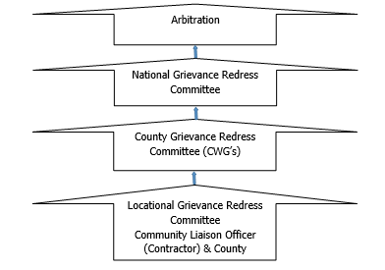

**Figure 7‑1: KOSAP Grievance Redress Mechanism**

It should be noted that if complainants are not satisfied with the grievance process, even after arbitration they have the right to present their complaint through the court system.

It is expected that most disputes will be resolved at the lowest level-Locational Grievance Redress Committee and since most disputes arise during the Construction and operation period the contractor’s Environmental and Social Safeguard team specifically the Community Liaison Officer will work closely with the community to be able to resolve disputes.

Responsibilities of the Community Liaison Officer include:

* Monitor day to day Implementation of the Project;
* Address grievances as they arise on the project;
* A member of the Locational and County Grievances Redress Management Committee to respond on issues that may have been brought to the attention of the committee before escalating to the National Grievance Redress Committee;
  + - * Escalate grievances internally to get a lasting solution.

**Existence of a Local Grievance Redress Mechanism in Madaghisi**

A Local grievance redress committee was constituted in 2020. The LGRM was not active during the site visit. It is anticipated that the committee shall become active during the construction and operation phase of the project. The LGRM is composed of the following members of the project committee:

1. The area chief;
2. Youth representatives;
3. Female representatives;
4. Male representative; and
5. Vulnerable persons representative.

# IMPACT SUMMARY AND CONCLUSION

## Introduction

This chapter gives a summary of impacts conclusion and recommendations

## Summary of impacts identified and assessed

### Construction Phase Impacts

A number of impacts have been identified as a result of the construction of the proposed Madaghisi project. Of these, impacts on employment, procurement and the economy have been determined to be positive.

The significance of the identified negative impacts associated with the construction phase is moderate prior to the application of appropriate mitigation measures. The significance of two of the identified negative impacts associated with the construction phase, specifically: impacts related to labour and working conditions and visual impacts are minor prior to the application of appropriate mitigation measures. With the application of appropriate mitigation measures, the significance of all the identified negative impacts associated with the construction phase will be reduced to minor or negligible.

### Operational Phase Impacts

A number of impacts have also been identified to be associated with the operational phase of the proposed Madaghisi solar project. Of these impacts, four (collectively referred to as Impacts on Employment, Procurement and the Economy) will be positive impacts. Prior to the application of appropriate mitigation measures, none of the identified negative impacts will be of major significance during the operational phase. The presence of electrical infrastructure will pose this health threat to avifauna prior to the application of appropriate mitigation measures. Four of the negative impacts are of minor significance before the application of appropriate mitigation measures. These include: impacts on water quality; health, safety and security and visual impacts.

With the application of appropriate mitigation measures, the significance of all the identified negative impacts associated with the operational phase will be reduced to MINOR or NEGLIGIBLE

## sa and VMGP Conclusion

The Madaghisi project has triggered the World Bank Operational Policy (OP 4.10) for Indigenous Peoples due to the known presence of indigenous peoples (IPs)/vulnerable and marginalized groups (VMGs) at the project area. Madaghisi area is overwhelmingly IP/VMG area and is inhabited predominantly by the Somali community. This is addition to The Kenya Constitution requirement to protect and promote the interests and rights of minorities and marginalized communities and the relevant laws and regulations of the Government of Kenya concerning VMG (Vulnerable and Marginalized Groups). The OP 4.10 Indigenous Peoples contributes to the Bank’s mission of poverty reduction and sustainable development by guaranteeing that the development process fully takes due regard to the dignity, human rights and cultures of indigenous people. The Bank requires that the Borrower engage the IPs/VMGs in a process of Free, Prior and Informed Consultations. This was the basis of the public participation in Madaghisi with the somali community which resulted in broad community support for the project by the affected IPs/VMGs.

## Conclusion AND RECOMMENDATIONS

With all the identified impacts, mitigation will reduce the significance of such impacts to a minor or negligible level. The mitigation measures provided and the management of residual impacts are described in the ESMMP has been described as a vehicle for the continued integrated management of all such impacts.

An Environmental and Social Management and Monitoring Plan (ESMMP) has been prepared to ensure that social and environmental impacts and risks identified during the ESIA process are effectively managed during the construction and operations of the Project. The ESMMP specifies the mitigation and management measures to which the Project Proponent and the Contractor will be committed and shows how the Project will mobilize organizational capacity and resources to implement these measures. The ESMMP also shows how mitigation and management measures will be scheduled and will ensure that the Project complies with the applicable laws and regulations within Kenya, as well as the requirements of WB OPs on environmental and social sustainability. The consultant is confident that every effort will be made by the Project Proponent and Contractor to accommodate the mitigation measures recommended during the ESIA process to the extent that is practically possible, without compromising the economic viability of the Project or having a lasting impact on the environment.

In summary, based on the findings of this assessment, the consultant finds no reason why the proposed Project, should not be moved to the next stage of Project planning and development, contingent on the mitigations and monitoring for potential environmental and socio-economic impacts as outlined in the ESMMP

# APPENDICES

|  |  |  |
| --- | --- | --- |
| **No** | **Appendix** | **Item** |
| 1 | Appendix 1 | List of attendance |
| 2 | Appendix 2 | Minutes of EIA consultation meeting |
| 3 | Appendix 3 | Minutes of Land acquisition meeting |
| 4 | Appendix 5 | A-RAP Document |
| 5 | Appendix 6 | Firm and Lead expert EIA practising licences |

## APPENDIX 1 – PUBLIC MEETING PARTICIPANTS’ REGISTER

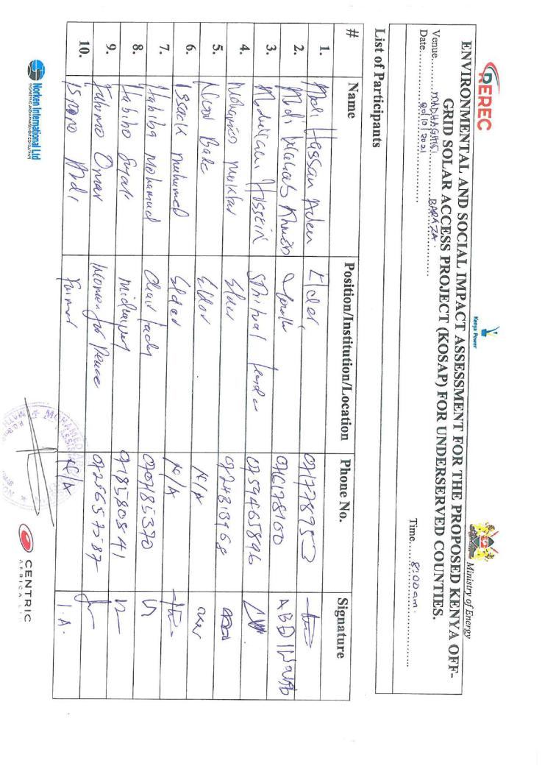

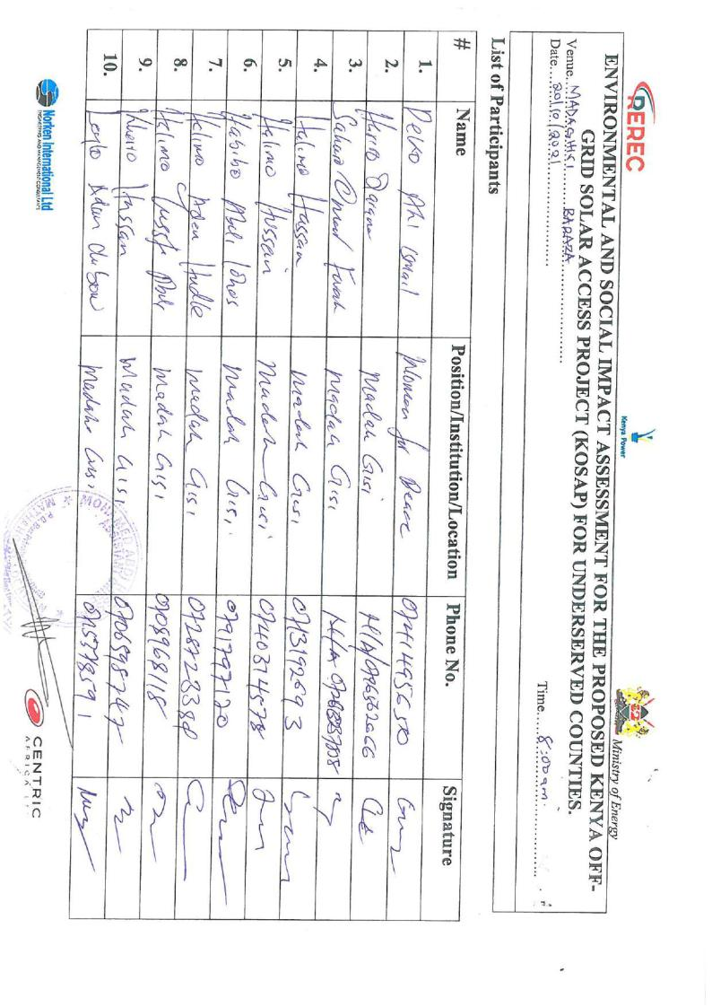

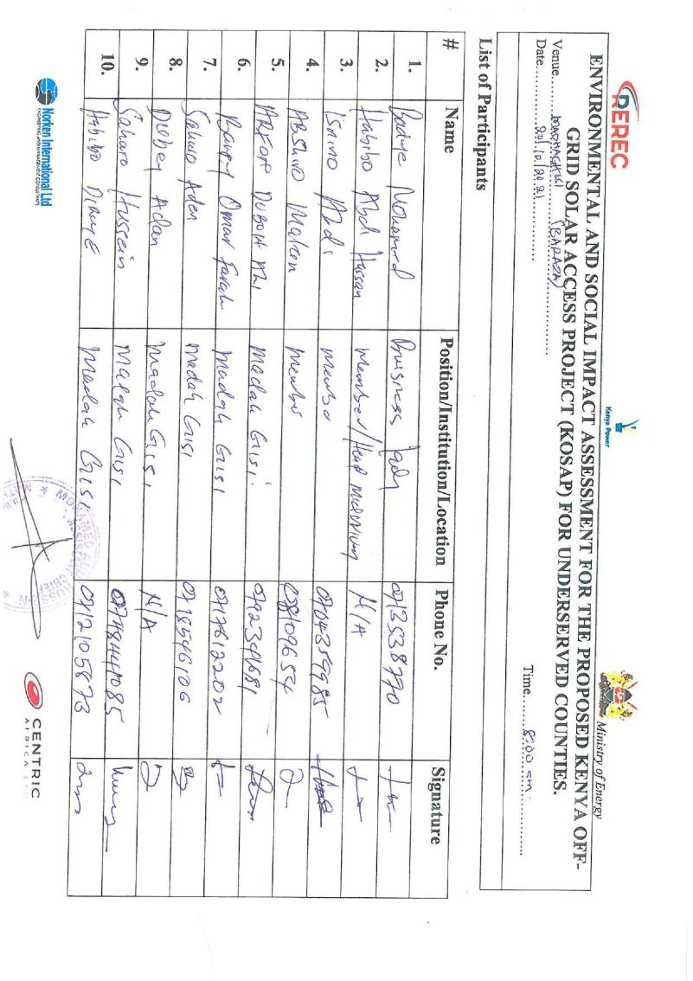

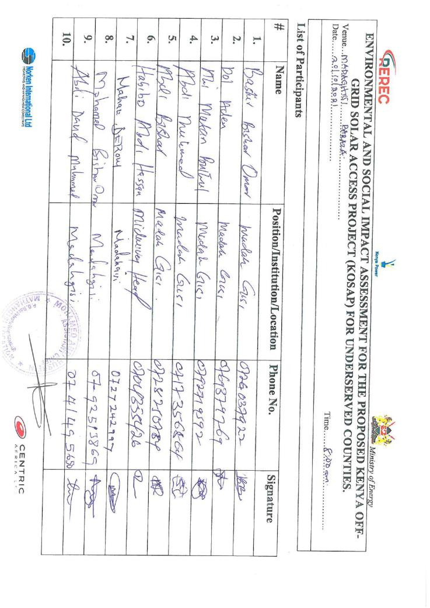

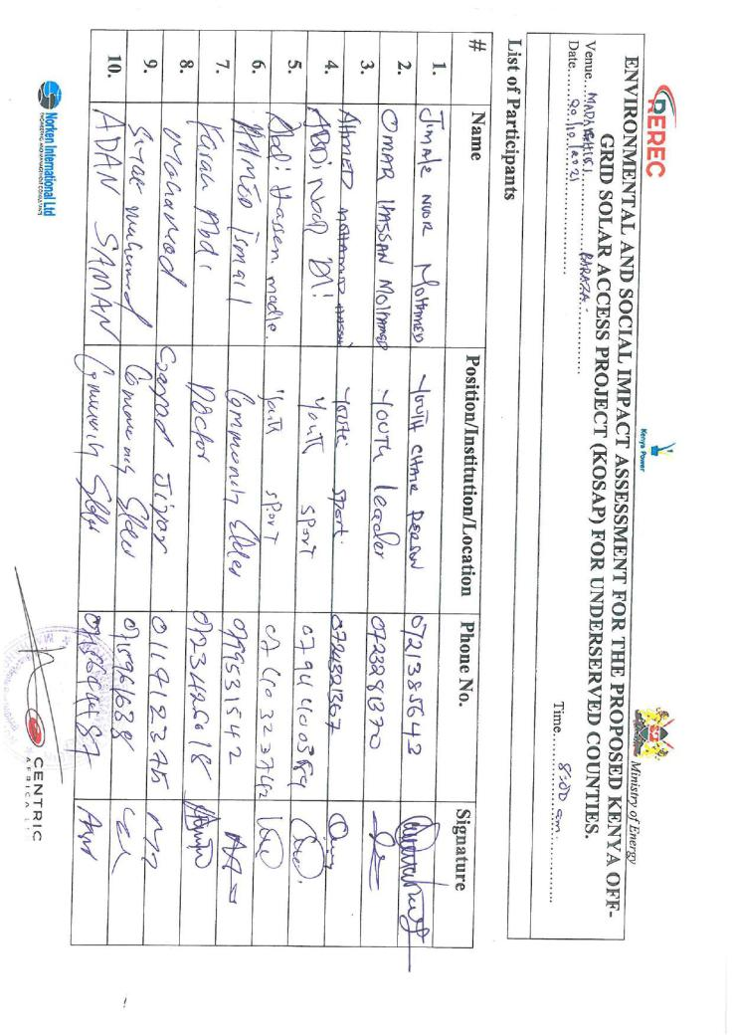 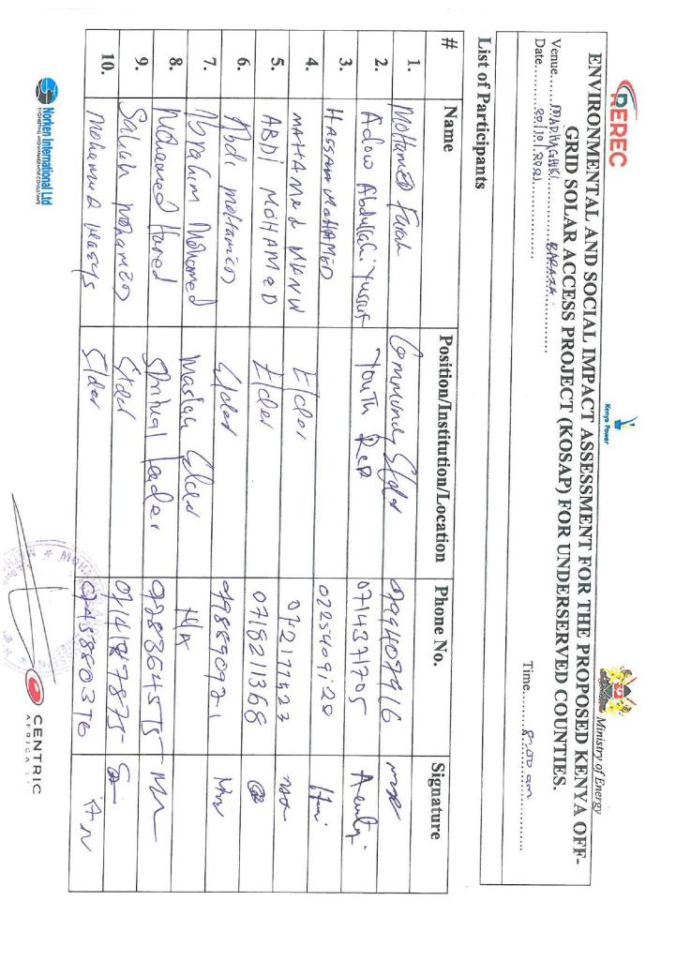

FOCUS GROUP DISCUSSION PARTICIPANTS REGISTER

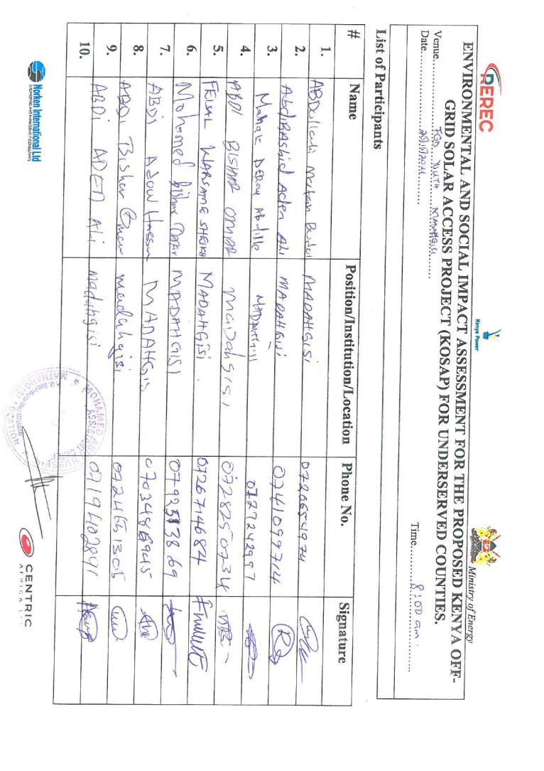

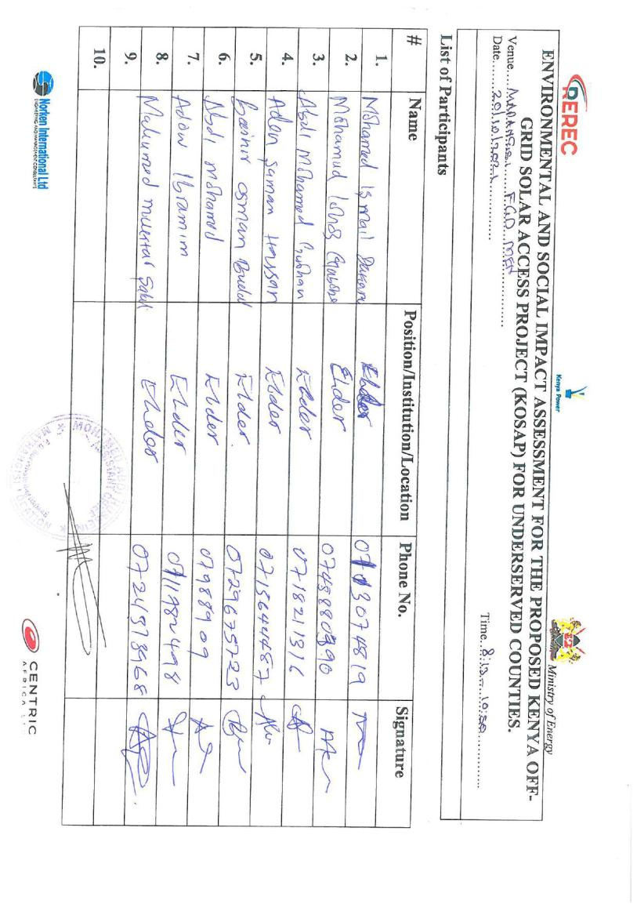

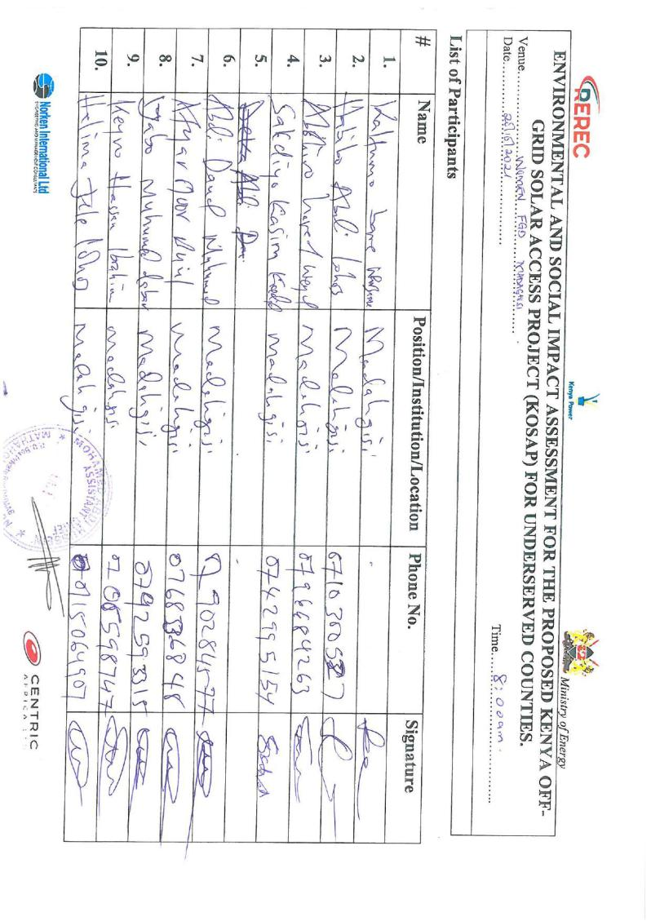

**– KEY INFORMANTS REGISTER**

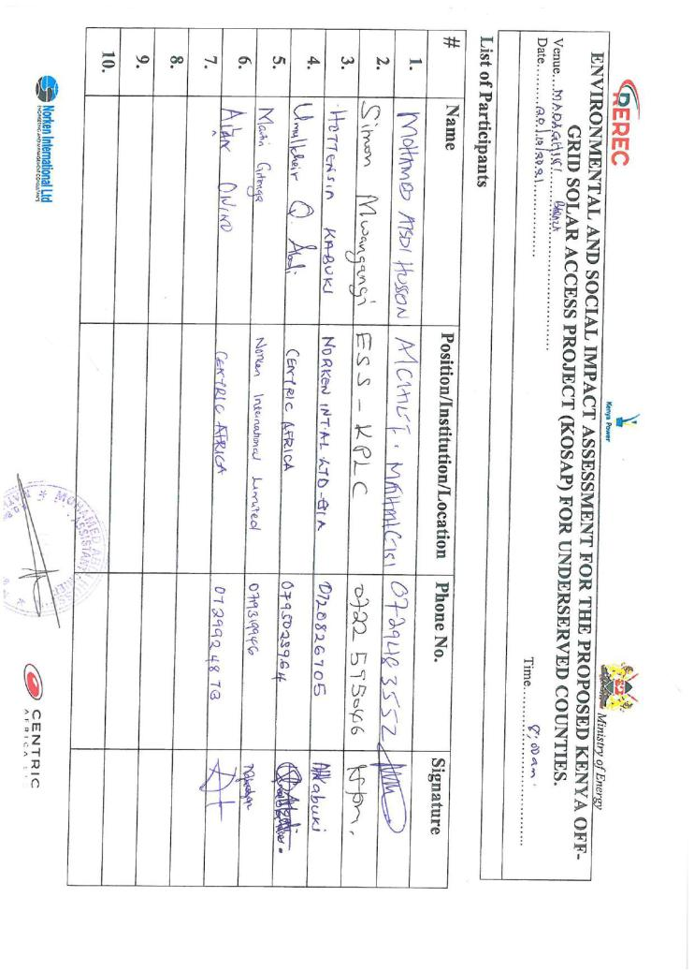

## APPENDIX 2 – MINUTES OF THE PUBLIC MEETING

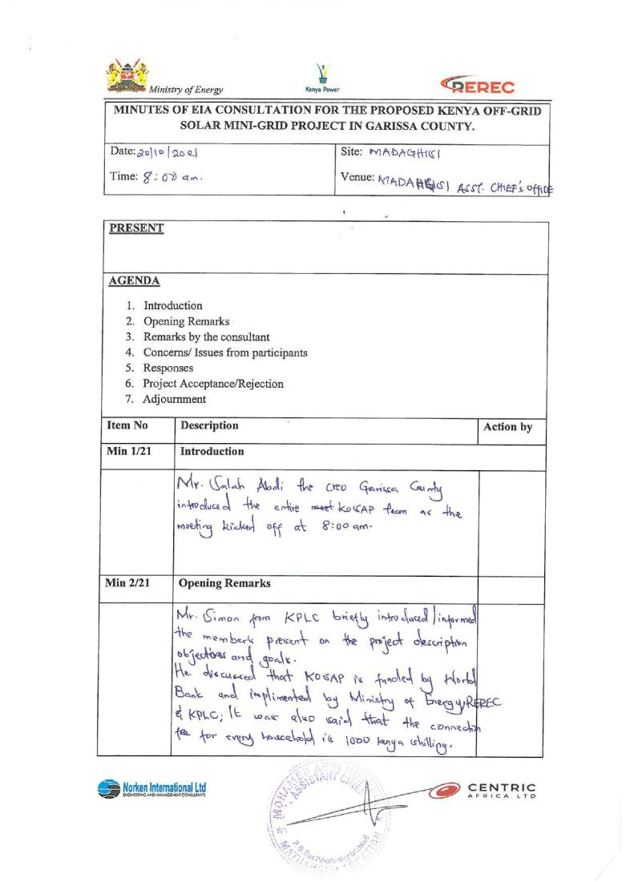

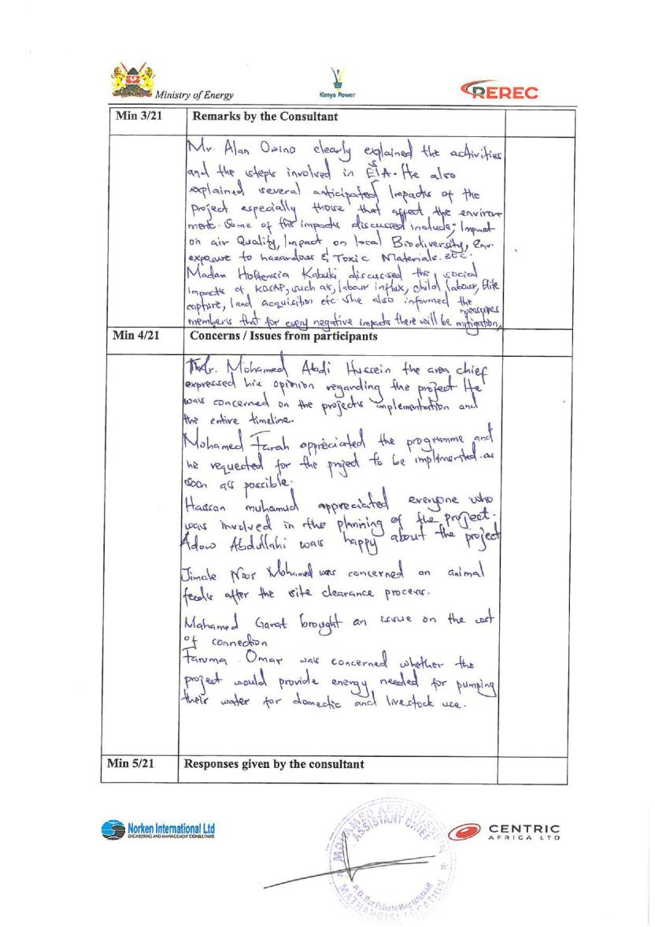

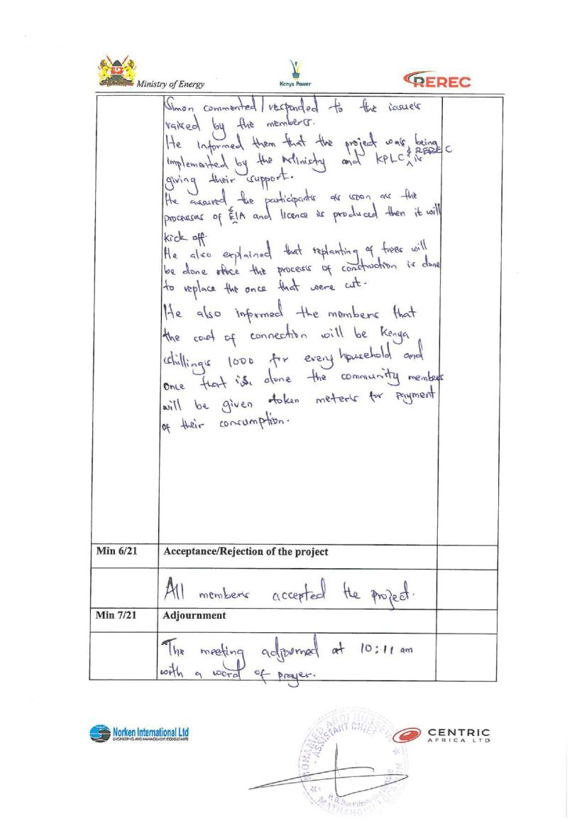

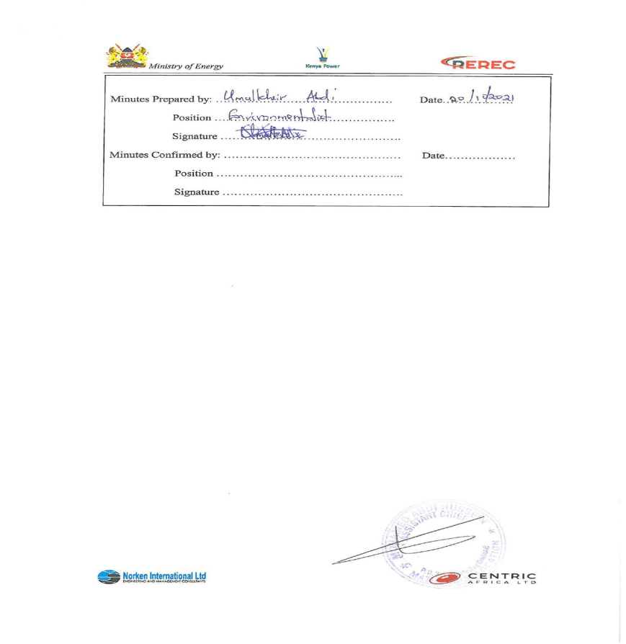

## APPENDIX 3 – MINUTES OF COMMUNITY CONSULTATIVE – FIRST MEETING IN 2021

**MINUTES OF COMMUNITY CONSULTATION MEETING LEADING TO LAND IDENTIFICATION AND GRIEVANCE REDRESS COMMITTEE CONSTITUTION FOR PROPOSED MALAGHISI SOLAR MINI-GRID PROJECT**

**Project:** Proposed Madaghisi Solar Mini-grid

**Venue of meeting**; Madaghisi Shopping Centre

***Date: 24/06/2021***

**AGENDAS**

1. Preliminaries
2. Project description
3. Positive Impacts of the project –Solar Mini-grid
4. Negative Impacts of the project and mitigations measures
5. Need for land for the project
6. Grievance Redress Mechanism for the project
7. Focus Group discussions
8. Environmental and social screening of the site

**Minute 1/KOSAP/2021: Preliminaries**

The Chief Malaghisi location called the meeting to order at 12:38 PM. The meeting began with a word of prayer from one community member. The language used to communicate was Kiswahili with a translator explaining to the community in the local Somali dialect. The chief welcomed all to the meeting and said the community is ready for the stakeholder engagement and asked them to participate actively so that the meeting would be fruitful.

The Chief welcomed the chief officer Garissa County Dr. Adan Mohamed to make his remarks and welcome the KOSAP project team to the ward. The Ward Administrator welcomed and thanked all for attending the meeting and asked the community to listen and participate in the consultation. He noted that the County government is in support of the projects that come to make the lives of the people better. He then invited Mr. Amin KPLC County business manager Garissa County to welcome the project team to talk to the community. Mr. Amin asked the community to feel free and participate in the engagement forums because they are part of the key stakeholders of the project.

Mr. Amin invited the project’s team leader Engineer Benson Mwakina from the Ministry of Energy (national government) to introduce the project team and proceed with the consultations. Engineer Mwakina asked the team to make brief introductions before they engage the community in different issues of the proposed project. Below is a list of KOSAP team members and Garissa county officials present.

**KOSAP team**

|  |  |  |
| --- | --- | --- |
| **S/No** | **Names** | **Position** |
| **1** | Engineer Benson Mwakina | Ministry of Energy -MOE |
| **2** | Dorothy Kagweria | Environmental Social safeguards Expert-MOE |
| **3** | Muriuki Marangu | Property Officer KPLC |
| **4** | George Nyambane | Surveyor Garisaa County |
| **5** | Amin Bishar | County Business manager Garissa |
| **6** | Dr.Adan Mohamed | Chief Officer Garissa County |
| **7** | Urbanus Muthoka | Surveyor-KPLC |
| **8** | Simon Mwangangi | Environmental and Social specialist-KPLC |
| **9** | Onesmus Maina | Engineer-KPLC |
| **10** | Samuel Mbugua | Environmental and Social specialist-KPLC |

**Minute 2/KOSAP/2021: Project Description**

Engineer Mwakina explained that the national government is implementing KOSAP in partnership with County Government in 14 counties in areas are far away from the national grid. He said the proposed project is called KOSAP-Kenya Off-grid Solar Access Project is being implemented jointly by the Ministry of Energy, the Kenya Power and Lighting Company (KPLC) and the Rural Electrification and Renewable Energy Corporation (REREC) in partnership with the World Bank as a development partner, County Government as a partner and the communities in Off-grid areas being the PAPs. Off-grid areas are those places where the national electricity grid has not reached, and whose electricity access has been very low. The reason for choosing solar energy was because this area is far away from the national grid and the fact that the area is well endowed with natural sunlight with high temperatures. He explained that the National Government strategy is to have all households connected to electricity by 2023 using various sources and solar energy is one of the identified sources with the added advantage of being clean energy. He further expounded that the proposed Solar Mini-grid being implemented under KOSAP is part of the government’s effort towards universal access to power. He said the proposed Malaghisi solar Mini-grid is one of the seventeen Solar Mini-grids to be funded by the KOSAP project in Garissa County. He told the community that the project was in the preliminary implementation stages which requires public participation of various stakeholders.

He further noted that the agenda of the visit was to undertake an environmental and social screening of the proposed sites to check suitability in terms of environmental, technical, social and health requirements. He said the second objective was to undertake community engagement to sensitize the community on the project. The other objective was to explain the land requirements for the project and the need for a project grievance redress mechanism.

He sensitize the community on the technical aspects of the project.

He called on the environmentalist (Mr. Mwangangi) to explain the benefits and negative impacts of the project.

**Minute 3/KOSAP/2021: Positive Impacts/Benefits of the Project**

Mr. Mwangangi explained that, every project has both positive impacts and negative impacts. Our assignment is to explain to you the impacts of the project so that you understand how the project will benefit you and the community at large. The project benefit both direct and indirect are as follows:

1. Better source of lighting- replacement of Kerosene lamp and small de-lite lamps with electricity lighting which is clean and has better lighting
2. Benefits to education- provide source of lighting which enables pupils and students to take advantage of longer hours of preps/study in homes. Electricity will be useful in availing power needed to enable use of radio and television sets. Once parents are able to buy these gadgets pupils can access electronic educational materials
3. Business opportunities-Power provides energy needed to power some gadgets that are difficult and expensive to power with generators. Access to electricity will therefore allow the community to take advantage of new business opportunities and enhance the existing ones e.g. Barber shops, salons, posho/maize mills, welding, photo copying, printing, fuel stations, milk coolers and fridges to preserve meat among others
4. Employment and wealth creation- community members will get opportunities to provide non-skilled and skilled labor during construction and operation phases
5. Local Material Supplies and other requirements- the proposed project provides opportunities to supply some materials available locally
6. Up Scaling Electricity Access to the off-grid areas- this area is far away from the grid and so the proposed project helps to reach such areas faster and in a cost effective manner as opposed to grid connections.
7. Impact on HIV/AIDS-due to availability of power, communities can purchase communication equipment like radios and televisions which in turn provides access to information on various issues such as health topics on HIV/AIDs, nutrition and the current Covid-19 pandemic among other information
8. Health benefits of the project- health benefits of the project includes replacement/elimination of use of kerosene lamps and candles, reduced or no use of fuel generators in the trading centers which emits smoke causing respiratory diseases, the health Centre under construction will also benefit from power that can be used to preserve drugs and vaccines alongside powering other medical equipment.
9. Improved standard of living- Living standards of the community is bound to improve as they take advantage of small house hold appliances like e.g. TV, Fridges, radios, blenders, iron boxes e.t.c.
10. Security- Enhanced security due to improvement in lighting up of the area through the street lights. Improved security also means more hours of business
11. Communications- improve communication due to availability of electricity to charge phones, opportunities to set up information communication and technology related business like cyber cafes, access to e-government services among others.
12. Presence of electricity will also attract other business investors to invest in the area

**Minute 4/KOSAP/2021: Negative impacts of the project**

Having discussed the benefits of the project, Mwangangi explained that projects also have negative impacts. He noted that the most important thing is to be able to mitigate the negative impacts so that they do not affect the community. He said ‘’the proposed solar Mini-grid will have the following negative impacts and also briefed the members on possible mitigation measures.

|  |  |  |
| --- | --- | --- |
|  | **Negative impact** | **Mitigation measures by contractor** |
| 1 | Vegetation clearance of the site identified. | * Clear only the areas that are needed to put up the mini-grid * After construction, do landscaping with grass to areas that have no electrical installation as opposed to living areas bare * Planting of trees |
| 2 | Air pollution dust from construction activities | * Fence off construction site to reduce dust going to the public * Use of masks for workers |
| 3 | Air pollution dust from construction vehicles | * Limit vehicle speed to minimum possible when passing residential areas |
| 4 | Air pollution from vehicle emissions | * Maintain vehicles/service vehicles * No idling of vehicles |
| 5 | Solid waste | * Clear all solid waste and dispose appropriately |
| 6 | Land acquisition/take  As you had been briefed before the site identified should;  -must not result in displacement of community members  - We must avoid land that is currently settled or which has squatters.  -There will be an impact of forgoing the current land uses if any or future land uses for the sake of the project. | * The community should be willing and ready to live with this impact |
| 7 | Occupation safety and health hazards e.g. accidents, fall from heights, pricks by sharp objects | * Use of proper personal protective equipment like gloves, overalls, helmet, safety shoes * Allocating work according to skills * Toolbox talks to workers to identify hazards and risky activities |
| 8 | Labor influx. The nature of the project will require technical skills that may not be available in this community. This will require movement of construction workers (labor influx) into this community. Some risks that are involved with labor influx include social ills, cultural conflict, and insecurity among others. | * All workers will be sensitized to respect the locals culture, and conduct themselves according to the contractors code of ethics. The project shall have an established and operational Grievance Redress Mechanism accessible to community members * Reduction of labor influx by tapping into the local workforce |
| 9 | Risk of social conflict due to competition for resources and opportunities | * Awareness-raising among local community and workers on the need to have a good /cordial working relation * Consultations with and involvement of local communities in project planning * Provision of cultural sensitization awareness for workers regarding engagement with local community. * Recruitment of local workforce to the extent possible especially unskilled and semi-skilled jobs * Contactor shall make provision to provide resourcesneeded by the workers if the need for such resources may result to competition e.g. water * Working closely between contractor and the project grievance redress committee to address complains on time. |
|  |
| 10 | Increased or illicit behavior and  crime (including prostitution, theft and substance abuse) | * Sensitization campaigns both for workers and local communities against such social evils * Enforcement of sanctions (e.g., dismissal) for workers involved in criminal activities |
| 11 | Communicable diseases (including STDs and HIV/AIDS) | * Education/awareness about transmission of diseases * Information campaigns on STDs among the workers and local community on ethics, morals, general good behavior and the need for the project to co-exist with the neighbors during the community and worker engagement forums. * Provide condoms to employees |
| 12 | Gender-based violence including sexual harassment and exploitation | * Information and awareness raising campaigns to you community members and specifically women and girls. * Mandatory awareness creation for workers on required lawful conduct in the community and legal consequences for failure to comply with laws * Report all complaints on gender-based violence or harassment through the GRM and also directly through CREO * Working closely and Instruction of local law enforcement to act on community complaints on time * Inclusion of GBV specific mitigation measures in the Environmental and Social Management and Monitoring Plan of contractor * Requirement of contractor to have code of conduct for the workers and to implement them |
| 13 | Child labor | * Ensuring that children and minors are not employed directly or indirectly on the project. * Enforcement of Employment Act that requires contractor to adhere to minimum age * Allowing your children to be employed is illegal and punishable by law because it interferes with the children’s right to education * Report any case to the chief’s office |
| 14 | Demand for Material/resources e.g water | Contractor to consult with elders before using the water resources in the community to avoid conflicts. |
| 15 | *Oil Spill Hazards* | * Contractor not to repair vehicles or equipment on site * Maintain vehicles and equipment in good state |
| 16 | *Storm water and erosion* | * Contractor to put measures to harvest rainwater and control erosion during construction |
| 17 | *Wastewater/ effluent* | Contractor will provide sanitation facilities for workers |
| 18 | *Noise resulting from excavation machinery, vehicles and workers* | * Contractor to comply with NEMA Noise and Excessive vibrations rules and regulations 2009. * Contractor to use machinery and equipment with noise attenuation systems. * Contractor to work only during the day * In case of blasting contractor to give notice to community through the village elders and chiefs office |
| 19 | Visual and Aesthetic Landscape Impacts | * The visual negative impacts can be mitigated through putting up a wall round the facility to keep off/screen the project stacks, poles, cables, panels by the contractor. * Proper siting decisions can help to avoid aesthetic impacts to the landscape. |
| 20 | Hazardous materials from damaged Panels- Photovoltaic panels may contain hazardous materials, and although they are sealed under normal operating conditions, there is the potential for environmental contamination if they were damaged or improperly disposed upon decommissioning. | * Proper planning and good maintenance practices can be used to minimize impacts from hazardous materials. * Proper disposal of used or Damage solar batteries and panels using NEMA registered disposers for such wastes |
| 21 | Fuel storage on site | Contractor will undertake proper installation of the fuel storage tanks and dispensing system like having a budded wall 1.5 times the fuel storage tank.  During operation implementing agency will ensure proper maintenance of the solar plank |
| 22 | Public safety –potential risk of shocks and electrocution | Proper wiring at houses and premises by a qualified technician |

***Public safety in regards to electricity***

Mwangangi educated the community by highlighting the importance of using electricity safely. He said electricity is good but failure to take the precautions while interacting with it can result in electric shocks, fires and even electrocution/death. He emphasized the following precaution/preventive measures to observe in order to prevent risk of electric shocks, fires and electrocutions.

* Engage a certified technician to do wiring in your premises
* Use quality materials while wiring
* Do not engage in individual illegal extensions of power lines to other houses
* Don’t touch sockets and switches with wet hands or wipe with wet cloths
* Do not tie your livestock on electric poles
* Do not cut earth wires that run along some electric poles
* Do not touch any electric wire if you find it fallen on the ground
* Report any incident regarding electricity at the local office –staff in charge of operating the Mini-grid
* Vet all new people coming to the village by checking whether they registered their presence with the office of the chief.
* In case of a black out do not open sockets or switches

**Minute 5/KOSAP/2021: Land requirements for the project**

Mr. Mwangangi told the community that one of the agendas of the project team’s visit was to progress land acquisition process for the proposed Mini-grid. He explained to the public forum that the proposed project will require about 2-3 acres of land. He explained that the piece of land identified will be screened for its Suitability for the purposes of the Community Mini-grid.

**Minute 6/KOSAP/2021: Grievance Redress Mechanism**

Mr Mwangangi explained that in a project, grievances may arise and it important to have a grievance redress mechanism that is known to all the community members and accessible with no costs to the community members.

Mr Mwangangi explained to the community that it is important to put in place a project grievance redress mechanism (GRM). He noted that the GRM to be set should borrow heavily from the existing conflict resolution structures in the community. He explained that the need for a GRM is to provide the community and other stakeholder’s opportunity to share project information and raise questions and grievances about the project. He told the community that they are free to raise any complain or request information about the project. He explained further that members of the project/ grievance redress committee will be chosen by the community members themselves. The committee chosen will be in charge of giving project information to the community and be a focal point for reporting project related issues of concern or grievances. He added that the composition of the committee should have representatives from all groups in the community including men, women, youth and persons with disability.

GRM team selected

|  |  |  |  |  |
| --- | --- | --- | --- | --- |
| **No.** | **Names** | **Represents** | **Id. No** | **Phone No.** |
|  | Fatuma Omar Shekhow | Women | 12912316 | 0725657587 |
|  | Ijabo Muhumed Daar | Women | 21091662 | 0792593315 |
|  | Mohammed Farah Omar | Men | 0034326 | - |
|  | Ador Abdulahi Yusuf | Youth | 23493429 | - |
|  | Mohammed Lotto Gababe | Men | 8503209 | - |
|  | Aden Ibrahim | Men | 8502422 | - |

**Minute 7/KOSAP/2021: Plenary session**

Mr Mwangangi made a brief summary of what had been discussed and invited the community members to ask questions or seek clarifications on the information shared. The questions raised and responses provided are presented in the table below.

|  |  |  |  |  |
| --- | --- | --- | --- | --- |
|  | **Name** | **Questions/suggestions** | **Response** | **Response by agency on how feedback will be used or acted upon** |
| 1. | Billow Said Diis | -Greetings  -we the community of Malaghisi are very happy with the project. Roads and Power are very important for the development of any Town. The community will cooperate with the government to ensure the project is a success. The community school has computers but it cannot operate because the area has no power. The area borehole is powered by diesel which is very expensive | **-** | - |
| 2 | Adow Abdulahi Yusuf | Greetings  We are very grateful for the project. we know how important power is for development so we don’t have any questions | **-** | - |
| 3 | Aden Ibrahim Kheri | Greetings  Most of the community members in this area are pastoralist that’s why you do not see many people in the meeting. Majority are out there with goats and camels looking for pasture. Our town is very populated and most youths don’t have jobs. The project will assist our youths get jobs |  |  |

**FOCUS GROUP DISCUSSION FOR YOUTHS**

This FGDs were led Samuel Mbugua

He welcomed the youths present for the focus group discussion. He further explained to them the proposed project the government wants to implement in their neighborhood will be supplying electricity to the community. This electricity will be generated through solar panels and standby generator. This project is being funded by the World Bank and being implemented by Ministry of Energy through Kenya Power and Lighting Company and County Government of Garissa.

The youths noted were engaged on how the proposed project will be implement in the area and they identified the following positive impact the project will come along with as follows;

* Creation of direct and indirect employment for the community people
* Reduction of travel expenses since health services will be near them
* Clean source of energy (electricity) in their neighborhood
* Improvement of education standards
* Increase of the land value
* Improvement of the economy of the area
* Access to information and news since the community members will invest in the purchasing of the radios, Tvs, and internet services

Further the youths identified the negative impacts that the proposed Mini-grid will come up with in their neighborhood;

* Introduction of visual impacts due to the proposed mini grid and low voltage lines
* Clearing of vegetation on the proposed project site to create room for the construction of the Mini-grid
* Increase of population in the neighborhood especially during the construction phase
* Increase of crimes and other evil vices i.e. unwanted children, early pregnancies, spread of sexual transmitted diseases, petty theft.
* Mixing of various cultures of different people who will be working during the construction and operational phases of the proposed Mini-grid project.
* More intake of water during the construction and operational phases of the proposed Mini-grid
* Instance of air pollution will be witnessed during the operation phase of the proposed mini-grid.

The youth further identified various areas of involvement during the implementation and operation of the proposed Mini-grid which include;

* Taking up of employment opportunities both skilled and unskilled within the project site. These employment chances include; security, traffic marshals, drivers, masonry and casual work among others.
* They will assist in dispute resolutions on various conflicts that might arise during the construction and implementation of the proposed Mini-grid.
* Ensure there are equal oppournities to all community members especially during employment and supplying of construction materials for the proposed Mini-grid.
* Orientation of the construction team of the proposed Mini-grid into local community’s culture and religion so as to avoid confrontations with the construction team
* To be given an oppournities to supply the construction materials that are local available especially the sand, marram, hardcore, building stones, wood among others
* To be provided with an oppournities of transporting other materials and equipments that could be required for construction and operation of the Mini-grid.
* Need to be involved in the ESIA consultation to ensure the project is environmental friendly.
* Land identification
* Sub- contracting especially supply of building materials, transportation services, supply of fuel, supply of food items and water
* Offering translation services between the contractors and the local community
* To have a representation in the project implementation committee.

When youths were asked if they support the proposed project? All of the youths present were in full support of the proposed mini grid project and agreed that they will lobby other youths to support the project.

The Youth selected their GRM representatives for Malanghisi mini-grid as follows:

|  |  |  |
| --- | --- | --- |
|  | **Name** | **ID** |
| 1 | Ador Abdulahi Yusuf | 23493429 |

**Discussion on Women Focus Group**

The group was led by Dorothy who was able to explain why a separate discussion was put up in order for them to have the opportunity to freely express themselves.

She explained the agenda of the visit by the officers from National government and county government was to undertake an environmental and social screening of the proposed site to check suitability in terms of environmental, technical, social and health requirements.

The second objective was to undertake community engagement to sensitize the community on the project and the third objective was about land acquisition for the project and the need for a project grievance redress mechanism.

She gave a summary of the project in terms of its positive and negative impacts and their mitigation measures, the safety precautions and the land acquisition process. She also explained the need for the women to select a representative to the project committee who would represent their views/issues to the committee for redress.

She ensured all the women had understood their rights, roles and benefits concerning the project. Further the women were educated on how they can take up economic opportunities that will raise during project implementation. They were also given opportunity to air their issues/ questions and or /give suggestions to make the project implementation process better.

The discussions went further to bring out issues on how the women can take advantage of the project benefits rather than taking a back seat. She explained to them that they would benefit more from the electricity because they will be able to use clean energy to cook and also benefit from access to information through use of radios and TV that are powered by electricity enabling them to make informed choices on different issues such as nutrition, health, farming among others. They were also set to benefit if they could set up small businesses like salons, cold drink kiosks, cooling milk because it spoils easily, children will have time to study and enhanced security due to the fact that the area will be well lit among other benefits. Gender based violence issues were also discussed including; forms of GBV, rationale for addressing GBV, ways in which a project can worsen existing GBV risks or create new risks, the need to report and document any complaints against workers, report incidences of GBV while ensuring survivor centered approach (respect for the choices, wishes, rights and dignity of the survivor). The women were told to be more vigilant to ensure young girls do not fall prey to GBV incidences. The women were requested to keep talking to the girls on GBV risks and the need to raise alarm in case of risks factors early enough.

All the women were in agreement for the project to be brought to Malanghisi

1. GRM Representative for Malahgisi Mini-grid-

|  |  |  |  |
| --- | --- | --- | --- |
| **Serial No.** | **Name** | **ID NO.** | **Cell No.** |
| 1 | Fatuma Omar Shekhow | 12912316 | 0725657587 |
| 2. | Ijabo Muhumed Daar | 21091662 | 0792593315 |

**Q/A Sahal Ahmed**-We have left behind our goats grazing, stopped fetching firewood and selling our goods at the shops to come for this meeting. What do you have for us in return?

**Reponse**-We have requested the leadership of the community to have this meeting in order to inform you of the project, its benefits and how you intend to benefit. An important step in government projects. After the meeting everyone is free to go back and continue with their activities

**Q2:** How long will it take before the project begins-An average of 18Months

**Q3**:Will there be jobs for young men and women who are educated here in Malaghisi

**Response**-Unskilled labor will be reserved for the locals, skilled labor can only be given to those that are qualified

**Comment**-The connection fee should be Kshs 500/= and not Kshs 1,000/=

**Response**-the connection fee is highly subsides compared to other projects of similar nature within the country. The community is therefore encouraged to support the project and connect to power once the project is complete

**FOCUS GROUP DISCUSSION FOR MEN**

Simon Mwangangi called the Focus group discussion for Men into order and thanked the Men present for turning up for the meeting in good numbers and for their contribution in the Public Baraza.

A focus group discussion was held with men above 35 years of age. This categorization was based on the assumption that these men; as the heads of families and with a deeper understanding of the community set up, roles, entitlements and were also a foundation of knowledge helpful to the project team in understanding the community better. The main objective of this discussion was to assess whether men had understood the proposed project and its requirements and to provide an opportunity for them to air their issues/give their opinions on the project.

Simon Mwangangi from KPLC explained the importance of holding a separate discussion with them so that they would have an opportunity to freely express themselves and inform the Project team how they would wish to be involved in the project. Simon reminded the men that as the heads of families, they played a crucial role in ensuring the project was a success. He explained to the men that the essence of the environmental and social screening of the project site was to assess its suitability in terms of environmental, technical, social and health requirements. The second objective was to undertake community engagement to sensitize the community on the project. The third objective was to explain the land requirements for the project and the need for a project Grievance Redress Mechanism (GRM) for the project. This would be achieved through the formation of a Grievance Redress Committee (GRC) in which men required to select their representative. Simon went further and summarized the project by explaining its positive and negative impacts and their mitigation measures and the requirements for identifying land for the project. He also explained the need for the men to elect a representative to the GRC which also doubled as the project committee. The representative would present their views/issues to the committee for redress and further action to ensure that the interests and needs of men were factored through-out all the phases of the project.

The men were further explained of their role and responsibility in terms of protecting and ensuring security for the project and the need for community ownership of the project. Simon further told men in the meeting that the identified site would be fenced and would hence forth be referred to as land put aside by the community for energy development project.

Simon went ahead and asked the Men to give their views on how they wished to be involved in the project, to ask questions, give suggestions and or seek clarifications. Their responses and concerns were as follows.

The men confirmed they were in agreement to have the project brought to the community and said they will give support to the project as required.

There were no questions.

The following were elected to be representatives for men in the GRM/ Project committee.

* 1. Mohammed Farah Omar of ID No. 0034326
  2. Aden Ibrahim of ID No. 850422
  3. Mohammed Lotto Gababe of ID No 8503209

**MINUTE 8/KOSAP/2021: A.O.B**

Six community members were identified to sign Land Identification Form on behalf of the community.

**Minute 9/KOSAP/2021: Closure of Meeting**

There being no other business, the Chief thanked all the attendants for turning up and their contributions. Members agreed to keep in touch and clarify on any necessary information as regards the intended projects. The meeting ended with a closing prayer at 3:30 PM

## APPENDIX 4 ABBREVIATED RESETTLEMENT ACTION PLAN (A-RAP)

1. **Madaghisi Sub-project Site**

The Madaghisi sub-project site is on unregistered community land and held in trust by the County Government of Garrisa on behalf of the community, in line with the Community Land Act 2016. The proposed site is uninhabited, has no structures, community facilities, or encumbrances and utilized by the community for grazing. Consultations leading to the identification and selection of the sub-project site are captured in the Environmental and Social Screening report for Madaghisi. *Refer to Chapter 5 of the ESIA for the comprehensive socio-economic profile.*

1. **Actual Census Survey of PAPs and Valuation of Affected Assets**

The number of project-affected persons (PAPs) is 15,000 (approximately 2000 households). The land acquisition-related impacts are loss of land and pasture. Mitigation measures include in-kind compensation for loss of land and pasture, and designing power distribution lines to avoid impacting trees, crops, structures, and community facilities. No physical displacement is anticipated; however, there is minimal loss of pasture occasioned by the acquisition of land utilized by the community for grazing. The 2.254 Hectares identified for the sub-project will be acquired compulsorily by the National Land Commission (NLC). The proposed site will be valued and compensated in line with the provisions of the Resettlement Policy Framework (RPF) prepared under KOSAP. *Refer to section 2.2 of the ESIA for the sketch map of the site.*

1. Compensation Measures Agreed with the PAPs and other Resettlement Assistance to be Provided

The proponent requested the community identify three priority projects, whereby one out of the three would be provided as in-kind compensation for loss of land and pasture. The Madaghisi community proposed provision of maternity ward. The value of the priority community project will be proportional to or higher than the value of land under acquisition. In addition, loss or damage to crops, trees, structures, and community facilities will be compensated in line with the provisions of the RPF, and as summarized in the entitlement matrix below.

**3.1 Entitlement Matrix**

|  |  |  |  |
| --- | --- | --- | --- |
| **Types of Impact** | **Person(s) Affected/Eligible for Compensation** | **Compensation/Entitlement/Benefits** | **Responsible organization** |
| 1. **Loss of Land** |  |  |  |
| Loss of unregistered community land. | Community. | Compensation in-kind as prioritized by the community. | KPLC |
| Loss of land in unregistered group ranches. | Group ranch members. | Compensation in-kind as prioritized by the community. |
| Loss of land in registered group ranches. | Group ranch members. | Compensation in-kind as prioritized by the community. |
| Loss of land owned by the National Police, county governments and the Ministry of Interior | Government agencies. | No compensation for public land allocated to another government body. |
| Loss of land owned by the Kenya Forest Service (KFS) and Kenya Wildlife Service (KWS). | Government agencies. | No compensation for public land allocated to another government body. However, payment of conservation fees to KWS and KFS as stipulated under their respective regulations is foreseen. |
| 1. **Loss of Use on Land** |  |  |  |
| Loss of use on public land (e.g., grazing, farming etc.). | Communities utilizing public land. | Communities do not own public land; however, they utilize public land with consent from the relevant agencies. The project will implement the infrastructure project prioritized by the community as compensation for the loss of public land use. | KPLC |
| Loss of use on unregistered community land, unregistered group ranches and registered group ranches ( e.g., grazing, farming etc.). | Communities utilizing unregistered community land, unregistered group ranches, and registered group ranches. | Compensation in-kind as prioritized by the community. |
| 1. **Loss of /Damage to Assets on Land** |  |  |  |
| Trees | Community members on unregistered community land; community members utilizing public land; members of registered and unregistered group ranches and government entities. | During detailed design for power distribution lines and construction of the mini grid and community project, any crops, structures, trees, and community facilities shall be avoided to the extent possible. However, loss or damage to the above will be compensated/restored at full replacement cost,[1] in line with the provisions of the RPF. | KPLC |
| Crops |
| Structures |
| Community facilities e.g., water sources (earth pans, boreholes etc.). | Community members on unregistered community land, community members utilizing public land, and members of registered and unregistered group ranches. |

4. Consultations with PAPs About Acceptable Compensation Options and Alternatives that have been Considered

Detailed consultations with PAPs on land acquisition and compensation, including the modalities of acquiring land and compensation options, were undertaken during the Environmental and Social Screening, Environmental and Social Impact Assessment, and the NLC land valuation process. The following sections provide a summary of the consultations.

**4.1 Engagement of Project -Affected Persons (PAPs)**

Local administration and County Renewable Energy Officers (CREOs) supported the proponent and implementing agency (IA) to mobilize community members and other stakeholders for public consultations and engagement activities. National and county government entities, community segments (men, women, youth, elders, persons with disability, vulnerable and marginalized groups, etc.), NGOs, and local leaders were engaged through key informant interviews, community meetings, and focus-group discussions. The proponent and IA implemented appropriate measures to ensure PAPs effectively participated in the consultations. *Refer to Chapter 5 of the ESIA on public consultation and engagement.*

Once the compensation award and Bill of Quantities (BoQs) are known, the Implementing Agency (IA) will engage the community and agree on the community project to be executed as in-kind compensation. During these consultations, the IA and the community will define the roles and responsibilities of the community in monitoring the implementation of in-kind compensation and maintenance once the IA hands it over to the community. Thus, the IA and the community will effect an agreement to be signed by the local leadership; representatives of the Grievance Redress Committees at the locational, county, and national levels; A-RAP Implementation Committee, and Implementing Agencies.

**4.2 Identification of Community Representatives**

The Madaghisi Locational Grievance Redress Committee (LGRC), constituting a chairperson, secretary, and three members, was formed through community consensus. The committee’s membership comprises men, women, youth, persons with disabilities, and ethnic minorities. The LGRC is responsible for engaging PAPs and resolving complaints. Refer to Chapter 6 of the ESIA on the Grievance Redress Committees. Further, the community will constitute the A-RAP Implementation Committee responsible for coordinating community engagements on the A-RAP and monitoring the implementation and closure of the A-RAP. The representation of the committee will consider gender, vulnerability, and intergenerational sensitivities.

**4.3 Summary of Consultations on Land Acquisition and Compensation Options**

|  |  |  |  |  |  |
| --- | --- | --- | --- | --- | --- |
| **Date** | **Objective** | **Implementing**  **Entities** | **Land Acquisition and Compensation Aspects**  **Discussed** | **Key Issues Raised** | **Responses**  **Given** |
| 24th June 2021 | Environmental and Social Screening.  Voluntary land donation (VLD).  Constitution of the Locational Grievance Redress Committee (GRC). | Ministry of Energy (MoE)  Kenya Power (KPLC)  Rural Electrification and Renewable Energy Corporation (REREC) | Site identification and land allocation for the sub-project.  Criteria for VLD.  Community entitlements (forms of compensation and implications for each). | none | none |
| 20th October 2021 | Environmental and Social Impact Assessment. | Consultants  MoE  KPLC  REREC | Land acquisition through compulsory acquisition (not voluntary land donation).  Selection of three priority community projects, whereby one is to be implemented as in-kind compensation for land. | Community requested for construction of maternity ward. | The proponent has set aside KES 1 million to implement the priority in-kind compensation project.  The value of the project will be proportional to or greater than the value of land.  NLC will determine the value of land. |
| May 2023 | Compulsory Land Acquisition. | NLC | Site inspection and inquiries.  Land valuation.  Award of compensation. |  |  |

5. Institutional Responsibility for Implementation of the ARAP

|  |  |
| --- | --- |
| **Entity** | **Role** |
| Ministry of Energy | * Coordinate A-RAP implementation and provide budget for in-kind compensation. |
| National Land Commission | * Implement the statutory process for compulsorily land acquisition, including site gazettement and inspections, inquiries, valuation, and award of compensation. |
| Kenya Power | * Monitor all land acquisition and compensation aspects (including A-RAP closure), complemented by a third-party monitor. * Provide budgets for stakeholder engagement, grievance management, and monitoring, including the facilitation of the Land Acquisition and Compensation Implementation Committee, and the Grievance Redress Committee. |
| Mini-grid Contractor | * Implement in-kind compensation concurrently with the solar mini-grid project. |
| Supervising Consultant | * Monitor and report on implementation of in-kind compensation, and overall project compliance with social safeguards. |
| Grievance Redress Committees | * Formed at the locational, county, and national levels, and responsible for resolving complaints, including A-RAP related grievances. |
| A-RAP Implementation Committee | * Coordinate A-RAP engagements at the community level, monitoring A-RAP implementation and closure. |
| Affected Community | * Responsible for the operation and maintenance (O&M) of in-kind compensation project. An agreement stipulating the O&M roles and responsibilities of the community will be effected. |

6. Procedures for Grievance Redress

The Project procedures for grievance redress were established through a public consultation process and informed by the existing conflict resolution structures in the community. The Grievance Redress Mechanism (GRM) comprises tiers at the project, county, and national levels. *Refer to Chapter 8 of the ESIA for a detailed GRM.*

7. Implementation Timetable and Budget for the ARAP Implementation

**7.1 Timelines**

The proponent will commission the community project by May 25th, 2025, before operationalizing the mini-grid. The mini-grid contractor will implement the mini-grid and the community project simultaneously. The Supervision Consultant and IAs will implement a commitment register to ensure the mini-grid contractor can achieve the agreed-upon milestones. The register will be complete with clear and practical timebound indicators, which can be monitored by all parties – the PAPs, IAs, the Ministry, third-party monitor, and the Bank.

**7.2 Budget**

The proponent has set aside KES 1 million for the community project (budget captured in the ESMP). The compensation award from NLC and the Bill of Quantities will inform the final cost of the community project. The costs for in-kind compensation, stakeholder engagement, grievance management (including the facilitation of the GRCs and the A-RAP Implementation Committee), and monitoring are covered under the project.

## APPENDIX 5 – NEMA LICENCES

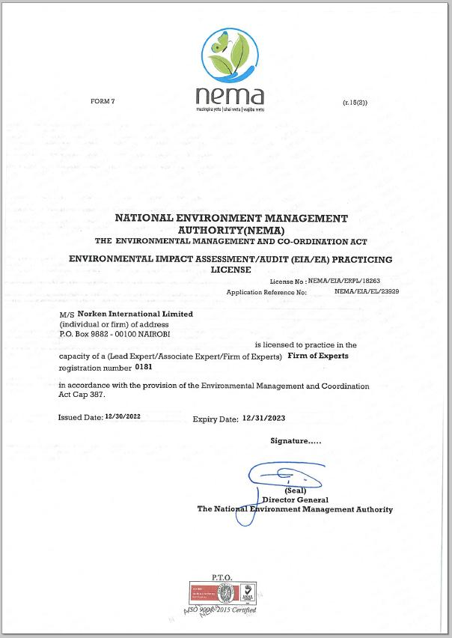

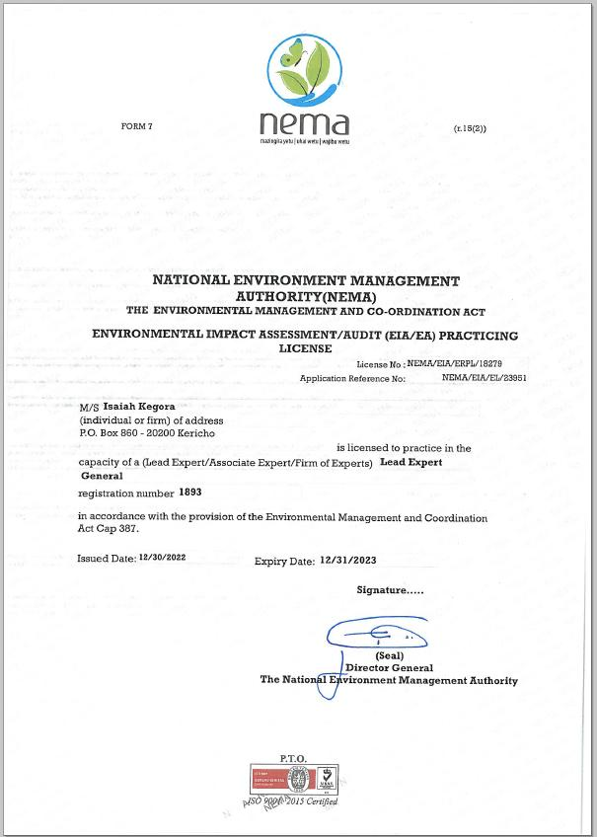

1. A cost basis that will yield compensation sufficient to replace assets, plus necessary transaction costs associated with asset replacement).